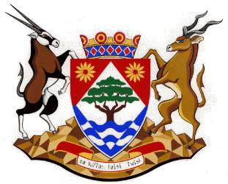
Northern Cape Department of Health
__________________________________________________________________________________

BID NUMBER: NCDOH/002/HAST/2026

FOR

CALL FOR APPLICATION NGO FUNDING 2026/27-2028/29

ADDENDUM NO.1
_____________________________________________________________________
DATE ISSUED: 23 APRIL 2026

ISSUED BY:

NORTHERN CAPE DEPARTMENT OF HEALTH
PRIVATE BAG X059
KIMBERLEY
8301
TEL: (053) 8300 696
EMAIL: hchipungu@ncpg.gov.za

Acknowledgement of Receipt

Name of Bidder: ___________________________________________

Name of Recipient: ___________________________________________

Signature of Recipient: ___________________________________________

Date Received: ___________________________________________

The signed Addendum receipt to accompany the bid submission.
No | Issue | Addendum
1. | Time of Compulsory briefing | Correct and Amend.  The E-Portal suggested 11h00am and was corrected to 10h00 am.

