Good day

Can in have a quote for the following items thank you.

Category 1
Please source quotes for the following:
- USB Keyboard and Mouse x 5 (Windows)
- Wireless Keyboard and Mouse x 5 (Windows)
- USB Type C to HDMI convertor x 5
- Thunderbolt to HDMI x 2
- Thunderbolt to VGA x 2
- USB Memory 32 GB x 6
- Military drop 2TB External HDD x 5 You need to change this item, we requested military drop which has a rubber
- Laptop Bags 14” x 4
- Laptop Bags 13” x 4
- Kensington Laptop Locking Station 2.0 x 5
- Kensington Combination Laptop Lock x 5
- USB type C 11 in 1 dock x 5
- HDMI 2M Cable x 4
- HDMI 10M Cable x 3
- Dell D3100 USB 3.0 Docking Station

Category 2
Imac’s X 5
- Mac 24-inch with Retina 5K display 512GB
- 16GB unified memory
- Apple M1 Chip with 8-core CPU and 8-core GPU

Hyper HyperDrive 6-in-1 USB-C Hub for iMac x 5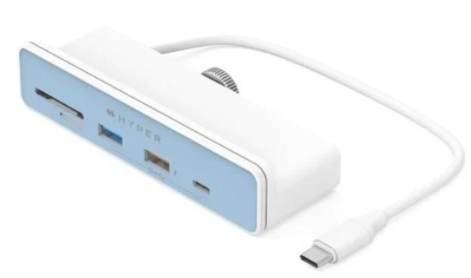

Catogory 3
(desktop)
Processor: Intel® Xeon® CPU E5-2640 x64 (or better), compatible
with dual- and quad-core processors
• Operating System: Windows 10, 64-bit Windows 8.1 Enterprise,
2012 R2 Standard, RHEL-7
• Memory: 1 GB minimum, 4 GB or more recommended for larger systems
• Hard Drive: 4 GB minimum, more recommended depending on archiving
requirements
• Display: Video card and monitor capable of displaying 1024 x 768 pixel
resolution or greater
• Network Support: Ethernet adapter (10/100 Mb with RJ-45 connector)

Supporting documents that needs to be completed in full and be send back with your quote.
• SBD 4 : Declaration of Interest
• SBD 6.1: PREFERENCE POINTS CLAIM FORM IN TERMS OF THE PREFERENTIAL PROCUREMENT REGULATIONS 2022
• Certified Copy of your valid BBBEE Certificate
• Proof of CSD registration starting with MAAA…………..

(If not registered please go to WWW.CSD.gov.za and click on register

Closing date : 24 FEB 2023

