- TIHL HEDGE PRUNERS X 2

2 X STIHL HS45 PETROL HEDGE TRIMMER
Petrol engine
Displacement | 27.2cm³
W | 0.75kw
Weight | 4.7kg
Total length | 95cm
Tooth spacing | 30mm
Tank volum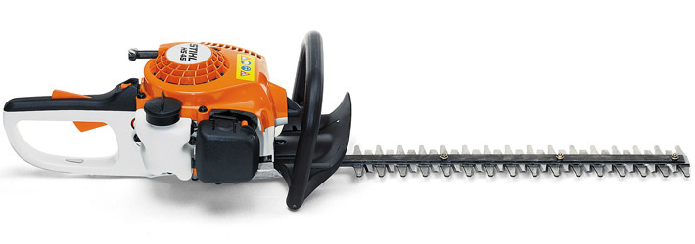e | 0.22l
Blade length | 450mm/18”

As in photo;

