Description of Request | A new support and maintenance contract on existing network security appliance hardware

- Background Information
Cyber threats are one of the most serious economic and information security challenges that organisations face in this digital era. Eskom like any organisation is exposed to a vast array of cybersecurity threats, both from an internal and external perspective. To protect Eskom against these cybersecurity security threats, Group IT procured and implemented Checkpoint Firewall Toolset solution in December 2016.

The solution comprises of 57 devices implemented in the Perimeter and Internal environments, and it is centrally managed through Firewall Management. The solution is implemented as follows:

- Firewall Management Environment (3 devices);
- Internet Edge Perimeter Environment (4 devices);
- OT and SCADA Environment (18 devices);
- Process (Boiler, Turbine, PLC) Environment (4 devices);
- Metering Environment (20 devices);
- Vending Environment (6 devices) and

This solution was implemented through a project which established a three year contract agreement catering for licencing, support and maintenance, hardware refresh, professional services and training of resources.

A new one year contract is required to replace the existing contract which is due to expire. The proposed procurement method is through the RFP process, i.e. an open tender.

The required new contract should cater for the following:
- Licencing (maintain subscriptions)
- Support and maintenance (patches and upgrades, incidence response, etc.)

The Checkpoint Solution is supported by various accredited Service Provides who are registered partners to Checkpoint in South Africa. It would be beneficial for Eskom to establish a contract with one of the accredited Service Providers in order to maintain the required network security services for the next year.
GIT requires a continued provision of software licensing, maintenance and support of the Checkpoint Solution in order to maintain a healthy cyber security posture for the organisation.

- Business motivation & benefits

  - Business motivation:

  - Checkpoint is one of three (3) approved firewall technology standards within the Eskom environment, including Cisco and Palo Alto.
  - The Checkpoint Firewalls provide appropriate Next Generation Threat Prevention (NGTP) type capabilities against cyber threats. These capabilities include network segregation, access control, Anti-bot, Application Control, Intrusion Prevention System (IPS) and URL Filtering among others.
  - Maintaining the service will ensure the remediation of advanced internal and external threats against the Eskom Enterprise infrastructure;
  - To improve/maintain the network security maturity level within the organisation; and continued use of Next Generation Threat Prevention (NGTP): for effective and sustainable controls in order to minimise the risk to Eskom of current information security threats and trends.

  - Benefits to Eskom

- Business Continuity with regards to licencing, maintenance and support including incident response.
- Reducing the risk of service disruptions and potential exploitations.
- The solution will enable Eskom Information Security services to maintain the security posture of the organisation. Some of the benefits include:

    - A total integrated Checkpoint Security suite of various subsystems to cater for our various environments, i.e. IT, OT and SCADA.
    - Enterprise wide situational awareness via centrally managed console of Eskom network where Checkpoint assets are deployed to prevent exploitation of IT/OT and SCADA infrastructure.
    - Integrated threat view between all Checkpoint appliances to mitigate advance threat exploitations of critical systems.
    - Appropriate security alignment with ISO 27002 security standards of checkpoint assets.

- Scope of work/Business requirements

  - Maintenance and Support for all Physical Hardware Checkpoint Appliances, models include:
Smart1-5150(3), Gateway-15600(4), Gateway-5600(26), Gateway-6200(22)

Device quantity numbers are in brackets for each model type
Maintenance and Support and Renewal of existing Subscription:
Next Generation Threat Protection (NGTP), Next Generation Firewall (NGFW), Next Generation Security Management (NGSM) and Software Licences for all Checkpoint Appliances:
Professional services (Telephonic/Remote and On-Site Support) to address business requirements - professional/technical Level 3 support
Access to checkpoint portal and knowledge base
Access to software download centre
Access to download and evaluate new release software

  - Service Level Agreement requirements

The Service Provider must provide 24/7/365 second and third line support with OEM

Service Level | Description | Escalation to SP | Escalation to OEM
Critical | Business has stopped | Response within 1 (one) hour – Level 1  Response within 3 (three) hours – Level 2 | Response within 4 (four) hours – Level 3
Major | Business severely impacted | Response within 1 (one) hour – Level 1  Response within 3 (three) hours – Level 2 | Response within 4 (four) hours – Level 3
Normal | Minor business impact / product failure | Response within 1 (one) business day – Level 1  Response within 2 (two) business days – Level 2 | Response within 1 (one) business day – Level 3
Low | No business impact but requires one or more updates | Response within 2 (two) business days – Level 1  Response within 2 (two) business days – Level 2 | Response within 2 (two) business days – Level 3
Informational | Request for information | Response within 3 (three) business days – Level 1  Response within 3 (three) business days – Level 2 | Response within 3 (three) business days – Level 3

  - Safety: Confirm if the third-party resources will be required to visit an Eskom site at any stage of the execution of the project and consultation with the Occupational Health and Safety Practitioner for applicable, SHE requirements is mandatory.

- Risk Analysis

Indicate risks applicable:

Risk Description | Risk Mitigation | Rating (H/M/L)
Security Risk | New contract | H
Possible Cyber Attack | New contract | H
Software Vulnerability | New contract | H
Hardware Failure | New contract | H
No email comms | New contract | H
Internet Interruption | New contract | H

- System Lifecycle Consideration

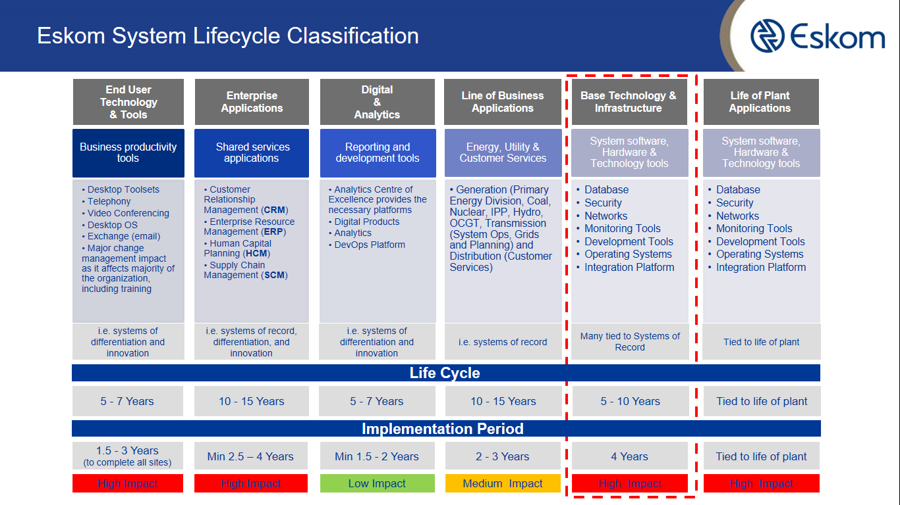

  - Provide details regarding the system lifecycle consideration
The current hardware assets have reached end of life, thus a maintenance and support contract will serve the purpose to maintain business requirement.

  - Development Period for new system/solution
Implementation period of one month to on board all the current devices, map a network diagram with the toolset and model each device with a backup configuration for analysis.

  - Support & Maintenance Period
  - Maintenance and Support for all Physical Hardware for period of 5 years
  - Device quantity numbers are in brackets for each model type
  - Yearly subscription renewal
  - Flexibility to procure additional licenses on future requirement
  - Replace/upgrade existing devices to newer high performance models id and when required – Non committal
  - Professional services (Telephonic/Remote and On-Site Support) to address business requirements - professional/technical Level 3 support with OEM
  - Training Services on new software/product releases (All components of the solution) - Non-committal

- Service Level Agreement requirements
Refer to point 3.2 applicable to the table as listed

- Approvals:

End user / requestor:  Senior manager: | Name: | Heinz Köllner
End user / requestor:  Senior manager: | Designation: | Senior Advisor
End user / requestor:  Senior manager: | Date: | 30 August 2022
End user / requestor:  Senior manager: | Signature:
Senior Manager: | Name: | Sithembile Songo
Senior Manager: | Designation: | Senior Manager Information Security
Senior Manager: | Date:
Senior Manager: | Signature:

