Scope of machines required to fabricate various types of sealing strips required by TGS Works.

Background

Eskom Rotek Industries SOC Ltd is a division of the Eskom Rotek Industries (TGS) SOC Ltd Group, is a wholly owned subsidiary of Eskom. Eskom Rotek Industries SOC Ltd provides a comprehensive maintenance capability which includes maintenance, repair, overhaul, commissioning, troubleshooting on steam turbines and generators.
Turbo Generation Services is a Business involved in the maintenance, repair and refurbishment of all rotating machinery, specialising in turbo generators at all Eskom Sites. Sealing strips of various sizes and shapes are required in the refurbishment of rotors, casings and BFPT etc. The responsibility of the supplier includes the supply of sealing strips machines (6) that can manufacture various sealing strips according to the specification as detailed in the scope of work and pricing schedule.
TGS is in the market seeking a reputable company to manufacture two different types of sealing strip machines to fabricate various types and design of sealing strip as per the attached scope document.

2mm roller bending sealing strip machine x 2.
The 2mm sealing strip machine is based on two concepts, one being a hand driven roller bending machine (pic attached) and the other being an electrically driven roller bending machine (220/380v) with a 3 roller system, floor mounted electrical cabinet, foot pedal (stop, start and variable speed control) with various slots cut on the bottom set of rollers. Rollers must be fabricated from the correct type of material and case harden including manufactured to the required specification. The business requires two machines, and each machine must come with one set of complete rollers 2.05 x 15 mm & 2.05 x 20 mm respectively. An off the shelf machine can be purchased and modified to suit our requirements, meaning that new roller needs to be manufactured to fit the purpose. Refer to drawing for sizes of the rollers. Over and above the rollers supplied with the machine TGS requires these additional rollers:
- 4 set of rollers with 2.05 mm x 10mm deep
- 4 set of rollers with 2.05 mm x 15mm deep
- 4 sets of rollers with 2.05 mm x 20mm deep

Machines must be supplied with approximately 5m electrical cabling and appropriate plugs and accessories to commission the machine for production. Provision must be made for cable covers which must be mounted on the floor to protect the cable and from a safety perspective.
Manufacture roller machine to fabricate 2mm x various width sealing strips.
Example of bending machine with 2.05 x 10mm grove cut on the bottom set of rollers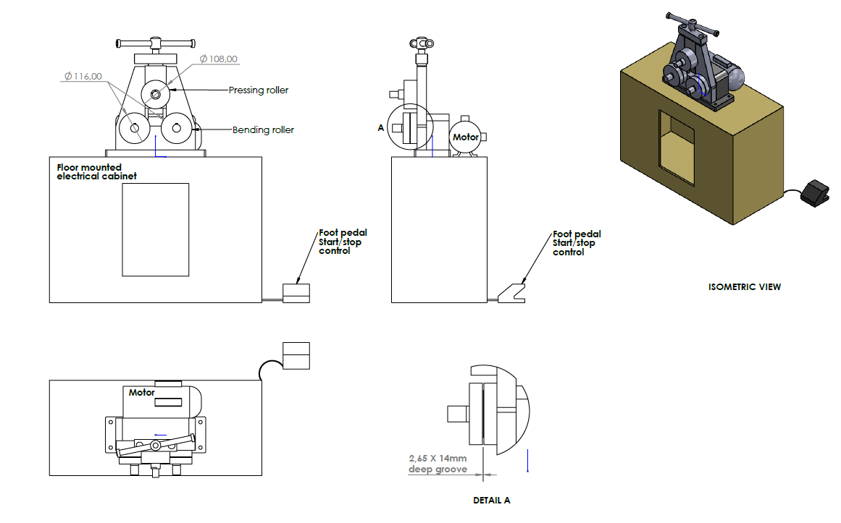

Example of bending machine with 2.05 x 20mm grove cut on the bottom set of rollers.
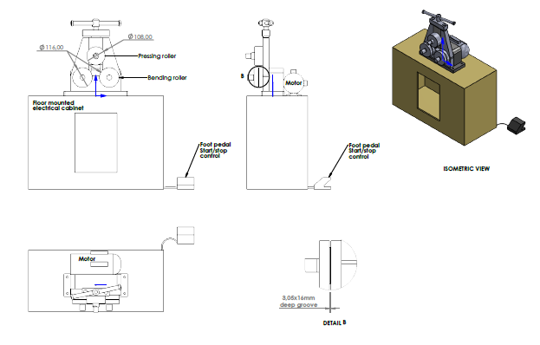
Concept one
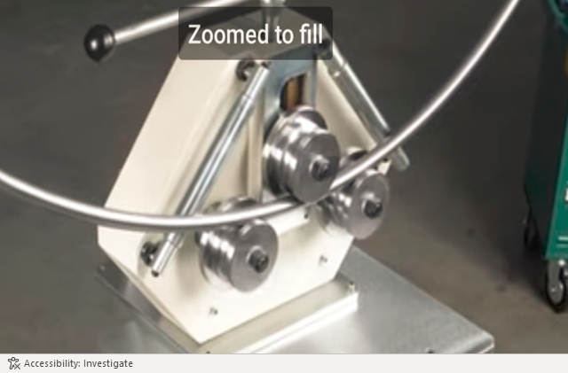

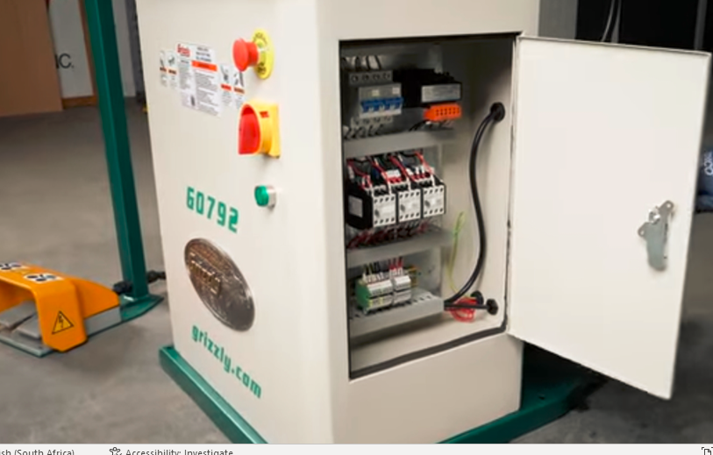
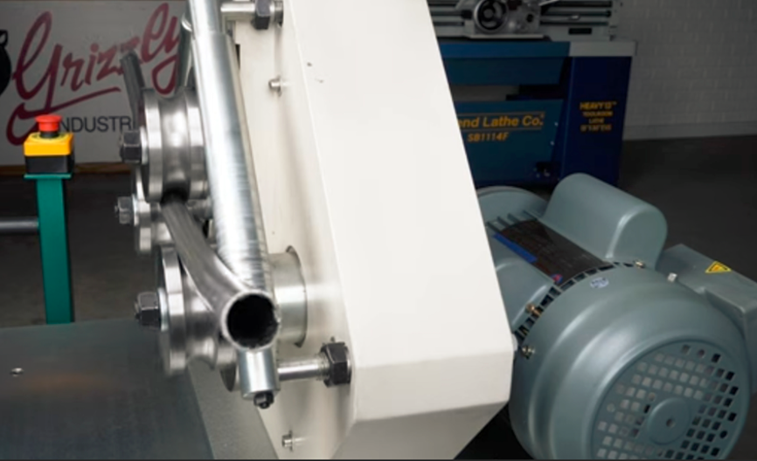

Concept 2
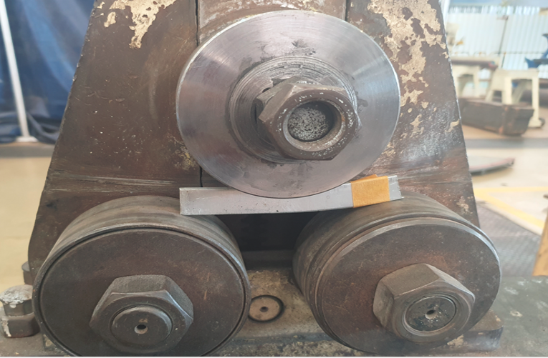

Few examples of 2 mm thick sealing strips with various width and different profiles fabricated on roller system.
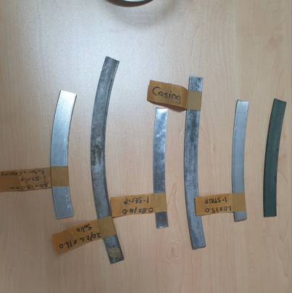
0.3 mm to 0.6 mm roller sealing strip machine x 4.
TGS does not have a design nor any pictures of a machine that can manufacture sealing strips of various shapes and design of material from 0.3 to 0.6 mm in thickness with various width.
The machine must be electrically driven either by a (220/380v) with approximately 10 sets of rollers to develop the desired shape/profile of the sealing strips with additional supplementary rollers to support the sealing strips during the shaping/profiling process. The machines must come with guide blocks, labyrinth feeder reels including various accessories to make the machine fully functional and fit for purpose. The machine must be floor mounted with a foot pedal (stop, start and variable speed control). Rollers must be fabricated from the correct type of material and hardness of material including manufactured to the required specification including various profiles.
The business requires four machines, and each machine must come with one set of complete rollers guide blocks, labyrinth feeder reels and all other accessories so that the machine is fully functional.
Over and above the rollers supplied with the machine TGS requires these additional rollers:
- 4 set of rollers/dies (8) to form full J shape.
- 4 set of rollers/dies (8) to form U shape.
- 4 set of rollers/dies (8) to form L shape.
- 4 set of rollers/dies (8) to form I shape.
- 4 set of rollers/dies (8) to form half J shape.
- 4 sets of guide rollers and 4 sets of guide blocks including all other wearable parts used to make the various profiles
- 12 x labyrinth feeder reels to accommodate various width of sealing strip material. (10mm, 12mm & 16mm width) 4 reels per material width

NB… sample of profile can be viewed during the site inspection/walk

Few examples of 0.3 to 0.6mm (various width) sealing strips of different profiles.
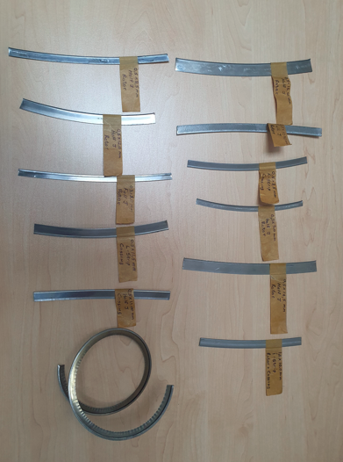

Few examples of Caulking wire
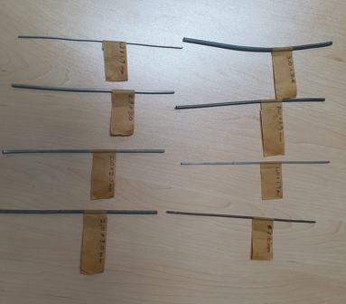

………………………….
Works Engineer – Xolani Ngidi

………………………….
Production Support Manager – Roy Ramkarran
12/03/2024

