FORM A3.3: DECLARATION OF TENDERER’S PAST SUPPLY CHAIN MANAGEMENT PRACTICES (Incorporating SBD8)

CONTRACT SANRAL N.006-010-2023/1F

Notes to tenderer:
- This declaration:
- must form part of all tenders submitted.
- in the case of a joint venture (JV), must be completed and submitted by each member of the JV
- This form serves as a declaration to be used by institutions in ensuring that when goods and services are being procured, all reasonable steps are taken to combat the abuse and/or misused the State’s procurement of the supply chain management system.
- The tender of any tenderer may be disregarded if that tenderer or any of its directors have –
- abused the institution’s supply chain management system;
- committed fraud or any other improper conduct in relation to such State system;
- has been charged with fraud, corruption or any other improper conduct whether of a criminal or civil nature during the course and scope of rendering services to the state or any other party and/or entity; or
- failed to perform on any previous contract with the State.
- In order to give effect to the above, the following questionnaire must be completed and submitted with this tender.

4.1 | Is the tenderer or any of its directors listed on the National Treasury’s Database of Restricted Suppliers as companies or persons prohibited from doing business with the public sector?  Companies or persons who are listed on this Database were informed in writing of this restriction by the Accounting Officer/ Authority of the institution that imposed the restriction after the audi alteram partem rule was applied.  The Database of Restricted Suppliers now resides on the National Treasury website (www.treasury.gov.za) and can be accessed by clicking on its link at the bottom of the home page. | Yes  ◻ | No  ◻
4.1.1 | If Yes, furnish particulars:
4.2 | Is the tenderer or any of its directors listed on the Register for Tender Defaulters in terms of Section 29 of the Prevention and Combatting of Corrupt Activities Act (No. 12 of 2004)?  The Register for Tender Defaulters can be accessed on the National Treasury website ((www.treasury.gov.za) by clicking on its link at the bottom of the home page. | Yes  ◻ | No  ◻
4.2.1 | If Yes, furnish particulars:
4.3 | Was the tenderer or any of its directors convicted by a court of law (including a court outside the Republic of South Africa) for fraud or corruption during the past five years? | Yes  ◻ | No  ◻
4.3.1 | If Yes, furnish particulars:
4.4 | Was any contract between the tenderer and any organ of State terminated during the past five years on account of failure to perform on or comply with the contract? | Yes  ◻ | No  ◻
4.4.1 | If Yes, furnish particulars:

CERTIFICATION

I, the undersigned, .........................................................................................................................
certify that the information furnished on this declaration form is true and correct.

I accept that, in addition to cancellation of a contract, action may be taken against me should this declaration prove to be false.

Signature: ..................................................................................................................................

Name: ........................................................................................................................................

Position: .....................................................................................................................................

Date: ..........................................................................................................................................

Name of tenderer: ......................................................................................................................

FORM A13: FORM SBD1 – INVITATION TO BID AND TERMS AND CONDITIONS FOR BIDDING

PART A

INVITATION TO BID
YOU ARE HEREBY INVITED TO BID FOR REQUIREMENTS OF THE SOUTH AFRICAN NATIONAL ROADS AGENCY SOC LIMITED
BID NUMBER: | N.006-010-2023/1F |  |  | CLOSING DATE: | 30 June 2023 |  | CLOSING TIME: |  |  |  | 11:00
DESCRIPTION | CONSULTING ENGINEERING SERVICES FOR THE PERIODIC MAINTENANCE ON NATIONAL ROUTE N6 SECTION 1 FROM EAST LONDON (KM 5.60) TO (KM 25.00)
BID RESPONSE DOCUMENTS MAY BE DEPOSITED IN THE BID BOX SITUATED AT (STREET ADDRESS)
SANRAL – Southern Region
20 Shoreward Drive, Bay West
Gqeberha (Port Elizabeth)
6025
BIDDING PROCEDURE ENQUIRIES MAY BE DIRECTED TO |  |  |  |  | TECHNICAL ENQUIRIES MAY BE DIRECTED TO:
CONTACT PERSON |  |  | Procurement Office |  | CONTACT PERSON |  |  |  | Procurement Office
TELEPHONE NUMBER |  |  | N/A |  | TELEPHONE NUMBER |  |  |  | N/A
FACSIMILE NUMBER |  |  | N/A |  | FACSIMILE NUMBER |  |  |  | N/A
E-MAIL ADDRESS |  |  | procurementsr2@sanral.co.za |  | E-MAIL ADDRESS |  |  |  | procurementsr2@sanral.co.za
SUPPLIER INFORMATION
NAME OF BIDDER
POSTAL ADDRESS
STREET ADDRESS
TELEPHONE NUMBER |  | CODE |  |  | NUMBER
CELLPHONE NUMBER
FACSIMILE NUMBER |  | CODE |  |  | NUMBER
E-MAIL ADDRESS
VAT REGISTRATION NUMBER
SUPPLIER COMPLIANCE STATUS |  | TAX COMPLIANCE SYSTEM PIN: |  |  | OR | CENTRAL SUPPLIER DATABASE No: |  | MAAA
ARE YOU THE ACCREDITED REPRESENTATIVE IN SOUTH AFRICA FOR THE GOODS /SERVICES OFFERED? |  | Yes No  [IF YES ENCLOSE PROOF] |  |  | ARE YOU A FOREIGN BASED SUPPLIER FOR THE GOODS /SERVICES OFFERED? |  |  |  |  | Yes No  [IF YES, ANSWER THE QUESTIONNAIRE BELOW]
QUESTIONNAIRE TO BIDDING FOREIGN SUPPLIERS
IS THE ENTITY A RESIDENT OF THE REPUBLIC OF SOUTH AFRICA (RSA)? YES NO
DOES THE ENTITY HAVE A BRANCH IN THE RSA? YES NO
DOES THE ENTITY HAVE A PERMANENT ESTABLISHMENT IN THE RSA? YES NO
DOES THE ENTITY HAVE ANY SOURCE OF INCOME IN THE RSA? YES NO
IS THE ENTITY LIABLE IN THE RSA FOR ANY FORM OF TAXATION? YES NO
IF THE ANSWER IS “NO” TO ALL OF THE ABOVE, THEN IT IS NOT A REQUIREMENT TO REGISTER FOR A TAX COMPLIANCE STATUS SYSTEM PIN CODE FROM THE SOUTH AFRICAN REVENUE SERVICE (SARS) AND IF NOT REGISTER AS PER 2.3 BELOW.

PART B

TERMS AND CONDITIONS FOR BIDDING

- BID SUBMISSION:
  - BIDS MUST BE DELIVERED BY THE STIPULATED TIME TO THE CORRECT ADDRESS. LATE BIDS WILL NOT BE ACCEPTED FOR CONSIDERATION.
  - ALL BIDS MUST BE SUBMITTED ON THE OFFICIAL FORMS PROVIDED (NOT TO BE RE-TYPED) OR IN THE MANNER PRESCRIBED IN THE BID DOCUMENT.
  - THIS BID IS SUBJECT TO THE PREFERENTIAL PROCUREMENT POLICY FRAMEWORK ACT, 2000 AND THE PREFERENTIAL PROCUREMENT REGULATIONS, THE GENERAL CONDITIONS OF CONTRACT (GCC) AND, IF APPLICABLE, ANY OTHER SPECIAL CONDITIONS OF CONTRACT.
  - THE SUCCESSFUL BIDDER WILL BE REQUIRED TO FILL IN AND SIGN A WRITTEN CONTRACT FORM (SBD7).

- TAX COMPLIANCE REQUIREMENTS
- BIDDERS MUST ENSURE COMPLIANCE WITH THEIR TAX OBLIGATIONS.
- BIDDERS ARE REQUIRED TO SUBMIT THEIR UNIQUE PERSONAL IDENTIFICATION NUMBER (PIN) ISSUED BY SARS TO ENABLE THE ORGAN OF STATE TO VERIFY THE TAXPAYER’S PROFILE AND TAX STATUS.
- APPLICATION FOR TAX COMPLIANCE STATUS (TCS) PIN MAY BE MADE VIA E-FILING THROUGH THE SARS WEBSITE WWW.SARS.GOV.ZA.
- BIDDERS MAY ALSO SUBMIT A PRINTED TCS CERTIFICATE TOGETHER WITH THE BID.
- IN BIDS WHERE CONSORTIA / JOINT VENTURES / SUB-CONTRACTORS ARE INVOLVED; EACH PARTY MUST SUBMIT A SEPARATE TCS CERTIFICATE / PIN / CSD NUMBER.
- WHERE NO TCS PIN IS AVAILABLE BUT THE BIDDER IS REGISTERED ON THE CENTRAL SUPPLIER DATABASE (CSD), A CSD NUMBER MUST BE PROVIDED.
- NO BIDS WILL BE CONSIDERED FROM PERSONS IN THE SERVICE OF THE STATE, COMPANIES WITH DIRECTORS WHO ARE PERSONS IN THE SERVICE OF THE STATE, OR CLOSE CORPORATIONS WITH MEMBERS PERSONS IN THE SERVICE OF THE STATE.”

NB: FAILURE TO PROVIDE / OR COMPLY WITH ANY OF THE ABOVE PARTICULARS MAY RENDER THE BID INVALID.

SIGNATURE OF BIDDER: ……………………………………………

CAPACITY UNDER WHICH THIS BID IS SIGNED: ……………………………………………
(Proof of authority must be submitted e.g. company resolution)

DATE: ……………………………

FORM A14: BLACK OWNERSHIP DECLARATION

CONTRACT SANRAL N.006-010-2023/1F

Note to tenderer:
- Verification of ownership will be based on share certificate. SANRAL reserves the right to engage with the shareholders. In the event of any difference between the percentage ownership claimed below and the percentage ownership as per the share certificate, the share certificate shall apply.
- Attach share certificate/s

No. | Name and Surname | Percentage
 | Additional table may be submitted if the space provided is insufficient
Total % black ownership

- I CERTIFY THAT THE INFORMATION FURNISHED ABOVE IS CORRECT.
- I ACCEPT THAT THE STATE MAY REJECT THE BID OR ACT AGAINST ME IN TERMS OF PARAGRAPH 6 OF PFMA SCM INSTRUCTION 03 OF 2021/22 ON PREVENTING AND COMBATING ABUSE IN THE SUPPLY CHAIN MANAGEMENT SYSTEM SHOULD THIS DECLARATION PROVE TO BE FALSE.

……………………………… ..……………………………………………
Signature Date

……………………………… ………………………………………………
Position Name of bidder

FORM A15: SUB-CONTRACTING DECLARATION

CONTRACT SANRAL N.006-010-2023/1F

TOTAL SUB-CONTRACTING TO TARGETED ENTERPRISES PERCENTAGE (%) | ____________________%

- I CERTIFY THAT THE INFORMATION FURNISHED ABOVE IS CORRECT.
- I ACCEPT THAT THE STATE MAY REJECT THE BID OR ACT AGAINST ME IN TERMS OF PARAGRAPH 6 OF PFMA SCM INSTRUCTION 03 OF 2021/22 ON PREVENTING AND COMBATING ABUSE IN THE SUPPLY CHAIN MANAGEMENT SYSTEM SHOULD THIS DECLARATION PROVE TO BE FALSE.

……………………………… ..……………………………………………
Signature Date

……………………………… ………………………………………………
Position Name of bidder

FORM D1: TENDERER’S B-BBEE VERIFICATION CERTIFICATE (Incorporating SBD6.1)

Notes to Tenderer:
- The tenderer shall attach to this form a valid copy of the B-BBEE Verification Certificate issued in accordance with:
- the amended Construction Sector Codes published in Notice 931 of 2017 of Government Gazette No 41287 on 1 December 2017 by the Department of Trade, Industry and Competition.
- if the Measured Entity operates in more than one sector or sub-sector (e.g. Contractor or BEP) the scorecard for the sector or sub-sector in which the majority of its core activities (measured in terms of Annual Revenue) are located will be acceptable.
- The certificate shall:
- have been issued by a Verification Agency accredited by the South African National Accreditation System (SANAS); or
- be in the form of a sworn affidavit (accompanied by a financial statement or management account on the latest financial year) or a certificate issued by the Companies and Intellectual Property Commission in the case of an Exempted Micro Enterprise (EME) with a total annual revenue of less than R1.8 million if issued in accordance with the amended Construction Sector Codes published in Notice 931 of 2017 of Government Gazette No 41287 on 1 December 2017 by the Department of Trade, Industry and Competition; and
- be valid at the tender closing date; and
- have a date of issue less than 12 (twelve) months prior to the tender closing date (see Tender Data C.2.15).
- In the event of an un-incorporated Joint Venture (JV), a valid project specific (must contain a SANRAL contract number) consolidated B-BBEE Verification Certificate in the name of the JV shall be attached.
- The attached Verification Certificate and the associated Assessment Report shall comply with the requirements of Tender Data, Clause 5.11.8 and shall identify:
- The name and domicilium citandi et executandi of the tenderer.
- The registration and VAT number of the tenderer.
- The dates of granting of the B-BBEE score and the period of validity.
- The expiry date of the Verification Certificate.
- A unique identification number.
- The standard and/or normative document, including the issue and/or revision used to evaluate the tenderer.
- The name and/or mark/logo of the B-BBEE Verification Agency.
- The scorecard (GENERIC, QSE, Exempt) against which the tenderer has been measured.
- The B-BBEE status level.
- The South African National Accreditation System (SANAS) logo on the Verification Certificate once verification agencies have been accredited.
- The B-BBEE procurement recognition level.
- The score achieved per B-BBEE element.
- The % black shareholding.
- The % black women shareholding.
- The % black persons with disabilities shareholding.
- The % black youth shareholding.
- the % black people living in rural or under-developed areas or townships shareholding.
- The % black military veterans shareholding.
- The value-added status of the tenderer.
5. The Employer will not be responsible to acquire data that it needs for its own reporting systems, and which may not form part of a Verification Agency’s standard certificate format. The tenderer, at its own cost, must acquire the specified data listed in 3 above from its selected Verification Agency and have it recorded on the certificate. Alternatively, such missing data must be supplied separately, but certified as correct by the same Verification Agency and also attached to this form.
- The tenderer will be declared non-responsive if:
- The B-BBEE certificate is not submitted or submitted B-BBEE certificate that has expired or is not valid; or
- The tenderer submits a B-BBEE certificated that does not comply with requirements (e.g. not SANAS); or
- The tenderer submits the Scorecard assessment report only; or
- In a case of a Joint Venture, the tenderer submits an unincorporated consolidated Joint Venture B-BBEE certificate which is not project specific; or
- In a case of a Joint Venture, the tenderer submits an unincorporated consolidated Joint Venture B-BBEE certificate does not have a contract description and/or a tender number; or
- A tenderer only submits 1 (one) B-BBEE certificate, where multiple tenders were issued by SANRAL; or
- An EME (not start-up) submits a Sworn Affidavit with total revenue above R1.8 million instead of a B-BBEE certificate; or
- A QSE submits a Sworn Affidavit instead of a B-BBEE certificate.
- The Sworn Affidavit is not valid. A valid Sworn Affidavit must contain the following:
    - Name/s of deponent as they appear in the identity document and the identity number.
    - Designation of the deponent as either the director, owner or member must be indicated in order to know that person is duly authorised to depose of an affidavit.
    - Name of enterprise as per enterprise registration documents issued by the CIPC, where applicable, and enterprise business address.
    - Percentage black ownership, black female ownership and whether they fall within a designated group.
    - Indicate total revenue for the year under review and whether it is based on audited financial statements or management accounts.
    - Financial year-end (day, month and year) as per the enterprise’s registration documents, which was used to determine the total revenue.
    - B-BBEE status level. An enterprise can only have 1 (one) status level.
    - Date deponent signed and date of Commissioner of Oath must be the same.
    - Commissioner of Oath cannot be an employee or ex-officio of the enterprise because, a person cannot by law, commission a sworn affidavit in which they have an interest.
- A valid BBBEE Certificates shall contain:
- Name of enterprise as per enterprise registration documents issued by CIPC, and enterprise business address.
- Value-Added Tax number, where applicable.
- The B-BBEE Scorecard against which the certificate is issued, indicating all elements and scores achieved for each element. The actual score achieved must be linked to the total points as per the relevant Codes.
- B-BBEE status with corresponding procurement recognition level.
- The relevant Codes used to issue the B-BBEE verification certificate.
- Date of issue and expiry (e.g. 9 June 2018 to 8 June 2019). Where a measured entity was subjected to a re-verification process, due to material change, the B-BBEE Verification Certificate must reflect the initial date of issue, date of re-issue and the initial date of expiry. Re-verification does not extend the lifespan of the B-BBEE Verification Certificate.
- Financial period which was used to issue the B-BBEE Verification Certificate.

APPENDIX B

PREFERENCE POINTS CLAIM FORM IN TERMS OF THE PREFERENTIAL PROCUREMENT REGULATIONS 2022 (SBD 6.1)
This preference form must form part of all tenders invited. It contains general information and serves as a claim form for preference points for specific goals.

NB: BEFORE COMPLETING THIS FORM, TENDERERS MUST STUDY THE GENERAL CONDITIONS, DEFINITIONS AND DIRECTIVES APPLICABLE IN RESPECT OF THE TENDER AND PREFERENTIAL PROCUREMENT REGULATIONS, 2022

- GENERAL CONDITIONS
  - The following preference point systems are applicable to invitations to tender:
- the 80/20 system for requirements with a Rand value of up to R50 000 000 (all applicable taxes included); and
- the 90/10 system for requirements with a Rand value above R50 000 000 (all applicable taxes included).

  - To be completed by the organ of state
- The applicable preference point system for this tender is the 90/10 preference point system.

- The applicable preference point system for this tender is the 80/20 preference point system.

- Either the 90/10 or 80/20 preference point system will be applicable in this tender. The lowest/ highest acceptable tender will be used to determine the accurate system once tenders are received.

  - Points for this tender (even in the case of a tender for income-generating contracts) shall be awarded for:
- Price; and
- Specific Goals.

  - To be completed by the organ of state:
The maximum points for this tender are allocated as follows:
 | POINTS
PRICE | 80
SPECIFIC GOALS | 20
Total points for Price and Specific Goals | 100

  - Failure on the part of a tenderer to submit proof or documentation required in terms of this tender to claim points for specific goals with the tender, will be interpreted to mean that preference points for specific goals are not claimed.
  - The organ of state reserves the right to require of a tenderer, either before a tender is adjudicated or at any time subsequently, to substantiate any claim in regard to preferences, in any manner required by the organ of state.

- DEFINITIONS
- “tender” means a written offer in the form determined by an organ of state in response to an invitation to provide goods or services through price quotations, competitive tendering process or any other method envisaged in legislation;
- “price” means an amount of money tendered for goods or services, and includes all applicable taxes less all unconditional discounts;
- “rand value” means the total estimated value of a contract in Rand, calculated at the time of bid invitation, and includes all applicable taxes;
- “tender for income-generating contracts” means a written offer in the form determined by an organ of state in response to an invitation for the origination of income-generating contracts through any method envisaged in legislation that will result in a legal agreement between the organ of state and a third party that produces revenue for the organ of state, and includes, but is not limited to, leasing and disposal of assets and concession contracts, excluding direct sales and disposal of assets through public auctions; and
- “the Act” means the Preferential Procurement Policy Framework Act, 2000 (Act No. 5 of 2000).

- FORMULAE FOR PROCUREMENT OF GOODS AND SERVICES

  - POINTS AWARDED FOR PRICE

3.1.1 THE 80/20 OR 90/10 PREFERENCE POINT SYSTEMS
A maximum of 80 or 90 points is allocated for price on the following basis:

80/20 or 90/10

$Ps=80\left(1-\frac{Pt-P\min{}}{P\min{}}\right)$ or $Ps=90\left(1-\frac{Pt-P\min{}}{P\min{}}\right)$
Where
Ps = Points scored for price of tender under consideration
Pt = Price of tender under consideration
Pmin = Price of lowest acceptable tender

- POINTS AWARDED FOR SPECIFIC GOALS

  - In terms of Regulation 4(2); 5(2); 6(2) and 7(2) of the Preferential Procurement Regulations, preference points must be awarded for specific goals stated in the tender. For the purposes of this tender the tenderer will be allocated points based on the goals stated in table 1 below as may be supported by proof/ documentation stated in the conditions of this tender:
  - In cases where organs of state intend to use Regulation 3(2) of the Regulations, which states that, if it is unclear whether the 80/20 or 90/10 preference point system applies, an organ of state must, in the tender documents, stipulate in the case of—
- an invitation for tender for income-generating contracts, that either the 80/20 or 90/10 preference point system will apply and that the highest acceptable tender will be used to determine the applicable preference point system; or
- any other invitation for tender, that either the 80/20 or 90/10 preference point system will apply and that the lowest acceptable tender will be used to determine the applicable preference point system, then the organ of state must indicate the points allocated for specific goals for both the 90/10 and 80/20 preference point system.

Table 1: Specific goals for the tender and points claimed are indicated per the table below.
The specific goals allocated points in terms of this tender | Criteria | Number of points  allocated  (90/10 system) | Number of points  allocated  (80/20 system) | Number of points claimed  (90/10 system)  (To be completed by the tenderer) | Number of points claimed (80/20 system)  (To be completed by the tenderer)
B-BBEE level scorecard of the tendering entity. | B-BBEE Level 1 | 1,00 | 2.00
B-BBEE level scorecard of the tendering entity. | B-BBEE Level 2 | 0,90 | 1.80
B-BBEE level scorecard of the tendering entity. | B-BBEE Level 3 | 0,60 | 1.20
B-BBEE level scorecard of the tendering entity. | B-BBEE Level 4 | 0,50 | 1.0
B-BBEE level scorecard of the tendering entity. | B-BBEE Level 5 | 0,40 | 0.80
B-BBEE level scorecard of the tendering entity. | B-BBEE Level 6 | 0,30 | 0.60
B-BBEE level scorecard of the tendering entity. | B-BBEE Level 7 | 0,20 | 0.40
B-BBEE level scorecard of the tendering entity. | B-BBEE Level 8 | 0,10 | 0.20
B-BBEE level scorecard of the tendering entity. | Non-compliant contributor | 0 | 0
Percentage black ownership of the tendering entity. | < 51 % black ownership | 0 | 0
Percentage black ownership of the tendering entity. | ≥ 51 to < 70 % black ownership. | 1 | 2
Percentage black ownership of the tendering entity. | ≥ 70 to < 100 % black ownership. | 2 | 4
Percentage black ownership of the tendering entity. | 100 % black ownership | 5 | 10
Percentage Subcontracting to Targeted Enterprises | Min 40 % sub-contracting | 0 | 0
 | > 40 to < 45 % subcontracting | 1 | 2
 | ≥ 45 to < 50 % sub-contracting | 2 | 4
 | ≥ 50 % sub-contracting | 4 | 8

Note to tenderers: The tenderer must indicate how they claim points for each preference point system.

- DECLARATION WITH REGARD TO COMPANY/FIRM
  - Name of company/firm…………………………………………………………………….
  - Company registration number: …………………………………………………………...
  - TYPE OF COMPANY/ FIRM
Partnership/Joint Venture / Consortium
One-person business/sole propriety
Close corporation
Public Company
Personal Liability Company
(Pty) Limited
Non-Profit Company
State Owned Company
[Tick applicable box]
  - I, the undersigned, who is duly authorised to do so on behalf of the company/firm, certify that the points claimed, based on the specific goals as advised in the tender, qualifies the company/ firm for the preference(s) shown and I acknowledge that:
- The information furnished is true and correct;
- The preference points claimed are in accordance with the General Conditions as indicated in paragraph 1 of this form;
- In the event of a contract being awarded as a result of points claimed as shown in paragraphs 1.4 and 4.2, the contractor may be required to furnish documentary proof to the satisfaction of the organ of state that the claims are correct;
- If the specific goals have been claimed or obtained on a fraudulent basis or any of the conditions of contract have not been fulfilled, the organ of state may, in addition to any other remedy it may have –
  - disqualify the person from the tendering process;
  - recover costs, losses or damages it has incurred or suffered as a result of that person’s conduct;
  - cancel the contract and claim any damages which it has suffered as a result of having to make less favourable arrangements due to such cancellation;
  - recommend that the tenderer or contractor, its shareholders and directors, or only the shareholders and directors who acted on a fraudulent basis, be restricted from obtaining business from any organ of state for a period not exceeding 10 years, after the audi alteram partem (hear the other side) rule has been applied; and
  - forward the matter for criminal prosecution, if deemed necessary.

……………………………………….
SIGNATURE(S) OF TENDERER(S)
SURNAME AND NAME: ……………………………………………………….
DATE: ………………………………………………………
ADDRESS: ………………………………………………………
………………………………………………………
………………………………………………………
………………………………………………………

SANRAL – EXPLANATION OF CONSULTANT TENDER EVALUATION
SCORING FOR CONVENTIONAL PROJECTS

This document does not look at the tenderer’s eligibility, compliance and responsive requirements, but merely explains the scoring methodology that is applied to tenders deemed complaint and responsive.

The criterion for scoring is made up as follows:

Evaluation Criteria | Points
Technical Knowledge | 30
Management Knowledge | 15
Quality System | 10
Past Performance | 15
Workplan Appropriateness | 30
TOTAL | 100

Dependant on the degree of complexity of the type of project and service requirements, the threshold is either a Category 1, 2 or 3, which equates to 70%, 80% or 85% respectively. This is decided before the tender is let and is indicated in the tender document.

For breakdown of individual components:

Technical Knowledge (30)

The tenderer, for each key position identified, may supply the 3 (three) most recent relevant project experience to that which the tender is let for. This is done in the form of returnable schedules, such as the one below:

For technical knowledge three (3) areas are evaluated:
- Project Type Relevance
- Period Relevance
- Position Held

Below are lists with possible key persons (with abbreviations) and different project types (with abbreviations) to be selected from:

ABBREVIATION | DEFINITIONS
MO/MA (Excl. RRM) | Maintenance Operations and Ad-hoc Maintenance (excluding RRM projects)
MP/MS | Periodic Maintenance and Special Maintenance
DS | Development Strengthening
DI | Development Improvement
DN | Development New Facilities
CD | Community Development
RRM | Routine Road Maintenance
MSC | Special Maintenance Concrete
MSB | Maintenance Special Bridge
DIB | Development Improvement Bridge
DNB | Development New Bridge
MSS | Maintenance Special Structures
DIS | Development Improvement Structures
DNS | Development New Structures
STREET LIGHTING | Street Lighting
TRAFFIC LIGHTS | Traffic Lights
BUILDING RETICULATION | Building Reticulation
INTERSECTION IMPROVEMENTS | Intersection Improvements
CAPACITY IMPROVEMENT | Capacity Improvement
ADDITIONAL LANES | Additional Lanes
INTERCHANGE DESIGN | Interchange Design
H/V RE-ALIGNMENT | Horizontal / Vertical Re-Alignment
NEW ALIGNMENT | New Alignment
ROUTE DETERMINATION | Route Determination
Strategic modelling/ demand forecasting | Strategic modelling/ demand forecasting
Static (meso) network simulation models | Static (meso) network simulation models
Dynamic (micro) simulation modelling | Dynamic (micro) simulation modelling
Traffic impact studies / local intersections | Traffic impact studies / local intersections
NMT and PT operations | NMT and PT operations
Transport economic studies | Transport economic studies
Transport policy development | Transport policy development
ITS systems | ITS systems
Earthworks Investigation & Design | Investigation and design of earthworks for slopes/cuttings, embankments/fills, borrow pits or quarries
Retaining Structure Investigation & Design | Investigation and design of conventional retaining structures (gravity-, piling-, cantilever-, anchored-walls etc.) or alternative retaining structures (soil nailing, soil strengthened walls, MSE etc.)
Foundation Investigation & Design | Investigation and design of shallow/deep foundations for bridges, major culverts or retaining structures
Tunnelling Investigation & Design | Investigation and design of tunnels for transport infrastructure
MAJOR TCC (WEIGH BRIDGES) | Major Traffic Control Centres (Weighbridge)
TOLLS | Tolls
FMS | Freeway Management Systems
MINOR TCC (BASIC WEIGH BRIDGE) | Minor Traffic Control Centres (Basic Weighbridge)
Geohazard Investigation (Slope Stability) | ● Slope Stability Investigation  ● Slope Condition Assessment  ● Slope Performance Monitoring (instrumental monitoring/remote sensing/GIS)  ● Slope Stability Management System
Geohazard Investigation (Subsidence) | ● Dolomite Stability Investigation  ● Subsidence Assessment  ● Subsidence Monitoring (instrumental monitoring/remote sensing/GIS)  ● Dolomite/Subsidence Management System
Geotechnical Investigation (CL, Quarry and BP Materials Related) | ● Subsurface investigation, material profiling, geological/geophysical logging, sampling, testing or mapping using boring methods  ● Trial pits, soil samplers or in-situ testing methods
Geotechnical Investigation (Tunnelling) | ● Subsurface investigation, material profiling, geological/geophysical logging, sampling, testing or mapping using boring or geophysical methods
Geophysical Investigation (Ground Based & Airborne) | ● Subsurface investigation, material profiling, testing or mapping using ground based or airborne geophysical methods

ABBREVIATION | DEFINITION
PL | Project Leader
APL | Assistant Project Leader
DS | Design Specialist
DA | Design Assistant
CE | Contracts Engineer
ACE | Assistant Contracts Engineer
RE | Resident Engineer
ARE | Assistant Resident Engineer
RM | RRM Route Manager
ARM | Assistant Route Manager
SMT | Senior Materials Technician
CM | Contracts Manager
SA | Site Agent
MT | Materials Technician
ETS | Electronics Systems Engineer
PL(T) | Project Leader (Toll)
DS(T) | Design Specialist (Toll)
CE(T) | Contracts Engineer (Toll)
CM(T) | Contracts Manager (Toll)
ETS(T) | Electronics Systems Engineer (Toll)
ES | Electrical Systems Engineer
MS | Mechanical Systems Engineer
PE(E) | Project Engineer (Client)

- Project Type Relevance

The relevance of the project type is evaluated against a pre-determined key person specific matrix. For a comprehensive list of matrixes please refer to the Consultant Technical Submission Spreadsheet. Below are examples of the matrices for various key Persons:

PL, CE, RE Conventional

 | Project Type Relevance
Project type  Experience | MO/MA | MP/MS | DS | DI | DN | CD
NONE | 0 | 0 | 0 | 0 | 0 | 0
MO/MA | 5 | 3 | 1 | 1 | 1 | 2
MP/MS | 5 | 5 | 2 | 2 | 2 | 3
DS | 5 | 5 | 5 | 3 | 3 | 4
DI | 5 | 5 | 5 | 5 | 4 | 5
DN | 5 | 5 | 5 | 5 | 5 | 5
CD | 4 | 3 | 2 | 2 | 2 | 5

For each project experience listed, a point (out of a maximum 5) from the matrix per project type relevancy and 15 (fifteen) points overall for project type relevancy can be scored for each key person.

- Period Relevance

For each project experience listed, a point is allocated for the time lapse between the experience gained and the tender closing date. If the experience is within 10 (ten) years of the tender closing a point of 5 (five) is allocated. If the experience is beyond 10 (ten) years but less than 15 (fifteen) years, 2.5 (two and a half) point is allocated. If the experience is longer than 15 (fifteen) years ago, 0 (zero) points are allocated.

If the experience is less than 6 (six) months, a pro-rata point is allocated to that of the point that would have been achieved as the experience is of a limited duration.

A maximum of 5 (five) points per project period relevancy and 15 (fifteen) points overall for project period relevancy can be scored for each key person.

- Position Held

The relevance of the position held during the project experience against the position that is tendered for is evaluated:

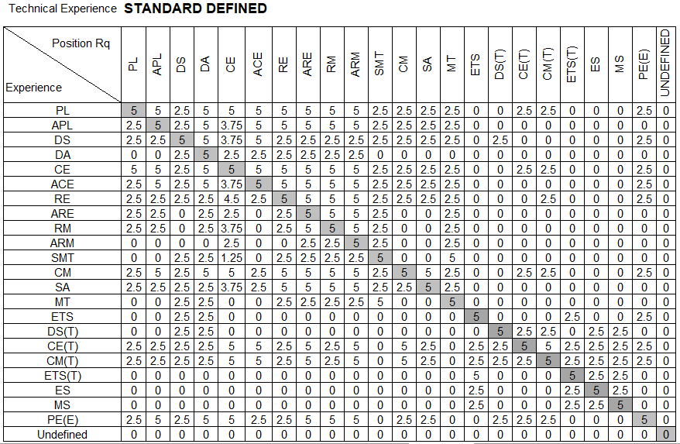

A maximum of 5 (five) points per project position held relevancy (technical experience) and 15 (fifteen) points overall for position held relevancy can be scored for each key person.

Therefore, a total of 45 (forty-five) points can be scored for each key person listed in the tender document. The total for all key persons is totalled and this score is then converted back down into a score out of a maximum of 30 (thirty) for technical knowledge.

Management Knowledge (15)

The same returnable schedules as for the Technical Knowledge is used to evaluate the Managerial Knowledge.

For management knowledge up to 2 (two) areas are evaluated:

- Client
- Position Held (only for managerial positions, e.g. PL; CE; RE)

- Client

The tender is allocated points for the client the work experience was done for:

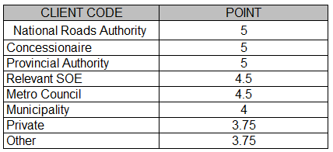

A maximum of 5 (five) points per project client relevancy and 15 (fifteen) points overall for client relevancy can be scored.

- Position Held (only for managerial positions)

This is only used for certain key positions that are expected to perform a managerial function during the contract. The relevance of the position held during the managerial experience against the position that is tendered for is evaluated:

A maximum of 5 (five) points per project position held relevancy (managerial experience) and 15 (fifteen) points overall for position held relevancy can be scored.

Therefore a total of 15 (fifteen) – non-managerial positions, and 30 (thirty) points – managerial positions, can be scored for each key position listed in the tender document. The total for all key positions are totalled and this score is then converted back down into a score out of 15 (fifteen) for managerial experience.

Quality System (10)

The quality assurance system offered by the tenderer is evaluated as follows:

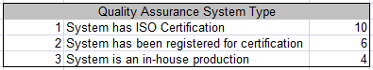

For full ISO certification, a tenderer is awarded 10 (ten) points, for a qualtiy assurance system that has been submitted to ISO for certificiation, but not yet recieved, 6 (six) points are allocated. If the tenderer’s quality assurance system is purely an in-house system, 4 (four) points are allocated.

The total number of points allocated are tallied and a score out of 10 (ten) is awarded.

Past Performance (15)

Past Performance reports must be submitted by the tenderer for any 3 (three) completed projects in the last 10 (ten) years by the tenderer (any member of the Joint venture).

Past Performance Ratings will be allocated based on any one or a combination of the following Performance Assessment reports:

    - CIDB: ANNEX 1 - PSP Performance Report for completed projects

A maximum of 5 (five) points per project and 15 (fifteen) points overall can be scored for past performance as per table below.

CIDB  Rating | Poor  x < - 0.1 | Adequate  - 0.1 < x < 0.9 | Good  0.9 < x < 1.8 | Excellent  x > 1.8
SANRAL score | 1 | 3 | 4 | 5

Reference letters

A maximum of 5 (five) points per project and 15 (fifteen) points overall can be scored for reference letters as per table below.

Rating | Poor | Adequate | Good | Excellent
SANRAL score | 1 | 3 | 4 | 5

Sworn Affidavit

For tenderers with less than 3 (three) completed projects, a sworn affidavit (refer to Returnable Schedule B6) shall be submitted stating that the tenderer has in the last 10 (ten) years only completed either 0 (zero), 1 (one) or 2 (two) projects, and as a result cannot submit the required 3 (three) past performance project reports. In the event of a submitted sworn affidavit, the following will apply:
  - Submission of 0 (zero) past performance project reports, a rating of “Adequate” or 2 (two) points will be applied for all 3 (three) projects.
  - Submission of 1 (one) past performance project reports, the rating as submitted will be applied, and a rating of “Adequate” or 2 (two) points will be applied for each of the other 2 (two) projects.
  - Submission of 2 (two) past performance project reports, the ratings as submitted will be applied, and a rating of “Adequate” or 2 (two) points will be applied for the other 1 (one) project.

Workplan Appropriateness (30)

The tender must supply proposed hours that certain identified items in the Pricing Schedule will require. This is used to gauge the tenderer’s knowledge and understanding of the amount of work required to perform the scope of work and is compared to the hours tendered by all the other tenderer’s hours to represent industry norm.

Each tender submits their hours calculated from various items in the Pricing Schedule:

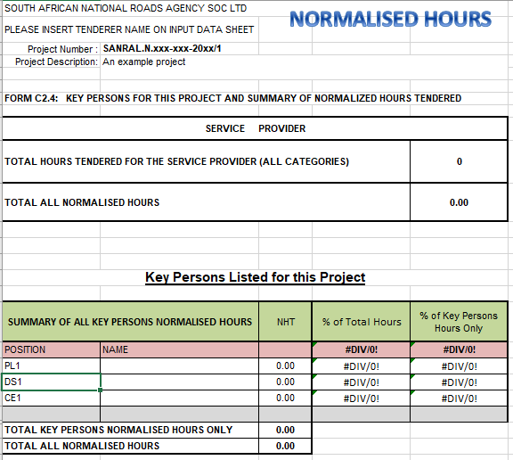

The Workplan Appropriateness hours are entered on a spreadsheet to calculate the 80th percentile.

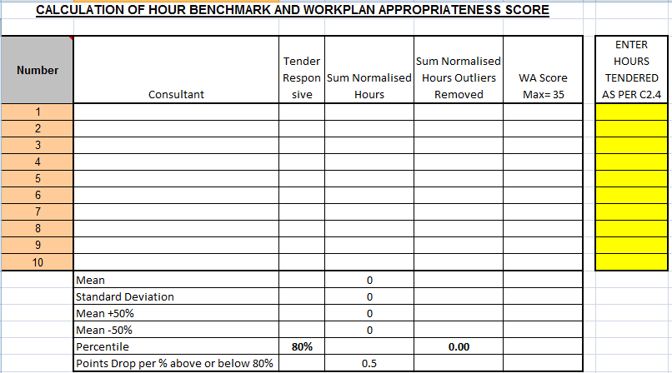
30

The following steps are followed:

- Calculate the mean of all compliant, responsive tenders.
- Determine 50% above and below the mean.
- Re-calculate the mean excluding any outliers identified above.
- Determine the 80% percentile based on the tenderers of Sum Normalised Hours with Outliers Removed.
- Allocate points (to all responsive tenders including outliers) out of 30 based on the percentage (%) difference between the tenderers normalised hours and the 80th percentile hours. Any negative values will score 0 (zero) points.
- The formula used to calculate the points allocated to each compliant responsive tenderer is:

= Workplan Appropriateness points (30)-100*((1-Tenderers hours/80 Percentile hours)*Points drop per % above or below 80 percentile(0,5))

Conclusion

The various scores for the 5 (five) criteria are added together to establish the final score for the tenderer and whether the tender makes the required threshold allocated to this project.

