Health and safety scope of work Main theatre

Request for quotations Description QTY PRICE
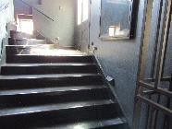
Kitchen and Bar Area – install secondary handrail
2,12
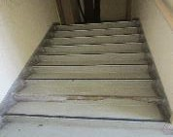
Loft theatre – replace stair nosing x 1 and install second handrail 24m
2,166
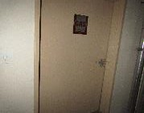
Loft theatre – no access to gas suppression room to be upgraded
2,167
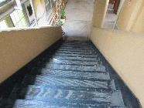
Quad Area – install handrails
2,174
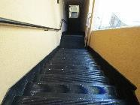
Quad Area – install handrails
2,175

