TRANSNET FREIGHT RAIL
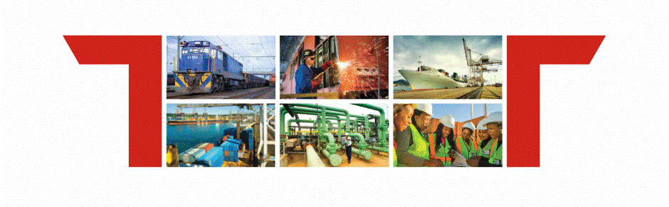

Facility Profile:
Worcester Warehouse

ANNEXURE A: FACILITY profile

Corridor | Location | Siding Name | Siding Size (SQM) | Wagons per Shunt | Siding Capacity (TEU per annum)
Cape Corridor | Worcester | Worcester shed | 62 285 sqm | 40 Wagons | 40 000

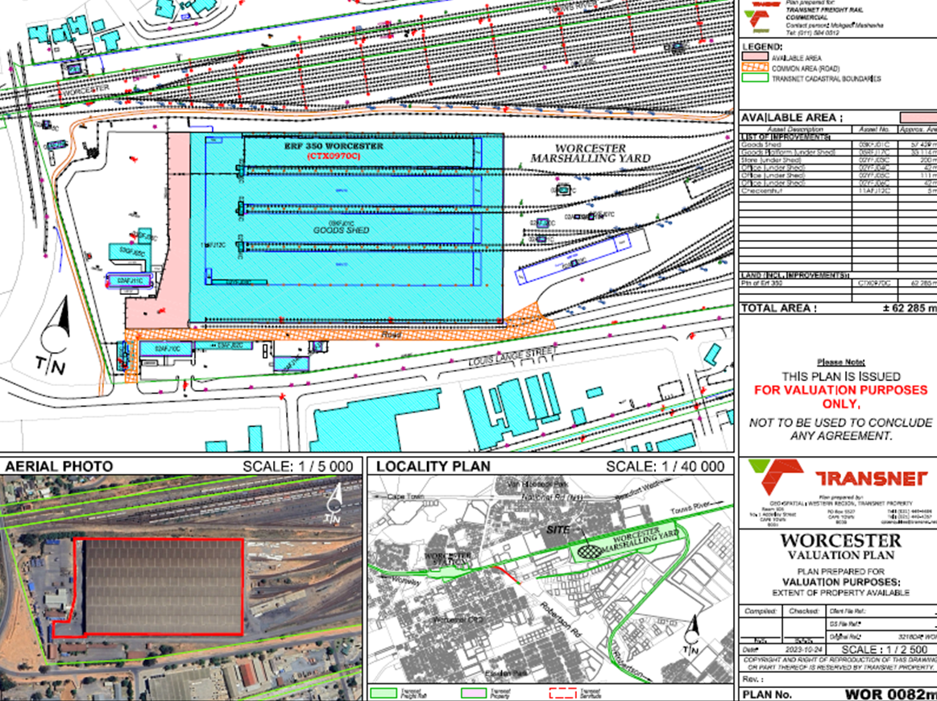

- Rail lines
- Tar slab
- Office Buildings
- Shed
- Land for development

