
ETHEKWINI MUNICIPALITY
Occupational Health & Safety Unit

Site Specific Health and Safety Specification in terms of 2014 Construction Regulations 5.1(b)

Document Title | Site Specific Health and Safety Specification
Client | Ethekwini Municipality
Project Name | CSA 3254: Caneside new OHS Parkhome Clinic
Contract Number | CSA 3254
Revision | 01
Date | 04-03-2020
Compiled by | Bongiwe Gazu
Approved by | Arty Zondi
Page numbers | 28

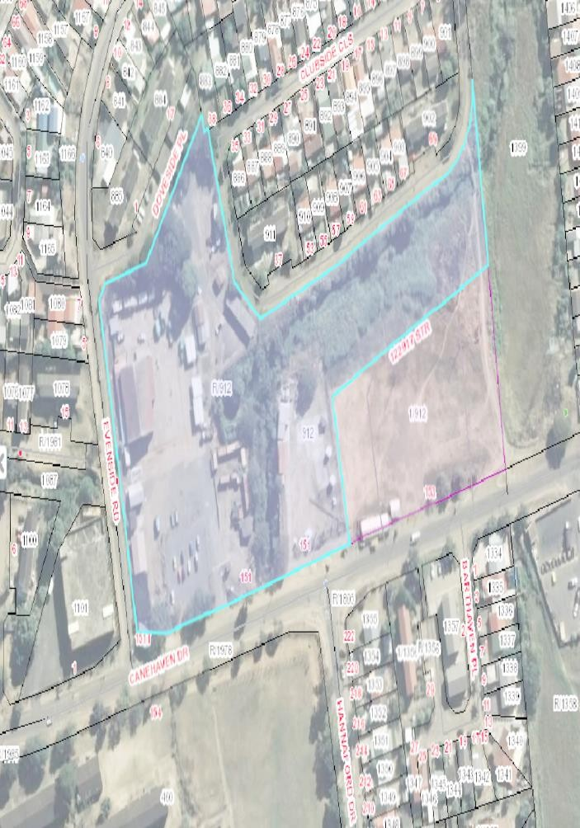
PROJECT LOCALITY

Project Floor Plan refer to project plan

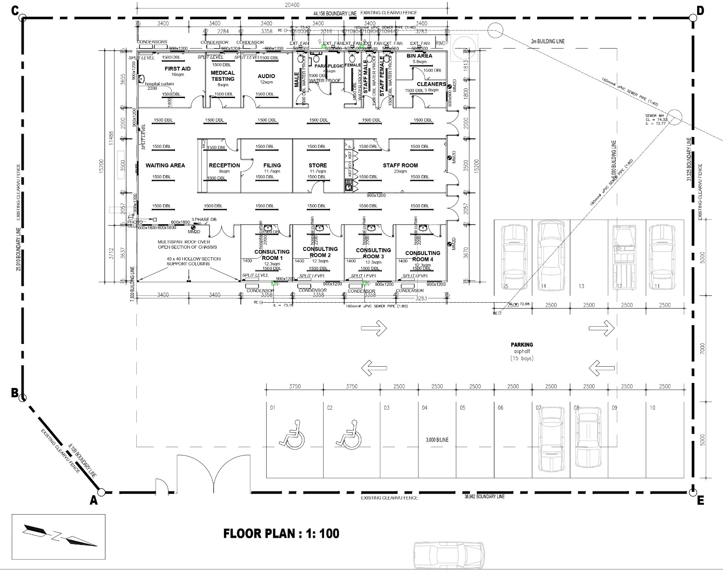
Table of contents

- Definitions
- Project Description
- Limitation of liability
- Purpose of the Construction Health and Safety Specification
- Project Health and Safety Cost
- Scope of Work
- Compensation for Occupational Injuries and Diseases Act, 130 of 199
- Notification of Construction work
- Management and Supervision of Construction
  - Construction Manager
  - Construction Safety Officer
  - Construction Supervisor
- Principal Contractor’s Health and Safety Plan
- Hazard Identification and Risk Assessment
- Health and Safety File
- Health and Safety Representatives and Committee
- Close–out and Consolidated Health and Safety File
- Health and Safety Training
- Incidents Management & First Aid
- Health & Safety Audits
- Fire Precautions on Construction Site
- Electrical Installations on Construction Sites
- Personal Protective Equipment (PPE) and Clothing
- Occupational Health and Safety Signage
- Duties of Principal Contractors and Contractors
- Fall Protection and Working on Elevated Position
- Temporary Works
- Structures
- Design Risk Management
- Excavation and Pilling Work
- Scaffolding
- Public Health Safety and Traffic Management Plan
- Construction Employees Facilities
- Storage and use of Flammable liquids
- Hazardous Chemical Substances
- Crane and lifting operations
- Bulk Mixing Plant
- Explosive actuated fastening devices
- Housekeeping and General Safe- Guarding on Construction Site
- Construction Medicals
- Stacking and Storage on Construction Site
- Induction and Toolbox Talk Programme
- Construction medicals
- Stacking and storage
- Environmental Management
- Heat Stress

DEFINITIONS

For the purpose of this Construction Health and Safety Specification, all definitions in the Occupational Health and Safety Act and Regulations, the abbreviations and the definitions given hereunder shall apply; where definitions may overlap, the most onerous requirement shall apply:

Acronym or Definition | Meaning
Agent | Refer to the Agent appointed by the Client to act on its behalf, and who is appointed in writing
CHSS | Refers to this document as the Construction Health and Safety Specification
Client | Refers to eThekwini Municipality
COIDA | Means Compensation for Occupational Injuries and Diseases Act 130 of 1993
Construction Site | Means the premises and grounds where construction work is being performed
Principal Contractor | Means an employer appointed by the Client to perform construction works
CR | Refers to the Construction Regulations of 2014
DSTI | Refer to a documented daily safe task instruction compiled and issued by a contractor and trained to all relevant employees
H&S | Refers to Health and Safety
Medical Certificate of Fitness | Means a valid medical certificate of fitness issued by an occupational medicine practitioner, such medical testing shall be relevant to the risks of the construction work on the construction site and shall conform to the Occupational Health and Safety Act and Regulations and to the requirement of this  Health and Safety Specification
Method Statement | Refer to a document detailing the key activities to be performed in order to reduce as reasonably as practicable the hazards identified in the Risk Assessment
OHSA | Refer to the Occupational Health and Safety Act
Regulations | Refer to the Regulations stipulated in the OHSA
S | Refer to a section in the OHSA
SACPCMP | Means the South African Council for the Project and Construction Management Professions
Sub-Contractor | Means an employer appointed by the Principal Contractor

PROJECT DESCRIPTION

This project delivers installation of new Cane side OHS parkhome Clinic. This entails that concept plans issued to Architecture Department were acceptable with the following to
be considered:
To provide adequate natural lighting
To provide adequate fresh air circulation To provide enough waiting area Encourage outdoor seating
Dedicated entrance to the clinic with security guard house Widen corridors circulation
To meet all city by-law with stormwater management

The Architecture Department was approached to undertake this upgrade and the project CSA 3254 Caneside new OHS Parkhome Clinic was allocated as a structural project which was handled by the Structural Department

LIMITATIONS OF LIABILITY

The Principal Contractor shall enter into a Mandatory Agreement with the Client, as defined in Section 37(2) of the Occupational Health and Safety ACT.

The Principal Contractor shall ensure that each contractor appointed by the Principal Contractor and each sub-contractor appointed by a contractor also into a Mandatory Agreement with the Principal Contractor, as defined in Section 37(2) of the Occupational Health and Safety ACT. These agreements shall be
included in the Principal Contractor’s H&S File on site and be valid for the duration of the contractors’ work on the construction site.

PURPOSE OF THE CONSTRUCTION H&S SPECIFICATION

This document defines the minimum management requirement that is to be implemented by the Principal Contractor/Contractor for the management of Health and Safety on any eThekwini Municipality project.
The aim of this document is to present the health and safety aspects that need to be controlled and managed on the project.
This Health and Safety specification identifies and encompasses the working behaviours and safe work practices that are expected of all employees, Vendors and Contractors, Sub-Contractors and Visitors, engaged on construction site.
Providing a guideline to comply with best Health & Safety practices and the Occupational Health and Safety Act85/1993 as amended, including reference to applicable legislative requirement.

PROJECT HEALTH AND SAFETY COST

The Client must ensure that potential Principal Contractor submitting tenders have made adequate provision for the cost of health and safety measures.
The Principal Contractor shall allow in their cost provision for complying with the requirements of this CHSS; resources for the following H&S controls shall be in place.

 | H&S cost item | Description
1. | Full time safety officer | Full time attendance on site of a SACPCMP registered safety officer from the start of construction until the end of project  handover
2. | Competent H&S Design | Services of competent designers for temporary works, scaffolding, fall arrest and recovery systems
3. | First Aiders | Standard first aid training  Special (additional) fall recovery first aid training
4. | Competent inspectors (trained, certified, competent) | Statutory inspections of excavations, temporary works, fire extinguishers, lifting equipment, lifting machinery, ladders, construction vehicles and mobile plant, portable electrical equipment, etc.
5. | Mandatory training in site legal register and risk assessments | Training of all employees holding statutory appointments as competent persons ensuring that they are familiar with the Occupational Health and Safety Act and Regulations.  H&S induction and Risk Assessment training all employees in Daily Safe Task Instructions
6. | Training of employees in H&S | Occupational Health and Safety Training in accordance with the skills matrix included in the approved H&S Plan.
7 | Medical certificate of fitness | Medical examination of all employees and certification of fitness by an Occupational Medicine Practitioner  Pre- employment, annual and exit medical  examination is required
8 | Supply and training for PPE | Standards set for all employees  Special sets including fall arrest, special respiratory, adapted hearing protection,  adapted hand protection, adapted eye and

 |  | face protection
9 | Dust mitigation | To reduce dust exposure to the employees and the public
10 | Public protection and barricading | To reduce risk exposure to the employees and members of the public
11 | Employee facilities | Refer to the Facilities Regulations (drinking water, change facility, personal lockers, and wash facilities, eating facilities.
12 | Other | Items not indicated in the Specification

SCOPE OF WORK

This project < CSA 3254 - Caneside Occupational Health & Safety Clinic -Parkhome a single storey Occupational Health Clinic, comprising of:
  - Delivering of fully fitted parkome clinic,
The works includes, inter alia, the following: -
- Delivering and installation of the parkhome

- Water, Electricity and Sewer services connection

COMPENSATION FOR OCCUPATIONAL INJURIES AND DISEASES ACT
The Principal Contractor, each contractor and each sub-contractor shall submit proof of Good Standing with COIDA Commissioner or a Mutual Association licensed in terms of Section 30 of COIDA, prior to starting any work on site.
A copy of the Letter of Good Standing with COIDA Commissioner must be included in the H&S Plan of each contractor working on the site and must remain updated for the duration of the construction work.

NOTIFICATION OF CONSTRUCTION WORK
The Principal Contractor must at least 7 days before that work is to be carried out notify the provincial director in writing in a form similar to Annexure 2 if the intended construction work will—
Include excavation work;

Include working at a height where there is risk of falling; Include the demolition of a structure; or
Include the use of explosives to perform construction work.

A contractor who intends to carry out construction work that involves construction of a single storey dwelling for a client who is going to reside in such dwelling upon completion, must at least 7 days before that work is to be carried out notify the provincial director in writing in a form similar to Annexure 2

MANAGEMENT AND SUPERVISION OF CONSTRUCTION WORK
9.1 Construction Manager
The Principal Contractor shall appoint a full-time competent person as the construction manager with the duty of managing all construction on the site including the duty of ensuring occupational health and safety compliance.
The Construction Manager must demonstrate competency in relation to work being performed and the ability to manage construction work which may include making all statutory appointments in terms of health and safety.

CONSTRUCTION SAFETY OFFICER
The Principal Contractor shall appoint a competent Construction Safety Officer for the construction work. The Construction Safety Officer shall be full/part time on the construction site for this project.
The Safety Officer shall be registered with the South African Council for the Projects and Construction Management Professions. Proof of competence and registration of the appointed Construction Safety Officer must be included in the H&S Plan.

CONSTRUCTION SUPERVISOR
A Construction Manager must in writing appoint construction supervisors responsible for construction activities and ensuring occupational health and safety compliance on the construction site.

A contractor must, upon having considered the size of the project, in writing appoint one
or more competent employees for different sections thereof to assist the construction supervisor contemplated in sub regulation (7), and every such employee has, to the extent clearly defined by the contractor in the letter of appointment, the same duties as the construction supervisor:
Provided that the designation of any such employee does not relieve the construction supervisor of any personal accountable for failing in his or her supervisory duties in terms of this regulation.

PRINCIPAL CONTRACTOR’S HEALTH AND SAFETY PLAN
The Principal Contractor shall submit a suitable, sufficiently documented and coherent specific health and safety plan based on the Client documented Health and Safety Specification. The health and safety plan shall include but not limited to the following
  - Objectives
  - Scope of work
  - Management of construction and supervision
  - Monitoring and review plan
  - Sub-Contractor Management
  - Risk Assessment & Written Safe Working Procedures
  - Excavation method statements
  - Roof work planning/method statement
  - Incident Management & First Aid
  - Fall Protection Plan
  - Emergency Evacuation Plan/Procedures
  - Fire Prevention & Protection
  - Public Safety
  - PPE Provision
  - Health & Safety Signage
  - Construction Vehicles and Mobile Plants
  - Hand & Electrical Tool Management
  - Construction Employees Facilities
  - Health & Safety Policies
  - Health and Safety Training & Competencies
  - Excavation Works/Bulk Earthworks
  - Housekeeping
  - Hazardous Chemicals
  - Site Barricading
  - Working at elevated position
  - Traffic Accommodation
  - Traffic Management
  - Induction
  - Medicals
  - Site Security

  - Stacking and Storage
  - Heat stress
  - Transportation of Employees
  - Internal Audit
  - Inspection Registers
  - Toolbox Talks
  - SHE Meetings and Committees Specific site activities but not limited to:
  - Delivering of fully fitted parkome clinic ,
The works includes, inter alia, the following: -
- Delivering and installation of the parkhome

- Water, Electricity and Sewer services connection

HAZARD IDENTIFICATION AND RISK ASSESSMENT
The Principal Contractor shall before commencement of any construction and during such construction works have risk assessments performed by appointed competent person in writing which forms part of the health and safety plan to be applied.
The provisions of Regulation 9 of the Construction Regulations shall be followed in every detail.

HEALTH AND SAFETY FILE

The Client must discuss and negotiate with a Principal Contractor the content of the Health and Safety Plan and thereafter finally approve the Health and Safety plan for implementation. The recommended Health and Safety file shall include the following:

  - Notification of Construction Work
  - Client Health & Safety Specification
  - Principal Contractor Health & Safety Plan
  - Updated letter of good standing with Commissioner
  - Section 37.2 Mandatory Agreement
  - Contractor appointment letter in terms of CR 5.1(k)
  - Risk Assessments
  - Written Safe Working Procedures
  - Applicable Inspection Registers
  - Incident/Accident Management
  - Award letter from SCM
  - Organogram
  - Copy of OHS Act and COID Act
  - Environmental Management Plan if applicable
  - Health and Safety Induction programme
  - Site Emergency Evacuation Plan
  - Key Personnel contact numbers
  - Site Safety Rules
  - Medical Records – Medical Fitness Certificate
  - Toolbox Talks Programme
  - HIV/AIDS Awareness Programme
  - Fall Protection Plan
  - Material Safety Data Sheets
  - SHE Policy
  - First Aid box and competent first aider
  - Appointment letters and competencies of the following (Construction Manager, Construction Supervisor, Construction Safety Officer, Risk assessor, Incident Investigator, Fall Protection Planner, Temporal Works Designer, Temporal Works Supervisor ect.)

- HEALTH AND SAFETY REPRESENTATIVES AND COMMITTEE Health and Safety Representatives
  - The Principal Contractor shall ensure that Health and Safety Representatives are appointed in writing and exercise their functions as defined in OHSA.
  - The Principal Contractor shall elect and appoint a health and safety representative regardless of the number of employees on the site.
  - The H&S representative shall at all times be on site and report to the Health and Safety Officer and Construction Manager.
Health and Safety Committee
  - The Principal Contractor shall ensure that the H&S committee meets on a monthly basis
  - The Principal Contractor’s management and each contractor shall be represented at the H&S committee meeting; contractors with more than 20 employees shall have an H&S representative at each committee meeting and each contractor shall have a management member attending each H&S committee meeting.

CLOSE- OUT CONSOLIDATED HEALTH AND SAFETY FILE
The Principal Contractor shall compile a consolidated H&S file and hand over to the Business Unit; OHS Unit will conduct a project close out using the appropriate checklist before the completion of the project.

HEALTH AND SAFETY TRAINING

The Principal Contractor shall ensure that employees are trained on health and safety measures this shall include but not limited to:
  - Written Safe Working Procedures
  - Risk Assessments
  - Health and Safety Plan
  - Emergency Management Plan
  - Induction
  - Toolbox Talks
  - MSDS

INCIDENTS MANAGEMENT & FIRST AID
All incidents and accidents as per Section of the Act must be reported, recorded and investigated as per General Administration Regulation 8 & 9
Where a fatality or permanent disabling injury or incident occurs on the Construction site, the Client must ensure that the Principal Contractor provides the Provincial Director with a report contemplated in Section 24 of the Act and the report includes the measures that the Principal Contractor intends to implement to ensure a safe construction site.

HEALTH AND SAFETY AUDITS
The Client must ensure that periodic health and safety audits are conducted at intervals mutually agreed upon between the Principal Contractor and the Client at least every 30 days, the copy of the health and safety audit report must be provided to the Principal Contractor within seven days after the audit.

FIRE PRECAUTIONS ON CONSTRUCTION SITE

The Principal Contractor shall provide suitable fire extinguishers which shall be serviced regularly in accordance with the manufacture’s recommendations.
Safety signage shall be prominently displayed in all areas where fire extinguishers are located. The Principal Contractor shall arrange for training of the relevant personnel, in the use of fire extinguishers.
The provisions of Regulation 29 of the Construction Regulations as well as Regulation 9 of Environmental Regulation for Workplaces shall be followed in every detail.

ELECTRICAL INSTALLATIONS AND MACHINERY ON CONSTRUCTION SITE.
The Principal Contractor shall designate a competent electrician in writing who shall control all electrical installations.
All temporary electrical installations used by the contractor are inspected at least once a week by a competent person and the inspection findings are recorded in a register kept on the construction site.
All Electrical machinery is inspected by the authorized operator or user on daily basis using a relevant checklist prior to use and the inspection findings are recorded in a register kept on the construction site.
The provisions of Regulation 5, 6 & 9 of the Electrical Installation Regulations shall be followed in every detail.

PERSONAL PROTECTIVE EQUIPMENT AND CLOTHING.

The Principal Contractor shall ensure that every employee is issued with, and wears SANS-approved P.P.E. as per the conducted risk assessment.
Failure to use protective equipment as per the risk assessment shall require disciplinary intervention and this process shall be documented in the induction.
No employer shall in respect of anything which he is in terms of this Act required to provide or to do in the interest of health or safety of an employee make any deductions from any employee’s remuneration or require or permit any employee to make any payment to him or to any other person.
The provisions of Regulation 2 of the General Safety Regulations shall be followed in every detail.

OCCUPATIONAL HEALTH AND SAFETY SIGNAGE
The Principal Contractor shall erect and maintain quality safety signage The signage shall include but is not limited to:
  - The construction work permit number displayed at the entrance
  - Access restrictions
  - A sign indicating that all visitors must report to the site office and must be accompanied by the Principal Contractor when accessing the site
  - The name and telephone number of the responsible person(s)
  - Emergency telephone number(s)
  - PPE to be worn at the particular site
  - When falling objects may occur, relevant barricading and warning signs must be erected
  - Excavations, heights structures, temporary structures and all risk areas must be indicated as per the specific methods defined in the H&S Plan.

DUTIES OF PRINCIPAL CONTRACTORS AND CONTRACTORS

Contractors and sub-contractors must be given a copy of the H&S specification and any additional specification issued by the Client and shall comply with these specifications integrally. All employers working on the site shall conform to the standard in the CHSS. All the duties of the Principal Contractor in this CHSS equally apply, in full, to contractors of such Principal Contractor and to sub- contractors of such contractors.
The Principal Contractor shall ensure that the comprehensive and updated list of all the contractors and sub-contractors on site includes:
  - A reference to the agreements between the parties, including all contractors Section 37(2) agreements with the Principal Contractor
  - The type of work being done
  - The date of the approval of the H&S Plan
  - The date of expiry of the COIDA certificate of good standing
  - The date of the last monthly audit

The provisions of Regulation 7 of the Construction Regulations shall be followed in every detail.

FALL PROTECTION AND WORKING ON ELEVATED POSITION

The Principal Contractor shall ensure that the fall protection plan include a risk assessment for all work carried out from the fall risk position and the safe work procedures.
All employees working from fall risk position are subject to medical examination. The Training Programme must be in place for employees working from a fall risk position.
The procedures of address the inspection, testing and maintenance of all fall risk protection equipment.
The rescue plan must have a detail procedure, personnel and suitable equipment to be used to rescue a person.
The Principal Contractor must that a competent person is designated to be responsible for the preparation of the fall protection plan.

The provisions of Regulation 10 of the Construction Regulations shall be followed in every detail.
- TEMPORARY WORK Temporary works designer:
The Principal Contractor shall submit the proof of competency and appointment letter of the competent person(s) appointed as temporary works designer in the H&S Plan.
The temporary works designer shall be competent to design, inspect and approve the erected temporary works on site before use.
The Principal Contractor, the Construction Manager and temporary works designer shall ensure that:
  - The temporary works drawing, or any other relevant document includes construction sequences and method statements.
  - The temporary works designer has been issued with the latest revision of any relevant structural design drawing.
  - The temporary works design and drawing is used only for the intended purpose and for a specific portion of a construction site.
  - The temporary works drawings are approved by the temporary works designer before the erection of any temporary works
  - The temporary works design and drawing are used solely for this intended purpose.
Temporary works Supervisor
The Principal Contractor shall submit the proof of competency and appointment letter of the competent person(s) appointed as temporary works supervisor in the H&S Plan.
The temporary works supervisor shall supervise all temporary works operations and shall ensure that all equipment used in temporary works structure are carefully examined and checked for suitability before being used.
The provisions of Regulation 12 of the Construction Regulations shall be followed in every detail.

STRUCTURES

A contractor must ensure that all reasonably practicable steps are taken to prevent the uncontrolled collapse of any new or existing structure or any part thereof, which may become unstable or is in a temporary state of weakness or instability due to the carrying out of construction work;

No structure or part of a structure is loaded in a manner which would render it unsafe;
All drawings pertaining to the design of the relevant structure are kept on site and are available on request to an inspector, other contractors, the client and the client's agent or employee.

DESIGN RISK MANAGEMENT
  - Based on the recent design changes, as well as change in the scope of works, the PC will be required to ensure a resubmission of an amended H&S Plan for approval. Further to this, the PC must ensure that similar information must be provided as it applies to the works to all their Contractors, within five (5) working days following notification thereof.
The PC must ensure that they have the latest designs on file i.e. Drawings, Loadings, Specifications. The PC must further ensure that a competent temporary works designer is appointed to inspect and approve the temporary works.
Design – in relation to any structure, includes drawings, calculations, design detail
and specifications’
  - Temporary works must be properly designed and signed off by a competent person who has sufficient experience in the design of the type of temporary work in question to be able to assess the design. The competent person/(s) appointed must either be a registered professional engineer or technologist. The appropriate competent person is to be appointed to manage and monitor such works to the satisfaction of the engineer and the H&S Agent. Records and registers are to be kept properly completed and kept in the H&S file. If temporary works are to be erected by a Contractor, this must be notified to the Engineer / H&S Agent.

EXCAVATION AND PILING WORK – NOT APPLICABLE
  - The Principal Contractor must ensure that all excavation work is carried out under the supervision of a competent person who has been appointed in writing for that purpose.
  - The Principal Contractor shall take cognisance of the geotechnical study pertaining to the conditions of the construction site and must plan all excavation work in accordance with the recommendations of the professional engineer.
  - The Principal Contractor must ensure that every excavation, including all bracing and shoring, is inspected daily, prior to the commencement of each shift and that no person enters the excavation or works in a risk zone until the excavation is assessed and declared safe.
  - All excavations must be left open for the minimum of time required and those that are left open on the site must be protected by a barrier or a fence of at least one meter in height as close to the excavation as is practicable. The protective barrier or fence must adequately prevent persons from falling into the excavation and barrier taping is not sufficient for this purpose
  - Excavation shoring and bracing, if required shall be designed by a designer appointed in writing who shall inspect and approve the installed shoring and bracing
  - Where persons work, inspect or test excavations, warning signs must be in place next to an excavation

The provisions of Regulation 13 of the Construction Regulations shall be followed in every detail.

Pilling Works – Not applicable
The Principal Contractor shall ensure where pilling is required that the works undertaken by a specialist contractor.
A works risk assessment and safe works procedure must be approved by Principal Contractor evidence of such approval must be shared with the Client Agent before works commences.

SCAFFOLDING
The Principal Contractor must appoint a competent person in writing who must ensure that all scaffolding work operations are carried out under his or her supervision and that all scaffold erectors, team leaders and inspectors are competent to carry out their work.

Scaffold erectors and inspectors must be formally trained, and certified competent such training must conform to the requirements of SANS 10085
Scaffolds must be clearly tagged with safe access signage; scaffolds must be inspected daily prior to use and weekly by the scaffold inspector. All scaffolds on site must be individually identified and display a safe / not safe sign.
Inspections by the scaffold inspector must be documented on the scaffold tag and in a register; a template of the tag and of the register shall be included in the H&S Plan
All scaffolds must be accessed with a ladder only. Ladders must be inside the scaffolds and hatches must be close ladder – openings in decks
All scaffold decks must be fully covered and barricaded so as to prevent persons working there from falling off.
Scaffold erectors must attach a fall prevention harness at all times; the double lanyards must be fitted with scaffold hooks only
Where a Principal Contractor is using access trestles must be in compliance with General Safety Regulation 6
The provisions of Regulation 16 of the Construction Regulations shall be followed in every detail.

PUBLIC HEALTH AND SAFETY

The site shall at all times be secured to prevent the unauthorized access of persons to construction risk areas.
Appropriate health and safety signage shall be posted and access control to site must be exercised via a single access point.

All members entering the site must indicate in what capacity them visiting the site.

The access point must be designed and constructed to allow for temporary parking, entry of construction vehicles, entry of personnel transport vehicles and entry of individual workers and other persons.
The principal Contractor shall ensure that each person visiting the site shall be inducted to the site and such abridged induction shall outline the hazards from on- site activities and the precautions to be observed to avoid or minimize those risks
Visitors must only enter when accompanied by a responsible person designated by the Principal Contractor.

CONSTRUCTION EMPLOYEES FACILITIES
The Principal Contractor shall provide at or within reasonable access of every construction site, the following clean, hygienic and maintained facilities:
- Shower facilities after consultation with the employees or employee’s
representatives, or at least one shower facility for every 15 persons;
- at least one sanitary facility for each sex and for every 30 workers;
- changing facilities for each sex; and
- sheltered eating areas.
The provisions of Regulation 2, 3, 4, 6, 7, 9 of the Facilities Regulations shall be followed in every detail.

STORAGE AND USE OF FLAMMABLE LIQUIDS
No flammable substances must be stored on site unless these are stored in a flammable store or cabinet approved by the Municipal Chief Fire Officer, no other materials shall be stored in the flammable store or cabinet
Where required the H&S Plan shall include a method statement detailing the safe use, storage, decanting and spill controls for all flammable liquids used and stored on site.
The provisions of Regulation 25 of the Construction Regulations shall be followed in every detail.

HAZARDOUS CHEMICAL SUBSTANCE
With respect to hazardous chemical substances used, the contractor shall ensure that:
  - All MSDS are included in the H&S File
  - A HCS risk assessment is included in the H&S Plan
  - The safe use, storage, emergency procedures and safe disposal of hazardous substances are addressed in a method statement(s) included in the H&S Plan.
  - Proof of competency and signed letters of appointment of the person responsible for chemical handling is included in the H&S File.
Any hazardous chemical substance intended to be applied on site during the project (i.e. after approval of the H&S Plan) shall be subject to an issue-based risk assessment and method statement which must be presented to the Client Agent prior to the substance being introduced on site.
The provisions of Regulation 3, 5, 7, 8, 9, 9A, 10, 11, 14, 15 of the Hazardous Chemical Substances Regulations shall be followed in every detail.

LIFTING OPERATIONS; CRANE
The Principal Contractor must unsure the cranes used are:
Are designed and erected under the supervision of a competent person;
A relevant risk assessment and method statement are developed and applied; The effects of wind forces on the crane are taken into consideration and that a wind speed device is fitted that provides the operator with an audible warning when the wind speed exceeds the design engineer’s specification;
The bases for the tower cranes and tracks for rail-mounted tower cranes is firm, level and secured;
The tower crane operators are competent to carry out the work safely; and
The tower crane operators have a medical certificate of fitness to work in such an environment, issued by an occupational health practitioner in the form of Annexure

- BULK MIXING PLANT If batching occurs on site:
  - The Principal Contractor must appoint a competent bulk mixing plant supervisor in writing
  - A bulk mixing plant operator must be appointed and no other person(s) may operate the plant.
  - The Principal Contractor must ensure that the machinery and plant comply with the legal requirements and is suitable for the application on the construction site
  - The bulk mixing plants installation, maintenance and repair record document on site at all times
  - The bulk mixing plant procedure is included in the H&S Plan and the relevant documents to be used are placed in the start-up H&S File.

The provisions of Regulation 20 of the Construction Regulations shall be followed in every detail.

EXPLOSIVE FASTENING DEVICE
The principal Contractor shall submit proof of competency and the appointment letter of the person in charge of explosives actuating fastening devices and of the person in charge of the issuing and collection of cartridges and nails. This shall be placed in the H&S Plan.
The H&S Plan shall include the method statement for the safe use of explosives actuating fastening devices including the type PPE, barricading and warning notice which the Contractor intends to use and the method of accounting for cartridges and nails.
The H&S Plan shall include proof of training and competency of all operators using explosive actuating fastening devices.
A template inspection register of explosive actuating fastening device shall be included in the H&S Plan.
A template record for the issuing and collection of cartridges and nails shall be included in the H&S Plan.

For the purpose of acquisition / transport of the cartridges the Principal Contractor is required to hold a permit in terms of the Explosive’s Act. This permit for the transportation of Blank cartridges used in Power-Actuated Tools shall be placed in the H&S Plan:
- Application for registration, licenses and permits must be submitted by the Chief Inspectors Office in Pretoria.
- The Principal Contractor is required to be in possession of a continuous transport license but is not required in terms of the Explosives Act to hold a permit for the use of the blank cartridges.
- Once the cartridges are delivered to the appointed responsible person is then required to ensure that the Regulations governing the safe use of explosive powered tools in terms of the Construction Regulation 21 of the Occupational Health and Safety Act, Act 85 of 1993 are complied with.

The provisions of Regulation 21 of the Construction Regulations shall be followed in every detail.

HOUSEKEEPING AND GENERAL SAFEGUARDING ON CONSTRUCTION SITE
The Principal Contractor shall appoint a person responsible for general housekeeping and stacking and storage of materials and equipment on the entire site.
The provisions of Regulation 27 of the Construction Regulations shall be followed in every detail.

CONSTRUCTION MEDICAL
A Principal Contractor must ensure that all his or her employees have a valid medical certificate of fitness specific to the construction work to be performed and issued by an Occupational Health Practitioner in the form of Annexure 3.

STACKING AND STORAGE ON CONSTRUCTION SITE

A Principal Contractor must, in addition to compliance with the provisions for the stacking of articles in the General Safety Regulations, 2003, ensure that—

A competent person is appointed in writing with the duty of supervising all stacking and storage on a construction site;

Adequate storage areas are provided; There are demarcated storage areas; and
storage areas are kept neat and under control.

INDUCTION, TOOLBOX PROGRAMME AND SAFETY AWARENESS
The Principal Contractor shall ensure that all employees have gone through the induction training before commencing duties on site.
The Principal Contractor must ensure that all visitors to the construction undergo health and safety induction pertaining hazards prevalent on the site and ensure that visitors have appropriate PPE. The Principal Contractor must at all time on his or her construction site keep records of health and safety induction training
No contractor may allow or permit any employee or person to enter any site, unless that
employees or person has undergone health and safety induction training pertaining to the
hazards prevalent on the site at the time of entry.

A contractor must ensure that all visitors to a construction site undergo health and safety
induction pertaining to the hazards prevalent on the site and must ensure that such visitors have the necessary personal protective equipment.

A contractor must at all times keep on his or her construction site records of the health and safety induction training contemplated in CR 7 sub regulation (6) and such records must be made available on request to an inspector, the client, the client’s agent or the principal contractor;.
The Principal Contractor must ensure that the toolbox talks are conducted on weekly basis and the training records kept on the safety file

CONSTRUCTION MEDICAL

A Principal Contractor must ensure that all his or her employees have a valid medical certificate of fitness specific to the construction work to be performed and issued by an Occupational Health Practitioner in the form of Annexure 3.

STACKING AND STORAGE ON CONSTRUCTION SITE
A Principal Contractor must, in addition to compliance with the provisions for the stacking of articles in the General Safety Regulations, 2003, ensure that—

A competent person is appointed in writing with the duty of supervising all stacking and storage on a construction site;

Adequate storage areas are provided; There are demarcated storage areas; and
storage areas are kept neat and under control.

ENVIRONMENTAL MANAGEMENT
A Project Environmental Management Plan (EMP) shall be developed which must be adhered to. The objective of the EMP is to manage the impacts of construction identified during the course of the Environmental Impact Assessment (EIA) process, as well as during the course of construction. This is document and will be continuously updated in order to reflect current site conditions and address any issues identified during the course of construction. The EMP therefore serves as an action plan for the implementation of mitigation measures proposed for the construction of low-income houses.

- HEAT STRESS Working in very hot conditions can cause illness when heat stress overcome the body’s temperatures regulatory system resulting in heat strokes, heat exhaustion, dehydration, heat syncope, heat cramps and heat rash.
Considering the elevated temperatures experienced in the KwaZulu Natal region and the arid and drought like conditions, it is imperative that the PC develop a Heat Stress Management Plan in order to reduce the risk associated with heat stress

