SPECIFICATIONS FOR REPAIR OF SEWERAGE PLANT: ARC-PHP

- Clean all the manholes and sewer line
- Diagnose the requirement to restore operational requirements.
- Supply and Replace the stolen gate valves
- Restore operational functionality to entire plant systems.
- Repair all leaks or even corroded galvanized pipes

NB. All the materials used must be SABS approved.
Use the same original dimeter size of the pipes.
There must be a one-year guarantee

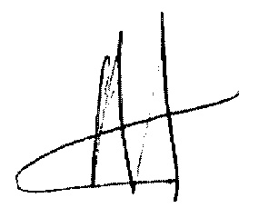
24/05/22

