Annexure A: Background Information

- The current Eskom Vending System is a revenue collection platform for 6.5 million prepaid electricity customers. It significantly contributes to Eskom’s revenue stream and compliance with NERSA requirements to serve our prepaid customer base, specifically indigent customers on the Free Basic Electricity Tariff.
- The current online vending system was initiated back in 2006 and since then the system has been enhanced several times and now there is a need for a more integrated system with enhanced controls and functionality aligned to the Smart Grid Technology strategy which needs to cater for:
  - An integrated, modernized solution with better controls and loss management capability
  - Currency vending and enable transfer of virtual prepaid electricity tokens automatically to the designated Eskom system (smart meters), in addition to the normal printing of numeric token receipts.
  - Other Eskom approved tariffs like, Businessrate and Landrate tariffs, and
  - The provision to accept non-electricity utility payments such as water, gas, rates and taxes.
- This RFI Scope is to obtain submissions to inform the design of a new integrated prepaid electricity vending system based on smart grid technology principles, to ensure that prepaid revenue can continue to be collected with better controls and loss management. Eskom has financial challenges, and this system is key to revenue generation.
- The detailed technical scoping requirements for the system are defined in Annexure B
- Annexure B is the core technical response sheet that the vendor must complete
- The following diagrams present an overview of the logical architecture

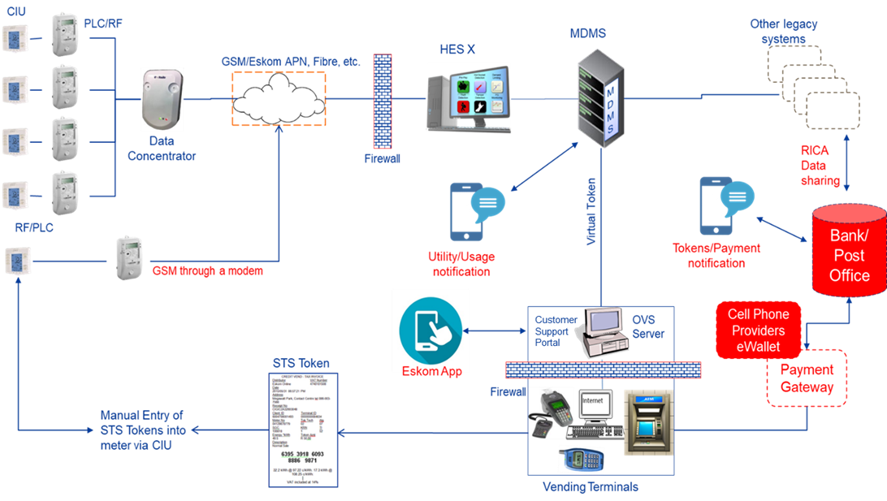
Figure: Overview of the Smart Prepayment Solution Architecture

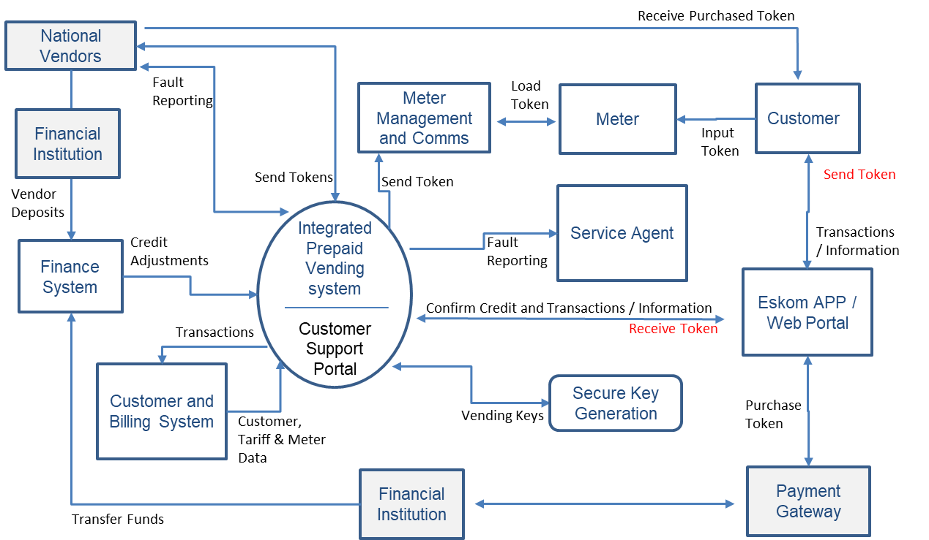
Figure: Logical System Integration

- Supplementary Information for the following areas are available on request:
  - End Systems Integration Design Requirements
  - Testing Requirements

