

REQUEST FOR QUOTATION (RFQ)

RFQ NUMBER: 10346263

REQUEST FOR QUOTATION (RFQ) FOR COLLECTION AND DISPOSAL OF HAZARDOUS AND GENERAL WASTE FOR ROLLING STOCK WESTERN CAPE REGION

NB!!! Quotations submitted by email must be limited to a maximum of 7MB, virus-free. They must be free from any form of virus or corrupted contents, or the quotations shall be rejected.

It shall remain your responsibility to ensure that your quotation will reach the email address below on or before the deadline.

Email Address for Quotations: RFQWC@prasa.com

Quotations that are received by Metrorail after the deadline, for whatever reason, shall not be considered for evaluation. Bidders are only to send their proposal directly to the above mentioned email address, and no other email as this will result in your proposal to be disqualified

SECTION 1: SBD1
PART A INVITATION TO BID
YOU ARE HEREBY INVITED TO BID FOR REQUIREMENTS OF PASSENGER RAIL AGENCY (PRASA)
BID NUMBER: | 10346263 |  |  |  | CLOSING DATE: |  |  |  | 05 March 2024 |  | CLOSING TIME: |  |  | 11:00 am
DESCRIPTION | FOR COLLECTION AND DISPOSAL OF HAZARDOUS AND GENERAL WASTE FOR ROLLING STOCK WESTERN CAPE REGION
BID RESPONSE DOCUMENTS SHALL BE ADDRESSED AS FOLLOWS:
1 ADDERLEY STREET
METRORAIL SUPPLY CHAIN MANAGEMENT
6TH FLOOR, ROOM 622
PROPNET BUILDING
CAPE TOWN
Or
Emailed to: RFQWC@prasa.com (Note: Buyer not to be copied in the email as this will result in disqualification)
BIDDING PROCEDURE ENQUIRIES MAY BE DIRECTED TO
CONTACT PERSON |  |  |  | ADRIANA HAGEN
TELEPHONE NUMBER |  |  |  | 021 818 7492
E-MAIL ADDRESS |  |  |  | Adriana.Hagen@prasa.com
SUPPLIER INFORMATION
NAME OF BIDDER
POSTAL ADDRESS
STREET ADDRESS
TELEPHONE NUMBER |  |  | CODE |  |  |  |  |  | NUMBER
CELLPHONE NUMBER
FACSIMILE NUMBER |  |  | CODE |  |  |  |  |  | NUMBER
E-MAIL ADDRESS
VAT REGISTRATION NUMBER
SUPPLIER COMPLIANCE STATUS |  |  | TAX COMPLIANCE SYSTEM PIN: |  |  |  |  | OR |  | CENTRAL SUPPLIER DATABASE No: |  |  | MAAA……………..
- ARE YOU THE ACCREDITED REPRESENTATIVE IN SOUTH AFRICA FOR THE GOODS /SERVICES /WORKS OFFERED? |  | Yes No  [IF YES ENCLOSE PROOF] |  |  |  |  | - ARE YOU A FOREIGN BASED SUPPLIER FOR THE GOODS /SERVICES /WORKS OFFERED? |  |  |  |  | Yes No  [IF YES, ANSWER THE QUESTIONNAIRE BELOW]
QUESTIONNAIRE TO BIDDING FOREIGN SUPPLIERS
IS THE ENTITY A RESIDENT OF THE REPUBLIC OF SOUTH AFRICA (RSA)? YES NO
DOES THE ENTITY HAVE A BRANCH IN THE RSA? YES NO
DOES THE ENTITY HAVE A PERMANENT ESTABLISHMENT IN THE RSA? YES NO
DOES THE ENTITY HAVE ANY SOURCE OF INCOME IN THE RSA? YES NO
IS THE ENTITY LIABLE IN THE RSA FOR ANY FORM OF TAXATION? YES NO
IF THE ANSWER IS “NO” TO ALL OF THE ABOVE, THEN IT IS NOT A REQUIREMENT TO REGISTER FOR A TAX COMPLIANCE STATUS SYSTEM PIN CODE FROM THE SOUTH AFRICAN REVENUE SERVICE (SARS) AND IF NOT REGISTER AS PER 2.3 BELOW.
PART B: TERMS AND CONDITIONS FOR BIDDING
- BID SUBMISSION:
  - BIDS MUST BE DELIVERED BY THE STIPULATED TIME TO THE CORRECT ADDRESS. LATE BIDS WILL NOT BE ACCEPTED FOR CONSIDERATION.
  - ALL BIDS MUST BE SUBMITTED ON THE OFFICIAL FORMS PROVIDED – (NOT TO BE RE-TYPED) OR IN THE MANNER
  - PRESCRIBED IN THE BID DOCUMENT.
  - THIS BID IS SUBJECT TO THE PREFERENTIAL PROCUREMENT POLICY FRAMEWORK ACT, 2000 AND THE PREFERENTIAL PROCUREMENT REGULATIONS, 2022, THE GENERAL CONDITIONS OF CONTRACT (GCC) AND, IF APPLICABLE, ANY OTHER SPECIAL CONDITIONS OF CONTRACT.
- TAX COMPLIANCE REQUIREMENTS
- BIDDERS MUST ENSURE COMPLIANCE WITH THEIR TAX OBLIGATIONS.
- BIDDERS ARE REQUIRED TO SUBMIT THEIR UNIQUE PERSONAL IDENTIFICATION NUMBER (PIN) ISSUED BY SARS TO ENABLE THE ORGAN OF STATE TO VERIFY THE TAXPAYER’S PROFILE AND TAX STATUS.
- APPLICATION FOR TAX COMPLIANCE STATUS (TCS) PIN MAY BE MADE VIA E-FILING THROUGH THE SARS WEBSITE WWW.SARS.GOV.ZA.
- BIDDERS MAY ALSO SUBMIT A PRINTED TCS CERTIFICATE TOGETHER WITH THE BID.
- IN BIDS WHERE CONSORTIA / JOINT VENTURES / SUB-CONTRACTORS ARE INVOLVED, EACH PARTY MUST SUBMIT A SEPARATE TCS CERTIFICATE / PIN / CSD NUMBER.
- WHERE NO TCS PIN IS AVAILABLE BUT THE BIDDER IS REGISTERED ON THE CENTRAL SUPPLIER DATABASE (CSD), A CSD NUMBER MUST BE PROVIDED.
- NO BIDS WILL BE CONSIDERED FROM PERSONS IN THE SERVICE OF THE STATE, COMPANIES WITH DIRECTORS WHO ARE PERSONS IN THE SERVICE OF THE STATE, OR CLOSE CORPORATIONS WITH MEMBERS PERSONS IN THE SERVICE OF THE STATE.”

NB: FAILURE TO PROVIDE / OR COMPLY WITH ANY OF THE ABOVE PARTICULARS MAY RENDER THE BID NVALID.
SIGNATURE OF BIDDER: ……………………………………………
CAPACITY UNDER WHICH THIS BID IS SIGNED: ……………………………………………
(Proof of authority must be submitted e.g. company resolution)
DATE: …………………………………………...

NB:
- Quotation(s) must be addressed to PRASA before the closing date and time shown above.
- PRASA General Conditions of Purchase shall apply.

SECTION 2

NOTICE TO BIDDERS

Responses to RFQ
Responses to this RFQ [Quotations] must not include documents or reference relating to any other quotation or proposal. Any additional conditions must be embodied in an accompanying letter.
Proposals must reach the PRASA before the closing hour on the date shown on SBD1 above and must be enclosed in a sealed envelope.

Communication
Respondent/s are warned that a response will be liable for disqualification should any attempt be made either directly or indirectly to canvass any SCM Officer(s) or PRASA employee in respect of this RFQ between the closing date and the date of the award of the business.

BIDDERS COMPLAINTS PROCESS

Bidders are advised utilize this email address (SCM.Complaints@prasa.co.za) for lodging of complains to PRASA in relation to this bid process. The following minimum information about the bidder must be included in the complaint:
    - Bid/Tender Description
    - Bid/Tender Reference Number
    - Closing date of Bid/Tender
    - Supplier Name;
    - Supplier Contact details
    - The detailed compliant

Legal Compliance
The successful Respondent shall be in full and complete compliance with any and all applicable national and local laws and regulations.

Changes to Quotations
Changes by the Respondent to its submission will not be considered after the closing date and time.

Pricing
All prices must be quoted in South African Rand on a fixed price basis, including all applicable taxes.

Binding Offer
Any Quotation furnished pursuant to this Request shall be deemed to be an offer. Any exceptions to this statement must be clearly and specifically indicated.

Disclaimers

PRASA is not committed to any course of action as a result of its issuance of this RFQ and/or its receipt of a Quotation in response to it. Please note that PRASA reserves the right to:

Modify the RFQ’s goods / service(s) and request Respondents to re-bid on any changes;

Reject any Quotation which does not conform to instructions and specifications which are detailed herein;

Reject Quotations submitted after the stated submission deadline or at the incorrect venue ;

Should a contract be awarded on the strength of information furnished by the Respondent, which after conclusion of the contract, is proved to have been incorrect, PRASA reserves the right to cancel the contract.

PRASA reserves the right to award business to the highest scoring bidder/s unless objective criteria justify the award to another Respondent.

Should the preferred fail to sign or commence with the contract within a reasonable period after being requested to do so, PRASA reserves the right to award the business to the next highest ranked Respondent provided that he/she is still prepared to provide the required goods at the quoted price.

LEGAL REVIEW
Proposed contractual terms and conditions submitted by a Respondent will be subjected to review and acceptance or rejection by PRASA’s Legal Counsel, prior to consideration for an award of business.

NATIONAL TREASURY’S CENTRAL SUPPLIER DATABASE

Respondents are required to self-register on National Treasury’s Central Supplier Database (CSD) which has been established to centrally administer supplier information for all organs of state and facilitate the verification of certain key supplier information. PRASA is required to ensure that price quotations are

invited and accepted from prospective bidders listed on the CSD. Business may not be awarded to a respondent who has failed to register on the CSD. Only foreign suppliers with no local registered entity need not register on the CSD. The CSD can be accessed at https://secure.csd.gov.za/.

PROTECTION OF PERSONAL DATA
In responding to this bid, PRASA acknowledges that it may obtain and have access to personal data of the Respondents. PRASA agrees that it shall only process the information disclosed by Respondents in their response to this bid for the purpose of evaluating and subsequent award of business and in accordance with any applicable law.
Furthermore, PRASA will not otherwise modify, amend or alter any personal data submitted by Respondents or disclose or permit the disclosure of any personal data to any Third Party without the prior written consent from the Respondents. Similarly, PRASA requires Respondents to process any personal information disclosed by PRASA in the bidding process in the same manner.

- EVALUATION METHODOLOGY
PRASA will utilise the following criteria [not necessarily in this order] in choosing a Supplier/Service Provider, if so required: (Amend where applicable)
EVALUATION CRITERIA | WEIGHTING
Stage 1 – Compliance
Stage 1A | Mandatory Requirements
Stage 1B | Other Mandatory Requirements
Stage 2
Technical/Functional Requirements | Threshold of 80% (N/A)
Stage 3
Price | 80
Specific Goals | 20
TOTAL | 100

- ADMINISTRATIVE RESPONSIVENESS
The test for administrative responsiveness will include completeness of response and whether all returnable and/or required documents, certificates; verify completeness of warranties and other bid requirements and formalities have been complied with. Incomplete Bids will be disqualified.

- Validity Period
  - PRASA requires a validity period of ……………90……………. Working Days from the closing date.
  - Respondents are to note that they may be requested to extend the validity period of their response, on the same terms and conditions, if the internal processes are not finalized within the validity period. However, once the delegated authority has approved the process the validity of the successful respondent(s)’ bid will be deemed to remain valid until finalization of the of award.),

- PUBLICATION OF INFORMATION ON THE National Treasury e-tender portal

Respondents are to note that, bid awards, amendments and cancellations will be published on the e-tender portal and or media used to advertise the bid. For the award of business, PRASA is required to publish the prices and preferences claimed of the successful and unsuccessful Respondents inter alia on the National Treasury e-Tender Publication Portal, (www.etenders.gov.za), on CIDB website for construction related RFQ’s. (Where applicable).

- Returnable Documents
Returnable Documents means all the documents, Sections and Annexures, as listed in the tables below. There are three types of returnable documents as indicated below and Respondents are urged to ensure that these documents are returned with the quotation based on the consequences of non-submission as indicated below:

15.1. Mandatory Returnable Documents
Failure to provide Mandatory Returnable Documents at the Closing Date and time of this RFQ will result in a Respondent’s disqualification. Respondents are therefore urged to ensure that all documents are returned with their Quotations.

SECTION 3

- EVALUATION CRITERIA:
Bidders are to comply with the following requirements and failure to comply may lead to disqualification.

Stage 1A – Mandatory Requirements
If you do not submit/meet the following mandatory documents/requirements, your be will be automatically disqualified.

Only bidders who comply with stage 1A will be evaluated further.
No. | Description of requirement
a) | Completion of ALL RFP documentation (includes ALL declarations)
b) | Briefing Session Form D.  Bidders must also reflect on the Compulsory Briefing Session Attendance Register  (Delete if not applicable) | N/A
c) | Joint Venture , Consortium Agreement or Partnering Agreement signed by all parties. The agreement should indicate the leading bidder where applicable.  (Delete if not applicable)
d) | Proof of CIDB grading ……. or higher (Delete if not applicable) | N/A

Stage 1B –Other Mandatory Requirements
If you do not submit/meet the following mandatory documents/requirements, PRASA may request the bidder to submit the information within five (5) working days. Should this information not be provided, your bid proposal will be disqualified.

Only bidders who comply with stage 1B will be evaluated further.
No. | Description of requirement
a) | Letter of Good Standing: COID. (Delete if not applicable) | N/A
b) | Supply of valid SARS Pin
c) | CSD supplier registration number
d) | Valid Tax Certification Pin
e) | Disposal certificates or recycled certificates are required for all hazardous waste.

  - Stage 2
Technical / Functionality Requirements (N/A)
Scoring of Functionality:
The minimum threshold for the Technical/functionality criteria is (80%) (N/A) and bidders who score below this minimum will not be considered for further evaluation in terms of price and Specific Goals.

  - Stage 3- Price and Specific Goals

The following formula, shall be used to allocate scores to the interested bidders :
The maximum points for this tender are allocated as follows:
DETAILS | POINTS
PRICE | 80
SPECIFIC GOALS | 20
TOTAL POINTS FOR PRICE AND SPECIFIC GOALS | 100

FORMULAE FOR PROCUREMENT OF GOODS AND SERVICES

POINTS AWARDED FOR PRICE

THE 80/20 PREFERENCE POINT SYSTEMS

A maximum of 80 points is allocated for price on the following basis:

80/20

PS = 80 $\left(1-\frac{Pt-Pmin}{Pmin}\right)$
Where
Ps = Points scored for price of tender under consideration
Pt = Price of tender under consideration
Pmin = Price of lowest acceptable tender

POINTS AWARDED FOR SPECIFIC GOALS

  - In terms of Regulation 4(2); 5(2); 6(2) and 7(2) of the Preferential Procurement Regulations, preference points must be awarded for specific goals stated in the tender. For the purposes of this tender the tenderer will be allocated points based on the goals stated in table 1 below as may be supported by proof/ documentation stated in the conditions of this tender:

Table 1: Specific goals for the tender and points claimed are indicated per the table below.

Note to tenderers: The tenderer must indicate how they claim points for each preference point system.)
The specific goals allocated points in terms of this tender | Number of points  allocated  (80/20 system)  (To be completed by the organ of state) | Number of points claimed (80/20 system)  (To be completed by the tenderer)
B-BBEE contributor status of at least level 2 | 10
EME or QSE 51% Black Owned | 10
TOTAL | 20

Acceptable Evidence
SPECIFIC GOALS | ACCEPTANCE EVIDENCE
B-BBEE | BEE Certificate / Affidavit (in case of JV, a consolidate scorecard will be accept)
EME or QSE 51% Black Owned | Audited Annual Financial/ B-BBEE Certificate / Affidavit

SECTION 4

PRICING AND DELIVERY SCHEDULE
Respondents are required to complete the attached Pricing Schedule Annexure: Page 25-26
- Prices must be quoted in South African Rand, inclusive of all applicable taxes.
- Price offer is firm and clearly indicate the basis thereof.
- Pricing Bill of Quantity is completed in line with schedule if applicable.
- Cost breakdown must be indicated.
- Price escalation basis and formula must be indicated.
- To facilitate like-for like comparison bidders must submit pricing strictly in accordance with this price schedule and not utilise a different format. Deviation from this pricing schedule could result in a bid being declared non-responsive.
- Please note that should you have offered a discounted price(s), PRASA will only consider such price discount(s) in the final evaluation stage on an unconditional basis.
- Respondents are to note that if price offered by the highest scoring bidder is not market related, PRASA may not award the contract to the Respondent. PRASA may:
- negotiate a market-related price with the Respondent scoring the highest points;
- if that Respondent does not agree to a market-related price, negotiate a market-related price with the Respondent scoring the second highest points;
- if the Respondent scoring the second highest points does not agree to a market-related price, negotiate a market-related price with the Respondent scoring the third highest points;
- If a market-related price is not agreed with the Respondent scoring the third highest points, PRASA must cancel the RFQ.
I / We ______________________________________________________________ (Insert Name of Bidding Entity) of _________________________________________________________________________________________
_____________________________________________________________________ code _________________
(Full address) conducting business under the style or title of: _________________________________________ represented by: ________________________________________________________________ in my capacity as:
____________________________________________________________________ being duly authorised, hereby offer to undertake and complete the above-mentioned work/services at the prices quoted in the bills of quantities / schedule of quantities or, where these do not form part of the contract,

at a lumpsum, of R _________________________________________________________________ (amount in numbers); _____________________________________________________________________________________________________________________________________________________________ (amount in words) Incl. VAT.

DELIVERY PERIOD: Suppliers are requested to offer their earliest delivery period possible.

Delivery will be affected within …………. working days from date of order. (To be completed by Service provider)

SECTION 5

PRASA GENERAL CONDITIONS OF PURCHASE

General
PRASA and the Supplier enter into an order/contract on these conditions to supply the items (goods/services/works) as described in the order/contract.

Conditions
These conditions form the basis of the contract between PRASA and the Supplier. Notwithstanding anything to the contrary in any document issued or sent by the Supplier, these conditions apply except as expressly agreed in writing by PRASA.
No servant or agent of PRASA has authority to vary these conditions orally. These general conditions of purchase are subject to such further special conditions as may be prescribed in writing by PRASA in the order/contract.

Price and payment
The price or rates for the items stated in the order/contract may include an amount for price adjustment, which is calculated in accordance with the formula stated in the order/contract.
The Supplier may be paid in one currency other than South African Rand. Only one exchange rate is used to convert from this currency to South African Rand. Payment to the Supplier in this currency other than South African Rand, does not exceed the amounts stated in the order/contract. PRASA pays for the item within 30 days of receipt of the Suppliers correct tax invoice.

Delivery and documents
The Supplier’s obligation is to deliver the items on or before the date stated in the order/contract. Late deliveries or late completion of the items may be subject to a penalty if this is imposed in the order/contract. No payment is made if the Supplier does not provide the item as stated in order/contract.
Where items are to be delivered the Supplier:
Clearly marks the outside of each consignment or package with the Supplier’s name and full details of the destination in accordance with the order and includes a packing note stating the contents thereof; On dispatch of each consignment, sends to PRASA at the address for delivery of the items, an advice note specifying the means of transport, weight, number of volume as appropriate and the point and date of dispatch; Sends to PRASA a detailed priced invoice as soon as is reasonably practical after dispatch of the items, and states on all communications in respect of the order the order number and code number (if any).

Containers / packing material
Unless otherwise stated in the order/contract, no payment is made for containers or packing materials or return to the Supplier.

Title and risk
Without prejudice to rights of rejection under these conditions, title to and risk in the items passes to PRASA when accepted by PRASA.

Rejection
If the Supplier fails to comply with his obligations under the order/contract, PRASA may reject any part of the items by giving written notice to the Supplier specifying the reason for rejection and whether and within what period replacement of items or re-work are required.
In the case of items delivered, PRASA may return the rejected items to the Supplier at the Supplier’s risk and expense. Any money paid to the Supplier in respect of the items not replaced within the time required, together with the costs of returning rejected items to the Supplier and obtaining replacement items from a third party, are paid by the Supplier to PRASA.
In the case of service, the Supplier corrects non-conformances as indicated by PRASA.

Warranty
Without prejudice to any other rights of PRASA under these conditions, the Supplier warrants that the items are in accordance with PRASA’s requirements and fit for the purpose for which they are intended, and will remain free from defects for a period of one year (unless another period is stated in the Order) from acceptance of the items by PRASA.

Indemnity
The Supplier indemnifies PRASA against all actions, suits, claims, demands, costs, charges and expenses arising in connection therewith arising from the negligence, infringement of intellectual or legal rights or breach of statutory duty of the Supplier, his subcontractors, agents or servants, or from the Supplier’s defective design, materials or workmanship.
The Supplier indemnifies PRASA against claims, proceedings, compensation and costs payable arising out of infringement by the Supplier of the rights of others, except an infringement which arose out of the use by the Supplier of things provided by PRASA.

Assignment and sub-contracting
The successful Respondent awarded the contract may only enter into a subcontracting arrangement with PRASA’s prior approval. The contract will be concluded between the successful Respondent and PRASA, therefore, the successful Respondent and not the sub-contractor will be held liable for performance in terms of its contractual obligations.

Governing law
The order/contract is governed by the law of the Republic of South Africa and the parties hereby submit to the non-exclusive jurisdiction of the South African courts.

SBD4

SECTION 6

BIDDER’S DISCLOSURE

- PURPOSE OF THE FORM
Any person (natural or juristic) may make an offer or offers in terms of this invitation to bid. In line with the principles of transparency, accountability, impartiality, and ethics as enshrined in the Constitution of the Republic of South Africa and further expressed in various pieces of legislation, it is required for the bidder to make this declaration in respect of the details required hereunder.

Where a person/s are listed in the Register for Tender Defaulters and / or the List of Restricted Suppliers, that person will automatically be disqualified from the bid process.

- Bidder’s declaration
2.1 Is the bidder, or any of its directors / trustees / shareholders / members / partners or any person having a controlling interest in the enterprise,
employed by the state? YES/NO
2.1.1 If so, furnish particulars of the names, individual identity numbers, and, if applicable, state employee numbers of sole proprietor/ directors / trustees / shareholders / members/ partners or any person having a controlling interest in the enterprise, in table below.
Full Name | Identity Number | Name of State institution

2.2 Do you, or any person connected with the bidder, have a relationship with any person who is employed by the procuring institution? YES/NO
2.2.1 If so, furnish particulars:
……………………………………………………………………………………
……………………………………………………………………………………

2.3 Does the bidder or any of its directors / trustees / shareholders / members / partners or any person having a controlling interest in the enterprise have any interest in any other related enterprise whether or not they are bidding for this contract? YES/NO

    - If so, furnish particulars:
…………………………………………………………………………….
…………………………………………………………………………….

- DECLARATION

I, the undersigned, (name)……………………………………………………………………. in submitting the accompanying bid, do hereby make the following statements that I certify to be true and complete in every respect:

3.1 I have read and I understand the contents of this disclosure;
3.2 I understand that the accompanying bid will be disqualified if this disclosure is found not to be true and complete in every respect;
3.3 The bidder has arrived at the accompanying bid independently from, and without consultation, communication, agreement or arrangement with any competitor. However, communication between partners in a joint venture or consortium will not be construed as collusive bidding.
3.4 In addition, there have been no consultations, communications, agreements or arrangements with any competitor regarding the quality, quantity, specifications, prices, including methods, factors or formulas used to calculate prices, market allocation, the intention or decision to submit or not to submit the bid, bidding with the intention not to win the bid and conditions or delivery particulars of the products or services to which this bid invitation relates.
3.4 The terms of the accompanying bid have not been, and will not be, disclosed by the bidder, directly or indirectly, to any competitor, prior to the date and time of the official bid opening or of the awarding of the contract.
3.5 There have been no consultations, communications, agreements or arrangements made by the bidder with any official of the procuring institution in relation to this procurement process prior to and during the bidding process except to provide clarification on the bid submitted where so required by the institution; and the bidder was not involved in the drafting of the specifications or terms of reference for this bid.
  - I am aware that, in addition and without prejudice to any other remedy provided to combat any restrictive practices related to bids and contracts, bids that are suspicious will be reported to the Competition Commission for investigation and possible imposition of administrative penalties in terms of section 59 of the Competition Act No 89 of 1998 and or may be reported to the National Prosecuting Authority (NPA) for criminal investigation and or may be restricted from conducting business with the public sector for a period not exceeding ten (10) years in terms of the Prevention and Combating of Corrupt Activities Act No 12 of 2004 or any other applicable legislation.

I CERTIFY THAT THE INFORMATION FURNISHED IN PARAGRAPHS 1, 2 and 3 ABOVE IS CORRECT.
I ACCEPT THAT THE STATE MAY REJECT THE BID OR ACT AGAINST ME IN TERMS OF PARAGRAPH 6 OF PFMA SCM INSTRUCTION 03 OF 2021/22 ON PREVENTING AND COMBATING ABUSE IN THE SUPPLY CHAIN MANAGEMENT SYSTEM SHOULD THIS DECLARATION PROVE TO BE FALSE.

……………………………… ..……………………………………………
Signature Date

……………………………… ………………………………………………
Position Name of bidder

SBD 6.1

PREFERENCE POINTS CLAIM FORM IN TERMS OF THE PREFERENTIAL PROCUREMENT REGULATIONS 2022

This preference form must form part of all tenders invited. It contains general information and serves as a claim form for preference points for specific goals.

NB: BEFORE COMPLETING THIS FORM, TENDERERS MUST STUDY THE GENERAL CONDITIONS, DEFINITIONS AND DIRECTIVES APPLICABLE IN RESPECT OF THE TENDER AND PREFERENTIAL PROCUREMENT REGULATIONS, 2022

- GENERAL CONDITIONS
  - The following preference point systems are applicable to invitations to tender:
- the 80/20 system for requirements with a Rand value of up to R50 000 000 (all applicable taxes included); and
- the 90/10 system for requirements with a Rand value above R50 000 000 (all applicable taxes included).

  - To be completed by the organ of state

- The applicable preference point system for this tender is the 80/20 preference point system.

  - Points for this tender (even in the case of a tender for income-generating contracts) shall be awarded for:
- Price; and
- Specific Goals.

  - To be completed by the organ of state:
The maximum points for this tender are allocated as follows:
 | POINTS
PRICE | 80
SPECIFIC GOALS | 20
Total points for Price and Specific Goals | 100

  - Failure on the part of a tenderer to submit proof or documentation required in terms of this tender to claim points for specific goals with the tender, will be interpreted to mean that preference points for specific goals are not claimed.

  - The organ of state reserves the right to require of a tenderer, either before a tender is adjudicated or at any time subsequently, to substantiate any claim in regard to preferences, in any manner required by the organ of state.

- DEFINITIONS
- “tender” means a written offer in the form determined by an organ of state in response to an invitation to provide goods or services through price quotations, competitive tendering process or any other method envisaged in legislation;
- “price” means an amount of money tendered for goods or services, and includes all applicable taxes less all unconditional discounts;
- “rand value” means the total estimated value of a contract in Rand, calculated at the time of bid invitation, and includes all applicable taxes;
- “tender for income-generating contracts” means a written offer in the form determined by an organ of state in response to an invitation for the origination of income-generating contracts through any method envisaged in legislation that will result in a legal agreement between the organ of state and a third party that produces revenue for the organ of state, and includes, but is not limited to, leasing and disposal of assets and concession contracts, excluding direct sales and disposal of assets through public auctions; and
- “the Act” means the Preferential Procurement Policy Framework Act, 2000 (Act No. 5 of 2000).

- FORMULAE FOR PROCUREMENT OF GOODS AND SERVICES

  - POINTS AWARDED FOR PRICE

3.1.1 THE 80/20 OR 90/10 PREFERENCE POINT SYSTEMS
A maximum of 80 or 90 points is allocated for price on the following basis:

80/20 or 90/10

$Ps=80\left(1-\frac{Pt-P\min{}}{P\min{}}\right)$ or $Ps=90\left(1-\frac{Pt-P\min{}}{P\min{}}\right)$
Where
Ps = Points scored for price of tender under consideration
Pt = Price of tender under consideration
Pmin = Price of lowest acceptable tender

  - FORMULAE FOR DISPOSAL OR LEASING OF STATE ASSETS AND INCOME GENERATING PROCUREMENT

    - POINTS AWARDED FOR PRICE

A maximum of 80 or 90 points is allocated for price on the following basis:

80/20 or 90/10

$Ps=80\left(1+\frac{Pt-P\max{}}{P\max{}}\right)$ or $Ps=90\left(1+\frac{Pt-P\max{}}{Pmax}\right)$

Where
Ps = Points scored for price of tender under consideration
Pt = Price of tender under consideration
Pmax = Price of highest acceptable tender

- POINTS AWARDED FOR SPECIFIC GOALS

  - In terms of Regulation 4(2); 5(2); 6(2) and 7(2) of the Preferential Procurement Regulations, preference points must be awarded for specific goals stated in the tender. For the purposes of this tender the tenderer will be allocated points based on the goals stated in table 1 below as may be supported by proof/ documentation stated in the conditions of this tender:
  - In cases where organs of state intend to use Regulation 3(2) of the Regulations, which states that, if it is unclear whether the 80/20 or 90/10 preference point system applies, an organ of state must, in the tender documents, stipulate in the case of—
- an invitation for tender for income-generating contracts, that either the 80/20 or 90/10 preference point system will apply and that the highest acceptable tender will be used to determine the applicable preference point system: or

- any other invitation for tender, that either the 80/20 or 90/10 preference point system will apply and that the lowest acceptable tender will be used to determine the applicable preference point system,
then the organ of state must indicate the points allocated for specific goals for both the 90/10 and 80/20 preference point system.

Table 1: Specific goals for the tender and points claimed are indicated per the table below.
(Note to organs of state: Where either the 90/10 or 80/20 preference point system is applicable, corresponding points must also be indicated as such.
Note to tenderers: The tenderer must indicate how they claim points for each preference point system.)

The specific goals allocated points in terms of this tender | NUMBER OF POINTS  ALLOCATED  (80/20 SYSTEM)  (To be completed by the organ of state) | NUMBER OF POINTS CLAIMED (80/20 SYSTEM)  (To be completed by the tenderer)
B-BBEE contributor status of at least level 2 | 10
EME or QSE 51% Black Owned | 10

DECLARATION WITH REGARD TO COMPANY/FIRM

  - Name of company/firm…………………………………………………………………….
  - Company registration number: …………………………………………………………...
  - TYPE OF COMPANY/ FIRM
Partnership/Joint Venture / Consortium
One-person business/sole propriety
Close corporation
Public Company
Personal Liability Company
(Pty) Limited
Non-Profit Company
State Owned Company
[Tick applicable box]

  - I, the undersigned, who is duly authorised to do so on behalf of the company/firm, certify that the points claimed, based on the specific goals as advised in the tender, qualifies the company/ firm for the preference(s) shown and I acknowledge that:
- The information furnished is true and correct;
- The preference points claimed are in accordance with the General Conditions as indicated in paragraph 1 of this form;
- In the event of a contract being awarded as a result of points claimed as shown in paragraphs 1.4 and 4.2, the contractor may be required to furnish documentary proof to the satisfaction of the organ of state that the claims are correct.
- If the specific goals have been claimed or obtained on a fraudulent basis or any of the conditions of contract have not been fulfilled, the organ of state may, in addition to any other remedy it may have –

  - disqualify the person from the tendering process.
  - recover costs, losses or damages it has incurred or suffered as a result of that person’s conduct;
  - cancel the contract and claim any damages which it has suffered as a result of having to make less favourable arrangements due to such cancellation.
  - recommend that the tenderer or contractor, its shareholders and directors, or only the shareholders and directors who acted on a fraudulent basis, be restricted from obtaining business from any organ of state for a period not exceeding 10 years, after the audi alteram partem (hear the other side) rule has been applied; and
  - forward the matter for criminal prosecution, if deemed necessary.

……………………………………….
SIGNATURE(S) OF TENDERER(S)

SURNAME AND NAME: ……………………………………………………….
DATE: ………………………………………………………
ADDRESS: ………………………………………………………
………………………………………………………
………………………………………………………
………………………………………………………

SECTION 11

SPECIFICATION/SCOPE OF WORK: FOR COLLECTION AND DISPOSAL OF HAZARDOUS AND GENERAL WASTE FOR ROLLING STOCK WESTERN CAPE REGION

Categories of waste:
No. | Description | Picture
1. | Sludge: Mixture of  Water, Oil, Crater, Turpentine, and degreasing. | 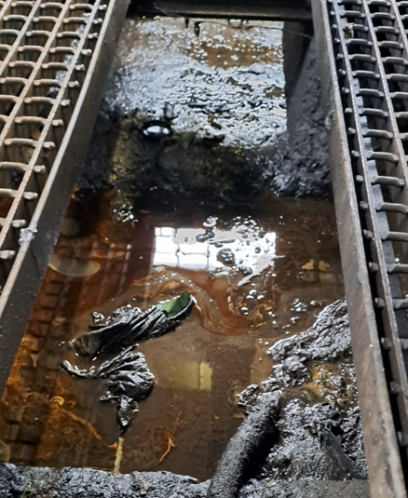
2. | Graphite grease | 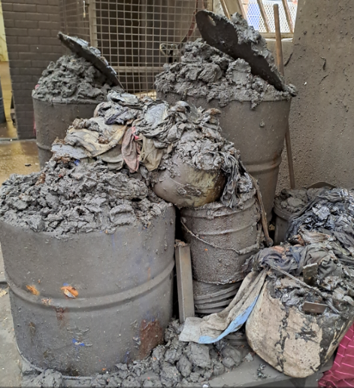
3. | Used Oil | 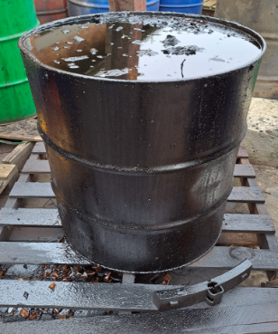
4. | Scrapped Brake blocks:  Have a fibre asbestos base and containing metallic particles. | 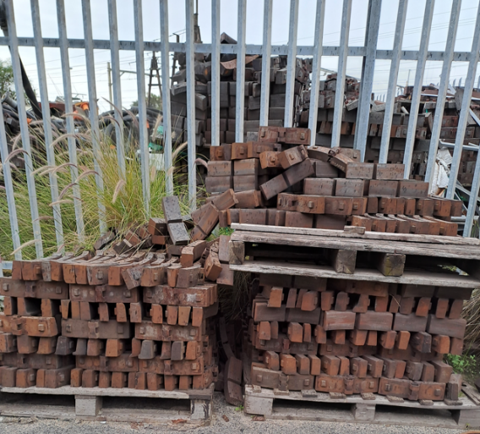
5. | Rubber train pipes and other rubber waste. | 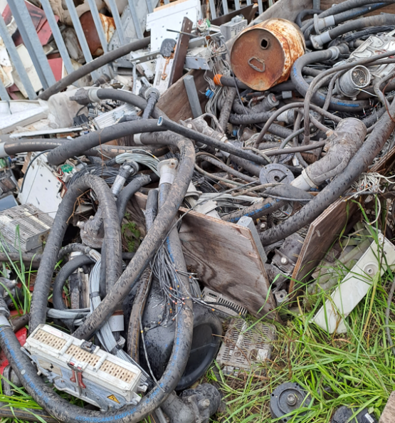
6. | Damaged arch chutes: Contains fiberglass. | 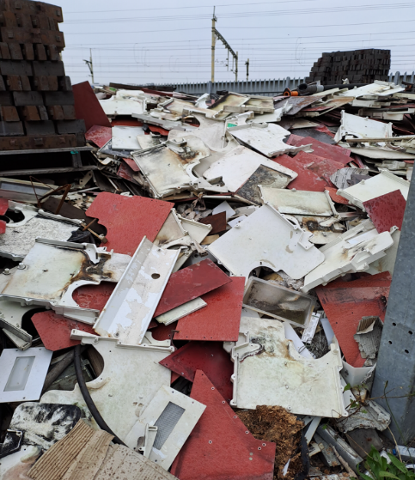
7. | Wood offcuts | 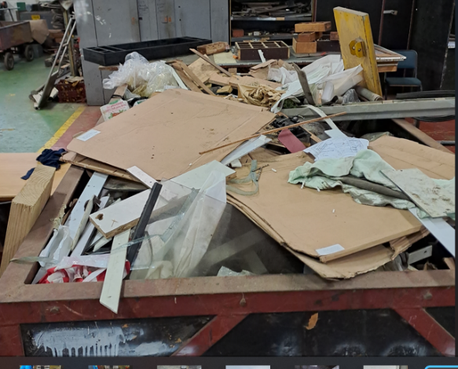
8. | Damaged seats | 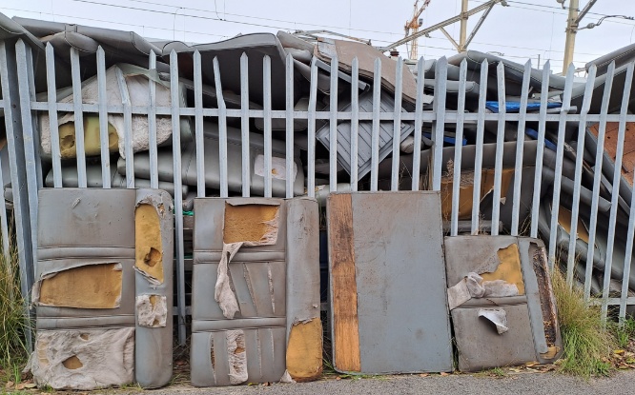
9. | Used HVAC, MA Filters | 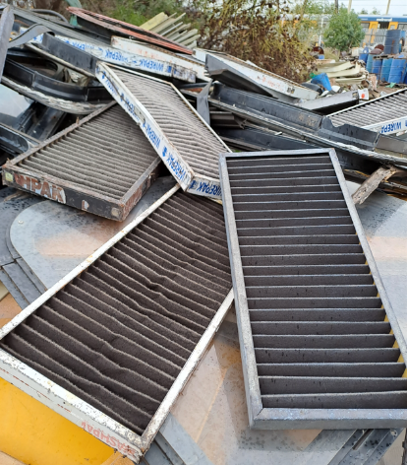
10. | Used Sandblast sand stored in drums. | 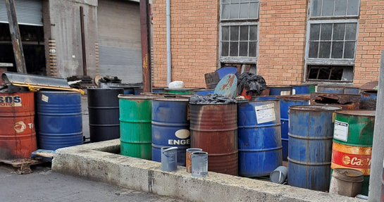
11. | Dirty rags stored in drums | 
12. | Plastic window frames. | 
13. | Smashed glass windows | 
14. | 20L Metal Pail | 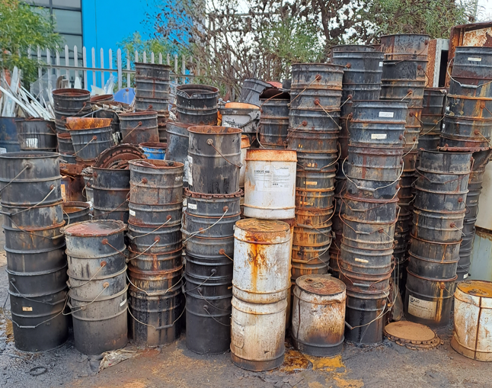
15. | 20L Plastic containers | 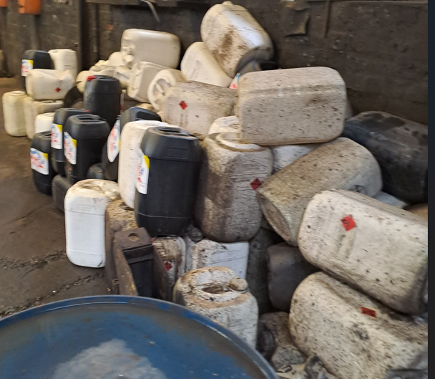
16. | Cardboard | 
Location where services will be rendered.

The service provider will collect transport and dispose hazardous and general waste from Rolling Stock Western Cape Region depots. Namely:
- Saltriver.
- Paarden Eiland.
- Firgrove.

Duration.

“Once off basis”

Compliance Requirements

No. | Requirements for Waste Handlers | Required by
1 | All waste must be disposed of in strict accordance with the National Environment Management Waste Act 59 of 2008. | NEM: Waste Act 59 of 2008
2 | Authorisation to dump waste in landfills or an account with landfill to dump hazardous waste. | NEM: Waste Act 59 of 2008
3 | Must hold valid transport licence for all applicable municipalities in Western Cape Province. | NEM: Waste Act 59 of 2008
4 | Fully equipped compactor vehicle’s, skip loader which does not cause pollution of any kind. | NEM: Waste Act 59 of 2008
5 | Must hold valid hazardous waste transport licence for hazardous waste handlers. | NEM: Waste Act 59 of 2008
6 | Valid Waste Accreditation Permit and relevant permits relating to waste management. ISO 14001:2015 | PRASA
7 | Proof that the proposed landfill site / waste handling facility is licensed. | PRASA
8 | Must provide traceability of all waste streams | PRASA
9 | Waste Handlers on Prasa sites to put on PPE when handling waste. | OHS Act 85 of 1993

Access to Prasa Rollingstock premises and working hours.

Successful service provider to collect and transport contracted hazardous and general waste during Prasa working hours. Prasa working hours are from 07h00 to 16h30, Monday to Friday.

BOQ/ PRICING SCHEDULE

The below will be used for evaluation purposes

No. | Waste stream | UOM | Unit Price excluding VAT | Unit Price Including VAT
1. | Drain and dispose Sludge (Mixture of Water, Oil, Crater, Turpentine, and degreasing) stored underground. | Per L
2. | Dispose Graphite grease in 210L drum. | Per drum
3. | Dispose oil in 210L drums. | Per drum
4. | Dispose scrapped brake blocks (Have a fibre asbestos base and containing metallic particles). | Per ton
5. | Rubber train pipes and other rubber material in 7m3 skip. | Per skip
6. | Dispose arch chutes: Contains fiberglass. | Per ton
7. | Remove Wood offcuts in 7m3 skip. | Per skip
8. | Dispose damaged seats in 7m3 skip. | Per skip
9. | Dispose HVAC, MA Filters in 7m3 skip. | Per skip
10. | Dispose Sandblasting sand in 210L drums. | Per drum
11. | Dispose oily rags/gloves in 210L drums. | Per drum
12. | Dispose plastic Window frames. | Per ton
13. | Dispose smashed glass windows in 7m3 skip. | Per skip
14. | Remove 20L empty Metal Pail. | Per unit
15. | Remove 20L empty Plastic Containers. | Per unit
16. | Remove cardboards. | Per ton
 | Remove 210L empty drums. | Per drum
 | Total
 | 15% VAT
 | Grand Total including VAT

NB: Prices to include labour and transportation of the waste.

Should bidders want to visit the site where the waste is please email Adriana Hagen (Adriana.hagen@prasa.com) to make appointment. No bidder will be accommodated without proper appointment.

the power, by one person or a group of persons holding the majority of the equity of an enterprise, alternatively, the person/s having the deciding vote or power to influence or to direct the course and decisions of the enterprise.
Joint venture or Consortium means an association of persons for the purpose of combining their expertise, property, capital, efforts, skill and knowledge in an activity for the execution of a contract.

