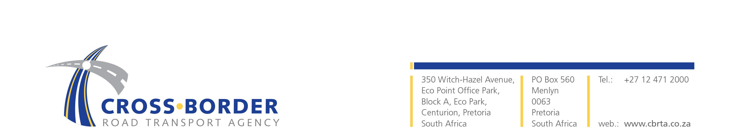

SCOPE OF WORK

TRAINING COURSE | COURSE DESCRIPTION | RECOMMENDED DURATION | ACCREDITATION RECOMMENDATION | DELIVERY MODE | DELEGATES
Negotiation Skills | Develop negotiation, persuasion, communication and conflict resolution skills for business and procurement environments. | 3 days | Non-accredited | Online | 9
Conflict Management | Techniques for identifying, managing and resolving workplace conflict effectively. | 2 days | Accredited | Online | 9
Innovation and Change Management | Managing organisational change, innovation, digital transformation and employee engagement. | 3 days | Non-accredited | Online | 4
Business Management | Fundamentals of strategic planning, operations, finance, leadership and business performance. | 3 days | Accredited preferred | Online | 3
Stock Management | Inventory control, warehouse management, stock valuation and demand forecasting. | 3 days | Accredited preferred | Online | 5
Public Transport Policy, Planning and Green Transport | Sustainable transport planning, transport policy, public transport systems and green mobility solutions. | 3 days | Non-accredited/CPD | Online | 1
Emerging Management Development Programme | Develop leadership, supervision, strategic thinking and people management skills for new managers. | 3 days | Accredited preferred | Online | 1

Office Management and Coordination | Office administration, records management, executive support and business communication. | 3 days | Accredited preferred | Online | 1
Financial Administration | Financial record keeping, budgeting, reconciliations and financial controls. | 5 days | Accredited | Online | 1
Basic Event Planning and Management | Planning, budgeting, logistics, stakeholder management and event coordination. | 3 days | Non-accredited | Online | 4
Data Analysis | Data preparation, Excel, Power BI, dashboards, reporting and data-driven decision-making. | 3 days | Accredited preferred | Online | 11
Certified Director | Corporate governance, board responsibilities, ethics and fiduciary duties. | 5 days | Professional Body Certification | Online | 1
International Trade & Transport Policy (SADC) | Regional trade agreements, customs procedures, transport corridors and logistics policy. | 5 days | Non-accredited/CPD | Online | 1
Systems Thinking | Understanding complex organisational systems, problem-solving and strategic decision-making. | 3 days | Non-accredited | Online | 1
ISO 39001:2013 Road  Traffic Safety Management Systems | Introduction, implementation and internal auditing of ISO 39001 Road Traffic Safety Management Systems. | 3 days | Accredited/Certified Lead Auditor preferred | Online | 1
Toastmasters/Public Speaking | Improve presentation skills, communication, confidence and leadership. | 2 days | Non-accredited | Online | 3
Incident Analysis within a Control Room Environment | Incident reporting, root cause analysis, risk management and emergency response. | 3 days | Accredited preferred | Online | 14

Supervisory Course | Supervision, performance management, labour relations and team leadership. | 3 days | Accredited preferred | Online | 8
Artificial Intelligence | AI fundamentals, Generative AI, automation, prompt engineering, ethics and workplace applications. | 3 days | Non-accredited/CPD | Online | 10
CIPS Ethics | Ethical procurement, governance, transparency and responsible sourcing. | 2 days | CIPS Accredited preferred | Online | 4
Specification Writing | Developing clear procurement specifications and terms of reference. | 2 days | Non-accredited | Online | 4
Environmental, Social and Governance (ESG) | ESG principles, sustainability reporting, governance and regulatory compliance. | 3 days | Non-accredited/CPD | Online | 2
Corporate Governance | King IV principles, governance frameworks, ethics and risk management. | 3 days | Non-accredited/CPD | Online | 8
Customer Care | Customer service excellence, complaint handling and relationship management. | 2 days | Accredited | Online | 5
GRAP and IFRS Updates | Latest accounting standards, financial reporting and public sector compliance updates. | 3 days | Professional CPD | Online | 6
Project Management | Project planning, scheduling, budgeting, monitoring and risk management. | 3 days | Accredited (PMI/PRINCE2/QCTO/SAQA  depending on provider) | Online | 5

