Contact Person | Mapule Msiza
Email Address | mapule.msiza@tia.org.za
Closing Date | 21 April 2026 @ 17:00m
delivery address | 1 Dickens Road, AECI Industrial Complex, Umbogintwini, 4120
Description of Goods / Services
Item Description |  | Quantity
Cold-room shaded pole fan motor  Supply and installation of 25w shaded pole fan motor for a cold-room blower.  1 to be installed and other supply as a spare.  specification:  BRAND: ebmpapst from metraclark  ebm max 5mm  m1q045-ea01-78  230v 50hz 0.62a  25W 1300rpm  fan Dia 300 v- 31°  it is mandatory for the supplier to be a certified hvac technician (the supplier must attach proof to show that they are certified hvac technician with-out attaching proof you will be disqualified  address for delivery and installation  1 Dickens Road, AECI Industrial Complex, Umbogintwini, 4120 |  |  | 2 |  |  | 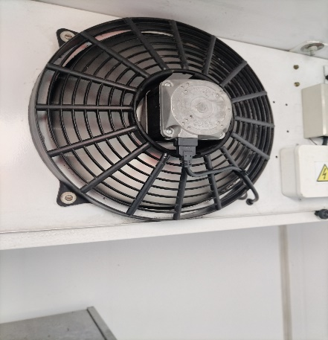
- Invoice paid after good and services delivery and within 30 days as per the National Treasury Act.
- Suppliers must all be registered on the Central Supplier Database
- Quotations: to be accompanied by SBD 4 AND 6.1 forms, Proof of specific goals where applicable, the completed and signed request for quotation form
- Quotation received after the closing date and time will not be considered.
- 80/20 preferential point system will be used
6. The validity period of price quotations after the closing date is 30 days
Specific Goals For TIA For Day - To - Day Procurement |  |  |  | Proof
50% Owned By Historically Disadvantaged Individuals |  | 5 |  | Share Register / CSD Report
51% Owned Black Women |  | 5 |  | Share register /CSD Report
At Least One Of The Owners Has A Disability / Disabilities |  | 5 |  | Statements Or Letters On A Physician’s / Medical Professional’s Letterhead With Practise Number Confirming Disability
At Least One Of The Owners Is A Youth |  | 5 |  | Copy Of A Certified ID CARD
Total |  | 20
Supplier’s Information
Company Name
Contact Person
Contact Number
Email Address
Signature |  |  |  |  | Date

