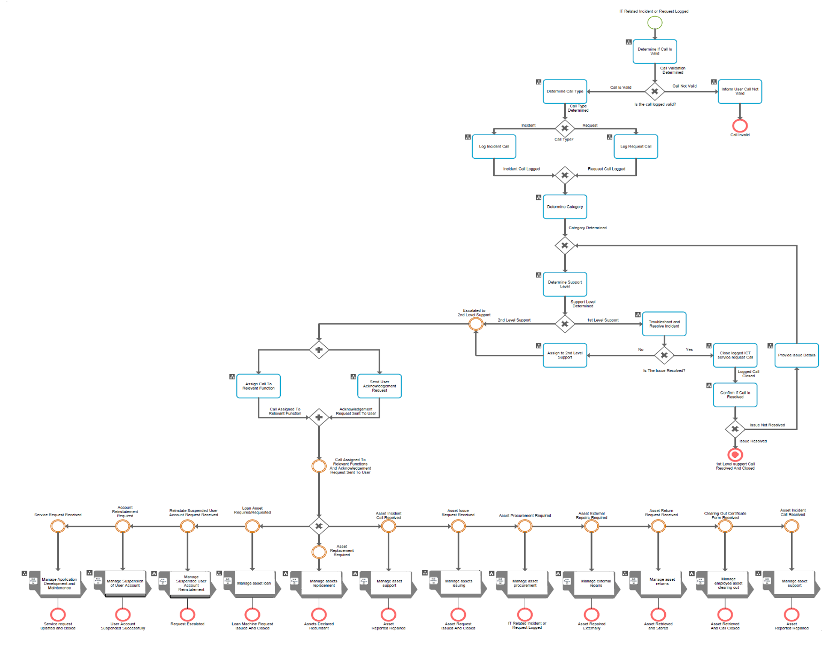

Figure 1: Armscor ICT Service Desk Business Process

    - Manage Application Development and Maintenance:
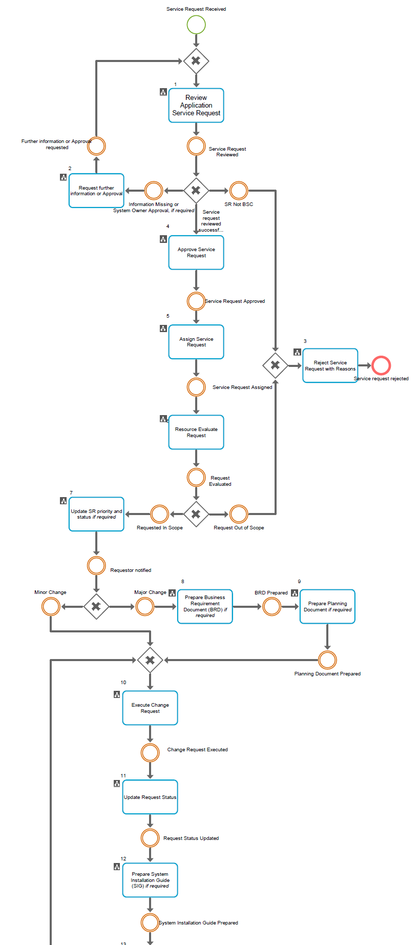
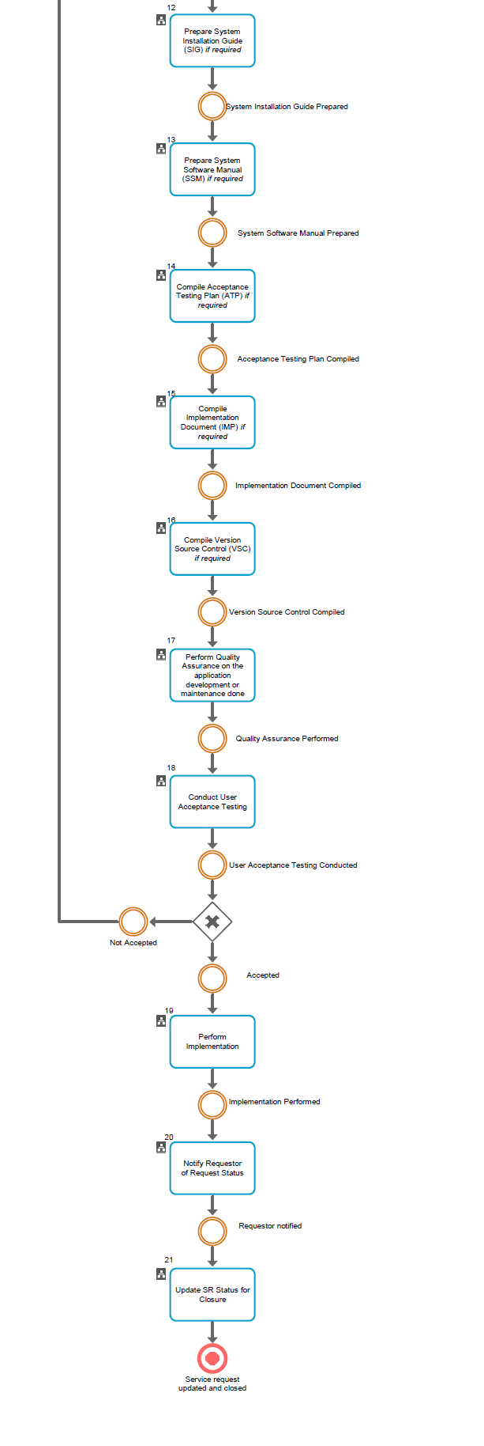
    - Manage ICT Stores (Assets Management):

