ENOCH MGIJIMA LOCAL MUNICIPALITY
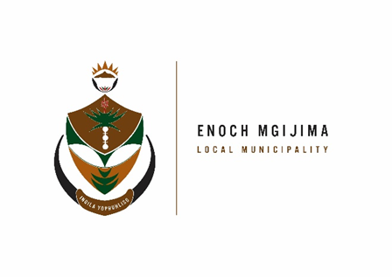
TENDER NOTICE

PROJECT NAME | TENDER NUMBER | COMPULSORY BRIEFING MEETING | DOCUMENT PRICE | CLOSING DATE
RE-ADVERT: SUPPLY AND DELIVERY OF 4 BULK WASTE CONTAINERS AND 40 STREET LITTER SWING BINS | SCM72/11/2023 | No Briefing | R300.00 | 28th February 2024 at 12h00
APPOINTMENT OF A PROFESSIONAL SERVICE PROVIDER FOR AUDIT READINESS AND ANNUAL FINANCIAL STATEMENT PREPARATIONS FOR THE 2024 and 2025 EXTERNAL AUDIT | SCM06/02/2024 | No Briefing | R300.00 | 29th February 2024 at 12h00
GENERAL VALUATION AND PREPARATION OF THE VALUATION ROLL FOR IMPLEMENTATION 1 JULY 2024 AND PREPARATION AND UPDATING OF THE VALUATION ROLL FOR THE PERIOD 1 JULY 2024 TO 30 JUNE 2030 | SCM07/02/2024 | No Briefing | R300.00 | 1st March 2024 at 12h00

The PPPFA act No.5 of 2000 and the New amended regulations of 2022 effective as from the 16 January 2023 as per gazette No. 47452 read together with gazette No. 49863 Vol. 702 scheduled as follows:
PPPFA – |  | 80/20
PRICE – |  | 80 Points
BBBEE – |  | 10 Points
SPECIFIC GOALS - |  | 10 Points
Banking details
: Acc Name: Enoch Mgijima Local Municipality
Bank :FNB
Acc No :62438159809
Acc Type :Cheque
Branch Code : 250655 (internet Banking)
Ref : 3010142551022
Bid documents containing detailed terms of reference will be available as from 14 February 2024 ; 08h00 - 16h00 week days, from the Supply Chain Management offices: Budget and treasury offices at No. 25-27 Owen Street; Queenstown upon payment of a non–refundable fee (either in cash or by means of an EFT made payable to the Enoch Mgijima Local Municipality) . Completed bid documents are to be place in a sealed envelope clearly marked the Bid number and Project Name and must be deposited in a bid Box situated at Budget and treasury offices at No. 25-27 Owen Street; Queenstown no later than 12h00pm on the closing date at which all bids will be opened in public
More details about the advert contact Mr. A Hoko (045 807 2000)
Issued By

A NTENGENYANE KOMANI HOSPITAL
MUNICIPAL MANAGER N6 ROUTE
KOMANI

