SCM SUBMISSION: SPECIFICATION / SCOPE OF WORK

DESCRIPTION OF GOODS / SERVICES / WORK | AS AND WHEN REQUIRED MAINTENANCE/SERVICING AND REPAIRS OF FIRE DETECTION AND ASSOCIATED EQUIPMENT IN THE WESTERN CAPE
REQUEST FOR QUOTATION NUMBER | 10344889
DIVISION | PRASA TECHNICAL
USER DEPARTMENT | Telecoms Department

TABLE OF CONTENTS
- INTRODUCTION
- BACKGROUND INFORMATION
- OBJECTIVE OF THE PROPOSED PROJECT
- SCOPE OF WORKS AND AREAS OF FOCUS
- SPECIFICATION OF SERVICES REQUIRED
- TECHNICAL SPECIFICATIONS RELATED TO THIS PROJECT
- TIME FRAMES / PROGRAM
- EVALUATION METHODOLOGY
- THE NATIONAL INDUSTRIAL PARTICIPATION PROGRAMME
- RECOMMENDATIONS

- INTRODUCTION
Fire detection systems are particularly important for businesses that operate trains and have telecoms, IT & Signals server rooms on their premises. These businesses require high levels of reliability and safety to ensure that their operations run smoothly and without interruption. A fire in a train or server room can have serious consequences, including damage to equipment, loss of data, and even injury or loss of life. Fire detection systems are essential components of building safety and protection. These systems are designed to identify and alert occupants of a building when there is a fire or smoke present. They provide an early warning of a potential fire, allowing occupants to evacuate the building safely and quickly, and enabling emergency responders to respond promptly.

There are several types of fire detection systems available, including:

- Smoke detectors: These are the most common type of fire detection system. They work by sensing smoke particles in the air and triggering an alarm when the level of smoke exceeds a certain threshold.

- Heat detectors: These systems detect changes in temperature and are often used in areas where smoke detectors are not suitable, such as kitchens or boiler rooms.

- Flame detectors: These systems detect the presence of flames through the use of sensors that detect the infrared or ultraviolet radiation given off by the fire.

- Gas detectors: These systems detect the presence of combustible gases, such as methane or propane, and can be used in areas where gas leaks are a concern.

Fire detection systems can be wired or wireless and can be integrated with other building systems, such as sprinkler systems and emergency lighting. They are typically installed by trained professionals and require regular maintenance to ensure they are functioning properly. Fire detection systems can be integrated with other safety systems, such as sprinkler systems and emergency lighting, to provide a comprehensive safety solution. Regular maintenance and testing of these systems is essential to ensure that they are functioning properly and can provide early warning of a potential fire. Additionally, these systems should be installed and maintained by trained professionals to ensure that they are effective and meet all relevant safety standards.
- BACKGROUND INFORMATION

Having a fire detection system in a server room is essential for any business, including those that operate trains. Server rooms are critical components of modern businesses, housing the computer systems and equipment that are essential for daily operations. These rooms are often filled with sensitive and expensive equipment that can be easily damaged or destroyed in a fire.

In addition, server rooms generate a lot of heat due to the high-powered equipment they contain. This heat can create a fire risk if it is not managed properly. A fire in a server room can cause significant disruption to a business, leading to data loss, downtime, and lost revenue.

For businesses that operate trains, the consequences of a fire in a server room can be especially severe. Train operations rely heavily on computer systems for everything from scheduling to safety monitoring. A fire in a server room can disrupt these systems, causing delays, cancellations, and safety risks.

A fire detection system in a server room can help to prevent these problems by providing early warning of a potential fire. Smoke or temperature sensors can detect the presence of a fire and trigger alarms or alerts, allowing staff to respond quickly and effectively. This can help to minimize damage and downtime and ensure that train operations can continue safely and efficiently.

  - STATUS QUO

The last existing AS AND WHEN REQUIRED MAINTENANCE/SERVICING AND REPAIRS OF FIRE DETECTION AND ASSOCIATED EQUIPMENT IN THE WESTERN CAPE just expired. There is currently no contract in place and there is a maintenance backlog due to this it may cause a delay in life critical and property protection emergency actions.

  - PROBLEM STATEMENT

The fire detection is non-compliant to South African National Standard (SANS 10139) and it therefore poses a threat to life and property. In addition, there are many false alarms in the station and the consequence of these false may be complacent behaviour from the occupants in the case of real fire, not having fire detection in a server room is that it creates a significant fire risk that could lead to damage or destruction of critical equipment, data loss, and business disruption. A fire in a server room can result in extended downtime, lost revenue, and potential safety risks for employees and customers.

Without a fire detection system, a fire in a server room can go undetected until it has already caused significant damage. By the time the fire is discovered, it may be too late to prevent equipment damage, data loss, or business disruption. In addition, without early warning of a fire, employees and customers may be at risk of injury or even death.

Furthermore, not having a fire detection system in a server room can also result in non-compliance with safety regulations. Many jurisdictions require businesses to have fire detection systems installed in server rooms and other critical areas to ensure the safety of employees and customers.

Overall, not having a fire detection system in a server room is a serious problem that can have significant consequences for businesses of all types, including those that operate trains. It is essential for businesses to install and maintain fire detection systems to minimize the risk of fire and ensure the safety of their employees, customers, and critical equipment.

- OBJECTIVE OF THE PROPOSED PROJECT

The objectives of having fire detection systems in a server room and business building are as follows:

- Early detection of fire: One of the primary objectives of fire detection systems is to provide early detection of a fire. Early detection enables quick response and can help to minimize damage, prevent loss of critical data, and ensure the safety of employees and customers.

- Rapid alerting: Fire detection systems are designed to provide rapid alerting of a fire. This can be achieved through audible alarms, visual alerts, and automated messaging systems that notify key personnel of the fire.

- Effective response: A fire detection system should be designed to enable an effective response to a fire. This includes providing clear instructions for evacuating the building, activating suppression systems, and coordinating with emergency responders.

- Integration with other systems: Fire detection systems should be integrated with other safety and building management systems, such as sprinkler systems, emergency lighting, and HVAC systems. This integration enables a coordinated response to a fire and can help to minimize damage and downtime.

- Compliance with regulations: Many jurisdictions have regulations that require businesses to have fire detection systems installed in server rooms and other critical areas. The objective of compliance is to ensure the safety of employees and customers and to avoid potential legal and financial consequences.

- Regular maintenance: Fire detection systems require regular maintenance to ensure that they are functioning properly. The objective of regular maintenance is to minimize the risk of false alarms, ensure that the system is detecting fires effectively, and extend the lifespan of the system.

Overall, the objectives of having fire detection systems in a server room and business building are to minimize the risk of fire, ensure the safety of employees and customers, and protect critical equipment and data.

- DESIRED OUTCOMES FOR CARRYING OUT THE PROPOSED PROJECT

The desired outcomes for carrying out a fire detection system project would typically include the following:

- Early detection of fire: The primary goal of a fire detection system is to provide early warning of a fire. Early detection can help prevent the spread of fire, minimize damage to property, and most importantly, protect the lives of people in the building.

- Rapid notification: Once a fire is detected, the fire detection system should rapidly notify the occupants of the building, as well as the local fire department, so that appropriate action can be taken.

- Effective suppression: In addition to detecting and notifying of a fire, the fire detection system may also include a suppression system that can help extinguish the fire or control its spread until the fire department arrives.

- Minimize false alarms: False alarms can be costly and disruptive, so it is important that the fire detection system is designed to minimize false alarms while still providing reliable detection.

- Compliance with regulations: The fire detection system should be designed and installed in compliance with local fire codes and regulations.

- Integration with other building systems: The fire detection system should be designed to integrate with other building systems, such as HVAC and security systems, to ensure that all systems work together effectively in the event of a fire.

- Ease of maintenance: The fire detection system should be designed for ease of maintenance and testing, to ensure that it remains in proper working order and is able to provide reliable detection over time.

- PROJECT BENEFITS TO PRASA

There are many benefits to having fire detection systems installed in a building, including:

- Early detection: Fire detection systems are designed to detect fires in their early stages, which can help prevent the spread of fire and minimize damage to property.

- Life safety: Fire detection systems are designed to alert occupants of a building to the presence of a fire, giving them time to evacuate before the fire spreads.

- Property protection: Fire detection systems can help minimize damage to property by detecting fires early and alerting the fire department to the scene quickly.

- Compliance with regulations: Many local fire codes and regulations require the installation of fire detection systems in certain types of buildings, so having a fire detection system installed can help ensure compliance with these regulations.

- Lower insurance premiums: Insurance companies often offer lower premiums to buildings that have fire detection systems installed, as they are seen as lower risk.

- Integration with other systems: Fire detection systems can be integrated with other building systems, such as HVAC and security systems, to provide a comprehensive safety and security solution for the building.

Having a fire detection system installed in a building can provide numerous benefits, including increased safety, protection of property, and compliance with regulations, while also reducing risk and providing peace of mind.

- CURRENT MECHANISMS IN PLACE TO ADDRESS THE PROBLEM

Currently the system needs service, and some are non-compliant to SANS 10139. We currently have no contract in place to service and maintain.

- SCOPE OF WORKS AND AREAS OF FOCUS

  - SCOPE OF THE DESIRED SOLUTION

The scope of a maintenance contract for a fire detection system will depend on the specific requirements of the system and the building it is installed in. However, the following are some of the elements that may be included in a maintenance contract for a fire detection system:

- Inspection and testing: Regular inspection and testing of the fire detection system may be included in the maintenance contract. This can help identify any issues or problems with the system and ensure that it is functioning properly.

- Cleaning and calibration: The maintenance contract may include cleaning and calibration of the system to ensure that it is functioning at optimal performance.

- Battery testing and replacement: The maintenance contract may include regular testing and replacement of batteries in the system to ensure that it is functioning properly in the event of a power outage.

- Software updates: If the fire detection system includes software, the maintenance contract may include regular updates to ensure that the system is up-to-date and functioning properly.

- Emergency service and repairs: The maintenance contract may include emergency service and repairs to address any issues or problems with the system that arise.

- Compliance with regulations: The maintenance contract may include ensuring that the fire detection system remains in compliance with local fire codes and regulations.

The scope of the maintenance contract should be tailored to the specific needs of the fire detection system and the building it is installed in. It is important to work with a qualified fire protection professional to design and implement a maintenance contract that meets these needs and ensures that the fire detection system remains in proper working order over time.

  - REQUIRED PROFFESIONAL SERVICES

There are several professional services that can help with fire detection. Here are a few examples:

- Fire Alarm System Installation and Maintenance Services: Professional fire alarm system installers can help design and install a fire alarm system that is tailored to your specific needs. They can also provide ongoing maintenance services to ensure that the system is functioning properly and in compliance with local codes and regulations.

- Fire Risk Assessment and Consulting Services: Fire risk assessment and consulting services can help identify potential fire hazards in your building or facility and recommend solutions to mitigate those risks. They can also provide guidance on fire safety regulations and compliance requirements.

- Fire Detection and Monitoring Services: Fire detection and monitoring services provide round-the-clock monitoring of your facility for signs of fire. They can also provide automatic fire detection systems that can alert authorities and trigger sprinkler systems in the event of a fire.

- Fire Safety Training: Fire safety training can help ensure that your employees are prepared to respond to a fire emergency. Professional trainers can provide customized training programs that cover fire prevention, evacuation procedures, and the proper use of fire extinguishers.

It's important to note that the specific professional services you need for fire detection will depend on the size and complexity of your facility, as well as local fire safety regulations. It's recommended to consult with a professional fire safety company to determine which services would be best suited for your needs.

  - INSURANCE REQUIREMENTS FOR THE PROJECT

The insurance requirements for a fire detection system project will depend on several factors, including the size and complexity of the project, the type of facility being protected, and local regulations.

Here are some general insurance requirements that may apply to a fire detection system project:

- Liability Insurance: Liability insurance is typically required for any contractor or subcontractor working on the project. This type of insurance protects against property damage or personal injury that may occur as a result of the work being performed.

- Professional Liability Insurance: Professional liability insurance, also known as errors and omissions insurance, may be required for companies providing fire detection and monitoring services. This type of insurance protects against claims of negligence or errors in the services provided.

- Workers' Compensation Insurance: Workers' compensation insurance is typically required for any employees working on the project. This type of insurance provides benefits to employees who are injured or become ill as a result of their work.

- Property Insurance: Property insurance may be required for the facility being protected by the fire detection system. This type of insurance covers damage or loss to the property as a result of a fire or other covered event.

It's important to consult with your insurance provider to determine the specific insurance requirements for your fire detection system project. They can help you understand your coverage options and ensure that you have the appropriate insurance in place to protect your project and your business.

  - TARGETED AREA BY THIS PROJECT

All corridors station bound building the location and extent of the Works is along the following rail corridors:
- Cape Town Station to Wellington Station
- Cape Town Station to Strand Station
- Cape Town Station to Simons Town Station
- Cape Town Station to Dieprivier Station via Cape Flats
- Cape Town Station to Bellville Station via Monte Vista Station
- Cape Town Station to Chris Hani Station
- Philippi Station to Kapteinsklip Station
- Eersterivier to Muldersvlei Station

The location and extent of the site of the Works is between the property boundaries of PRASA WC and TFR in the Western Cape. The Contractor shall acquaint himself with the available access to the various sites and the condition of the roads during the site inspection.

  - PRASA’S RESPONSIBILITIES

PRASA, or the Passenger Rail Agency of South Africa, has several responsibilities when going out on a project. These responsibilities are guided by the Public Finance Management Act (PFMA) and the Treasury Regulations, which provide a framework for project management in the public sector.

Some of PRASA's responsibilities when going out on a project include:

- Conducting a feasibility study: PRASA must conduct a feasibility study to determine the viability of the project, including its technical, financial, environmental, and social aspects.

- Developing a project plan: PRASA must develop a comprehensive project plan that outlines the project objectives, scope, timeline, budget, and risk management strategies.

- Securing funding: PRASA must secure funding for the project, either through its own budget or through external funding sources.

- Ensuring compliance with relevant legislation: PRASA must ensure that the project complies with all relevant legislation, regulations, and policies, including environmental and social impact assessments.

- Appointing a project team: PRASA must appoint a project team that includes a project manager, technical experts, and other relevant stakeholders.

- Monitoring and evaluating the project: PRASA must monitor and evaluate the project to ensure that it is progressing according to plan, and to identify any issues that need to be addressed.

- Managing the project budget: PRASA must manage the project budget effectively, ensuring that all costs are accounted for and that the project remains financially viable.

- Reporting on the project: PRASA must report regularly on the project to stakeholders, including the public, government, and funders.

By fulfilling these responsibilities, PRASA can ensure that its projects are well-planned, well-executed, and deliver the intended benefits to the public.
The information contained in this communication from the sender is confidential. This e-mail message is intended for the sole use of the individual or entity to which it is addressed. If you have received this email in error, please notify the sender immediately by email or telephone, and thereafter delete this email from any and all computer systems in which it may be stored. Any views or opinions presented in this e-mail are solely those of the individual sender and shall not be construed as those of Passenger Rail Agency of South Africa (PRASA).

  - EXTENT AND COVERAGE OF THE PROPOSED PROJECT

PRASA: Western Cape region

  - MEASUREMENTS AND PAYMENT

The measurement and payment provisions for as and when required maintenance/servicing and repairs of fire detection and associated equipment would typically be set out in the contract between PRASA and its contracting partner.

In a contract for as and when required maintenance/servicing and repairs, the payment provisions would typically be based on the actual work performed and materials used, rather than a pre-determined lump sum or unit price. This means that the contractor would be required to submit invoices for each instance of work performed, detailing the specific tasks carried out, the time spent on each task, and the materials used.

The payment provisions would also typically specify the rate or rates to be applied for each type of work or service provided. For example, there may be different rates for routine maintenance, emergency repairs, and replacement of equipment. The rates may be based on hourly or daily rates for labour, and cost-plus for materials used.

The contract may also include provisions for verifying and approving invoices, including requirements for documentation, such as timesheets and receipts, and a process for resolving disputes or disagreements over invoices.

It is important for both parties to carefully review and understand the payment provisions of the contract to ensure that they are clear and fair, and that they accurately reflect the nature of the work to be performed.

  - FORM OF CONTRACT

The GCC is a standard form of contract that is commonly used for the procurement of goods and services by public entities in South Africa. This form of contract is generally used for the procurement of goods and services that do not require specialized engineering or professional services.

Since the maintenance, servicing, and repair of fire detection and associated equipment is typically a routine and ongoing service, it is likely that PRASA would use the GCC for this type of procurement. The GCC sets out the general terms and conditions of the contract, including the scope of work, payment terms, warranties, and dispute resolution procedures.

It is important to note, however, that the specific form of contract used by PRASA for this procurement would depend on the specific requirements of the project and the procurement regulations and guidelines that apply to the agency. If there are specialized engineering or professional services required for this project, PRASA may use the Engineering and Construction Contract (ECC) or the Professional Services Contract (PSC) instead.

  - OTHER RELATED PROJECTS

- No related projects

- SPECIFICATION OF THE WORK OR PRODUCTS OR SERVICES REQUIRED

8,1 PROFESSIONAL TECHNICAL STAFF REQUIREMENTS

KEY PROFESSIONAL STAFF
Experience key professional staff in relation to the scope of work – Professionals Services:

In South Africa, the qualifications required for technicians to maintain fire detection systems are regulated by the South African Qualifications Authority (SAQA) and the Department of Employment and Labour (DEL). The specific qualifications required may vary depending on the type of fire detection system and the level of responsibility of the technician.

Generally, technicians should have a strong understanding of fire safety principles, electrical systems, and electronics. They should also have received specialized training on the specific fire detection system they will be maintaining, and be able to follow the manufacturer's instructions and industry best practices.

The DEL requires that fire detection system technicians are registered with the South African Fire Protection Association (SAFPA) and hold a valid SAQCC-Fire Detection and Alarm Systems accreditation. The accreditation requires technicians to have successfully completed a SAQCC-Fire Detection and Alarm Systems course, which covers the installation, commissioning, and maintenance of fire detection and alarm systems.

Additionally, some fire detection system manufacturers may require their own certification or training programs for technicians who maintain their systems.

It is important to consult with local authorities and industry associations in South Africa to determine the specific qualifications necessary for maintaining fire detection systems in that country.

8.1.1.1 Technician

There are several categories of registration available through SAQCC Fire and the desired minimum qualifications for the Technician are as follows:

- Installer: for individuals or companies involved in the installation of fire protection equipment and systems.
- Commissioner: for individuals or companies involved in the commissioning and testing of fire protection systems.
- Inspector: for individuals or companies involved in the inspection and maintenance of fire protection systems.
- Designer: for individuals or companies involved in the design of fire protection systems.
- Approver: for individuals or companies involved in the approval of fire protection systems.

To register with SAQCC Fire, practitioners must meet the minimum requirements for their chosen category of registration, which may include relevant qualifications, experience, and training. They must also pass an assessment and demonstrate ongoing compliance with relevant regulations and standards. Once registered, practitioners are required to maintain their registration by meeting ongoing training and compliance requirements set by SAQCC Fire.

  - TECHNICAL INFORMATION TO BE PROVIDED WITH TENDER

When preparing a tender for as and when required maintenance, it is important to include technical information that clearly outlines the scope of work, requirements, and specifications for the maintenance services to be provided. Some of the technical information that may be required in a tender for as and when required maintenance includes:

- Scope of work: A clear description of the work to be performed, including the types of equipment and systems that will require maintenance, the expected frequency of maintenance, and any specific requirements or limitations.

- Experience and qualifications: Information about the contractor's experience and qualifications in providing maintenance services for similar types of equipment and systems. This may include details about the contractor's technical expertise, certifications, and references from previous clients.

- Technical specifications: Detailed technical specifications for the equipment and systems to be maintained, including information about the manufacturer, model numbers, and any specific technical requirements or limitations.

- Work plan: A detailed work plan outlining the contractor's approach to carrying out the maintenance services, including schedules, timelines, and any procedures or protocols that will be followed.

- Quality assurance: Information about the contractor's quality assurance processes, including how they ensure that the work is performed to a high standard and meets all relevant safety and quality standards.

- Health and safety: Information about the contractor's health and safety policies and procedures, including how they will ensure that all work is carried out safely and in compliance with relevant regulations and standards.

- Reporting: Details about how the contractor will report on the maintenance work performed, including any required documentation, reporting formats, and frequency of reporting.

The technical information provided in a tender for as and when required maintenance should demonstrate the contractor's expertise, experience, and ability to meet the requirements and specifications of the contract. It should also provide PRASA with a clear understanding of what the contractor will be doing and how they will be doing it, to ensure that the maintenance work is carried out effectively and efficiently.

- TECHNICAL SPECIFICATIONS RELATED TO THIS PROJECT

The engineering specification of the items for the systems is described below. All relevant specifications and datasheets have been included, “Please note the materials, equipment and systems specified is not limited to a specific product unless indicated by Metrorail. If any other material is used than those recommended in the tender document, the tenderer is obliged to submit detailed specifications of the material, equipment and system that is being offered as an alternative. These materials will be subject to PRASA Metrorail’s approval.”

A maintenance plan for fire detection systems is essential to ensure that the system is working correctly and can detect fires quickly and accurately. Here are some steps you can take to develop a maintenance plan for fire detection:

- Regular Inspections: Fire detection systems should be inspected regularly to ensure they are working correctly. This includes checking the sensors, control panel, and other components to ensure they are clean and free of damage.

- Testing: Fire detection systems should be tested periodically to ensure that they are functioning correctly. This includes testing the smoke detectors, heat detectors, and other sensors to ensure that they can detect a fire quickly and accurately.

- Cleaning: Fire detection systems should be cleaned regularly to remove dirt, dust, and other debris that can affect their performance. This includes cleaning the sensors, control panel, and other components.

- Record Keeping: All maintenance and testing activities should be recorded in a logbook or other record-keeping system. This will help you track the performance of the system over time and identify any issues that need to be addressed.

- Professional Maintenance: It is important to have a qualified professional perform regular maintenance on your fire detection system to ensure that it is working correctly. This includes testing and inspecting the system, as well as making any necessary repairs or upgrades.

By following these steps, you can develop a comprehensive maintenance plan for your fire detection system that will help ensure it is working correctly and can detect fires quickly and accurately.

Maintenance Plan

1. Daily Checks
- Checks to ensure system is operating normally.
- Rectify and record any faults found.

2. Weekly Tests
- Checks to ensure signal to monitoring station are functioning.
- Check battery and voltage conditions.
- Rectify and record any faults.

3. Monthly Tests
- Simulate fire and fault conditions in all zones.
- Check that the power supply, indicator, alarm outputs etc. are operating correctly.
- Rectify and record any faults.

SMOKE ALARM MAINTENANCE CHECKLIST

Smoke alarm has been tested because of:
routine test and maintenance extended absence of occupants
annual test and maintenance complaint __________________________
change of tenancy other ______________________________

- WEEKLY ROUTINE TEST AND MAINTENANCE YES NO
1 | Smoke alarm is securely fastened to the wall or ceiling.
2 | Smoke alarm shows no evidence of physical damage, paint application, or excessive grease and dirt accumulations.
3 | Ventilation holes on the smoke alarm are clean and free of obstructions.
4 | Smoke alarm signal sounds when the test device is operated.

- MONTHLY ROUTINE TEST AND MAINTENANCE YES NO
1 | Smoke alarm is securely fastened to the wall or ceiling.
2 | Smoke alarm shows no evidence of physical damage, paint application, or excessive grease and dirt accumulations.
3 | Smoke alarm has been vacuumed.
4 | Smoke alarm is powered by: __ AC wiring; __ standard battery; __ long life battery that expires in the year____ For battery operated smoke alarms: __ Battery has been replaced and securely connected to the clips. Battery is of the type____ as recommended by the manufacturer. Battery terminals are free of corrosion and signs of leakage.
5 | Smoke alarm signal sounds when the smoke alarm is tested using smoke.  produced from a burning: __ incense stick, __ punk stick, or__ cotton string.

- SERVICE ROUTINE TEST AND MAINTENANCE (Complete this section if “No” is checked in sections A or B.)
Smoke alarm has been serviced as follows: _____________________________________
__________________________________________________________________________
Smoke alarm has been replaced because of:
failure to sound alarm during test frequent false alarms
physical damage battery leakage
painted exterior case age
excessive stains, grease, or dirt accumulations other_______________________

According to SANS 10139, the maintenance intervals for fire detection sensors can vary depending on the type of sensor and its specific application. Here are some general guidelines:

1. Smoke Detectors:
- Optical Smoke Detectors: Typically, these detectors should undergo a functional test and inspection every six months. The detector's chamber should also be cleaned at least once a year.
- Ionization Smoke Detectors: These detectors require a functional test and inspection every six months. The radioactive source should be checked every five years, and the detector's chamber should be cleaned annually.

2. Heat Detectors:
- Fixed Temperature Heat Detectors: These detectors should undergo a functional test and inspection every six months.
- Rate-of-Rise Heat Detectors: Similar to fixed temperature heat detectors, these detectors should undergo a functional test and inspection every six months.

3. Flame Detectors:
- Ultraviolet (UV) Flame Detectors: These detectors should undergo a functional test and inspection every six months. The detector's lens should be cleaned annually.
- Infrared (IR) Flame Detectors: These detectors should undergo a functional test and inspection every six months. The detector's lens should be cleaned annually.

4. Gas Detectors:
- Gas detectors, such as carbon monoxide (CO) or carbon dioxide (CO2) detectors, should undergo a functional test and inspection every six months.

It's important to note that these maintenance intervals are general recommendations, and specific requirements may vary depending on factors such as the manufacturer's guidelines, environmental conditions, and local regulations. It's crucial to consult the manufacturer's documentation and adhere to any specific recommendations provided for the fire detection sensors installed in your system.

Additionally, remember to document all maintenance activities, including the dates of inspections, functional tests, and any repairs or replacements performed on the sensors. Proper record-keeping is essential for compliance and tracking the performance of the fire detection system over time.

In order to ensure the proper maintenance and adherence to standards for our fire detection systems, it is imperative that a project manager approves any job related to the maintenance of the system components mentioned in SANS 10139 guidelines. This approval requirement is effective immediately and applies to all personnel involved in fire detection systems maintenance.

The project manager will be responsible for reviewing and approving job requests, including but not limited to inspections, functional tests, repairs, replacements, and calibration activities for smoke detectors, heat detectors, flame detectors, and gas detectors. The purpose of this approval process is to ensure consistency, compliance, and optimal performance of our fire detection systems.

To obtain approval for a fire detection system job, please follow the following procedure:

1. Prepare a detailed job request, including the scope of work, specific tasks to be performed, and any required materials or equipment.

2. Submit the job request to the project manager responsible for fire detection systems maintenance. Include any supporting documentation or reports as necessary.

3. The project manager will carefully review the job request, assess its feasibility, and evaluate its compliance with SANS 10139 guidelines and any other relevant standards or regulations.

4. Upon approval, the project manager will provide authorization to proceed with the job, including any specific instructions or requirements.

5. If any modifications or changes are required to the job request, the project manager will communicate them to the requesting personnel for further clarification or adjustment.

Please note that any fire detection system job performed without prior approval from the project manager will not be considered authorized and may be subjected to disciplinary action.

By implementing this approval process, we aim to ensure the highest level of safety and reliability of our fire detection systems.

ZP3 Series Analogue Addressable Control Panels
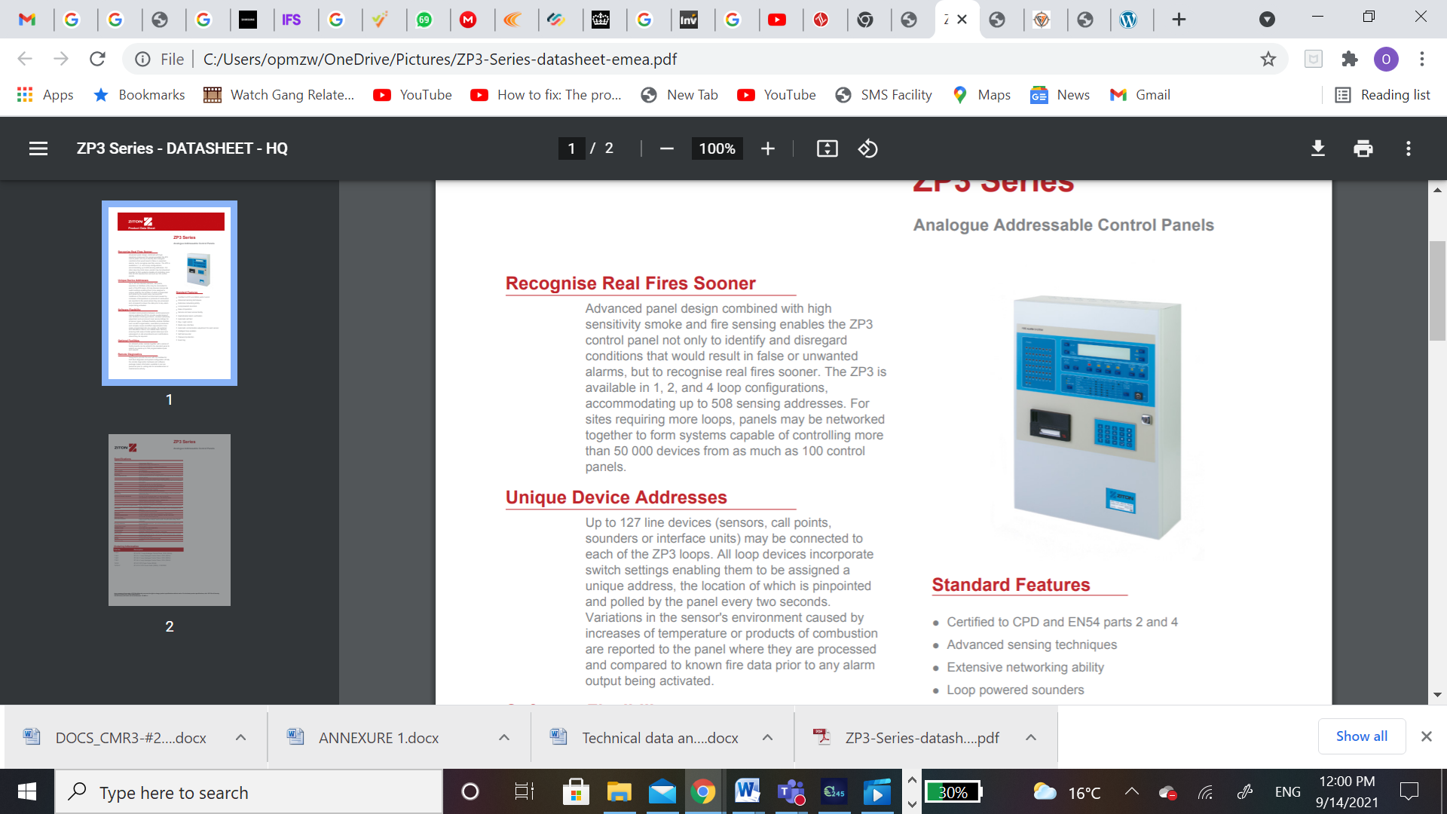
Figure 1: ZP3 Series Analogue Addressable Control Panels

Description

Recognise Real Fires Sooner

Up to 127-line devices (sensors, call points, sounders, or interface units) may be connected to each of the ZP3 loops. All loop devices incorporate switch settings enabling them to be assigned a unique address, the location of which is pinpointed and polled by the panel every two seconds. Variations in the sensor's environment caused by increases of temperature or products of combustion are reported to the panel where they are processed and compared to known fire data prior to any alarm output being activated.

Unique Device Addresses

Up to 127-line devices (sensors, call points, sounders, or interface units) may be connected to each of the ZP3 loops. All loop devices incorporate switch settings enabling them to be assigned a unique address, the location of which is pinpointed and polled by the panel every two seconds. Variations in the sensor's environment caused by increases of temperature or products of combustion are reported to the panel where they are processed and compared to known fire data prior to any alarm output being activated.

Software Flexibility

Constant communication between control panel and sensor enables the ZP3 to provide a wide range of user facilities including pre alarm, constant sensitivity adjustment and service and near service listings for all sensor types. Software flexibility enables facilities such as alarm organisation, evacuation procedures and complex cause and effect requirements to be easily programmed into any system. All customer and site data are held in non-volatile flash memory, ensuring both ease of initial system data input and subsequent on-site amendments and modifications should they be required.

Optional Facilities

An onboard printer module together with a series of facility boards can be added to the standard panel to extend any panel up to 768 programmable inputs and outputs.

Remote Diagnostics

Designed to provide the user with full facilities for both fault diagnosis and system configuration off site, the remote diagnostics hardware and software package makes information available to service personnel prior to visiting site for remedial action or maintenance activity.

Standard Features

- Certified to CPD and EN54 parts 2 and 4.
- Advanced sensing techniques
- Extensive networking ability
- Loop powered sounders
- Ease of operation
- Service and near service facility
- Sophisticated alarm verification
- Automatic self-test
- Day / night control
- Radio loop interface
- Automatic contamination adjustment for each sensor
- Intelligent loop isolation
- Self-test sounder
- Password protection
- Event log

Specifications
Specification | - Control panel EN54 Pt 2  - Integral power supply unit EN54 Pt 4  - Meets recommendations in systems to BS5839 Pt1
EMC | CE marked (EEC89/336)
Loop capacity | 127 addresses
Compatibility | Surface or recessed (with ZP3 flushing collar)
Power Requirements | - Panel (Quiescent at 24 VDC) 4 loops 420mA Load of panel only, excluding any external devices.  - Panel (Alarm at 24 VDC) 820mA 25% of zones in alarm  - Per Loop (Quiescent at 24 VDC) 70mA Fully loaded loop, with 127 ZP devices, not in alarm
Power Supply | - Input 230 Vac 50 Hz + or -10% 0.75 Amps  - Optional input DC 24 to 50 volts load dependent.  - User output 24 Vdc (nominal) up to 3.0 Amps  - Battery charge 28.2 Vdc 1.2 Amps
Wiring | 2 cores screened (to local codes and standards)
Monitoring | Loop wiring Open and short circuit fault, earth leakage, sensor removed and wrong device type
Switched outputs (standard) | - Sounder circuits (programmable) 2 x dual (monitored)  - Fire (common) 1-volt free N/O or N/C 1-volt free N/O or N/C  - Fault (common) 1-volt free N/O or N/C (software set)  - Remote manned centre (fire) 1 monitored.  - Remote manned centre (fault) 1 monitored
Switched I/O (optional & programmable) | Non loop devices, sounder circuits, relay outputs, transistor outputs monitoring inputs 768 total max
Indicators | System status 87 light emitting diodes, text display 4-line, 160-character, LCD (back lit)
Optional printer | 24 characters (built into front door)
Software | Firmware and site configuration programming - Flash memory
Communications ports | Z-Port 1 Planner, RS 232 Z-Port 2 Network, RS 485 / fiber optic
Repeater Panel | ZP3 RDUB1-24 remote display unit
Selectable features | Common sounders, Coincidence alarm, RMC fire, RMC fault, Zone walk test, Control output, Output delays, Alarm counter, Sounder silence delay, Alarm verification
Standby batteries | 2 x 12-volt sealed lead acid - up to 28 Ah (Panasonic) accommodated inside panel enclosure
Temperature range | -5°C to +40°C
Humidity range | 10% to 90% RH (non-condensing)
Environmental | IP30 (indoor installation)
Construction | Enclosure - Back box and hinged door - sheet steel
Dimensions | 540 mm (H) x 410 mm (W) x 137 mm (D) Overall dimensions when mounted in flushing collar 623 mm (H) x 512 mm (W) 15 mm projection when recessed
Colour | Pantone 428c Cool grey
Weight | 11.0 Kg with printer (batteries excluded)
Publication No | PS1278

Ordering Information

Part No. | Description
71321 | ZP3-LITE 1 Loop Analogue Control Panel, 230V (EN54)
71301 | ZP3-1L 1 Loop Analogue Control Panel, 230V (EN54)
71401 | ZP3-2L 2 Loop Analogue Control Panel, 230V (EN54)
71501 | ZP3-4L 4 Loop Analogue Control Panel, 230V (EN54)
76102 | ZP3-FC ZP3 Flush Collar (EN54)
76102-C | ZP3-FC-C ZP3 Flush Collar (EN54) - CHROME

ZP2-F2-S-xx Addressable Fire Panel with User Interface - 2 Loop small cabinet.

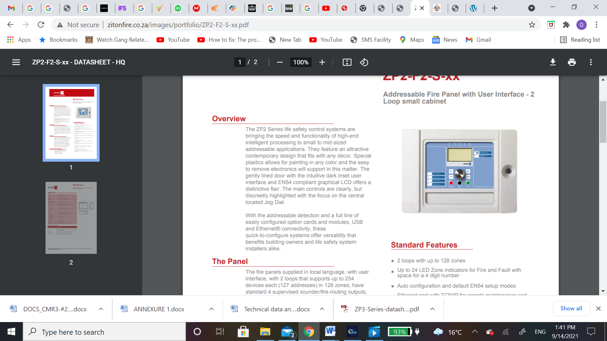
Figure 2:ZP2-F2-S-xx Addressable Fire Panel with User Interface - 2 Loop small cabinet

Description

Overview
The ZP2 Series life safety control systems are bringing the speed and functionality of high-end intelligent processing too small to mid-sized addressable applications. They feature an attractive contemporary design that fits with any decor. Special plastics allows for painting in any color and the easy to remove electronics will support in this matter. The gently lined door with the intuitive dark inset user interface and EN54 compliant graphical LCD offers a distinctive flair. The main controls are clearly, but discreetly highlighted with the focus on the centrally located Jog Dial. With the addressable detection and a full line of easily configured option cards and modules, USB, and Ethernet® connectivity, these quick-to-configure systems offer versatility that benefits building owners and life safety system installers alike.

The Panel
The fire panels supplied in local language, with user interface, with 2 loops that supports up to 254 devices each (127 addresses) in 128 zones, have standard 4 supervised sounder/fire-routing outputs, which can be used as freely programmable outputs as well. In addition, 2 conventional relay outputs and 2 supervised outputs, working in pair and dedicated to common fire and fault conditions, as well as 2 user configurable inputs for monitoring and control are available.

Options
The panels support one auxiliary relay board with 8 outputs - 2 standard fitted with relays and 6 open collector outputs with the option to add relays afterwards - and one network board to create a maximum of 32 nodes / 32 loops network of fire panels, fire panel repeaters and black-boxes (including conventional fire panels and fire panel repeaters up to a maximum of 64 conventional zones). Last but not least, in case separate zone indications are required, a 24-zone fire/fault LED indicator board can be mounted in the panel or repeater with space for a 4-digit number.

Approvals & Compliance
- CE / CPD / EN54-2 / EN54-4
- NEN2535 / NBNS21-100 compliant
- BS5839-1 compliant
- Veds and LPCB certified.
- WEEE / RoHS compliant

Standard Features
- 2 loops with up to 128 zones
- Up to 24 LED Zone indicators for Fire and Fault with space for a 4-digit number
- Auto configuration and default EN54 setup modes
- Ethernet port with TCP/IP for remote maintenance and programming
- EN54 compliant graphical LCD with icons and symbols for easy recognition of events
- Jog Dial with 4 soft buttons for simple and intuitive user control
- Aesthetic pleasing design with special paintable synthetic door
- Easily removable door and chassis for quick and clean installation
- All pluggable connectors
- 3 USB ports with memory stick support and RS232 for printer support
- Email notification for events directly from the panel (4 user accounts)
- 3 operator level menu structure with username and password
- History log memory for 9999 events
- Compatible with the Zitone loop powered sounders/beacons and base sounders and Zitone series detectors.

Specifications

Mains supply
Voltage | 230 / 110 VAC (+10% / -15%)
Frequency | 50 / 60 Hz (±5%)
Current | Nom. 0.6 / 1.3 A, Max. 1.5 / 3.15 A
Fuse rating | 2 / 4 A
Cable type | 3 x 1.5 mm² (live, neutral, earth)
Batteries | Max. 2 x 12V/18Ah (use supplied cables)
Outputs
Programmable supervised | 2, 750mA / 19.5-28VDC (24VDC nominal)
General Fire + Fault supervised | General Fire + Fault supervised
General Fire + Fault relay | 2
Aux | 1 resettable, 500mA / 19.5-28VDC (24VDC nominal)
Cable type | Recommended 2 core 1.5 mm² twisted pair
End of Line resistor | 15kohm
Inputs
Programmable | 2
Cable type | Recommended 2 core 1.5 mm² twisted pair
End of Line resistor | 15kohm
Maximum Load | 150 mA
Loops
Outputs | 2, 300mA@11VDC (peak 500mA@20V)
Cable length | max 75ohms / 700nF (max 3.5km with 2mm² and 127 detectors)
Cable type | Recommended 2 core 1.5 mm² twisted pair
Environmental conditions
Storage temperature | -10°C to +50 °C
Operating temperature | -8°C to +42 °C
Relative humidity | max. 95 % (non-condensing)
Mechanical
Size (W x D x H) | 410 x 162 x 298 mm
Weight | 5.2 kg (without batteries)
Color | RAL7035
Cable entries (Top / Bottom / Back) | 18 (20mm) / 2 (20mm) / 2 removable plates
IP rating | IP30: for indoor use only

Ordering Information

Part No. | Description
ZP2-F2-S-xx | Addressable Fire Panel with User Interface - 2 Loop small cabinet
-xx | Replace by the applicable language code (check with your local UTC Fire & Security equipment supplier)
ZP2-ZI-24-S | Addressable Fire Panel Component - LED indicator - 24 zone
2010-2-NB | Addressable Fire Panel Accessory - Network Printed Circuit Board
BS127N | Sealed Lead-Acid Battery - 12V 7.2Ah - VdS approved
2010-2-FTP-C30 | Addressable Fire Panel Accessory - Cable FTP CAT5 - 3m
2010-2-USB-C30 | Addressable Fire Panel Accessory - Cable USB A to B - 3m

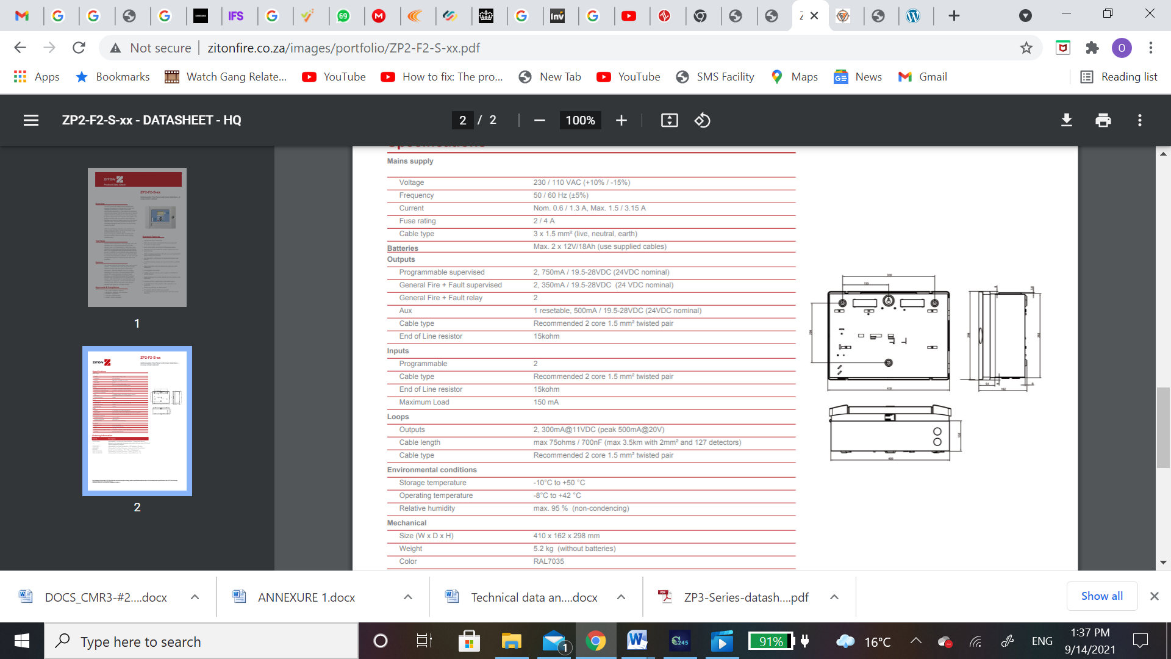
Figure 3: TYPICAL DIMMENSION EXAMPLE

1200/2000 Series Addressable Fire Panel with 2 to 4 loops, 16 zone LEDs
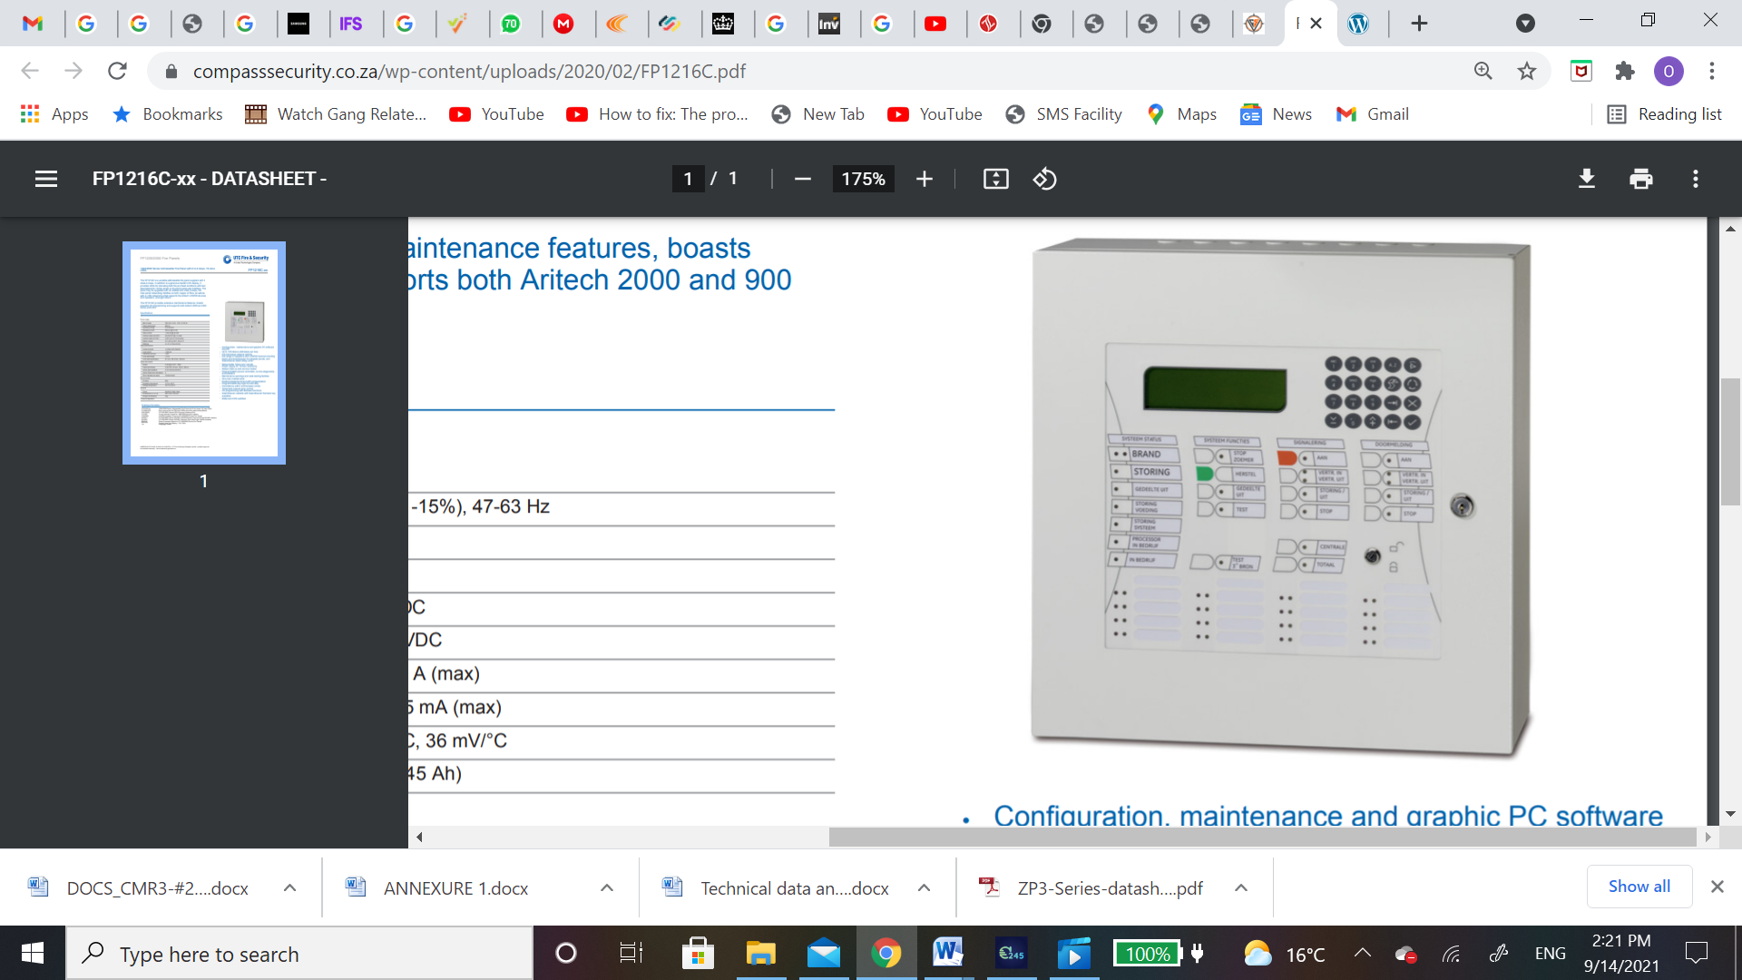
Figure 4:1200/2000 Series Addressable Fire Panel with 2 to 4 loops, 16 zone LEDs.

Description
The FP1216C is a versatile addressable fire panel supplied with 2 class-A loops. In addition to a generous backlit LCD display, it provides LEDs for indicating both fire and fault conditions with text descriptions for 16 fire zones on the front panel user interface. The panel may be upgraded with an additional 2 class-A loops, full inter-panel networking facilities on both copper or fiber, as w ell as with a LON network bus that supports the Artech LON700 devices and repeaters, amongst others. The FP1216C provides extensive maintenance features, boasts powerful I/O programming, and supports both Artech 2000 and 900 series protocols.

Standard Features
- Configuration, maintenance, and graphic PC software support
- Up to 128 device addresses per loop
- Full intercanal network options
- Full range of repeaters and LON700 devices including Dutch and Scandinavian fire brigade panels, and Scandinavian alarm delay units
- Networkable ''black box'' panels
- Power supply for 72-hour autonomy
- Default start-up and service modes
- Programmable service reminders, on-line diagnostics, and statistics
- Maintenance warnings and soak testing facilities
- One-man maintenance
- Floating background and drift compensation
- Programmable day/night functionality
- Coincidence within and between zones
- Timed and manual zone control
- I/O programming with Boolean functions
- Scandinavian variants with Scandinavian firemen’s key available
- EN54 and CPD certified.

Specifications

Power Supply
Mains supply | 230 VACS (+10%, -15%), 47-63 Hz
Power requirement | 200 VA
Operating voltage | 21 to 28 VDC
Operating current | 200 mA @ 24 VDC
Alarm current | < 240 mA @ 24 VDC
Auxiliary supply (24 VDC) | 9 to 28 VDC @ 1 A (max)
Auxiliary supply (5 VDC) | 5 VDC (±0.1V) 75 mA (max)
Battery charger | 27.3 VDC at 20°C, 36 mV/°C
Batteries | 2 x 12 V (7Ah to 45 Ah)
Loop specifications
Loops per panel | 4 (Class A)/8 (Class B)
Loop current | < 500 mA
Addresses per loop | <128
Loop cable length | < 2 km
Loop cable specification | Ø 1 mm, 300 nF/km, 100 ohms
Inputs and outputs
Relays | 4 (2A @ 24 VDC - 60W)
Supervised Relays | 4 (24 VDC, 30 ohm, 120 nF, 500 m)
Inputs (Opto Isolated) | 4 (15 VAC/0 to 28 VDC)
Inputs (Supervision selectable) | 4
Zone indicators per panel | 16 (fire & fault)

Environmental
IP rating | IP54
Operating temperature | -5°C to +40°C
Storage temperature | -20°C to +60°C
Physical
Colour | RAL9016 Traffic White
Dimensions (h x w x d) | 445 x 445 x 120 mm
Weight (no batteries) | 9 kg
Protocol dependent

Ordering Information

FP1216C-xx | 1200/2000 Series Addressable Fire Panel with 2 to 4 loops, 16 zone LEDs
FP-RIM1270 | Rim surround for the 780 and 1200N series fire panel boxes (Black)
ESPA2000 | FP1200/2000 Series ESPA Protocol Hardware Key
LC1502 | 2-loop extension board for 1200/2000 series fire panels
LON2000 | LON700 Interface Driver for FP1200/2000 Series Fire Panels
NC2011 | FP1200/2000 Series ARCNET RS485 Network Card with Single RS485 Interface
NC2051 | FP1200/2000 Series ARCNET Network Card with Single Optical Interface
RB2016 | Relay Expansion Board for FP1200/2000 Series Fire Panels
BS131N | Sealed Lead-Acid Battery - 12V 18Ah
-xx | Language Codes

Call Point

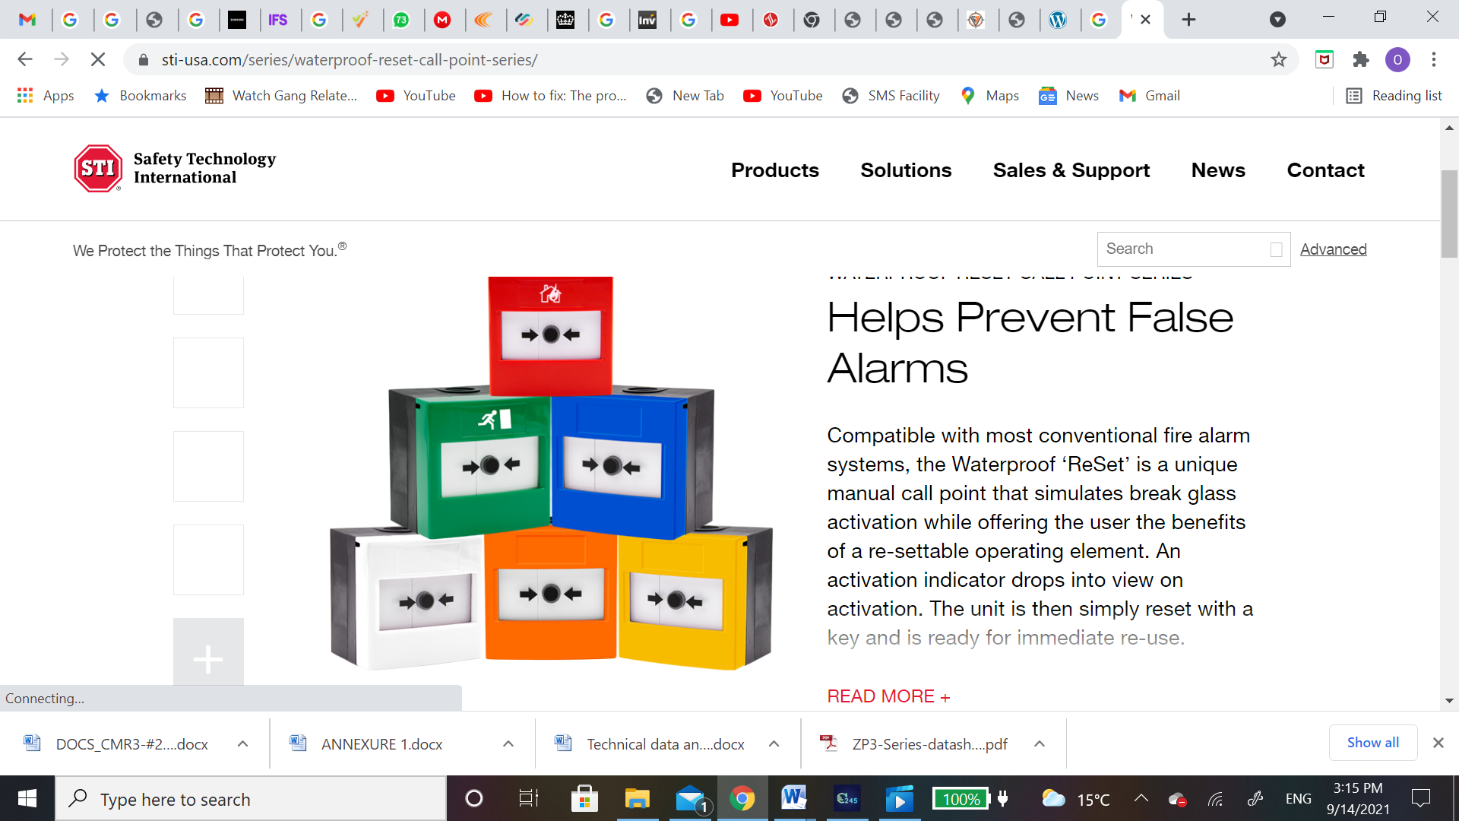
a) Mounting: Addition of back-box for surface or single gang socket box for flush fixing b) Wiring: 2 core loop c) Monitoring: Open/short circuit, removal & device type d) Indication: Alarm LED (red) e) Operating voltage: Loop 19.5 to 20.5 V 13 f) Current: Quiescent: 600µA Alarm: 700µA g) Operating principle: Micro switch h) IP Rating: IP24D i) Application: Type A - Indoor installation j) Environment: Indoor k) Addressing method: 7-way dipswitch l) Operating principle: Micro switch m) Temperature range: -10OC to +55OC n) Colour: Red o) Humidity range: 20% to 95% RH (non-condensing)
Figure 5: Call Point

Smoke Detector

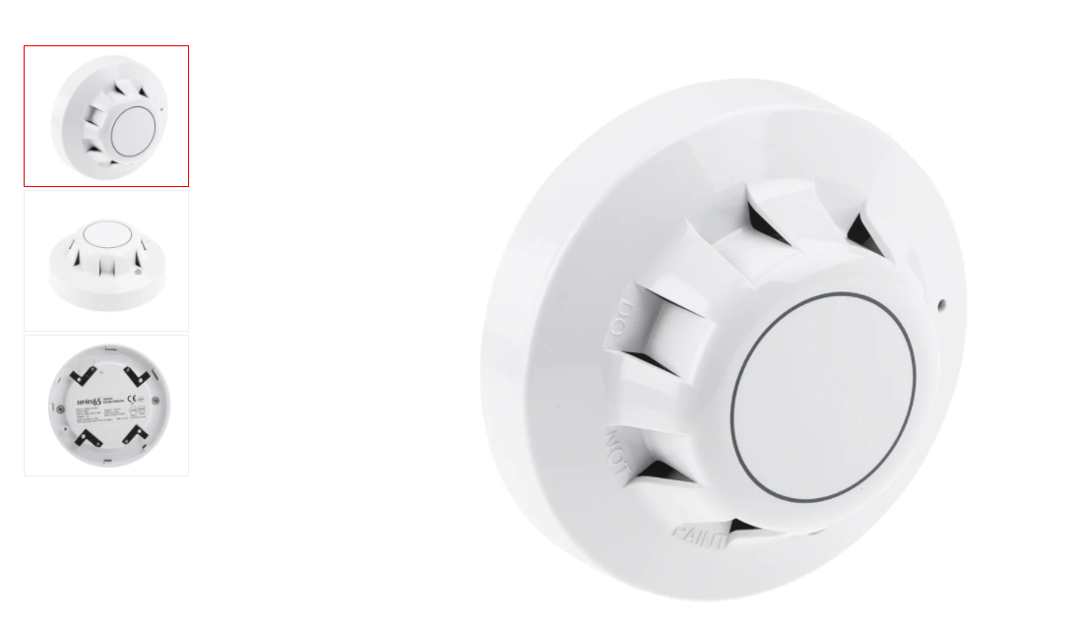

a) Mounting: Plugs into surface or semi recessed base b) Area coverage: Optical: 100m2 , subject to local codes c) Wiring: 2-core loop d) Monitoring: Open and short circuit fault. Sensor removal and device type. 12 e) Indication: Alarm LED (red) f) Operating voltage: 19.5 to 20.5V max. line loss 4V g) Current consumption: Quiescent: 600µA Alarm: 700µA h) Addressing method: 7-way DIP switches in head i) Detection principle: Smoke: Photo electric light scatter j) Environmental: IP32 k) Application: Indoor use l) Temp range: -10oC to +75oC m) Humidity range: 20% to 95% RH (non-condensing)

Figure 6: Smoke Detector

Heat Detector

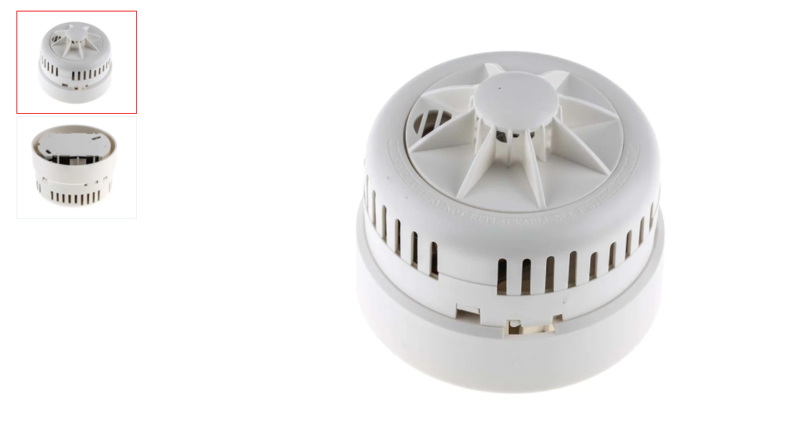
a) Mounting: Plugs into surface or semi recessed base b) Area coverage: Up to 21.3 m spacing c) Wiring: 2 wire zonal d) Monitoring: Open and short circuit by end of line resistor e) Indication: Alarm LED (red) f) Operating voltage: 15 - 30 volts DC g) Current (quiescent):

Figure 7: Smoke Detector

Sounder& Red LED

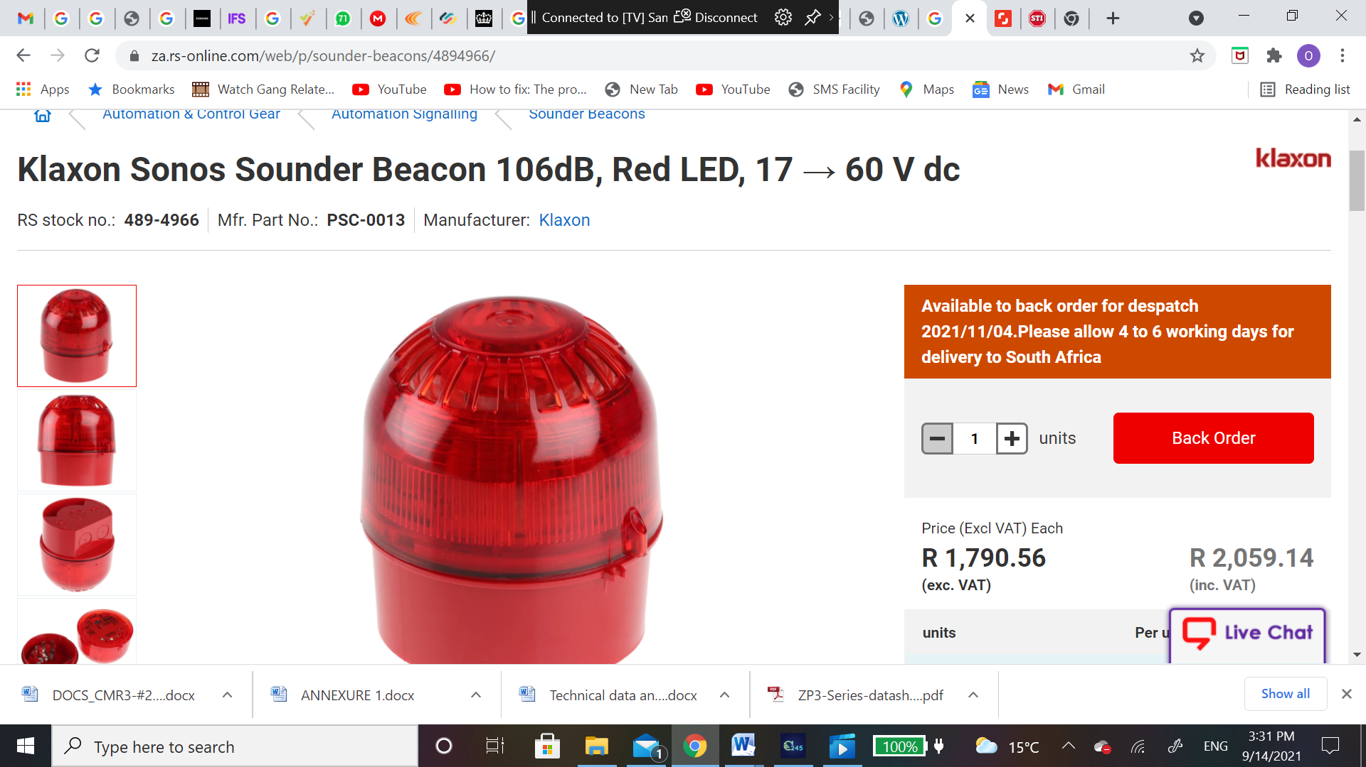

a) Sound Projection Level [dBA/1m]: 102 dBA b) Sound types: User configurable c) Visual indicator: Light source: Red LED array Light output: 1J Flash frequency: 0.8 Hz d) Mounting: Surface mount with plug in base e) Wiring: 2-core loop f) Monitoring: Open/short circuit, sound output, removal, device type g) Operating voltage: Loop powered: 19.5 - 20.5V Externally powered: 18 - 30VDC h) Loop current: Quiescent (when loop powered): 820μA Active (when loop powered): 9.6mA Quiescent (when externally powered): 470μA Active (when externally powered): 500μA i) Devices per loop (max): 20 (1km loop of 1.5mm² cable, 50 m to first device) j) Addressing method: 7-way dipswitch k) Environmental: Application: Indoor IP rating: IP21C l) Operating temperature: -10°C to 60°C m) Humidity range: 10% to 60% RH (non-condensing) n) Colour: Red

Figure 8: Smoke Detector

- TIME FRAMES / PROGRAMS
  - Contract period:

This is “AS AND WHEN REQUIRED MAINTENANCE/SERVICING AND REPAIRS OF FIRE DETECTION AND ASSOCIATED EQUIPMENT IN THE WESTERN CAPE
” contract for the period of three years.

- EVALUATION AND SCORING METHODOLOGY
The evaluation of the Bids by the evaluation committees will be conducted at various levels.
The following levels will be applied in the evaluation:
LEVEL | DESCRIPTION
Verify completeness | The Bid is checked for completeness and whether all required documentation, certificates; verify completeness warranties and other Bid requirements and formalities have been complied with. Incomplete Bids will be disqualified.
Verify compliance | The Bids are checked to verify that the essential RFP requirements have been met. Non-compliant Bids will be disqualified.
Detailed Evaluation of Technical | Detailed analysis of Bids to determine whether the Bidder is capable of delivering the Project in terms of business and technical requirements. The minimum threshold for technical evaluation is [70%], any bidder who fails to meet the minimum requirement will be disqualified and not proceed with the evaluation of Price and Specific Goals.
Specific Goals | Evaluate Specific Goals
Price Evaluation | Bidders will be evaluated on price offered.
Scoring | Scoring of Bids using the Evaluation Criteria.
Recommendation | Report formulation and recommendation of Preferred and Reserved Bidders
Best and Final Offer | PRASA may go into the Best and Final Offer process in the instance where no bid meets the requirements of the RFP and/or the Bids are to close in terms of points awarded.
Approval | Approval and notification of the final Bidder.

  - Evaluation Criteria
Interested bidders for this project shall be evaluated in terms of their business credentials, financial standing, empowerment, technical capacity and experience. The evaluation committee shall use the following Evaluation Criteria depicted in Table 1 below for the selection of the preferred bidder that shall render professional services and construction management work for the project.

EVALUATION CRITERIA | WEIGHTING
Stage 1 | Compliance
Stage 1A - Mandatory Requirements | Administrative Responsiveness
Stage 1B - Other Mandatory Requirements | Substantive Responsiveness
Stage 2 | Technical/Functionality
Technical/Functional Requirements | Threshold of 70%
Stage 3 | Price and Specific Goals
Price | 80
Specific Goals | 20
TOTAL | 100
Table 1: Evaluation criteria for the selection of a potential bidder

The details of the stages outlined in Table 1 above are presented in following sections below.

    - STAGE 1: COMPLIANCE REQUIREMENTS
Bidders must comply with the following requirements and failure to comply will lead to immediate disqualification.
      - Stage 1A- Mandatory Requirements
If you do not submit/meet the following mandatory documents/requirements, your bid will be automatically disqualified:
No. | Description of requirement
a) | Completion of ALL RFP documentation (includes ALL) | X
b) | Briefing Session Form D.  Bidders must also reflect on the Compulsory Briefing Session Attendance Register  (Delete if not applicable) | X
c) | Signed Joint Venture, Consortium Agreement or Partnering Agreement (whichever is applicable)
d) | Proof of CIDB grading 2SF or higher | X
Table 2: Mandatory Requirements
12.1.1,2 Stage 1B - Other Mandatory Requirements
If you do not submit/meet the following mandatory documents/requirements, PRASA may request the bidder to submit the information within five (5) working days. Should this information not be provided, your bid proposal will be disqualified.

No. | Description of requirement
a) | Letter of Good Standing: COID
b) | Valid SARS Pin
c) | CSD supplier registration number
d) | Professional Registration of key personnel:  Technician with 3 X SAQCC Fire Safety Registration  NB: Provide copies of original qualifications and certificates of professional bodies. The copies must be certified by commissioner of oath. The date on the stamp shall be three months or less old, before the closing date of the tender. If the qualification has been awarded in other language either than English please provide translation. | X
e) | Provide copies of original Identity. The copies must be certified by commissioner of oath. The date on the stamp shall be three months or less old, before the closing date of the tender. | X
Table 3: Other Mandatory Requirements

    - STAGE 2: TECHNICAL / FUNCTIONALITY REQUIREMENTS
Qualifying bidders shall then be evaluated on functionality after meeting all compliance requirements outlined above. The minimum threshold for the technical/functionality requirements is 70% as per the standard Evaluation Criteria presented in Table 1 above. Bidders who score below this minimum requirement shall not be considered for further evaluation in stage 3.
Details of the technical/functional requirements are presented in the Table 4 below.

ITEM | CRITERIA | WEIGHT
1 | Skills: | 50
2 | Previous Company / Organisational Experience: | 50
 | TOTAL | 100

Table 4: Technical Evaluation Criteria

Details of the scoring methodology presented above are outlined below:

12.1.2.1Functional Evaluation Criteria
Bidders are evaluated based on the functional criteria set out in this RFP. Only those Bidders which score [70] points or higher (out of a possible 100) during the functional evaluation will be evaluated during the second stage of the Bid.
Details of the scoring methodology presented above are outlined below:
Functionality evaluation matrix & Criteria:
Details of the detailed scoring methodology are presented in the table below

ID | FUNCTIONALITY QUALITY CRITERIA | SUB-CRITERIA SCORING  (Refer to Indicators for The Rating of Quality Criteria Table below) |  | POINTS
1 | Experience of Key Personnel based on submitted CVs.  You must Provide Proof of such Documents which relate to such Employees to support your claim:  - CV’s stating experience installation/ Maintenance/ Servicing and Testing of Fire Detection system.  NB: Should CVs not submitted or meet above requirements for skilled key personnel, such personnel shall not be considered when determining the number of years for scoring. | Excellent  18 Years collective experience or above  3x Technician with SAQCC Registration. | 5 | 50
1 |  | Very good  14-17 Years collective experience  3 x Technician with SAQCC Registration. | 4 | 50
1 |  | Good  11-13 Years collective experience  3 x Technician with SAQCC Registration. | 3 | 50
1 |  | Satisfactory  7-10 Years collective experience  3 x Technician with SAQCC Registration. | 2 | 50
1 |  | Poor  1-6 Years collective experience  3 x Technician with SAQCC Registration | 1 | 50
1 |  | Very Poor  No Experience  3 x Technician with SAQCC Registration | 0 | 50
2 | Previous Company / Organisational Experience:  Supply 5 Reference Letters from previously completed projects of fully maintained sites of Fire Detection System.  Reference letters must specify:  - Previous Client and Completed Works/Services Information  - Name of the Organisation  - Description of Works/Goods/Services that were provided  - Year  - Duration  - Evaluation of Service Providers Performance  - Were the work/service/product completed/delivered within the stipulated timeframes.  - Were the work/service/product meet the expected and specified quality.  NB: Reference letter has to be fully completed to be considered. | Excellent  Five projects or more successfully completed with five or more reference letters | 5 | 50
2 |  | Very good  Four projects successfully completed with four relevant reference letters | 4 | 50
2 |  | Good  Three projects successfully completed with three relevant reference letters | 3 | 50
2 |  | Satisfactory  Two projects successfully completed with two relevant reference letters | 2 | 50
2 |  | Poor  One project successfully completed with one relevant reference letter | 1 | 50
2 |  | Very poor  No project completed with no relevant reference letter | 0 | 50
Total |  |  |  | 100

NO | QUALITY CRITERIA | INDICATORS
NO | QUALITY CRITERIA | 0 – Very Poor  (% Weighting =0 ) | 1-Poor  (% Weighting =20) | 2 - Satisfactory  (% Weighting = 40) | 3- Good  (% Weighting = 60) | 4 - Very Good  (% Weighting = 80 ) | 5 – Excellent  (% Weighting = 100 )
1 | Experience of Key Personnel based on submitted CVs.  You must Provide Proof of such Documents which relate to such Employees to support your claim:  - CV’s stating experience installation/ Maintenance/ Servicing and Testing of Fire Detection system.  NB: Should CVs not submitted or meet above requirements for skilled key personnel, such personnel shall not be considered when determining the number of years for scoring. | Key staff have limited  Levels (experience of one year or less) of general experience.  Key staff have limited  Levels(Have not worked in similar project or only worked in similar project for  No Experience  (3 x Technician with SAQCC Registration)  of project specific  education, training and  no experience  Key staff has limited knowledge of issues pertinent to the project. | Key staff have extensive  Levels (experience of two year but less than three years) of general experience.  Key staff have extensive  levels of project specific education, training and  1-6Years collective experience  (3 x Technician with SAQCC Registration)  experience Key staff have knowledge  Of issues pertinent to the project. | Key staff have extensive  Levels (experience of three years and more but less than four years) of general experience.  Key staff have extensive  levels of project specific education, training and  7-10 Years collective experience  (3 x Technician with SAQCC Registration.)  Key staff have knowledge Of issues pertinent to the project. | *Key staff have extensive  Levels (experience of four years and more but less than five years) of general experience.  Key staff have extensive  levels of project specific education, training and  11-13 Years collective experience  (3 x Technician with SAQCC Registration.)  experience  Key staff have knowledge Of issues pertinent to the project. | Key staff have exceptional levels (experience of five years or more) of general experience.  Key staff have outstanding levels of project specific education, training and  14-17 Years collective experience  (3 x Technician with SAQCC Registration)  experience.  Key staff has outstanding knowledge of issues pertinent to the project. | Key staff have exceptional levels (experience of five years or more) of general experience.  Key staff have outstanding levels of project specific education, training and  18 Years collective experience or above  (3x Technician with SAQCC Registration)  experience.  Key staff has outstanding knowledge of issues pertinent to the project.
2 | Previous Company / Organisational Experience:  Supply 5 Reference Letters from previously completed projects of fully maintained sites of Fire Detection System.  Reference letters must specify:  - Previous Client and Completed Works/Services Information  - Name of the Organisation  - Description of Works/Goods/Services that were provided  - Year  - Duration  - Evaluation of Service Providers Performance  - Were the work/service/product completed/delivered within the stipulated timeframes.  - Were the work/service/product meet the expected and specified quality.  NB: Reference letter has to be fully completed to be considered. | Note: 0% of points allocated for this criteria  No project completed with no relevant reference letter | Note: 20% of points allocated for this criteria.  One project successfully completed with one relevant reference letter  Note: The reference letter must be signed, stamped and comply with the two listed criteria.  If the reference letter reflects a negative report attributable to the Supplier, that reference letter will not be considered.  If the reference letter does not feature all criteria, then the tenderer will be given the lowest score.  The referenced work has to specifically be previous completed projects of installation and commissioning of “Fire Detection” system. | Note: 40% of points allocated for this criteria.  Two projects successfully completed with two relevant reference letters  Note: The reference letter must be signed, stamped and comply with the two listed criteria.  If the reference letter reflects a negative report attributable to the Supplier, that reference letter will not be considered.  If the reference letters does not feature all criteria, then the tenderer will be given the lower score.  The referenced work has to specifically be previous completed projects of installation and commissioning of “Fire Detection” system. | Note: 60% of points allocated for this criteria.  Three projects successfully completed with three relevant reference letters  Note: The reference letter must be signed, stamped and comply with the two listed criteria.  If the reference letter reflects a negative report attributable to the Supplier, that reference letter will not be considered.  If the reference letters does not feature all criteria, then the tenderer will be given the lower score.  The referenced work has to specifically be previous completed projects of installation and commissioning of “Fire Detection” system. | Note: 80% of points allocated for this criteria.  Four projects successfully completed with four relevant reference letters  Note: The reference letter must be signed, stamped and comply with the two listed criteria.  If the reference letter reflects a negative report attributable to the Supplier, that reference letter will not be considered.  If the reference letters does not feature all criteria, then the tenderer will be given the lower score.  The referenced work has to specifically be previous completed projects of installation and commissioning of “Fire Detection” system. | Note: 100% of points allocated for this criteria.  Five projects or more successfully completed with five or more reference letters  Note: The reference letter must be signed, stamped and comply with the two listed criteria.  If the reference letter reflects a negative report attributable to the Supplier, that reference letter will not be considered.  If the reference letters does not feature all criteria, then the tenderer will be given the lower score.  The referenced work has to specifically be previous completed projects of installation and commissioning of “Fire Detection” system.

Note: Bidders that fail to achieve the minimum overall qualifying score of 80% on functional/ technical requirements will not be considered for further Price and Specific Goals (Stage 3) evaluation.

    - STAGE 3: PRICING AND Specific Goals

Bidders should provide their price proposal in envelope 2, which should include Form C (Financial Offer) and also provide proof of Specific Goals.

The following formula, shall be used by the Bid Evaluation Committee to allocate scores to the interested bidders :

The maximum points for this tender are allocated as follows:
 | POINTS
PRICE | 80
SPECIFIC GOALS | 20
TOTAL POINTS FOR PRICE AND SPECIFIC GOALS

13.FORMULAE FOR PROCUREMENT OF GOODS AND SERVICES

13.1 POINTS AWARDED FOR PRICE

THIS IS A 80/20 PREFERENCE POINT SYSTEMS

A maximum of 80 points is allocated for price on the following basis:

80/20

PS = 80 $\left(1-\frac{Pt-Pmin}{Pmin}\right)$
Where
Ps = Points scored for price of tender under consideration
Pt = Price of tender under consideration
Pmin = Price of lowest acceptable tender

14. POINTS AWARDED FOR SPECIFIC GOALS
In terms of Regulation 4(2); 5(2); 6(2) and 7(2) of the Preferential Procurement Regulations, preference points must be awarded for specific goals stated in the tender. For the purposes of this tender the tenderer will be allocated points based on the goals stated in table 1 below as may be supported by proof/ documentation stated in the conditions of this tender:
In cases where organs of state intend to use Regulation 3(2) of the Regulations, which states that, if it is unclear whether the 80/20 or 90/10 preference point system applies, an organ of state must, in the tender documents, stipulate in the case of—
- an invitation for tender for income-generating contracts, that either the 80/20 or 90/10 preference point system will apply and that the highest acceptable tender will be used to determine the applicable preference point system: or

- any other invitation for tender, that either the 80/20 or 90/10 preference point system will apply and that the lowest acceptable tender will be used to determine the applicable preference point system,
then the organ of state must indicate the points allocated for specific goals for both the 90/10 and 80/20 preference point system.

Table 1: Specific goals for the tender and points claimed are indicated per the table below.
(Note to organs of state: Where either the 90/10 or 80/20 preference point system is applicable, corresponding points must also be indicated as such.
Note to tenderers: The tenderer must indicate how they claim points for each preference point system.)
The specific goals allocated points in terms of this tender | Number of points  allocated  (80/20 system)  (To be completed by the organ of state) | Number of points claimed (80/20 system)  (To be completed by the tenderer)
B-BBEE at least LEVEL 2 | 4
BLACK WOMAN OWNED | 4
BLACK YOUTH OWNED | 4
PEOPLE WITH DISABILITIES | 4
PEOPLE IN RURAL AREAS | 4
TOTAL | 20

METRORAIL WESTERN CAPE

CONTACTABLE REFERENCE FOR TENDERER

AS AND WHEN REQUIRED MAINTENANCE/SERVICING AND REPAIRS OF FIRE DETECTION AND ASSOCIATED EQUIPMENT IN THE WESTERN CAPE

Name of the tenderer: _______________________________________

To: PRASA – Metrorail – Western Cape
I, the undersigned duly authorized representative, hereby furnish this reference on behalf of the organisation named herein:

- Previous client and completed works/services information

- Name of the organisation:______________________________

- Description of works/goods/services that were provided : ______________________________

______________________________________________________________________________

- Year : ________________________________

- Evaluation of service provider’s performance

- Were the works/service/ product completed/delivered within stipulated timeframes Yes No
If no kindly comment __________________________________________________________________
_________________________________________________________________________________

- Were the works/services/product meet the expected and specified quality Yes No
If no kindly comment____________________________________________________________________________Signature: _______________________
Telephone: _______________________
Date: ____________________
Business stamp with date

- RECOMMENDATION

It is recommended that PRASA approve the as-and-when-required maintenance, servicing, and repairs of fire detection and associated equipment in the Western Cape railway stations, to legal compliance, regular maintenance and servicing of fire detection and associated equipment are essential in protecting the lives of employees and passengers who use the railway stations. In the event of a fire, early detection and alarm can help prevent injuries and save lives. Additionally, fire detection equipment can help to prevent damage to property and assets. Therefore, I recommend that PRASA approve the as-and-when-required maintenance, servicing, and repairs of fire detection and associated equipment in the Western Cape railway stations.

Project Description: | (Insert project name)
Compiled by
END USER
Name & Surname:

Signature: ………..………………………..

Date:
lApproved/Not Approved
(Head of the End-User Department)
Name & Surname:

Signature: ………………………………….

Date: ………………………………………...
Comments/Remarks:

