ARC Infruitec-Nietvoorbij
Private Bag X5026, Stellenbosch, 7599, South Africa
Tel: (021) 809 3172
Fax: (021) 809 3400/3592
OFFICE OF SUPPLY CHAIN MANAGEMENT
DESCRIPTION OF SERVICE/PRODUCT:

Supply and Delivery - Automatic Water Controller for fynbos projects

Automatic Water Controller |  | NO | If No, Please Indicate Deviation
1. Specific Description | Compliance to Specification (Yes) | NO | If No, Please Indicate Deviation

Automatic Water Controller -

Gardena Easy Control OR Similar

Description
Automatic water controller with electronic data display and programming tailored to individual requirements. Switches on and off automatically.

- Easy programming; programming steps flash up step by step
- Removable programme unit
- With low battery indicator

Specifications
Energy supply |  | 1 x 9 V alkaline battery
Sensor connection |  | Yes
Operating pressure Min |  | 0.5 bar
Operating pressure Max |  | 12 bar
Thread |  | For taps with 26.5 mm  (G 3/4) and 33.3 mm  (G1) thread
Irrigation settings
Watering cycles per day | 3
Watering duration | 2 min – 60 minutes
Watering frequency | Every 24 hrs or every 2nd, 3rd, 7th day  Once, twice or three times in each case
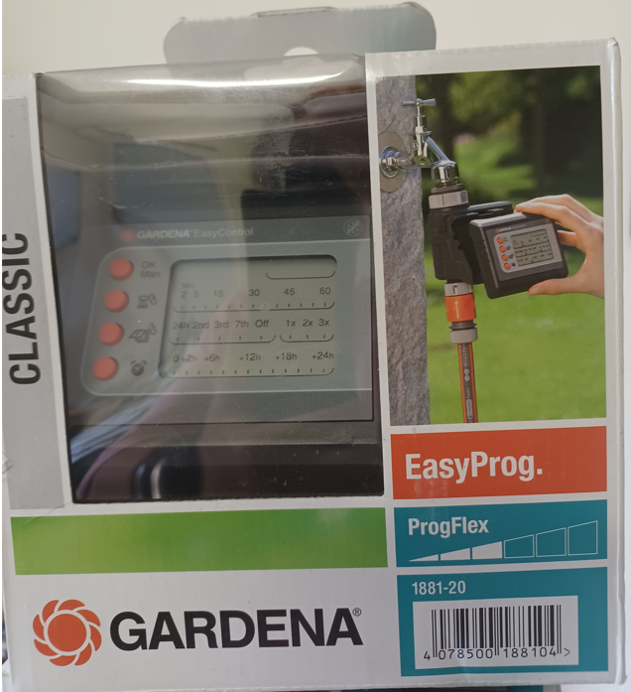 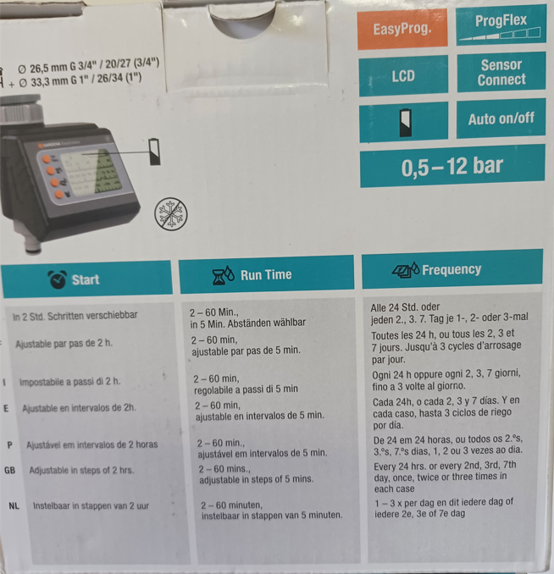
PICTURE IS FOR DEMONSTRATION PURPOSES ANY EQUIVALENT / SIMILAR PRODUCT IS ACCEPTIBLE

2. General
Delivery at Infruitec on Helshoogte road, Stellenbosch

PRICING SCHEDULE FOR DELIVERY AND INSTALLATION OF Automatic Water Controller

Item description | Quantity | Unit price | Total Price
Automatic Water Controller -  Gardena - Easy Control OR Similar | 4
SUBTOTAL
VAT
GRANDTOTAL

Company name:……………………………………………………………………………………………….

Contact person:………………………………………………………………………………………………..

Contact number:……………………………………………………………………………………………….

Date and signature:…………………………………………………………………………………………

Contact Person – Louisa Blomerus Email address: blomerusl@arc.agric.za
NB: Bidders must complete the table below as per the commitment of the RFQ.
AGREE WITH THE ABOVE SPECIFICATION: We the undersigned submit this RFQ in accordance with the conditions contained in the referenced above RFQ document and attach the documents required:
Bidders representative:…………………………………………………………………….
Capacity:………………………………………………………………………………………
Date and signature:…………………………………………………………………………

DISAGREE WITH THE ABOVE SPECIFICATION:
PAGE NUMBER | CLAUSE NUMBER | DEVIATION
Bidders representative and capacity …………………………………………………………………………..
Date and signature …………………………………………………………………………………………………………………………

- EVALUATION PROCESS & CRITERIA STAGE ONE FOR SUPPLY AND INSTALLATION FOR IMAGE ANALYZER CAMERA SYSTEM AND SOFTWARE
ADMINISTRATIVE COMPLIANCE EVALUATION OF ALL PROPOSALS
 | Comply with specification. Please indicate Yes or No
 | Yes | No | If no, indicate deviation
EVALUATION PROCESS: NB: It must be noted that ARC reserve the rights to request for clarification if all the below questions are not answered properly.
STAGE ONE: ADMINISTRATION COMPLIANCE
All suppliers are duly lodged will be examined to determine compliance with quoting requirements and conditions. Quotes with obvious deviations from the requirements/conditions, will be eliminated or disqualified from further adjudication.
          - Mandatory
Quotes will only be compliant if supplier has submitted the following documents:
Administrative documents
- According to National Treasury SCM Instruction number 4 of 2016/2017, only suppliers who are registered on Central Supplier Database (CSD) may be appointed. Suppliers is therefore encourage to register their entities on CSD, www.csd.gov.za and such information will be verified through Central Supplier Database (CSD);
- All SBD documents must be submitted and completed;
          - Non-Mandatory
- Valid B-BBEE certificate or sworn affidavit certify by commissioner of oaths.

