Annexure A
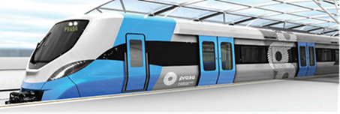

PROJECT SPECIFICATION AND BILL OF QUANTITY
FOR:

REQUEST FOR QUOTATION FOR REPLACEMENT OF SCRAPPED EQUIPMENT
Contents

1. The technical specification for various tools………………………………………………………….1-8
2. Benchmark……………………………………………………………………………………………………..…….9
3. Bill of quantities...………………………………………………………………………………………..….….…10
4. Specification Compliance Statement……………….…………………………………………………….11.

1. The technical specification for various tools
The contractor is required to Supply and Deliver of Tools for Infrastructure Department. The tools must adhere to the Occupational Health and Safety Act 85 of 1993 and Driven Machinery Regulations, 2015 requirements.

Table 1.1: Technical specification for Chainsaw.
Technical data
Battery life AR 3000 L | up to 281 min
Chain gauge | 3/8" P
Cordless System | Lithium-ion PRO
Weight with Battery | 3,6 kg
Model Number | MSA 220 C-B or Equivalent

Table 1.2: Technical specification for Brush Cutter.
Comes with the following.
- Auto cut 56-2 Cutting Attachment
- Harness
- Deflector for mowing heads
Technical data
Capacity cm3 | 57,1
Performance kW | 2.8
Weight kg | 10,2
Tank volume l | 0.99
Anti-vibration system | 4 Point AV-System
Model Number | FS 560 C or Equivalent

Table 1.3: Technical specification for Fibreglass Extension Ladder.
- Heavy duty fiberglass extension ladder.
- Non-conductive for electrical applications.
- D-shaped aluminum rungs.
- Rope & pulley
- Spiked feet
- Safe working load of 135kg
- Rubber non-slip feet for added safety and stability
- Size 11.1m
- 12mm all-weather polypropylene rope.
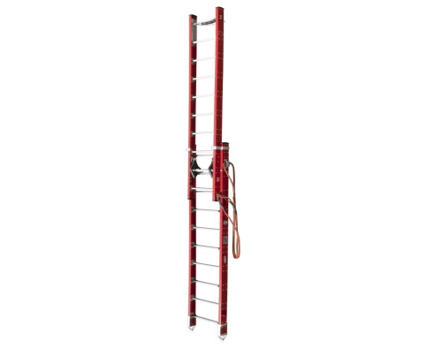
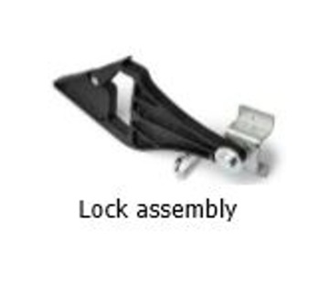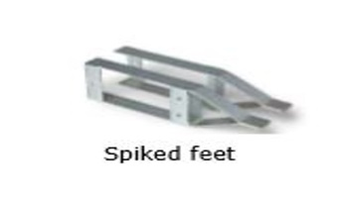

Table 1.4: Technical specification for Welding Machine

Technical data
Rated Power | 400A at 24 VDC, 100% duty cycle CC/DC
Voltage | 15 V when the power source is not in use
Auxiliary Voltage | 230 VAC, 12 KVA peak and 10 KVA continuous output
Fuel Type | Diesel
Model Number | W052400 or Equivalent

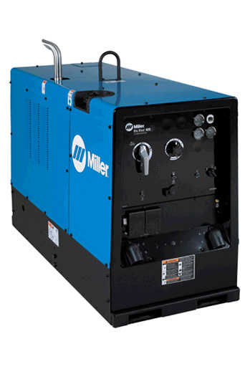

3. Bill of quantities

ITEM | DESCRIPTION AS PER ON TECHNICAL SPECIFICATION ATTACHED | UNIT | QUANTITY | RATE |  | AMOUNT
1 | Chainsaw | Each | 1
2 | Brush Cutter | Each | 3
3 | Fibreglass Extension Ladder | Each | 5
4 | Welding Machine | Each | 2
Sub - Total (excl VAT)
Vat @ 15%
Total Cost (Incl VAT)

4. Specification Compliance Statement (Mandatory Returnable Document)

Respondents are required to indicate if the offered products/services comply with all the specifications set by PRASA by indicating “Comply” next to each of the specification items mentioned below and attach a data sheet for each item as a proof of compliance. Any deviations from PRASA’s requirement must be indicated under the comments column provided. The bidder is required to supply a manufactures warranty upon delivery of each item in accordance with PRASA contract document.

Note: Failure to duly complete and submit this form and fully (100%) comply with all of the requirements below will results in the respondent’s disqualification.

ITEM | DESCRIPTION AS PER ON TECHNICAL SPECIFICATION | COMPLIANCE RESPONSE | COMMENTS
Chainsaw | Battery life AR 3000 L: up to 281 min  Chain gauge: 3/8" P  Cordless System: Lithium-ion PRO  Weight with Battery: 3,6 kg  Model Number: MSA 220 C-B or Equivalent
Brush Cutter | Capacity cm3: 57,1  Performance kW: 2.8  Weight kg: 10,2  Tank volume l: 0.99  Anti-vibration system: 4 Point AV-System  Model Number: FS 560 C or Equivalent
Fibreglass Extension Ladder | - Heavy duty fiberglass extension ladder.  - Non-conductive for electrical applications.  - D-shaped aluminum rungs.  - Rope & pulley  - Spiked feet  - Safe working load of 135kg  - Rubber non-slip feet for added safety and stability  - Size 11.1m  - 12mm all-weather polypropylene rope.
Welding Machine | 400A at 24 VDC, 100% duty cycle CC/DC.  15 V when the power source is not in use.  230 VAC, 12 KVA peak and 10 KVA continuous output. Diesel  W052400 or Equivalent.

Note: The full specification for Replacement of Scrapped Equipment is on this document above from page 1-2 and must be used when completing the above table.

