QUESTIONS AND ANSWERS IN RED BELOW FOR THE SUPPLY AND DELIVERY OF THREE (3) TRUCK AND THREE (3) LIGHT VEHICLE SIMULATORS TO TRANSNET ACADEMY - FACULTY OF RAIL FOR A PERIOD OF 14 MONTHS INCLUDING A THREE (3) YEARS SUPPORT AND MAINTENANCE:

No | Questions | Answers
1 | Can we use a single use container, otherwise it must be new and is prohibitively expensive because it is shipped here empty? | No. We need a new container.
2 | Do you need any specific engineering certificates for the container foundations? | Yes, it must be approved by qualified person
3 | Do you want size and roof insulation in the container? | Yes
4 | Do you want an aircon? | Split in aircons for both light vehicle and truck vehicle.
5 | Are we working on one 12m container per site? This depends on best layout of equipment including trainer workbench etc. Please advise is it one container one simulator? | One container for both simulators partitioned into two (2) with Trainer work station.
6 | The container will need to get a floor as the standard wood is not good. Please confirm | Yes it must have a floor
7 | Will you require an electrical Certificate of Compliance for each container, yes or no? | Yes
8 | For the foundation please advise on the the options would be to hire a local team or send a team from here? | Up to the supplier
9 | Please could you elaborate on instructor station because the simulator will have virtual instructor. Please could you give an example how should the instructor station be and also should it be separate section in the container? | The instructor station should be part of the simulator where the Trainer/Instructor will be able to operate the simulator (Start and shut off the simulator) Picture one an example of the instructor station.
10 | Please could you elaborate on the touch screen. If our simulation has a touch pad on the side that gives the user control on the screens to select applications similar to a mouse pad on the laptop will that be acceptable? It will give the same functionality as a touch screen. | Mouse pad on the laptop/desktop will be accepted.
11 | Do you want 3 screens for the Truck simulator as well, and how many inches should it be? Is this what you mean by having 180 and 360 views? | You can put the screen on the container itself depending on your design. Picture 2 an example of the design.
12 | 4. "Full simulation of virtually any type of heavy vehicle from dump trucks to highway tractor trailer and semitrailer application". On this point do you mean our simulator can have any type of heavy vehicle and that will be fine? Even if it's having one application of a heavy truck simulator? The dump truck has an extra lever for controlling the back carriage and that is a separate simulator as its similar to yellow machine simulators e.g. cranes and etc. | Priority is the Heavy truck application.

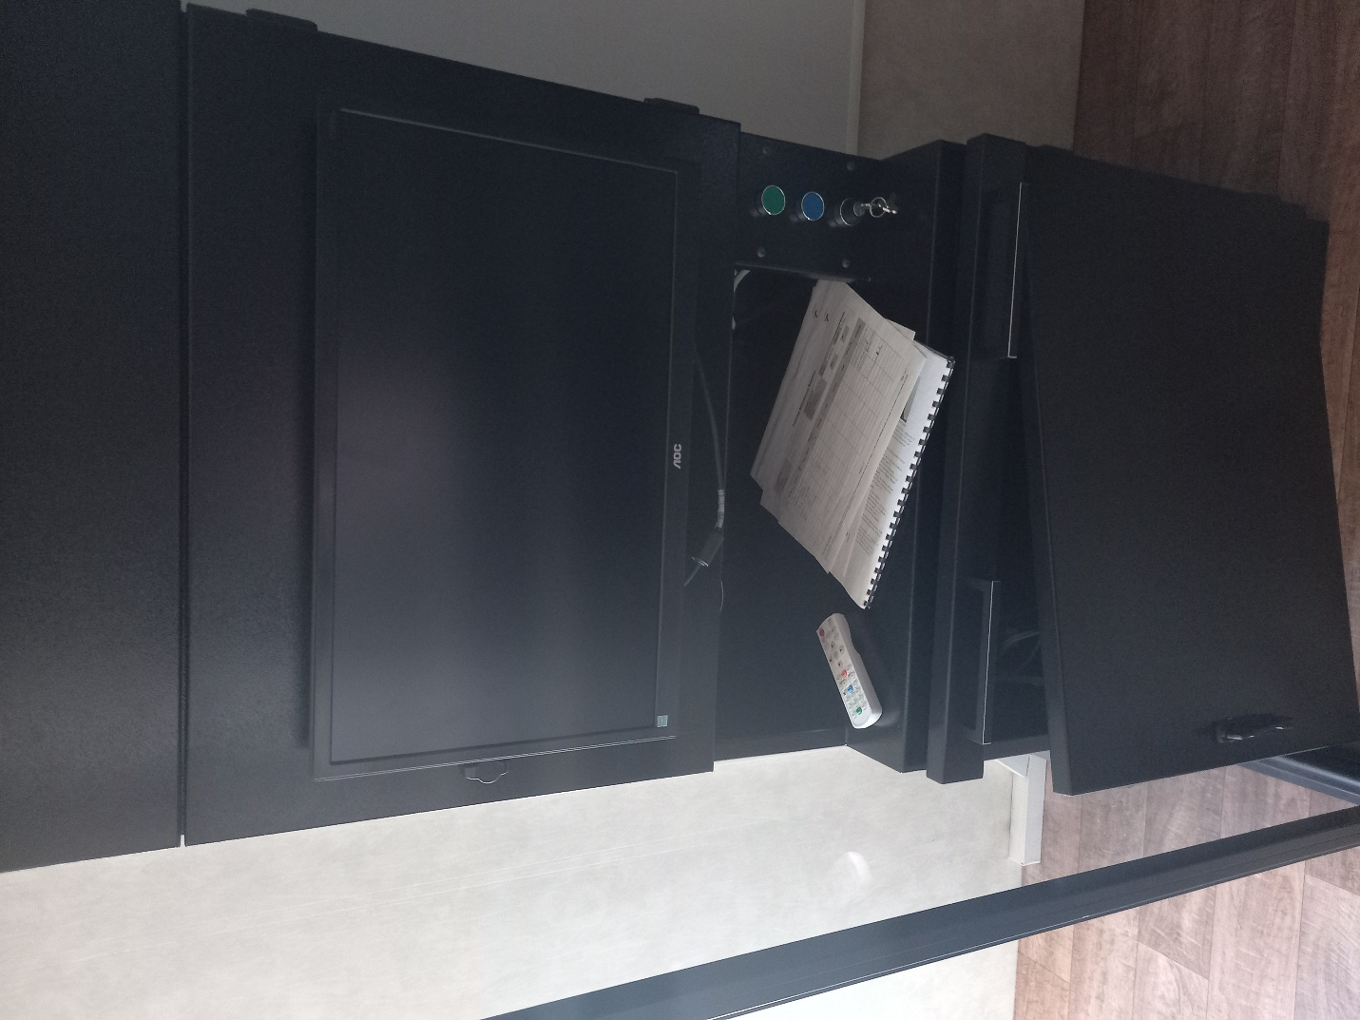

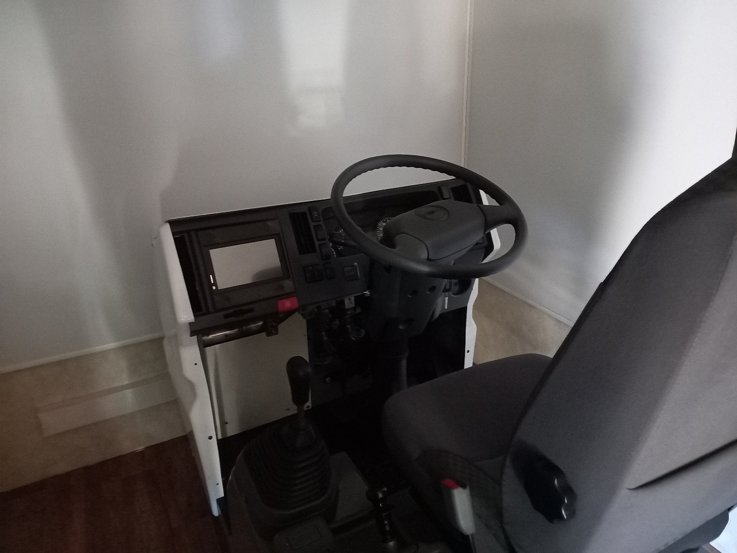

May kindly advise on below questions. Find response in red below:
Chapter | Page | Requirement | Question
SECTION 3: BACKGROUND, OVERVIEW AND SCOPE OF REQUIREMENTS  Light Vehicle simulator | 14 | - Image generation : Single 72’ or 88’ screen  - Triple screen mounting system attached to the simulator frame.  - Front monitor with 88’ and sides monitor with 72’ with built in speakers. | There seems to be an inconsistency in the required screen dimensions.  - Please confirm that a solution based on three 27 inches LCD screen compliant? Which is in line with “Triple screen mounting system attached to the simulator frame.” 27 inches is suitable for the container
SECTION 3: BACKGROUND, OVERVIEW AND SCOPE OF REQUIREMENTS  Truck simulator | 14 | - Mobile Version (Fix version) | Can you elaborate on this point, what does it refer to and mean in this context?

