CONTRACT DATA

A contract between
SENTECH, Sender Technology Park, Radiokop, Octave Road, Honeydew,
and
____________________________________________________________________________________
____________________________________________________________________________________
for the
Appointment of a suitable service provider to service and maintain Fire Detection, Fire Alarm, and Suppression System at Sentech Head Office and Nasrec to Sentech SOC LTD for a period of 3 years.

Bid Number: RFX6000000893

Contents

Part C1: Agreements and contract data
Form of Offer and Acceptance
Contract Data provided by the Sentech
Contract Data provided by the Supplier

Part C2: Pricing Data

Part C3: Scope of Work

Conditions of Contract (available separately)

PART C1: AGREEMENTS AND CONTRACT DATA –

Form of Offer and Acceptance
Offer
Sentech, identified in the acceptance signature block, has solicited offers to enter into a contract for the appointment of a suitable service provider to service and maintain Fire Detection, Fire Alarm, and Suppression System at Sentech Head Office and Nasrec.

The Bidder, identified in the offer signature block, has examined the documents listed in the Tender Data and addenda thereto as listed in the Bid schedules, and by submitting this offer has accepted the conditions of the Bid.
By the representative of the Bidder, deemed to be duly authorized, signing this part of this form of offer and acceptance, the Bidder offers to perform all of the obligations and liabilities of the Bidder under the Contract including compliance with all its terms and conditions according to their true intent and meaning for an amount to be determined in accordance with the conditions of contract identified in the Contract Data.
THE OFFERED TOTAL OF THE PRICES INCLUSIVE OF APPLICABLE TAXES; (in the Bids applicable currency).
_______________________________________________________________________ (amount in words);
________________________________________________________________________(amount in figures)
NB: The Prices quoted above is the total Bid offer inclusive of all applicable taxes for the Contract duration. The price must be carried over from the price breakdown / schedule of rates provided in the Bid document.
This offer may be accepted by Sentech by signing the acceptance part of this form of offer and acceptance and returning one copy of this document to the Bidder before the end of the period of validity stated in the Tender Data, whereupon the Bidder becomes the party named as the Bidder in the conditions of contract identified in the Contract Data.
Bidder’s Signature(s) ___________________________
Signed by the Bidder at ____________ on this the __________ day of _____________ 20__________
Name(s) _________________________________ ___________________________________________
Capacity ___________________________________ __________________________________________
Address (Domicillium)

Acceptance
By signing this part of this form of offer and acceptance, Sentech accepts the Bidder’s offer. In consideration thereof, Sentech shall pay the Bidder the amount due in accordance with the conditions of contract identified in the Contract Data. Acceptance of the Bidder’s offer by the signature by Sentech shall form an agreement between Sentech and the Bidder upon the terms and conditions contained in this agreement and in the contract that is the subject of this agreement.
The terms of the contract, are contained in:
Part C1 Agreements and contract data, (which includes this agreement)
Part C2 Pricing data
Part C3 Scope of work.
and drawings and documents or parts thereof, which may be incorporated by reference into Parts C1 to C3 above.
Deviations from and amendments to the documents listed in the Tender Data and any addenda thereto as listed in the Bid schedules as well as any changes to the terms of the offer agreed by the Bidder and the employer during this process of offer and acceptance, are contained in the schedule of deviations attached to and forming part of this agreement. No amendments to or deviations from the said documents are valid unless contained in this schedule of deviations.
Failure to fulfil any of these obligations in accordance with those terms shall constitute a repudiation of this agreement.

Sentech’s Signature(s) ________________________________
Signed by Sentech at ____________ on this the __________ day of _____________ 20__________
Name(s) _________________________________
Designation_______________________ ___________________________________________

SENTECH SOC LIMITED,
Sender Technology Park
Octave Road
Radiokop
Honeydew
Johannesburg
Date ___________________
Upon acceptance by Sentech of the Bidder's offer, a contract will come into existence.

SCHEDULE OF DEVIATIONS
Notes:
- The extent of deviations from the Bid documents issued by the Sentech before the Bid closing date is limited to those permitted in terms of the conditions of Bid.
- A Bidder’s covering letter shall not be included in the final contract document. Should any matter in such letter, which constitutes a deviation as aforesaid, become the subject of agreements reached during the process of offer and acceptance, the outcome of such agreement shall be recorded here.
- Any other matter arises from the process of offer and acceptance either as a confirmation, clarification or change to the Bid documents and which it is agreed by the Parties becomes an obligation of the contract shall also be recorded here.
- Any change or addition to the Bid documents arising from the above agreements and recorded here shall also be incorporated into the Contract.

1. Subject
Details________________________________________________________________________

2. Subject
Details_________________________________________________________________________

3. Subject
Details__________________________________________________________________________

- Subject
Details__________________________________________________________________________
By the duly authorised representatives signing this schedule of deviations, Sentech and the Bidder agree to and accept the foregoing schedule of deviations as the only deviations from and amendments to the documents listed in the Tender Data and addenda thereto as listed in the Bid schedules, as well as any confirmation, clarification or changes to the terms of the offer agreed by the Bidder and Sentech during this process of offer and acceptance.
It is expressly agreed that no other matter whether in writing, oral communication or implied during the period between the issue of the Bid documents and the receipt by the Bidder of a completed signed copy of this Agreement shall have any meaning or effect in the contract between the parties arising from this agreement.

Contract Data
Part one - Data provided by Sentech given in all contracts
- The Purchaser is
SENTECH SOC LIMITED,
Sender Technology Park
Octave Road
Radiokop
Honeydew
Johannesburg

- General
The National Treasury General Conditions of Contract for goods and services (NT GCC, 2010) or General Conditions of Contract for Works (2015) as issued by National Treasury and the Construction Industry Development Board of the Republic of South Africa apply, respectively.
The goods are specified in the Scope of Work. The Special Conditions of Contract (SCC) are stipulated in the Tender Data.

- Goods information:
The Goods Information is in the document called “Scope of Work” and in the documents and drawings referred to by it.

- Terms of Delivery
The Terms of Delivery are contained in the General Conditions of Contract (GCC) and Special Conditions of Contract.

- Language
The language of this contract is English.

- Governing Laws and Jurisdiction
The Contract shall be governed by and interpreted according to the laws of the Republic of South Africa.
In the event of a conflict between or inconsistency in the laws applicable in the various provinces of the Republic of South Africa, the law as applied and interpreted in the Gauteng Province shall prevail.
The parties irrevocably submit to the exclusive jurisdiction of the South Gauteng High Court, Johannesburg in respect of any action or proceeding arising from this Bid.

This Bid and all contracts emanating there from will be subject to the General Conditions of Contract issued in accordance with Treasury Regulation 16A published in terms of the Public Finance Management Act, 1999 (Act 1 of 1999). The Special Conditions of Contract are supplementary to that of the General Conditions of Contract. Where, however, the SCC are in conflict with the GCC, the SCC shall prevail.

- Sub-contracting post award
A Bidder awarded a Bid may only enter into a subcontracting arrangement with the approval of Sentech. The successful bidder may not subcontract more than 25% of the value of the contract to any other enterprise that does not have an equal or higher B-BBEE status level of contributor than the Bidder concerned, unless the contract is subcontracted to an EME that has the capability and ability to execute the subcontract.

- Transformation Plan

A transformation plan is a record of activities an entity intends to undertake to improve its BBBEE Level through Ownership, Management and Control; Skills Development; Enterprise and Supplier Development and Socio-Economic Development.

Sentech reserves the right to request a BBBEE transformation plan with clearly defined timelines and milestones if the recommended bidder does not meet Sentech’s transformation goals. These milestones must be achieved over the term of the contract. This transformation plan shall be submitted within 10 working days from the written request, failing which Sentech reserves the right to withdraw its appointment of the preferred recommended Bidder.

- Warranty
The warranty period is 12 months after Delivery.

- Payment
The method and conditions of payment are contained in the Tender Data, GCC and SCC.
The interest on late payment is 0 % per complete week of delay.

- Currency

South African registered businesses that purchase equipment overseas and quote in foreign currency will be required to provide Sentech a 6-month forward cover contract on appointment. The 6 months forward cover will be re-negotiated and renewed every 6 months should the contract term on this tender be longer than 6 months.

- General - Prices

Unless approval has been obtained from Sentech, no adjustment in contract prices will be made.
Applications for price adjustment must be accompanied by documentary evidence in support of any adjustment.

- Price Negotiations

Sentech reserves the right to negotiate market related prices. If market-related prices are not agreed to, Sentech reserves the right to cancel the Bid.

- Liabilities indemnities and insurance
Insurance is required from the Bidder in respect of delivery and transportation where applicable.

- Disputes
Should any dispute, disagreement or claim arise between the parties ("the dispute") concerning this Agreement, the parties shall try to resolve the dispute by negotiation. This entails one party inviting the other party to meet and attempt to resolve the dispute within fourteen (14) days from the date of the written invitation.
If the dispute has not been resolved by such negotiation as referred to in this clause above, the Parties shall submit the dispute to the Arbitration Foundation of Southern Africa ("AFSA") for administered mediation, upon the terms set out by the AFSA secretariat.
Failing such resolution, the dispute shall be resolved by arbitration in accordance with the rules and procedures of AFSA by an arbitrator appointed by AFSA. Where the arbitration route is followed, the dispute must be adjudicated within Johannesburg in the English language and finally resolved in accordance with the rules of AFSA, by an arbitrator or arbitrators appointed by that Foundation.
The provisions of this clause shall not preclude any party from obtaining relief from a Court of competent jurisdiction. To this extent, the Parties hereby consent to the jurisdiction of the South Gauteng High Court, Johannesburg, South Africa. The provisions of this clause shall continue to be binding on the Parties, notwithstanding any termination or cancellation of this Agreement.

- Termination
Sentech shall have the right, at its sole and exclusive discretion, upon written notice to the Bidder, to terminate this Agreement, in whole or in part should the Bidder fail to perform any of its obligations or deliver any deliverable timeously or should Sentech not be satisfied with the quality of any service/s in terms of this Agreement, to the satisfaction of Sentech.
Sentech shall furthermore have the right, as a result of such termination, to appoint a third party to perform the obligations of the Bidder in terms of the Agreement and the Bidder indemnifies Sentech against all costs incurred by Sentech in appointing such third party to fulfil the obligations of the Bidder.
Sentech shall have the right, at its sole and exclusive discretion, to terminate this Agreement, at any time, upon 30 (thirty) days’ written notice to the Bidder.

- Contract Term

This contract will run for a period of ___________months.

- Supplier Due Diligence

Sentech reserves the right to conduct supplier due diligence at any time pre, during and post the contract period. This may include announced or unannounced site visits.

Sentech's Representative is
Name: Mr Zunaid Adams
Address: SENTECH SOC LIMITED,
Sender Technology Park
Octave Road
Radiokop
Honeydew
Johannesburg

Tel No. 0114714400
Email: adamsz@sentech.co.za
Sentech's Representative is the Executive: Legal and Regulatory.

14. Delay damages
As stipulated in the Special Conditions of Contract.
Contract Data
Part two - Data provided by the Bidder
Statements given in all contracts
The Bidder is:
Name
Address
a company / close corporation / partnership duly incorporated in accordance with the laws of the Republic of South Africa.

PART C2: PRICING DATA
Price List
Insert detailed cost breakdown structure

Scope of work for Appointment of a suitable service provider to service and maintain Fire Detection, Fire Alarm, and Suppression System at Sentech Head Office and Nasrec.

SCOPE OF WORK

The scope of work covers all the work which the Service provider is supposed to execute. The pricing will be measured in terms of the work executed as per the below items. Inspections will be done looking at the below items and the service provider has to make sure tha a service logbook is recorder timeously during the contract period. Any damage whatsoever that will be done as a result of the service provider will be to the service provider’s account.

Nasrec:
- Network equipment room- servicing and testing of gas suppression system (cylinders, smoke detectors, fire panels, power supplies, actuators, sounders, bells, checking log book.)
- Satellite termination room- servicing and testing of gas suppression system (cylinders, smoke detectors, fire panels, power supplies, actuators sounders, bells, checking log book.)
- HPA room- servicing and testing of gas suppression system (cylinders, smoke detectors, fire panels, power supplies, actuators sounders, bells, checking log book.)
- Telkom room- servicing and testing of gas suppression system (cylinders, smoke detectors, fire panels, power supplies, actuators sounders, bells, checking log book.)
- UPS room- servicing and testing of gas suppression system (cylinders, smoke detectors, fire panels, power supplies, actuators sounders, bells, checking log book.)
- Fibre room- servicing and testing of gas suppression system (cylinders, smoke detectors, fire panels, power supplies, actuators sounders, bells, checking log book.)
- Satellite equipment room- servicing and testing of gas suppression system (cylinders, smoke detectors, fire panels, power supplies, actuators sounders, bells, checking log book.)
- Gas Suppression Enclosure- Integrity test in accordance with SANS14520

Honeydew:

- Telkom room- - servicing and testing of gas suppression system (cylinders, smoke detectors, fire panels, power supplies, actuators, sounders, bells, checking log book.)
- Server room- - servicing and testing of gas suppression system (cylinders, smoke detectors, fire panels, power supplies, actuators, sounders, bells, checking log book.)
- Engineering Services- Servicing of Fire Detection Control Panel, Smoke Detectors, Heat Detectors, Sounders, Power Supplies, Checking Log Book
- Canteen - Servicing of Fire Detection Control Panel, Smoke Detectors, Heat Detectors, Sounders, Power Supplies, Checking Log Book
- Ku Band - - servicing and testing of gas suppression system, Fire Detection Control Panel (cylinders, smoke detectors Heat Detectors, fire panels, power supplies, actuators, sounders, bells, checking logbook.)
- C Band - Servicing of Fire Detection Control Panel, Smoke Detectors, Heat Detectors, Sounders, Power Supplies, Checking Log Book
- Gas Suppression Enclosure- Integrity test in accordance with SANS14520

Description | Unit | QNT |  | Quarter 1 |  | Quarter 2 |  | Quarter 3 |  | Quarter 4 | Total Q1 – Q4 | Year 1 (Q1+Q2+Q3+Q4) | Year 2 (Q1+Q2+Q3+Q4) (CPI escalated | Year 3 (Q1+Q2+Q3+Q4) CPI escalated
Servicing of smoke detectors, Heat detectors, power supplies, actuators, sounders, bells (STP) and (Nasrec)  330001764 | Each | 356
Service Fire-Detection Control Panel, Mimic Panel  fire panels, power supplies, actuators, sounders, bells)  (Nasrec and STP)  330001770 | Each | 9
servicing and testing of gas suppression system Cylinders (cylinders, power supplies, actuators, sounders, bells, checking log book.)  (Nasrec and STP)  330001762 | each | 36
Integrity Test- Gas Suppression System Enclosure test in accordance with SANS14520 (STP/Nasrec)  330001763 | each | 12
TOTAL YEA1 + YEAR 2 + YEAR
FINAL SUMMARY

Total brought forward

STP HONEYDEW
KU-BAND
NASREC
SUB-TOTAL (Year 1 + Year 2 + Year 3)
VAT@15%
TOTAL

Servicing Fire Detection Control Panel  Conduct an inspection and service Fire Detection Control Panel for proper operation. | 330001761
Service-Test Gas Supresion System(Telkom  Conduct an inspection and servicing and testing of gas suppression system cylinders | 330001762
Integrity Test Gas Suppression Enclosure  Inspect the Gas Suppression Enclosure- and do an Integrity test in accordance with SANS14520 | 330001763
Servicing Of Smoke Detectors  Inspect and service the detection system for proper operation, record in the logbook | 330001764
Servicing Heat Detectors  Inspect and service the HEAT detection system for proper operation, record in the logbook | 330001765
Servicing Sounders  Inspect and service the Sounder system for proper operation, record in the logbook | 330001766
Servicing Power Supplies  Inspect and service the Powder supplies system for proper operation, record in the logbook | 330001767
Servicing Actuators  Inspect and service the Actuators system for proper operation, record in the logbook | 330001768
Service-Test Gas Suppression System(Sat)  Satellite equipment room-Nasrec. servicing and testing of gas suppression system (cylinders, smoke detectors, fire panels, power supplies, actuators, sounders, bells, checking log book.) | 330001769
Service Fire-Detection Control Panel (STP)  Server room-Honeydew servicing and testing of gas suppression system (cylinders, smoke detectors, fire panels, power supplies, actuators, sounders, bells, checking log book.) | 330001770

ANNEXURE A
PICTURE | AREA
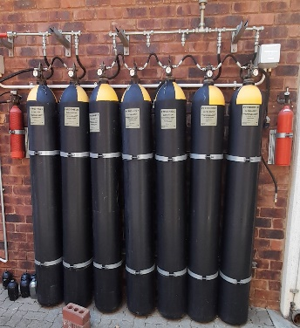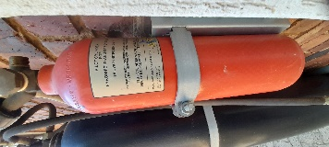  7 in number | Main Building
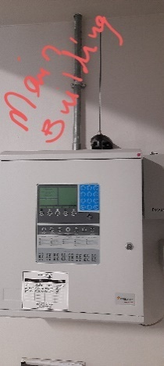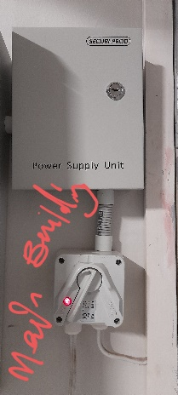 | Main Building
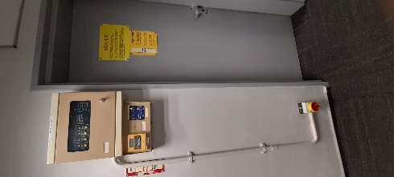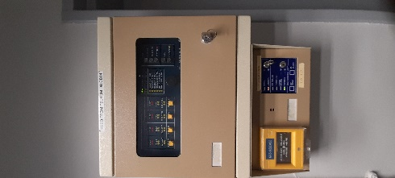 | Main Building
  376 in number | Sample smoke detector STP and Nasrec
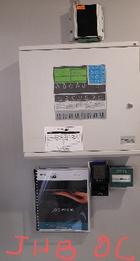 | JHB OC
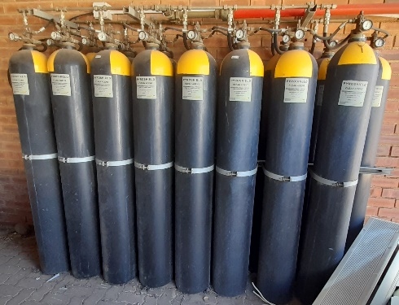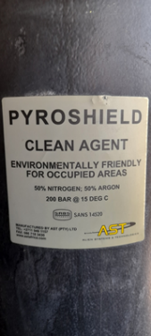  17 in number | KU Band
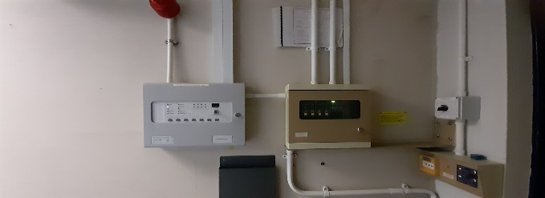  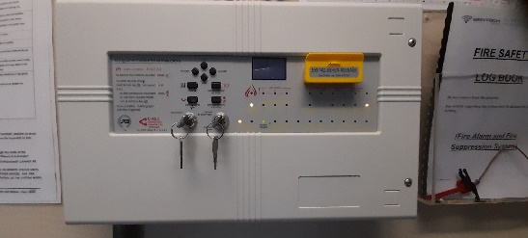  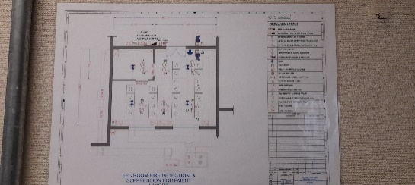  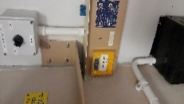 | KU Band Encoder Room
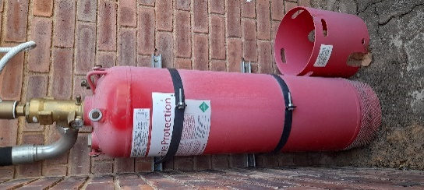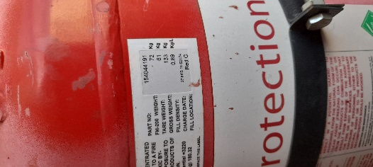  1 in Number | KU Band
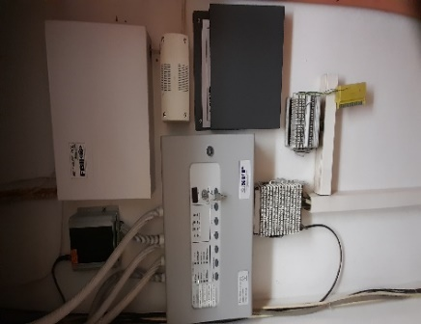 | Canteen
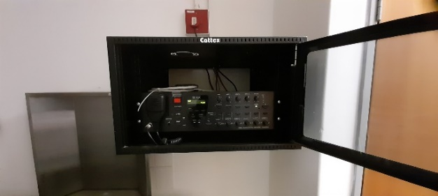 | Canteen
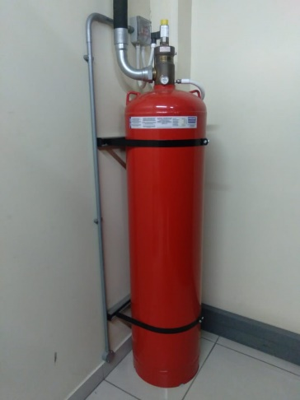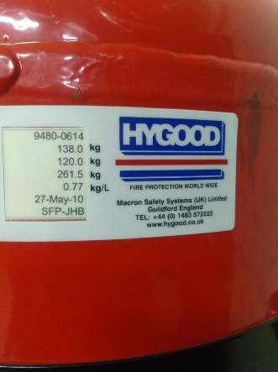  1 in number | Nasrec  Nasrec  Nasrec
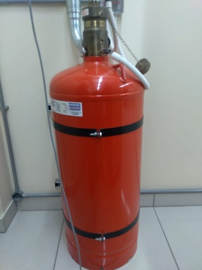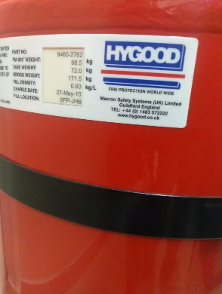  2 in number | Nasrec  Nasrec  Nasrec
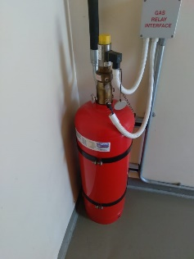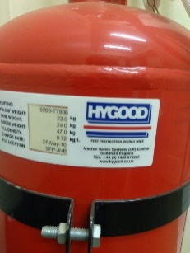  3 in number | Nasrec  Nasrec  Nasrec

PART C3: SCOPE OF WORK

SENTECH’S GOODS INFORMATION

- TECHNICAL REQUIREMENTS

CODES OF PRACTICE FOR INSPECTION AND MAINTENANCE

The inspection and maintenance are to be conducted in accordance with the following standards:

- SANS 10139 - Fire detection installations in buildings
- National Building Regulations
- Occupational Health and Safety Act

SCOPE OF WORK:

Inspect logbook for any recorded faults and rectify, the client should check his system weekly the operator must display a thorough knowledge of the system and take relevant actions. (SANS3691, 10.3).

Inspect building to ensure building changes have not affected sitting of the detectors, manual call points or sounders, room dimensions have not been altered.

Acceptance of functionality / User training (SANS - 11.4.2.b5) The user shall take ownership of the system and ensure all users are trained in its operation

INSPECTING AND SERVICING

- Inspect panel for any alarm condition and rectify.
- Each zone is to be tested for fire and fault conditions.
- All break glass manual alarm units shall be checked for satisfactory operation.
- Audible alarms at the control panel and in fire zones shall be tested.
- All equipment (other than air conditioning equipment and gas extinguishers equipment)
- Activated or deactivated by the detection and alarm system shall be checked for operation.
- Signals only from the detection and alarm system to any gas extinguishing system or air conditioning equipment such as fire dampers fans and fan coil units shall be checked, and the response of the equipment noted.
- Inspect the building to ensure building changes have not affected the setting of the detectors, manual call points or sounders.
- Every detector to be checked for correct operation.
- Check all cables and terminations are secure and undamaged.

CENTRAL CONTROL PANEL AND POWER SUPPLY EQUIPMENT

- All visual and audible alarms associated with the zones are being tested to be checked for correct position.
- All control signals to remote stations and equipment within the complex shall be tested for satisfactory operation.
- Power supply units shall be checked for satisfactory operation.
- Wipes clean the top of the battery cell
- Check the battery chargers and delivering a charge to the batteries.
Maintenance work not covered by the agreement:
Rates Valid:
From 08h00 to 16h30 weekdays | R Per Hour
After hours, weekends, and public holidays | R Per Hour
Traveling time labour | R Per Hour
Rate per KM Travelled | R Per KM

STATUTORY REQUIREMENTS
All of the above-mentioned work shall comply with the following statutory requirements:

- SANS 10019 Transportable containers for compressed dissolved and liquefied gases – basic design, manufacture, use, and maintenance.
- SANS, ISO 14520-1 2006, Gaseous Fire extinguishing systems; Pressure Equipment Regulations.
- SANS 347 - Standard specification for categorisation and conformity assessment criteria for all pressure equipment
- SANS 10139 –Fire Detection and Alarm Systems for Buildings
- OHS ACT and Regulations 85 of 1993 under the section of Vessels under Pressure Regulations

Daily work progress

The contractor will be required to give feedback on the progress of the work carried out for each day. Any problems encountered must be brought to the attention of the Project Manager/Manager: Occupational Health and Safety.

Management strategy and start-up.

The Contractor’s plan for the service:

- The Contractor must supply a detailed plan of when the intended dates for performing the service throughout the service period.
- This is for the yearly and quarterly services of the respective equipment.
- The plan should include the period of time that will be spent on-site by Technicians for a yearly service and for that of a quarterly service.

Notes:
Meetings of a specialist nature may be convened by persons and at times and locations to suit the Parties, the nature, and the progress of the service. Records of these meetings shall be circulated by the person convening the meeting within five days of the meeting. All meetings shall be recorded using minutes or a register prepared and circulated by the person who convened the meeting. Such minutes or registers shall not be used to confirm actions or instructions under the contract as these shall be done separately by the person identified in the conditions of the contract to carry out such actions or instructions.

COMPANY BRANDING

The Contractor shall provide all overalls (when needed) for his staff with clearly identifying motifs depicting the company name. Each service technician shall be required to always wear their SAQCC ID.

ENVIRONMENTAL CONSTRAINTS AND MANAGEMENT

All environmental Legislations, are to be adhered to:

- The Contractor will be required to ensure that all works are carried out as per the ISO 14001 standard. The following environmental requirements are always complied with:

- Zero liquid effluent discharge.
- No chemicals will be dumped into the Sentech drains or on the premises.
- No oil or waste will be dumped in an unauthorised area or unlicensed waste site.
- Asbestos will be handled and stored according to Asbestos Regulations.
- No materials or waste will be burnt on site.
- Hazardous substances shall be handled and stored according to the hazardous substances Act
- No effluent shall be discharged into the public streams.

Quality control requirements

The Contractor must possess an accredited Quality Management System. A pre-approved Quality Control Plan (QCP) is to be used for the tasks at hand

TESTING, COMMISSIONING, AND ACCEPTANCE.

Testing:

- The Contractor must provide test certificates and reports of any test that was conducted as per ISO 14520.
- Gas cylinders’ code of manufacture, manufacturer, and certificate of manufacture.
- Pressure relief valves test certificate
- Test all detection and actuation components
- Test to verify that all alarms are conveyed to the respective panel or operator (where applicable) at the Fire Panel Computer (where applicable)
- Gas cylinders’ code of manufacture, manufacturer, and certificate of manufacture.
- Pressure relief valves test certificate
- Test all detection and actuation components

Commissioning

- Commissioning should be done by a competent person. The person must have knowledge and understanding of gas suppression system design and fire detection systems. The system will be accepted when there are ZERO defects
- The contractor must supply testing and commissioning procedures (TO THE APPOINTED SERVICE PROVIDER)

EXAMPLE
 |  |  |  |  |  |  |  | C. FIRE DETECTION & FIRE SUPPRESSION SYSTEM
Item  No | Description |  |  |  | Capacity |  | Quantity  Year 1 |  | Quantity  Year 2 | Quantity  Year 3 | Unit  Measure | Price / Year 1 | Price /  Year 2 | Price /  Year 3
1. | TECHNOSWITCH FIRE PANEL
2. | Aritech FEC403 3Zone Fire panel
3. | Ziton ZP3 4 Loop Panel
4. | Ziton ZP3 LITE 1Loop Fire Panel
5. | Ziton ZP3 4 Zone Fire Control Panel
6. | Optical detectors
7. | Optical smoke detectors
8. | Manual call point
9. | Interface
10. | Ionization Detectors
11. | Heat detector
12. | Gas Cylinders (Carbon Dioxide)
13. | Smoke detectors
14. | Sonos sounder beacon(LED) reds lens, shallow base(17-60Vdc)
15. | Modular suppression system. Each with 231cylinder c/w 17.97kg gas
16. | Fire detection siren test, service, and maintenance

GENERAL REQUIREMENTS

  - Glossary of Terms
Abbreviations | Descriptions

- Introduction
Sentech is a state-owned company and is the largest broadcasting signal distributor in South Africa. Sentech is a licensed Electronic Communications Network Service provider in South Africa. It currently operates many telecommunication networks for Satellite, Television, Radio, the Internet, and more. As such, Sentech is a global enabler of broadcasting and digital content delivery.

Senetch also owns a number of immovable assets such as buildings, which must comply with the requirements of the National Building Regulations (NBR), and Occupational Health and Safety Act (OHSA). The buildings are fitted with fire protection systems which is an obligation by the OHSA and NBR and they must be serviced regularly by a competent service provider. The service provider will be appointed to service and do maintenance of the fire protection systems at STP and Nasrec for a period of three (3) years. Each service will be accompanied by a service record indicating the status of the equipment if they require replacement or they are still in an acceptable working condition.

- Requirements
The Contractor to note and comply with the following:

- Direction and Instructions

The Contractor shall operate under the direction and instructions of Sentech or such appointed person/s who may give instruction without transgression of the contract, any legislation and regulations including the Occupational Health and Safety Act, and other Safety Regulations.

- Workmanship

The Contractor shall maintain a high standard of workmanship as expected by the Sentech and shall comply with any quality assurance and quality procedures implemented by the Sentech.

RECORDS OF CONTRACTOR’S EQUIPMENT

All equipment, tools, transport, and consumables for performing the services are to be supplied by the Contractor. All the Contractor’s power tools and equipment must be on a planned maintenance schedule and must be inspected before being dispatched to Sentech.

The Contractor shall maintain a calibration and inspection schedule for all measuring equipment used and shall make the Schedule and results available to the Sentech upon request.

Access to the site with equipment and tools will only be granted upon the submission of a printed tool/equipment list to the security department. Any items not on the list and brought onto the site, may not be removed from the site thereafter.
Contractor to provide general tools to execute maintenance tasks.

  - Information to Bidders
- the bidders are required to meet the mandatory and functional criteria set by Sentech to be considered for this RFQ
- Sentech is a state-owned company and a National Key Point, where only South African Citizens will be considered to work in their space.
- Bidders will undergo vetting and security screening.
- Bidders will be required to provide fingerprints for the employees who will be doing the work to Head Security for further security checks
- Bidders will be required to compile a safety file following Sentech health and safety requirements.
- All employees from the successful bidder to produce Identity documents, name cards and be on the company’s regalia.
- Every employee will be subjected to security checks when accessing Sentech premisses and failure to comply with these requirements will mean no entry.

