ARC INFRUITEC - NIETVOORBIJ

Private Bag/Private X5026, Stellenbosch, 7599, South Africa
Tel: (021) 809 3093. Fax: (021) 809 3400/3592

Office of the Supply Chain Management

1.1 Description of Service: Supply and INSTALL REPLACEMENT WATER FILTERS FOR REVERSE OSMOSIS SYSTEM, ARC Infruitec-Nietvoorbij.

Background:
We use a reverse osmosis (RO) water purification system in the embryo rescue (tissue culture) laboratory at Nietvoorbij. We use tap water that goes through a series of filters to put out purified water fit for preparation of culture medium (laboratory use). Over time the filters are clogged by impurities in tap water and the whole system needs to be serviced (to check the quality of the water it delivers) and the filters replaced if necessary. Ideally, the system should be serviced and filters replaced annually.
The filters should be installed and fit a RO103TDS reverse osmosis water purification system (photo further down)

SPECIFICATIONS FOR FILTERS:
SPECIFICATION | Comply with specification. Please indicate (Yes or No)
 | Yes | No | If no, indicate deviation
Service (test water quality output) and replace filters for a RO103TDS reverse osmosis water purification system
10” 5M Carbon block filter (x 1)
10” UDF GAC Filter both ends blue (x 1)
Blue mixed bed resin 250G (x 1)
In-line white 10” Carbon filter (x 1)
PP 10” 5M Pleated sediment filter (x 1)
PP10” 5M Spun sediment filter (x 1)
GENERAL CONDITIONS FOR THE PURCHASE ORDER AGREEMENT
Replace/install filters for a RO103TDS reverse osmosis water purification system at the embryo rescue laboratory of the Crop Development division, Nietvoorbij Campus, ARC Infruitec-Nietvoorbij. Check the water quality delivered.

1.2 PRICING SCHEDULE

Item description | QTY | Unit price | Total Price
- Other: Labour and call-out fees if applicable
SUBTOTAL
VAT
GRANDTOTAL

Delivery Address: ARC Infruitec-Nietvoorbij, Nietvoorbij Campus R44, Stellenbosch
Supplier’s Details: ……………………………………………………………………..
Company Name: ……………………………………………………………………….
Contact person: …………………………………………………………………………
Contact number: ……………………………………………………………………….
Date & Signature: ………………………………………………………………………
Contact: Ms P Burger burgerp@arc.agric.za, 021-809 3021

Under sink RO system as installed
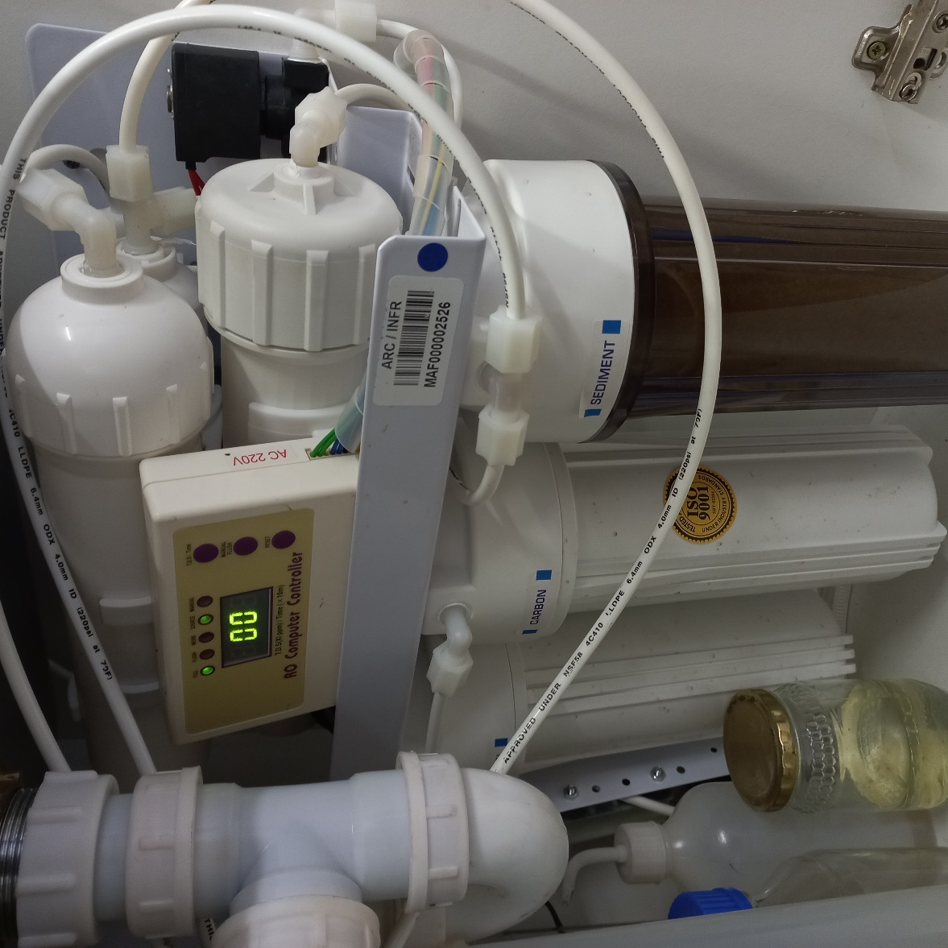

NB: Bidders must complete the TABLE below as per the commitment of the RFQ.
AGREE WITH THE ABOVE SPECIFICATION: We the undersigned submit this RFQ in accordance with the conditions contained in the referenced above RFQ document and attach the documents required:
Bidders representative:…………………………………………………………………….
Capacity:………………………………………………………………………………………
Date and Signature:…………………………………………………………………………

DISAGREE WITH THE ABOVE SPECIFICATION:
PAGE NUMBER | CLAUSE NUMBER | DEVIATION
Bidders representative and Capacity …………………………………………………………………………..
Date and signature …………………………………………………………………………………………………………………………

  - EVALUATION PROCESS & CRITERIA STAGE ONE FOR
ADMINISTRATIVE COMPLIANCE EVALUATION OF ALL PROPOSALS
 | Comply with specification. Please indicate (Yes or No)
 | Yes | No | If no, indicate deviation
EVALUATION PROCESS: NB: It must be noted that ARC reserve the rights to request for clarification if all the below questions are not answered properly.
STAGE ONE: ADMINISTRATION COMPLIANCE
All suppliers are duly lodged will be examined to determine compliance with quoting requirements and conditions. Quotes with obvious deviations from the requirements/conditions, will be eliminated or disqualified from further adjudication.
          - Mandatory
Quotes will only be compliant if supplier has submitted the following documents:
Administrative documents
- According to National Treasury SCM Instruction number 4 of 2016/2017, only suppliers who are registered on Central Supplier Database (CSD) may be appointed. Suppliers is therefore encourage to register their entities on CSD, www.csd.gov.za and such information will be verified through Central Supply Database (CSD);
- All SBD documents must be submitted and completed;
- The supplier must comply with all the required specification
          - Non-Mandatory
- Valid B-BBEE certificate or sworn affidavit certify by commissioner of oaths.

