ARC Infruitec-Nietvoorbij
Private Bag X5026, Stellenbosch, 7599, South Africa
Tel: (021) 809 3172
Fax: (021) 809 3400/3592
OFFICE OF SUPPLY CHAIN MANAGEMENT
- DESCRIPTION OF SERVICE: CHEF DR111 Electrodes
Scope of Work, Conditions for CHEF DR111 Electrodes.
CHEF DR111 Electrodes |  | Quantity | If No, Please Indicate Deviation
1. Specific Description | Compliance to Specification (Yes/No)  *Describe If Specification Differs | Quantity | If No, Please Indicate Deviation
- Electrodes, thick to be compatible with the BIO-RAD CHEF DR111 cell (pk of 6) |  | 1 pkt
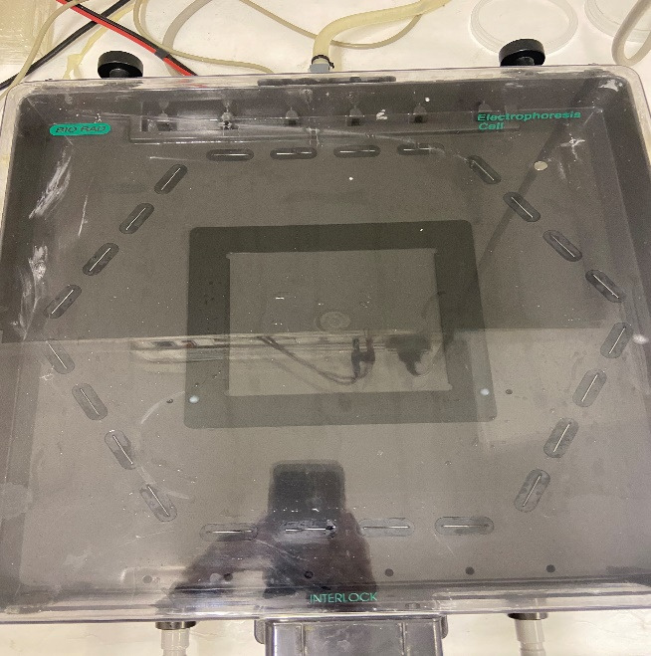 | 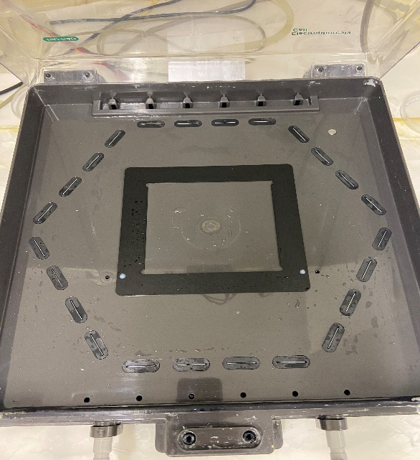
2. General
- PRICING SCHEDULE FOR CHEF DR111 Electrodes

Item description | Quantity | Unit price | Total Price
- Electrodes, thick to be compatible with the BIO-RAD CHEF DR111 cell (pk of 6) | 1 pkt
- Delivery costs | 1
SUBTOTAL
VAT
GRANDTOTAL

Company name:……………………………………………………………………………………………….

Contact person:………………………………………………………………………………………………..

Contact number:……………………………………………………………………………………………….

Date and signature:…………………………………………………………………………………………

Contact: Valmary van Breda – vbredav@arc.agric.za or 021 809 3039

