ENOCH MGIJIMA LOCAL MUNICIPALITY
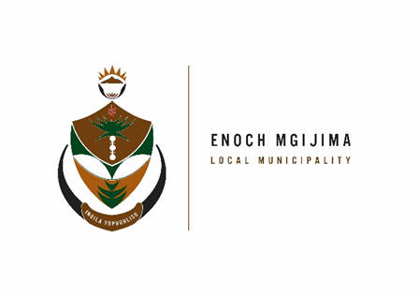
TENDER NOTICES

PROJECT NAME | NOTICE NUMBER | DOCUMENT PRICE | CIDB GRADING | PPPFA | COMPULSORY BRIEFING MEETING | ENQURIES | CLOSING DATE
Supply and delivery of construction material for a period of 24 months | SCM90/11/2022 | R250.00 | n/a | 80/20 | n/a | Mr. M Nkenke 045 807 6000  Mnkenke@enochmgijima.gov.za | 14 December 2022 at 12h00  Opening register will be uploaded on the municipal website
Leasing of multi-functional printers for a period of 3 years | SCM91/11/2022 | R250.00 | n/a | 80/20 | n/a | Ms..T Hewu  045 807 2040 /1  thewu@enochmgijma.gov.za | 13 December 2022 at 12h00  Opening register will be uploaded on the municipal website
Appointment of a service provide to provide an accredited learnership program on municipal finance management: nqf6 (saqa unit standard id 48965) at enoch mgijima local municipality for a period of 24 months for 20 people. | SCM92/11/2022 | R250.00 | n/a | 80/20 | n/a | Mrs. M Nozewu  045 807 2086  nozewum@yahoo.com | 14 December 2022 at 12h00  Opening register will be uploaded on the municipal website
Maintenance contract for fire equipoment at enoch mgijima local municipality for a period of three (3) years | SCM93/11/2022 | R250.00 | 3SF or Higher | 80/20 | n/a | Mr. W Bezuidenhout  045 807 2086  Wbezuidenhout@enochmgijima.gov.za | 13 December 2022 at 12h00  Opening register will be uploaded on the municipal website

Bids are hereby invited from suitably qualified service providers for the projects listed above and must also take note of the following.
Bid documents containing detailed terms of reference will be available as from Wednesday 30 November 2022 ; 08h00 - 16h00 week days, from the Supply Chain Management offices: Budget and treasury offices at No. 25-27 Owen Street; Queenstown upon payment of a non–refundable fee (either in cash or by means of an EFT made payable to the Enoch Mgijima Local Municipality) . Completed bid documents are to be place in a sealed envelope clearly marked the Bid number and Project Name and must be deposited in a bid Box situated at Budget and treasury offices at No. 25-27 Owen Street; Queenstown no later than 12h00pm on the closing date at which all bids will be opened in public. Banking details: Acc Name: Enoch Mgijima Local Municipality
Bank :FNB
Acc No :62438159809
Acc Type :Cheque
Branch Code : 250655 (internet Banking)
Ref : 3010142551022
More details about the adverts phone Mr. A Hoko on 045 807 2000

Issued By

D A VAN WYK KOMANI HOSPITAL
ACTING MUNICIPAL MANAGER N6 ROUTE
KOMANI

