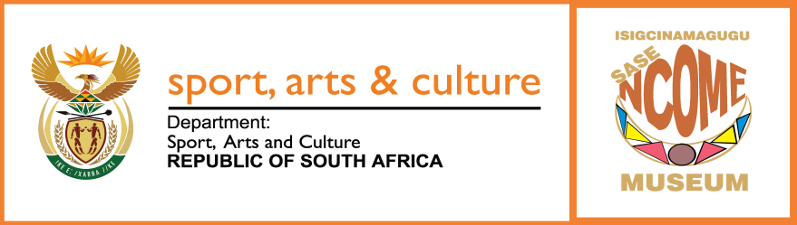

TENDER ADVERT

Bid Number: NMT 01 OF 2025

DESCRIPTION: APPOINTMENT OF SECURITY SERVICES FOR NCOME MUSEUM

Name of Institution: uMsunduzi and Ncome Museums

Date Published: 30 OCTOBER 2025

Compulsory site Briefing: 07 NOVEMBER 2025, 11H:00

Venue: Ncome Museum, Ohaleni,Nquthu, 3000.

Closing Date and Time: 28 NOVEMBER 2025, 12H:00

Enquiries:
Contact Person: Mr. Msizi Mfeka or Njabulo Mpungose
E-mail:mmfeka@msunduzimuseum.org.za/nmpungose@msunduzimuseum.org.za
Telephone: 033 394 6834

Where bid documents can be obtained:

This bid may be downloaded directly from the National Treasury e-Tender Publication Portal at www.etenders.gov.za free of charge.

Where bids should be delivered:
NCOME MUSEUM
OHALENI, NQUTHU
3000

