ANNEXURE 1

SPECIFICATIONS FOR TOOLS

Item no. |  | Description | Quantity
 |  | Supply and delivery of building tools and accessories
1 | 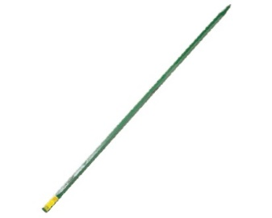 | Crow Bar 25 x 1500mm | 2
2 | 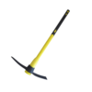 | Pick with Poly Pick Handle, hardened steel core | 4
3 | 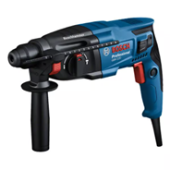 | Drill 720W with drill bit set for wood and masonry | 1
4 | 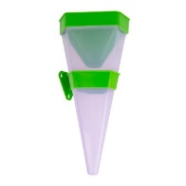 | Triangle rain gauge | 20
5 | 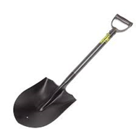 | Shovel Round Nose | 2
6 | 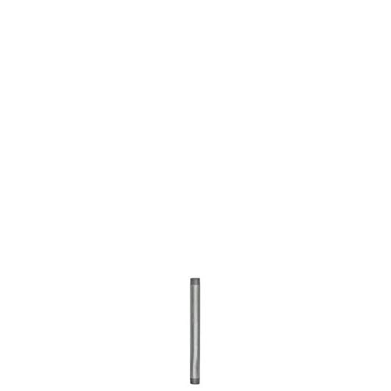 | Galvanized standpipe 20mm x 300mm (must be thick to allow welding) | 6
7 | 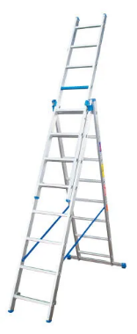 | 2.4 m 5-in-1 Step/Extension Aluminium Ladder | 1
8 | 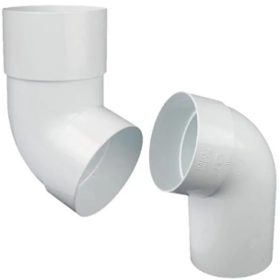 | Downpipe offset- round (Swanneck 110º) | 10
9 | 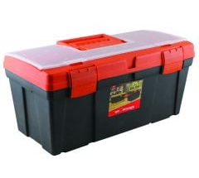 | Black Delux Toolbox 560 x 260 x 250mm | 2
10 | 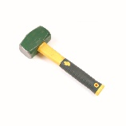 | Hammer 1.1kg | 2
11 | 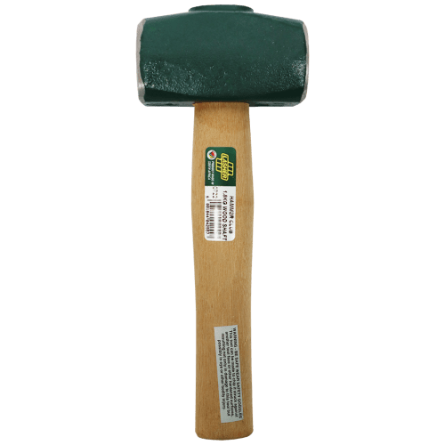 | Hammer 1.8 kg | 2
12 | 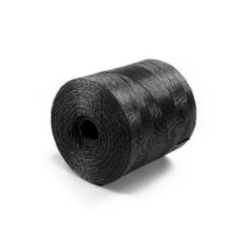 | Lacing cord 1 kg (Black) | 6
13 | 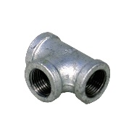 | Galvanized tee 20 x 20 x 20 mm | 10
14 | 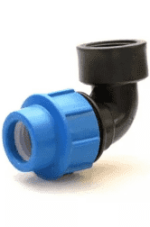 | 20mm x ½ Inch compression female elbow | 10
15 | 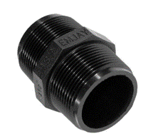 | 20 mm Barrel Nipple (Poly) | 30
16 | 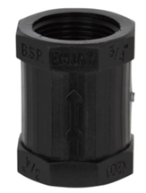 | 20 mm threaded socket | 10
17 | 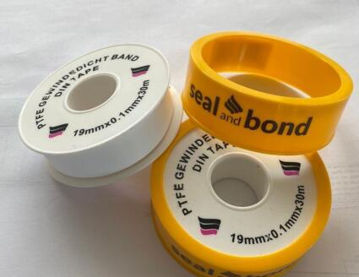 | Thread tape 19mm x 0.1mm x 30m | 10
18 | 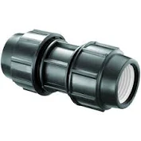 | 40mm Compression coupler | 20
19 | 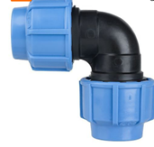 | 40mm Compression elbow (90 degree) | 20
20 | 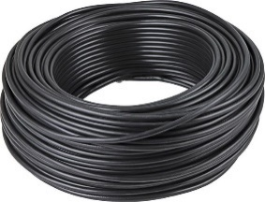 | Black 3 Core Cabtyre 1.0mm x 50m | 1
21 | 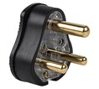 | Black plug top 3pin | 30
22 | 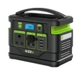 | Portable power station 500-600Watt | 1
 |  | Delivery at the Agricultural Research Council – Agricultural Engineering campus, 141 Cresswell Road, Weavind Park, Silverton, 0184 | 1

