ARC Infruitec-Nietvoorbij
Private Bag X5026, Stellenbosch, 7599, South Africa
Tel: 0829632345
Email: DelportP@arc.agric.za
DESCRIPTION OF SERVICE/PRODUCT (Detailed specs):

Supply and installation of the shade netting cover in the SG parking area: ARC Infruitec, Helshoogte Rd, Stellenbosch Central, Stellenbosch, 7599
Repair of shade net area |  | Quantity | If No, Please Indicate Deviation
1. Specific Description | Compliance to Specification (Yes/No)  *Describe If Specification Differs | Quantity | If No, Please Indicate Deviation
Supply and installation of the shade netting cover in the parking area for SG vehicles. Size of the parking: refer to the below sketch. The parking area is big enough to accommodate 4 vehicles (2 x 2). It was ripped on various places due to strong winds and tear & wear, SP to give allowance for the repair of the existing frame (where necessary). Shade netting cover must be durable and sturdy enough to withstand harsh winds, provide protection from UV rays, and be made from materials strong enough to withstand the force of hail. Bidders to attend compulsory site briefing. |  | 2
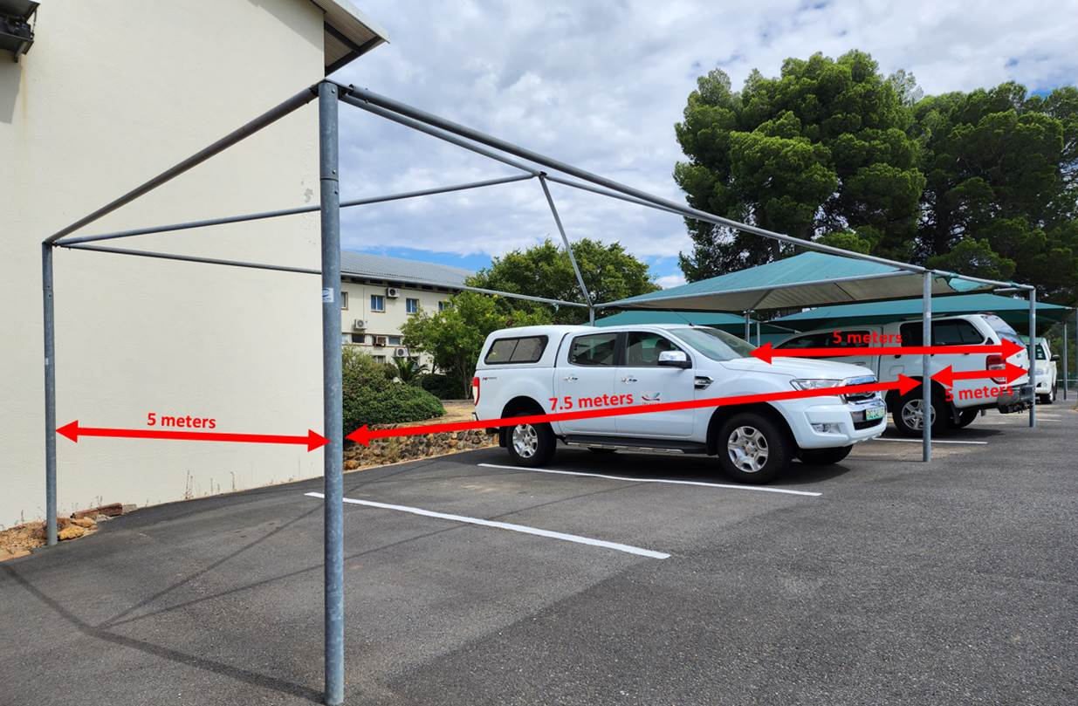
2. General
- Site meeting is compulsory | Date: | Contact person: Petrus Delport 0829632345
- Parking area is located on the ARC Infruitec Helshoogte Rd, Stellenbosch Central
- Supplier will supply the required safety equipment to complete the repair
- Supplier will not damage existing frame
- Supplier will only work on site during normal working hours (08:00 to 16:30)

