Appendix B:

- BRS 13 : Ability of a system to input a monthly water chemistry report

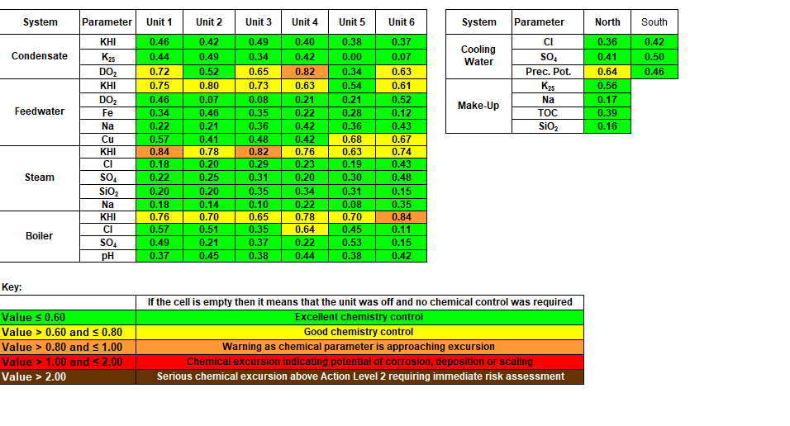

- BRS_R1.1 The capability to view the results of Level 1 level 2 and level 3 Risks assessment in a matrix form as below

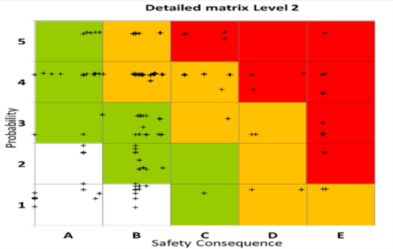

- BRS_R1.2 Ability of a system to generate a view of the plant components subjected to risk assessment, e.g. Boiler components, turbine components

- BRS_1.3 A search capability that will enable management to easily access and compare components data between stations

