STRUCTURAL REMEDIATION WORKS AND CONCRETE/MASONRY DIAMOND CORE DRILLING WORKS AT SENTECH’S JOHANNESBURG T97 TRANSMITTER SITE

Sentech Ltd is the common carrier for broadcasting signal distribution in South Africa and transmits radio and television signal countrywide via integrated terrestrial and satellite networks. Sentech has a network of transmitting sites throughout South Africa. These sites typically consist of an access road leading to a fenced compound enclosing a mast and transmitter building. These remote and unmanned sites are visited by Sentech on a call-out or scheduled maintenance basis.

The Johannesburg T97 transmitter site is situated in the suburb of Brixton in the greater Johannesburg area. Sentech’s Regional Office will provide daily access to the site. The site is accessed off the M17, between Stanley avenue and Bartlett road.

Sentech is expanding its services at this site. The expansion will require structural remediation works and concrete/masonry core drilling works, before these services can be implemented.
A basic description of the requirement is as follows:
- FRP Structural remediation to the 1st floor RC floor slab soffit
- Concrete core drilling in 320mm thick RC floors (6no Ø100mm and 3no Ø50mm)
- Masonry core drilling in 230mm interior/250mm exterior brick walls (3no Ø150mm)

A full description of the work items can be found in the accompanying BoQ, Particular Specification and drawings (drawings 1124-300-001, T09700/A/101B and T09700/A/102B).

General Notes:
- Site co-ordinates are: 26° 11" 31’ S and 28° 00" 26’ E
- Site access is via security controlled gates
- Water points for hose pipes are not available inside the Transmitter building. Contractors must make their own arrangements for the provision of a water reservoir for the core drilling inside/outside the building and provision for this must be incorporated in their quotation
- Electricity is available on site (extension cords from power point to works area to be provided by the contractor)
- Sentech Regional staff will be on site on an ad hoc basis
- Only normal working hours will be allowed

FRP structural remediation notes:
- Refer to the attached Particular Specifications and drawings

Concrete core drilling notes (refer to the Particular Specifications and drawings for additional requirements):
- Dust shall not be generated during the coring works
- The formation of holes in the RC floors and brick walls shall be conducted by the water-lubricated diamond concrete core drilling method
- A screen shall be erected around floor and wall holes to be drilled to protect the adjacent areas/equipment from water, debris, water splatter, etc
- A dam shall be created around floor slab holes to be drilled in the floor to prevent the lubricating water from spreading
- An industrial wet/dry vacuum cleaner must be on site to suck up the lubricating water during the drilling process
- Concrete cores shall not be allowed to fall freely to the floor below. measures shall be put in place to catch the cores

The site quotation briefing and the following attached drawings and documentation detail the requirement as well as outline the responsibilities of the Contractor, and will assist in compiling a quotation:
- Drawings 1124-300-001, T09700/A/101B and T09700/A/102B
- Particular Specifications
- BoQ
- Conditions of Contract
- Google snapshots of the site layout and site location
- Site Photos
- Typical OHS file index format

The following documents must be included with the submission of your quotation:
- Documentation as required by Sentech’s SCM Department
- The completed BoQ
- A signed company letterhead with the quoted prices depicted, availability to conduct the works, etc.
- A program showing indicative lead times, duration of works, etc from the receipt of a Purchase Order (date independent) to the completion of work

The site is available immediately, however, should your quotation be successful, and once Sentech issues a Purchase Order, you will be required to:
- Undertake security and vetting of all the works team members, as required by Sentech’s Security Department (The site is listed as a National Key Point)
- Supply a Occupational Health Safety and Environmental Project File for scrutiny and approval by Sentech’s OHS Department. A typical index for your project file is attached to this document
before work can commence on site.

Site Locality
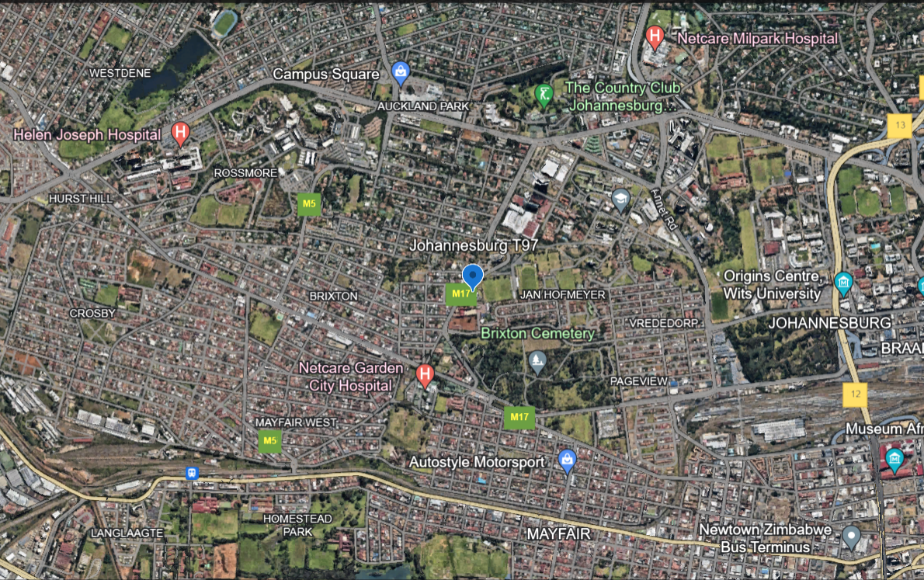

Site Locality
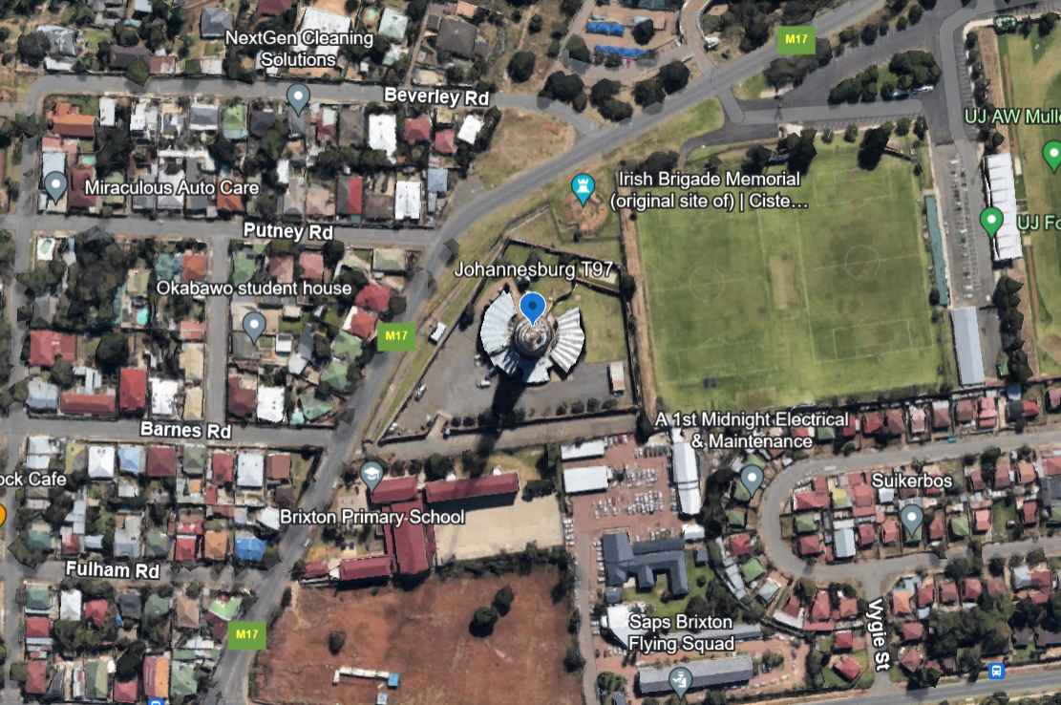

First floor. 3no new transmitters will be positioned to the left of the transmitter on the right. 6no Ø100mm and 3no Ø50mm holes to be cored in the 320mm thick floor slab.
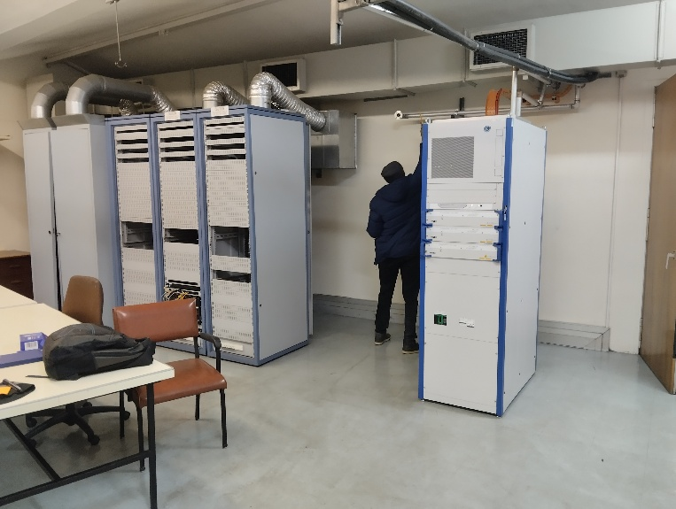
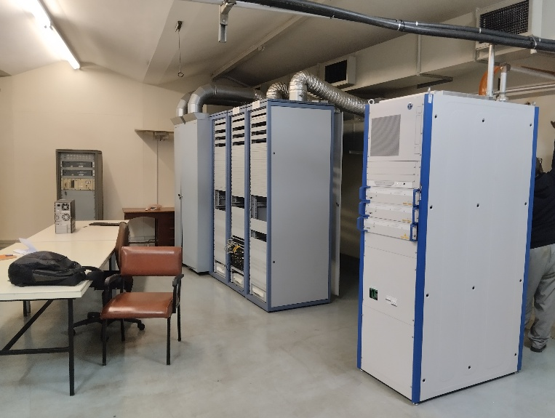

Ground floor. View of the underside of the first floor RC slab where holes are to be drilled.
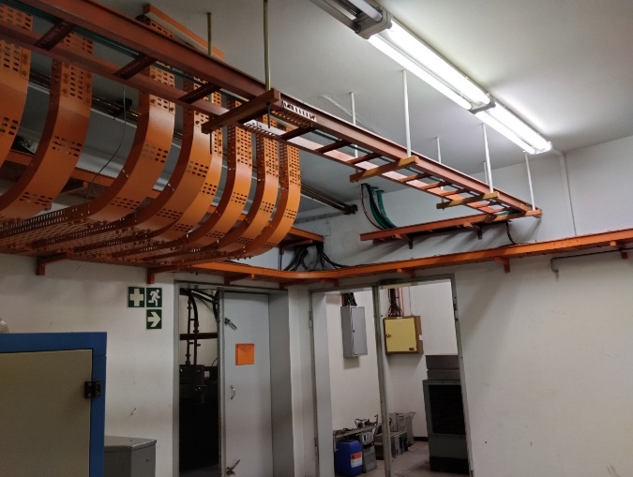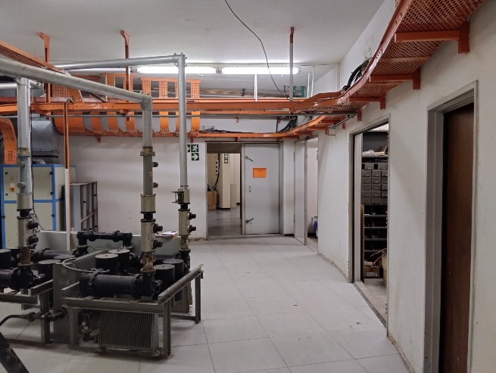

First floor. Position of new Ø150mm hole to be cored in the brick wall adjacent to an existing hole behind the new transmitter, below an existing AC duct. Drilling will take place from the other side of this interior wall.
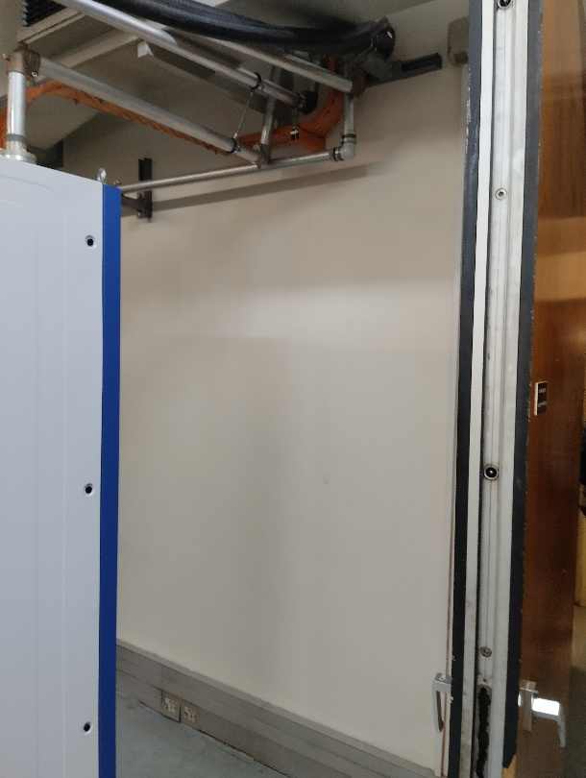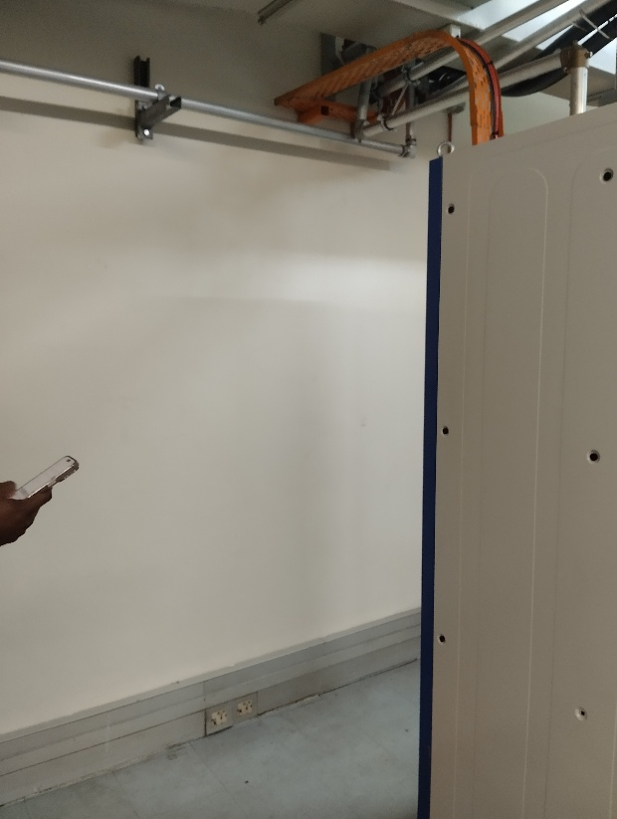

First floor. Position of new Ø150mm hole to be cored in the brick wall adjacent to an existing hole. Pictures from the adjacent Transmitter Room. Drilling will take place from this side above the cable tray, adjacent to the existing Ø150mm hole.
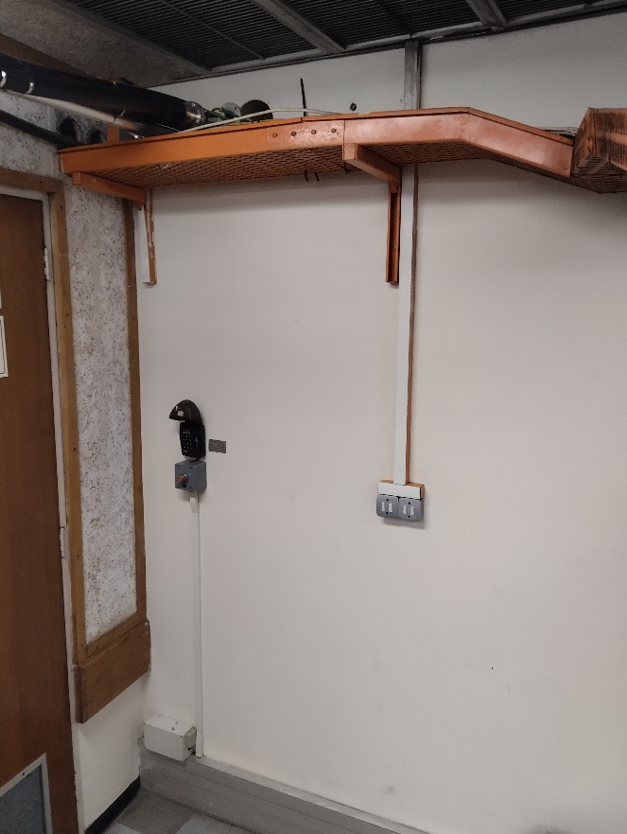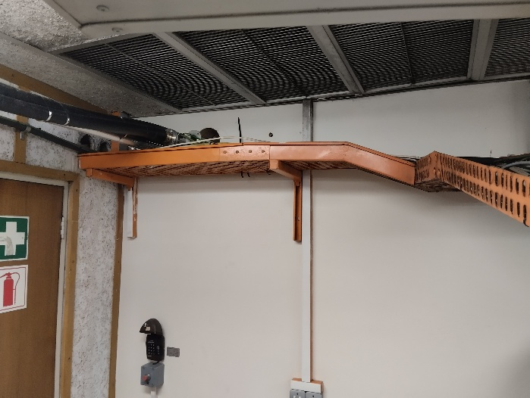

Ground floor. Exterior wall. Internal pictures. Position of 2no Ø150mm holes to be cored in the brick wall below the existing RC ring beam. Drilling will take place from the outside.
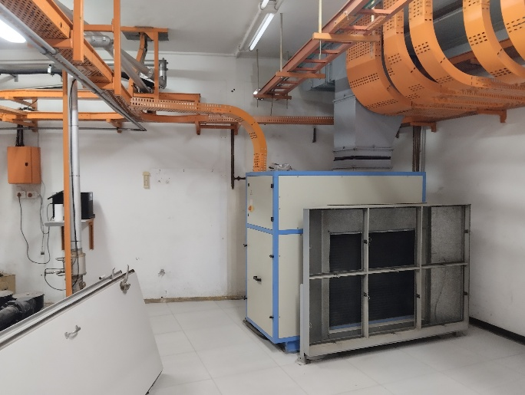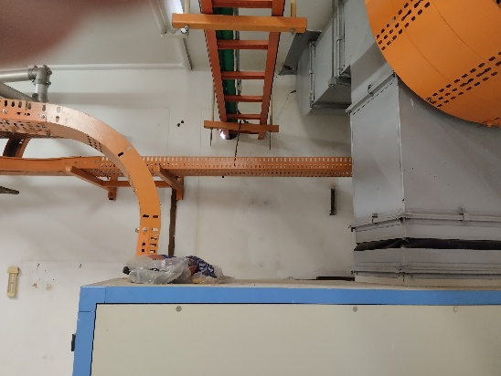

Ground floor. Exterior wall. External pictures. Position of 2no Ø150mm holes to be cored in the brick wall below the existing RC ring beam. Drilling to take place from this side adjacent to the existing Ø150mm hole.

