

(“The DSI”)

TERMS OF REFERENCE

REQUEST FOR PROCUREMENT OF FOUR HEATERS FOR THE MINISTRY CAPE TOWN OFFICE.

N.B. | : | By providing us with your Personal Information, you consent to the DSI processing your Personal Information, which the DSI undertakes to process strictly in accordance with the section 18 informed consent document.

- BACKGROUND

The Department of Science and Innovation’s (DSI), Ministry office in Cape town currently does not have heaters that are working, a request was then sent requesting the heaters. As part of our responsibility as the asset management unit, the request was approved for the procurement of four heaters for the Cape Town office.

- PURPOSE

The purpose of this submission is to request for the sourcing and procurement of four heaters for the Ministry Cape Town office.

- SPECIFICATION

The appointed service provider will be expected to carry out the condition assessment as follows: -

  - Type of heater:
- 9 fin oil heater (2000w) similar to image below
- Colour-White/Black
- 3 different heat seatings
- Automatic thermostat control
- Safety thermostat
- Handle and castors to make movement easier.
- Size -130mm(L) x 420mm(W) x 580mm(H)
- Provide warranty certificate.
- Four heaters requested.
- Delivery address: Dept of Science & Innovation, 120 Plein Bld,10th Floor, Cape Town - 8001
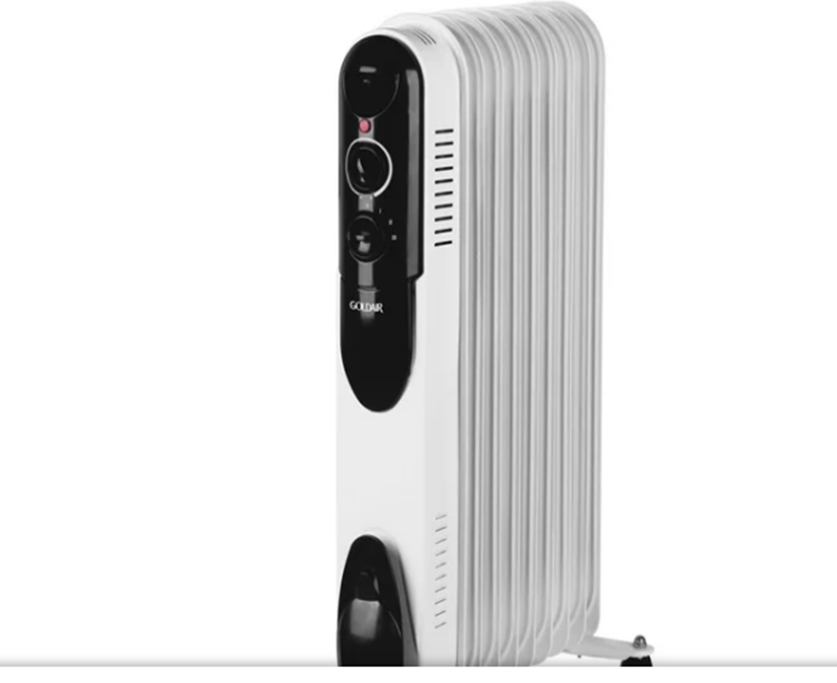

- INFORMATION TO BE FURNISHED BY RESPONDENTS IN THEIR PROPOSAL

  - All prices quoted must include VAT and should be linked with specific tasks to be undertaken.

  - A service provider should comply with the specification.

  - The proposals will go through two stages of the evaluation process which will include the following:

- Mandatory Evaluation.
- Evaluation on Price and Specific Goals.

  - Mandatory and Administrative Requirements

The following documents are compulsory and should be submitted together with the proposal; failure to submit the following will result in disqualification:

- Proof of registration to the Central Supplier Database (CSD) held by National Treasury.
- Compliant tax matters as per CSD or SARS e-filling.
- Completed and signed SBD 1, SBD 4 and SBD 6.1.
- Submit a certified B-BBEE certificate or Sworn Affidavit to claim B-BBEE credentials.
- Latest Company registration documents (CIPRO) with detailed particulars of ownership, failure to submit will not invalid your proposal but will score 0 points for strategic goals.
- A bid that fails to meet any pre-qualifying criteria, specifications/scope of work, terms and conditions stipulated in the tender documents is an unacceptable tender and will be disqualified.
- Accreditation letter from the vendor, proofing that you have the rights to sell the product.

N.B. | : | By providing us with your Personal Information, you consent to the DSI processing your Personal Information, which the DSI undertakes to process strictly in accordance with the section 18 informed consent document.

  - Price and Specific Goals Evaluation

Price inclusive of VAT will be evaluated as indicated below.

a) In terms of regulation 4 of the Preferential Procurement Regulations, 2022 pertaining to the Preferential Procurement Policy Framework Act, 2000 (Act 5 of 2000), responsive bids will be adjudicated by the DSI on the 80/20 preference point system in terms of which points are awarded to service providers on the basis of:

- The bid price (maximum 80 points)
- Specific Goals mentioned below in Table1 (maximum 20 points)

Service providers can only claim specific goal credentials, by providing a detailed company ownership certificate.

b) The following formula will be used to calculate the points for price in respect of service providers with a rand value equal to or above R30 000.00 up to R50 000 000.00:

Ps = 80

Where

Ps = Points scored for price of tender under consideration;
Pt = Price of tender under consideration;
Pmin = Price of lowest acceptable tender.

- A maximum of 20 points will be awarded to a tenderer for the specific goal specified for the tender, as per the table below:

Table 1 – Specific goals
The specific goals allocated points in terms of this tender: | Number of points allocated (80/20 system)
Companies owned by black people | 07
Companies owned by women | 05
Companies owned by youth | 05
Companies owned by people with disabilities | 03

- A bidder must submit proof of its Specific goals’ status.
- A bidder failing to submit proof of Specific goals’ status or failing to meet the Specific goals, may not be disqualified, but (a) may only score points out of 80 for price; and (b) score 0 points out of 20 for Specific goals.
- The points scored by a bidder for Specific goals in accordance with the preceding paragraphs 6.4(c) must be added to the points scored for price under paragraph 6.4(b).
- The points scored must be rounded off to the nearest two decimal places.
- If the price offered by a tenderer scoring the highest points is not market-related, the Department may not award the bid to that tenderer.
    - The Department may negotiate a market-related price with the tenderer scoring the highest points or cancel the tender.
    - If the tenderer does not agree to a market-related price, the Department may negotiate a market-related price with the tenderer scoring the second highest points or cancel the tender.
    - If the tenderer scoring the second highest points does not agree to a market-related price, the Department may negotiate a market-related price with the tenderer scoring the third highest points or cancel the tender.
    - If a market-related price is not agreed in all the aforementioned respects, the Department must cancel the tender.
- In the event that two or more tenderers score an equal total number of points, the contract must be awarded to the tenderer that scored the highest points for specific goals. (2) If two or more tenderers score equal total points in all respects, the award must be decided by the drawing of lots.
- A contract may, on reasonable and justifiable grounds, be awarded to a bid that did not score the highest number of points.

NB: All costs that the service provider may incur due to the preparation of the project for the DSI shall be the sole responsibility of the service provider.

- AWARDING OF THE BID

  - The successful service provider will work in close collaboration with the DSI team so as to ensure that the objectives of the Department are accommodated.

- SUBMISSION OF PROPOSALS

  - The deadline for the proposal is 28th August 2023 at 11:00. .

  - The proposals should be sent to the relevant SCM Practitioner who sourced quotations using the details provided through the email used to source. It should be noted that no documents can be delivered to the DSI building.

- CONTACT PERSONS

Enquiries relating to this request should be addressed to the Zimbini Mkondweni 066 186 2502, Zimbini.Mkondweni@dst.go.za (Technical queries)

