

SUPPLY AND DELIVERY OF REFUSE SKIP CONTAINERS FOR A PERIOD OF ONE YEAR

NOTICE: 150 OF 2021

BID NO: 8/2/RNM0332

NAME OF THE BIDDER

__________________________________________________

BID AMOUNT R _________________________

COMMUNITY SERVICES
P.O. BOX 5
PORT SHEPSTONE
4240

OCTOBER 2021

TABLE OF CONTENTS

Page number
1. Bid Advert | 5-6
2. Standard forms | 7-19
3. Evaluation Criteria | 19-20
4. General conditions of contract | 21-29
5. Attachments:
6.1. RNM /MBD 3.1. Pricing Schedule (Firm Prices) | 31
6.2. RNM /MBD 4. Declaration of Interest | 37-38
6.3. RNM /MBD 5.1. Past experience(1) | 40-41
6.4. RNM /MBD 6.1. Points claimed (BBBEE certificate) | 43-44
6.5 RNM /MBD 8 Declaration past SCM practices | 56-57
6.6. RNM /MBD 9 Certificate of Independent Bid  Determination | 58-60

MUNICIPAL NOTICE: 150 of 2021
BID NO: 8/2/RNM0332

SUPPLY AND DELIVERY OF REFUSE SKIP CONTAINERS FOR A PERIOD OF ONE YEAR
The Ray Nkonyeni Municipality hereby invites bids for the Supply and Delivery of Refuse Skip Containers for a period of one year.

Bid documents can be downloaded for free from e-tenders portal https://etenders.treasury.gov.za and Ray Nkonyeni Municipality website www.rnm.gov.za from Friday, 29 October 2021

Bidders to submit two (02) copies of the bid document together with the original bid document, bidders that fail to submit copies will be disqualified. Fully completed Bid documents must be submitted in a sealed envelope, clearly marked “8/2/RNM0332 Supply and Delivery of Refuse Skip Containers for a period of one year and must be deposited in the Bid box at the Municipal offices at 10 Connor Street, Port Shepstone, no later than 12h00 on 15 November 2021 after which all Bids will be opened in public.

Ray Nkonyeni Municipality subscribes to the Broad-Based Black Economic Empowerment Act (BBBEEA), Act 53 of 2003, Preferential Procurement Policy Framework Act, 2000 (Act No 5 of 2000), and Preferential Procurement Regulations, 2017. The 80/20 preference point system shall be applicable during the evaluation and adjudication of this Bid proposal.

Enquiries can be directed to Mr Sithole on 039 6882069.

LOCAL CONTENT
A bid may be disqualified if the Declaration Certificate and the Annex C (Local Content Declaration: Summary Schedule) are not submitted as part of the bid documentation.
Steel 100%

The stipulated minimum threshold for local production and content (refer to Annex A of SATS 1286:2011) for this bid is 100% regarding protective clothing refer to MBD 6.2

Pre-Qualifying Stage 1
The bidder must be level one B_BBEE
Tenders will be evaluated on functionality, price and BBBEE. All tender offers that fail to score the minimum of 60% of points will be rejected. The following criteria will be used for functionality evaluation:-

Criteria | Possible Full Points
Experience | 10
TOTAL | 10

NOTE TO BIDDERS ON CONDITIONS OF THE BID:

- The Supply Chain Management Policy of Ray Nkonyeni Municipality will apply. The Council reserves the right not to accept the lowest bid or any bid and reserves the right to accept the whole or part of the bid, or to reject all bids and cancel the notice to bid;

- Bids that are submitted late, incomplete, not initialled on each page, unsigned or by facsimile, electronically or not completed in black ink will be rejected and not accepted for further evaluation;

- Service providers are required to buy bid documents before the clarification meeting, and present them in meeting on a specified date if any;

- Only service providers registered in the Central Supplier Database (CSD) will be considered, attach proof of registration failure to attach will result in your bid not evaluated further.

- Members or Directors of Companies or Service Providers who are state employees are not allowed to bid or quote;

- Unsuccessful bidders will be informed of the Bid outcome through the Municipal website. Aggrieved unsuccessful bidders will be allowed to lodge, within fourteen (14) days of the decision or action, a written objection or complaint to the Office of the Municipal Manager through email, mm@rnm.gov.za or fax number 0865297195. Complaints or objections received after fourteen (14) days of the date of the notice will not be entertained; and

- The original bid document plus TWO extra (02) copy must be submitted, failure to submit two copies will result in disqualification.

- Bids submitted are to be valid for a period of 120 days.

S M Mbili
MUNICIPAL MANAGER
P.O. Box 5
PORT SHEPSTONE, 4240

ALL BIDS MUST BE SUBMITTED ON THE OFFICIAL FORMS
(NOT TO BE RE-TYPED)

NB!!!!! Please attach copies of the following documents.
- Company registration documents.
- Certified copy of ID documents of directors/owners/members/
shareholders.
- Copy of a valid TAX Compliance Certificate
Or Tax Compliance Status PIN Sheet.
- Certified copy of BBBEE Certificate /SWORN AFFIDAVIT
- Declarations (MBD 4, 6.1, 8 & 9).
- Joint Venture agreements (where applicable)

STANDARD FORMS

THIS BID IS SUBJECT TO THE GENERAL CONDITIONS OF CONTRACT (GCC) AND, IF APPLICABLE, ANY OTHER SPECIAL CONDITIONS OF CONTRACT. THIS BID WILL BE EVALUATED AND ADJUDICATED ACCORDING TO THE FOLLOWING CRITERIA:

- Relevant specifications
- Value for money
- Capability to execute the contract
- PPPFA & associated regulations

NB: NO BIDS WILL BE CONSIDERED FROM PERSONS IN THE SERVICE OF THE STATE

MBD 1
RAY NKONYENI MUNICIPALITY
STANDARD FORM FOR BIDS
YOU ARE HEREBY INVITED TO BID FOR REQUIREMENTS OF THE (NAME OF MUNICIPALITY/ MUNICIPAL ENTITY)
BID NUMBER: | 8/2/RNM0332 |  | CLOSING DATE: |  | 15 NOVEMBER 2021 |  |  |  |  |  | CLOSING TIME: |  |  |  |  | 12:00
DESCRIPTION | Supply and Delivery of Refuse Skip Containers for a period of one year
THE SUCCESSFUL BIDDER WILL BE REQUIRED TO FILL IN AND SIGN A WRITTEN CONTRACT FORM (MBD7).
BID RESPONSE DOCUMENTS MAY BE DEPOSITED IN THE BID BOX SITUATED AT (STREET ADDRESS
RAY NKONYENI MUNICIPALITY
PO BOX 5
PORT SHEPSTONE (10 Connor Street)
4240
SUPPLIER INFORMATION
NAME OF BIDDER
POSTAL ADDRESS
STREET ADDRESS
TELEPHONE NUMBER |  | CODE |  |  |  |  |  |  | NUMBER
CELLPHONE NUMBER
FACSIMILE NUMBER |  | CODE |  |  |  |  |  |  | NUMBER
E-MAIL ADDRESS
VAT REGISTRATION NUMBER
TAX COMPLIANCE STATUS |  | TCS PIN: |  |  |  |  | OR |  |  | CSD No:
B-BBEE STATUS LEVEL VERIFICATION CERTIFICATE  [TICK APPLICABLE BOX] |  | Yes  No |  |  |  |  | B-BBEE STATUS LEVEL SWORN AFFIDAVIT |  |  |  |  | Yes  No
[A B-BBEE STATUS LEVEL VERIFICATION CERTIFICATE/ SWORN AFFIDAVIT (FOR EMES & QSEs) MUST BE SUBMITTED IN ORDER TO QUALIFY FOR PREFERENCE POINTS FOR B-BBEE]
ARE YOU THE ACCREDITED REPRESENTATIVE IN SOUTH AFRICA FOR THE GOODS /SERVICES /WORKS OFFERED? |  | Yes No  [IF YES ENCLOSE PROOF] |  |  |  |  |  | ARE YOU A FOREIGN BASED SUPPLIER FOR THE GOODS /SERVICES /WORKS OFFERED? |  |  |  |  |  |  | Yes No  [IF YES, ANSWER PART B:3 ]
TOTAL NUMBER OF ITEMS OFFERED |  |  |  |  |  |  |  | TOTAL BID PRICE |  |  |  |  |  |  | R
SIGNATURE OF BIDDER |  | ……………………………… |  |  |  |  |  | DATE

CAPACITY UNDER WHICH THIS BID IS SIGNED
BIDDING PROCEDURE ENQUIRIES MAY BE DIRECTED TO: |  |  |  |  |  | TECHNICAL INFORMATION MAY BE DIRECTED TO:
DEPARTMENT |  | TREASURY SCM |  |  |  | CONTACT PERSON |  |  |  |  |  |  |  | COMMUNITY SERVICES
CONTACT PERSON |  | MR BONGANI MFENQA |  |  |  | TELEPHONE NUMBER |  |  |  |  |  |  |  | MR PATRICK SITHOLE
TELEPHONE NUMBER |  | 039-3128304 |  |  |  | FACSIMILE NUMBER |  |  |  |  |  |  |  | 039-6882069
FACSIMILE NUMBER |  |  |  |  |  | E-MAIL ADDRESS
E-MAIL ADDRESS |  | Bongani.Mfenqa@rnm.gov.za

MBD 1

PART B
TERMS AND CONDITIONS FOR BIDDING

- BID SUBMISSION:
  - BIDS MUST BE DELIVERED BY THE STIPULATED TIME TO THE CORRECT ADDRESS. LATE BIDS WILL NOT BE ACCEPTED FOR CONSIDERATION.
  - ALL BIDS MUST BE SUBMITTED ON THE OFFICIAL FORMS PROVIDED–(NOT TO BE RE-TYPED) OR ONLINE
  - THIS BID IS SUBJECT TO THE PREFERENTIAL PROCUREMENT POLICY FRAMEWORK ACT AND THE PREFERENTIAL PROCUREMENT REGULATIONS, 2017, THE GENERAL CONDITIONS OF CONTRACT (GCC) AND, IF APPLICABLE, ANY OTHER SPECIAL CONDITIONS OF CONTRACT.
  - The bid offer MUST BE signed by a person authorized to sign on behalf of the Bidder;
  - A bidder who submitted a bid as a Joint Venture has included an acceptable Joint Venture Agreement with his/her bid;
  - ONLY A CONSOLIDATED B-BBEE CERTIFICATE, ISSUED BY A SANAS APPROVED VERIFICATION AGENCY, WILL BE ACCEPTABLE FOR THE CLAIMIMG OF PREFERENCE POINTS WHERE BIDDERS SUBMITTED THEIR BID AS A JOINT VENTURE / CONSORTIUM;
  - A bidder who Is a Joint Venture has included mbd 4, 8 & 9 FOR EACH ENTITY IN THE JOINT VENTURE / CONSORTIUM with his/her bid
  - The bidderer or a competent authorised representative of the Contractor who submitted the bid has attended the compulsory clarification meeting or site inspection;

- TAX COMPLIANCE REQUIREMENTS
- BIDDERS MUST ENSURE COMPLIANCE WITH THEIR TAX OBLIGATIONS.
- BIDDERS ARE REQUIRED TO SUBMIT THEIR UNIQUE PERSONAL IDENTIFICATION NUMBER (PIN) ISSUED BY SARS TO ENABLE THE ORGAN OF STATE TO VIEW THE TAXPAYER’S PROFILE AND TAX STATUS.
- APPLICATION FOR THE TAX COMPLIANCE STATUS (TCS) CERTIFICATE OR PIN MAY ALSO BE MADE VIA E-FILING. IN ORDER TO USE THIS PROVISION, TAXPAYERS WILL NEED TO REGISTER WITH SARS AS E-FILERS THROUGH THE WEBSITE WWW.SARS.GOV.ZA.
- FOREIGN SUPPLIERS MUST COMPLETE THE PRE-AWARD QUESTIONNAIRE IN PART B:3.
- BIDDERS MAY ALSO SUBMIT A PRINTED TCS CERTIFICATE TOGETHER WITH THE BID.
- IN BIDS WHERE CONSORTIA / JOINT VENTURES / SUB-CONTRACTORS ARE INVOLVED, EACH PARTY MUST SUBMIT A SEPARATE TCS CERTIFICATE / PIN / CSD NUMBER.
- WHERE NO TCS IS AVAILABLE BUT THE BIDDER IS REGISTERED ON THE CENTRAL SUPPLIER DATABASE (CSD), A CSD NUMBER MUST BE PROVIDED.
- QUESTIONNAIRE TO BIDDING FOREIGN SUPPLIERS
  - IS THE ENTITY A RESIDENT OF THE REPUBLIC OF SOUTH AFRICA (RSA)? YES NO
  - DOES THE ENTITY HAVE A BRANCH IN THE RSA? YES NO
  - DOES THE ENTITY HAVE A PERMANENT ESTABLISHMENT IN THE RSA? YES NO
  - DOES THE ENTITY HAVE ANY SOURCE OF INCOME IN THE RSA? YES NO
  - IS THE ENTITY LIABLE IN THE RSA FOR ANY FORM OF TAXATION? YES NO

IF THE ANSWER IS “NO” TO ALL OF THE ABOVE, THEN IT IS NOT A REQUIREMENT TO REGISTER FOR A TAX COMPLIANCE STATUS SYSTEM PIN CODE FROM THE SOUTH AFRICAN REVENUE SERVICE (SARS) AND IF NOT REGISTER AS PER 2.3 ABOVE.

NB: FAILURE TO PROVIDE ANY OF THE ABOVE PARTICULARS MAY RENDER THE BID INVALID.
NO BIDS WILL BE CONSIDERED FROM PERSONS IN THE SERVICE OF THE STATE.

SIGNATURE OF BIDDER: ……………………………………………

CAPACITY UNDER WHICH THIS BID IS SIGNED: ……………………………………………

DATE: …………………………………………...

EVALUATION OF TENDER OFFERS
Pre-Qualifying Stage 1
The bidder must be level one B_BBEE

The procedure for evaluation of responsive Bid Offers will be METHOD 4 if applicable to your bid: (Financial Offer, preference and quality (functionality) with 80/20 Preference Points System. Score quality, rejecting all Bid Offers that fail to score the minimum number of points for quality stated in the Bid Data. The total score awarded will be the addition of the two scores for price and preference.

The following formula will be used in Calculation of Percentage for Functionality
PS=So x Ap
Ms
Where:
Ps = percentage scored for functionality by Bid/proposal under consideration
So = total score of bid/proposal under consideration
Ms = Maximum possible score
Ap = percentage allocated for functionality

- A maximum of 10 points will be awarded for a Company with 3 years of more relevant experience

- Point system for functionality will be as per table below:-

KEY ASPECT OF CRITERION | POINTS | EVALUATION CRITERION | VERIFICATION METHOD
Experience in supplying and delivering of refuse skip containers | 10 | Company with 3 years relevant experience in supplying and delivering of refuse skip containers | 3 Appointment Letters
 | 8 | Company with 1-2 years relevant experience in supplying and delivering of refuse skip containers | 2 Appointment Letters
 | 6 | Company with 1 year relevant experience in supplying and delivering of refuse skip containers | 1 Appointment letter

GENERAL CONDITIONS OF CONTRACT
TABLE OF CLAUSES

1. Definitions
2. Application
3. General
4. Standards
5. Use of contract documents and information inspection
6. Patent Rights
7. Performance security
8. Inspections, tests and analyses
9. Packing
10. Delivery and documents
11. Insurance
12. Transportation
13. Incidental Services
14. Spare parts
15. Warranty
16. Payment
17. Prices
18. Variation orders
19. Assignment
20. Subcontracts
21. Delays in the supplier’s performance
22. Penalties
23. Termination for default
24. Anti-dumping and countervailing duties and rights
25. Force Majeure
26. Termination for insolvency
27. Settlement of Disputes
28. Limitation of Liability
29. Governing language
30. Applicable law
31. Notices
32. Taxes and duties
33. Transfer of contracts
34. Amendments of contracts
35. Prohibition of restrictive practices
General Conditions of Contract

1. Definitions 1.1 The following terms shall be interpreted as indicated:

1.2 “Closing time” means the date and hour specified in the bidding documents for the receipt of bids.

1.3 “Contract” means the written agreement entered into between the purchaser and the supplier, as recorded in the contract form signed by the parties, including all attachments and appendices thereto and all documents incorporated by reference therein.

1.4 “Contract price” means the price payable to the supplier under the contract for the full and proper performance of his contractual obligations.

1.5 “Corrupt practice” means the offering, giving, receiving, or soliciting of anything of value to influence the action of a public official in the procurement process or in contract execution.

1.6 "Countervailing duties" are imposed in cases where an enterprise abroad is subsidized by its government and encouraged to market its products internationally.

1.7 “Country of origin” means the place where the goods were mined, grown or produced or from which the services are supplied. Goods are produced when, through manufacturing, processing or substantial and major assembly of components, commercially recognized new product results that is substantially different in basic characteristics or in purpose or utility from its components.

1.8. “Database application form” means the application form required by the Ray Nkonyeni Municipality to be filled in by the successful Bidder, following the award of the contract, for inclusion on the RNM database before payment is made.

1.9 “Day” means calendar day.

1.10 “Delivery” means delivery in compliance of the conditions of the contract or order.

1.11 “Delivery ex stock” means immediate delivery directly from stock actually on hand.

1.12 “Delivery into consignees store or to his site” means delivered and unloaded in the specified store or depot or on the specified site in compliance with the conditions of the contract or order, the supplier bearing all risks and charges involved until the goods are so delivered and a valid receipt is obtained.

1.13 "Dumping" occurs when a private enterprise abroad market its goods on own initiative in the RSA at lower prices than that of the country of origin and which have the potential to harm the local industries in the RSA.
1.14 ”Force majeure” means an event beyond the control of the
supplier and not involving the supplier’s fault or negligence and not foreseeable. Such events may include, but is not restricted to, acts of the purchaser in its sovereign capacity, wars or revolutions, fires, floods, epidemics, quarantine restrictions and freight embargoes.

1.15 “Fraudulent practice” means a misrepresentation of facts in
order to influence a procurement process or the execution of contract to the detriment of any bidder, and includes collusive practice among bidders (prior to or after bid submission)designed to establish bid prices at artificial non-competitive levels and to deprive the bidder of the benefits of free and open competition.

1.16 “GCC” means the General Conditions of Contract.

1.17 “Goods” means all of the equipment, machinery, and/or other materials that the supplier is required to supply to the purchaser under the contract.

1.18 “Imported content” means that portion of the bidding price represented by the cost of components, parts or materials which have been or are still to be imported (whether by the supplier or his subcontractors) and which costs are inclusive of the costs abroad, plus freight and other direct importation costs such as landing costs, dock dues, import duty, sales duty or other similar tax or duty at the South African place of entry as well as transportation and handling charges to the factory in the Republic where the goods covered by the bid will be manufactured.

1.19 “Local content” means that portion of the bidding price, which is not included in the imported content provided that local manufacture does take place.

1.20 “Manufacture” means the production of products in a factory using labour, materials, components and machinery and includes other related value-adding activities.

1.21 “Order” means an official written order issued for the supply of goods or works or the rendering of a service.

1.22 “Project site,” where applicable, means the place indicated in bidding documents.

1.23 “Purchaser” means the organization purchasing the goods.

1.24 “Republic” means the Republic of South Africa.

1.25 “SCC” means the Special Conditions of Contract.

1.26 “Services” means those functional services ancillary to the supply of the goods, such as transportation and any other incidental services, such as installation, commissioning, provision of technical assistance, training, catering, gardening, security, maintenance and other such obligations of the supplier covered under the contract.

1.27 “Supplier” means the successful bidder who is awarded the contract to maintain and administer the required and specified service(s) to the State.

1.28 “Tort” means in breach of contract.

1.29 “Turnkey” means a procurement process where one service provider assumes total responsibility for all aspects of the project and delivers the full end product / service required by the contract.

1.30 “Written” or “in writing” means hand-written in ink or any form of electronic or mechanical writing.

2. Application 2.1 These general conditions are applicable to all bids,
contracts and orders including bids for functional and professional services (excluding professional services related to the building and construction industry), sales, hiring, letting and the granting or acquiring of rights, but excluding immovable property, unless otherwise indicated in the bidding documents.

2.2 Where applicable, special conditions of contract are also laid down to cover specific goods, services or works.

2.3 Where such special conditions of contract are in conflict with these general conditions, the special conditions shall apply.

3. General 3.1 Unless otherwise indicated in the bidding documents, the
purchaser shall not be liable for any expense incurred in the preparation and submission of a bid. Where applicable a nonrefundable fee for documents may be charged.

3.2 Invitations to bid are usually published in locally distributed news media and on the municipality/municipal entity website.

4. Standards 4.1 The goods supplied shall conform to the standards
mentioned in the bidding documents and specifications.

5. Use of 5.1 The supplier shall not, without the purchaser’s prior written consent,
contract disclose the contract, or any provision thereof, or any specifications,
documents plan, drawing, pattern, sample, or information furnished by or on
and behalf of the purchaser in connection therewith, to any person other
information than a person employed by the supplier in the of the contract.
inspection Disclosure to any such employed person shall be made in confidence and shall extend only so far as may be necessary for purposes of such performance.

5.2 The supplier shall not, without the purchaser’s prior written consent, make use of any document or information mentioned in GCC clause 5.1 except for purposes of performing the contract.

5.3 Any document, other than the contract itself mentioned in GCC clause 5.1 shall remain the property of the purchaser and shall be returned (all copies) to the purchaser on completion of the supplier’s performance under the contract if so required by the purchaser.

5.4 The supplier shall permit the purchaser to inspect the supplier’s records relating to the performance of the supplier and to have them audited by auditors appointed by the purchaser, if so required by the purchaser.

6. Patent rights 6.1 The supplier shall indemnify the purchaser against all third
party claims of infringement of patent, trademark, or industrial design rights arising from use of the goods or any part thereof by the purchaser.

6.2 When a supplier developed documentation / projects for the municipality / municipal entity, the intellectual, copy and patent rights or ownership of such documents or projects will vest inthe municipality / municipal entity.

7. Performance 7.1 Within thirty (30) days of receipt of the notification of contract award,
security the successful bidder shall furnish to the purchaser the performance
security of the amount specified in SCC.

7.2 The proceeds of the performance security shall be payable to the purchaser as compensation for any loss resulting from the supplier’s failure to complete his obligations under the contract.

7.3 The performance security shall be denominated in the currency of the contract, or in a freely convertible currency acceptable to the purchaser and shall be in one of the following forms:

(a) a bank guarantee or an irrevocable letter of credit issued by a reputable bank located in the purchaser’s country or abroad, acceptable to the purchaser, in the form provided in the bidding documents or another form acceptable to the purchaser; or
(b) a cashier’s or certified cheque.

7.4 The performance security will be discharged by the purchaser and returned to the supplier not later than thirty (30) days following the date of completion of the supplier’s performance obligations under the contract, including any warranty obligations, unless otherwise specified.

8. Inspections, 8.1 All pre-bidding testing will be for the account of the bidder.
tests and
analyses 8.2 If it is a bid condition that goods to be produced or services
to be rendered should at any stage be subject to inspections, tests and analyses, the bidder or contractor’s premises shall be open, at all reasonable hours, for inspection by a representative of the purchaser or organization acting on behalf of the purchaser.

8.3 If there are no inspection requirements indicated in the bidding documents and no mention is made in the contract, but during the contract period it is decided that inspections shall be carried out, the purchaser shall itself make the necessary arrangements, including payment arrangements with the testing authority concerned.

8.4 If the inspections, tests and analyses referred to in clauses 8.2and 8.3 show the goods to be in accordance with the contract requirements, the cost of the inspections, tests and analyses shall be defrayed by the purchaser.

8.5 Where the goods or services referred to in clauses 8.2 and 8.3do not comply with the contract requirements, irrespective of whether such goods or services are accepted or not, the cost in connection with these inspections, tests or analyses shall be defrayed by the supplier.

8.6 Goods and services which are referred to in clauses 8.2 and 8.3and which do not comply with the contract requirements may be rejected.

8.7 Any contract goods may on or after delivery be inspected, tested or analyzed and may be rejected if found not to comply with the requirements of the contract. Such rejected goods shall be held at the cost and risk of the supplier who shall, when called upon, remove them immediately at his own cost and forthwith substitute them with goods, which do comply with the requirements of the contract. Failing such removal the rejected goods shall be returned at the suppliers cost and risk. Should the supplier fail to provide the substitute goods forthwith, the purchaser may, without giving the supplier further opportunity to substitute the rejected goods, purchase such goods as may be necessary at the expense of the supplier.
8.8 The provisions of clauses 8.4 to 8.7 shall not prejudice the right of the purchaser to cancel the contract on account of a breach of the conditions thereof, or to act in terms of Clause 22 of GCC.

9. Packing 9.1 The supplier shall provide such packing of the goods as is
required to prevent their damage or deterioration during transit to their final destination, as indicated in the contract. The packing shall be sufficient to withstand, without limitation, rough handling during transit and exposure to extreme temperatures, salt and precipitation during transit, and open storage. Packing, case size weights shall take into consideration, where appropriate, the remoteness of the goods’ final destination and the absence of heavy handling facilities at all points in transit.

9.2 The packing, marking, and documentation within and outside the packages shall comply strictly with such special requirements as shall be expressly provided for in the contract, including additional requirements, if any, and in any subsequent instructions ordered by the purchaser.

10. Delivery and 10.1 Delivery of the goods and arrangements for shipping and
documents clearance obligations, shall be made by the supplier in accordance with the terms specified in the contract.

11. Insurance 11.1 The goods supplied under the contract shall be fully
insured in freely convertible currency against loss or damage incidental to manufacture or acquisition, transportation, storage and delivery in the manner specified.

12. Transportation12.1 Should a price other than an all-inclusive delivered price be
required, this shall be specified.

13. Incidental 13.1 The supplier may be required to provide any or all of the
services following services, including additional services, if any:

(a) performance or supervision of on-site assembly and/or commissioning of the supplied goods;

(b) furnishing of tools required for assembly and/or maintenance of the supplied goods;

(c) furnishing of a detailed operations and maintenance manual for each appropriate unit of the supplied goods;

(d) performance or supervision or maintenance and/or repair of the supplied goods, for a period of time agreed by the parties, provided that this service shall not relieve the supplier of any warranty obligations under this contract; and

(e) training of the purchaser’s personnel, at the supplier’s plant and/or on-site, in assembly, start-up, operation, maintenance, and/or repair of the supplied goods.

13.2 Prices charged by the supplier for incidental services, if not
included in the contract price for the goods, shall be agreed upon in advance by the parties and shall not exceed the prevailing rates charged to other parties by the supplier for similar services.

14. Spare parts 14.1 As specified, the supplier may be required to provide any
or all of the following materials, notifications, and information pertaining to spare parts manufactured or distributed by the supplier:

(a) such spare parts as the purchaser may elect to purchase from the supplier, provided that this election shall not relieve the supplier of any warranty obligations under the contract; and;

(b) in the event of termination of production of the spare parts:

(i) advance notification to the purchaser of the pending termination, in sufficient time to permit the purchaser to procure needed requirements; and

(ii) following such termination, furnishing at no cost to the purchaser, the blueprints, drawings, and specifications of the spare parts, if requested.

15. Warranty 15.1 The supplier warrants that the goods supplied under the
contract are new, unused, of the most recent or current models, and that they incorporate all recent improvements in design and materials unless provided otherwise in the contract. The supplier further warrants that all goods supplied under this contract shall have no defect, arising from design, materials, or workmanship (except when the design and/or material is required by the purchaser’s specifications) or from any act or omission of the supplier, that may develop under normal use of the supplied goods in the conditions prevailing in the country of final destination.

15.2 This warranty shall remain valid for twelve (12) months after the goods, or any portion thereof as the case may be, have been delivered to and accepted at the final destination indicated in the contract, or for eighteen (18) months after the date of shipment from the port or place of loading in the source country, whichever period concludes earlier, unless specified otherwise.

15.3 The purchaser shall promptly notify the supplier in writing of any claims arising under this warranty.

15.4 Upon receipt of such notice, the supplier shall, within the period specified and with all reasonable speed, repair or replace the defective goods or parts thereof, without costs to the purchaser.

15.5 If the supplier, having been notified, fails to remedy the defect(s) within the period specified, the purchaser may proceed to take such remedial action as may be necessary, at the supplier’s risk and expense and without prejudice to any other rights which the purchaser may have against the supplier under the contract.

16. Payment 16.1 The method and conditions of payment to be made to the
supplier under this contract shall be specified.

16.2 The supplier shall furnish the purchaser with an invoice accompanied by a copy of the delivery note and upon fulfillment of other obligations stipulated in the contract.

16.3 Payments shall be made promptly by the purchaser, but in no case later than thirty (30) days after submission of an invoice or claim by the supplier.

16.4 Payment will be made in Rand unless otherwise stipulated.

16.5. Payment will only be made if the supplier has filled in and submitted the necessary database application form to the satisfaction of the Chief Financial Officer.

17. Prices 17.1 Prices charged by the supplier for goods delivered and
services performed under the contract shall not vary from the prices quoted by the supplier in his bid, with the exception of any price adjustments authorized or in the purchaser’s request for bid validity extension, as the case may be.

18. Variation 18.1 In cases where the estimated value of the envisaged
orders changes in purchase does not vary more than 15% of the total value of the original contract, the contractor may be instructed to deliver the goods or render the services as such. In cases of measurable quantities, the contractor may be approached to reduce the unit price, and such offers may be accepted provided that there is no escalation in price.

19. Assignment 19.1 The supplier shall not assign, in whole or in part, its
obligations to perform under the contract, except with the purchaser’s prior written consent.

20. Subcontracts 20.1 The supplier shall notify the purchaser in writing of all
sub-contracts awarded under this contracts if not already specified in the bid. Such notification, in the original bid or later, shall not relieve the supplier from any liability or obligation under the contract.

21. Delays in the 21.1 Delivery of the goods and performance of services shall be
supplier’s made by the supplier in accordance with the time schedule
performance prescribed by the purchaser in the contract.

21.2 If at any time during performance of the contract, the supplier or its subcontractor(s) should encounter conditions impeding timely delivery of the goods and performance of services, the supplier shall promptly notify the purchaser in writing of the fact of the delay, its likely duration and its cause(s). As soon as practicable after receipt of the supplier’s notice, the purchaser shall evaluate the situation and may at his discretion extend the supplier’s time for performance, with or without the imposition of penalties, in which case the extension shall be ratified by the parties by amendment of contract.

21.3 The right is reserved to procure outside of the contract small quantities or to have minor essential services executed if an emergency arises, the supplier’s point of supply is not situated ator near the place where the goods are required, or the supplier’s services are not readily available.

21.4 Except as provided under GCC Clause 25, a delay by the supplier in the performance of its delivery obligations shall render the supplier liable to the imposition of penalties, pursuant to GCC Clause 22, unless an extension of time is
agreed upon pursuant to GCC Clause 22.2 without the application of penalties.

21.5 Upon any delay beyond the delivery period in the case of a
goods contract, the purchaser shall, without cancelling the contract, be entitled to purchase goods of a similar quality and up to the same quantity in substitution of the goods not supplied inconformity with the contract and to return any goods delivered later at the supplier’s expense and risk, or to cancel the contract and buy such goods as may be required to complete the contract and without prejudice to his other rights, be entitled to claim damages from the supplier.

22. Penalties 22.1 Subject to GCC Clause 25, if the supplier fails to deliver
any or all of the goods or to perform the services within the period(s)specified in the contract, the purchaser shall, without prejudice to its other remedies under the contract, deduct from the contract price, as a penalty, a sum calculated on the delivered price of the delayed goods or unperformed services using the current prime interest rate calculated for each day of the delay until actual delivery or performance. The purchaser may also consider termination of the contract pursuant to GCC Clause 23.

23. Termination 23.1 The purchaser, without prejudice to any other remedy for
for default breach of contract, by written notice of default sent to the supplier, may terminate this contract in whole or in part:

(a) if the supplier fails to deliver any or all of the goods within the period(s) specified in the contract, or within any extension thereof granted by the purchaser pursuant to GCC Clause 21.2;

(b) if the supplier fails to perform any other obligation(s) under the contract; or

(c) if the supplier, in the judgement of the purchaser, has engaged in corrupt or fraudulent practices in competing for orin executing the contract.

23.2 In the event the purchaser terminates the contract in whole or in part, the purchaser may procure, upon such terms and in such manner, as it deems appropriate, goods, works or services similar to those undelivered, and the supplier shall be liable to the purchaser for any excess costs for such similar goods, works or services. However, the supplier shall continue performance of the contract to the extent not terminated.

23.3 Where the purchaser terminates the contract in whole or in part, the purchaser may decide to impose a restriction penalty on the supplier by prohibiting such supplier from doing business with the public sector for a period not exceeding 10 years.

23.4 If a purchaser intends imposing a restriction on a supplier or any person associated with the supplier, the supplier will be allowed a time period of not more than fourteen (14) days to provide reasons why the envisaged restriction should not be imposed. Should the supplier fail to respond within the stipulated fourteen (14) days the purchaser may regard the supplier as having no objection and proceed with the restriction.

23.5 Any restriction imposed on any person by the purchaser will, at the discretion of the purchaser, also be applicable to any other enterprise or any partner, manager, director or other person who wholly or partly exercises or exercised or may exercise control over the enterprise of the first-mentioned person, and with which enterprise or person the first-mentioned person, is or was in the opinion of the purchaser actively associated.

23.6 If a restriction is imposed, the purchaser must, within five (5)working days of such imposition, furnish the National Treasury, with the following information:

(a) the name and address of the supplier and / or person restricted by the purchaser;

(b) the date of commencement of the restriction;

(c) the period of restriction; and

(d) the reasons for the restriction.

These details will be loaded in the National Treasury’s central database of suppliers or persons prohibited from doing business with the public sector.

23.7 If a court of law convicts a person of an offence as contemplated in sections 12 or 13 of the Prevention and Combating of Corrupt Activities Act, No. 12 of 2004, the court may also rule that such person’s name be endorsed on the Register for Bid Defaulters. When a person’s name has been endorsed on the Register, the person will be prohibited from doing business with the public sector for a period not less than five years and not more than 10 years. The National Treasury is empowered to determine the period of restriction and each case will be dealt with on its own merits. According to section 32 of the Act the Register must be open to the public. The Register can be perused on the National Treasury website.

24. Anti-dumping 24.1 When, after the date of bid, provisional payments are required , or
and anti-dumping or countervailing duties are imposed, or the amount of
countervailing amount of a provisional payment or anti-dumping or countervailing
duties and rights right is increased in respect of any dumped or subsidized import, the State is not liable for any amount so required or imposed, or for the amount of any such increase. When, after the said date, such a provisional payment is no longer required or any such anti-dumping or countervailing right is abolished, or where the amount of such provisional payment or any such right is reduced, any such favorable difference shall on demand be paid forthwith by the supplier to the purchaser or the purchaser may deduct such amounts from moneys (if any) which may otherwise be due to the supplier in regard to goods or services which he delivered or rendered, or is to deliver or render in terms of the contract or any other contract or any other amount which may be due to him.

25. Force 25.1 Notwithstanding the provisions of GCC Clauses 22 and 23, the
majeure supplier shall not be liable for forfeiture of its performance security, damages, or termination for default if and to the extent that his delay in performance or other failure to perform his obligations under the contract is the result of an event of force majeure.

25.2 If a force majeure situation arises, the supplier shall promptly notify the purchaser in writing of such condition and the cause thereof. Unless otherwise directed by the purchaser in writing, the supplier shall continue to perform its obligations under the contract as far as is reasonably practical, and shall seek all reasonable alternative means for performance not prevented by the force majeure event.

26. Termination 26.1 The purchaser may at any time terminate the contract by giving
for insolvency written notice to the supplier if the supplier becomes bankrupt or other wise insolvent. In this event, termination will be without compensation to the supplier, provided that such termination will not prejudice or affect any right of action or remedy, which has accrued or will accrue thereafter to the purchaser.

27. Settlement 27.1 If any dispute or difference of any kind whatsoever arises
of disputes between the purchaser and the supplier in connection with or arising out of the contract, the parties shall make every effort to resolve amicably such dispute or difference by mutual consultation.

27.2 If, after thirty (30) days, the parties have failed to resolve their dispute or difference by such mutual consultation, then either the purchaser or the supplier may give notice to the other party of his intention to commence with mediation. No mediation in respect of this matter may be commenced unless such notice is given to the other party.

27.3 Should it not be possible to settle a dispute by means of mediation, it may be settled in a South African court of law.

27.4 Notwithstanding any reference to mediation and/or court proceedings herein,

(a) the parties shall continue to perform their respective obligations under the contract unless they otherwise agree; and

(b) the purchaser shall pay the supplier any monies due the supplier for goods delivered and / or services rendered according to the prescripts of the contract.

28. Limitation of 28.1 Except in cases of criminal negligence or willful
liability misconduct, and in the case of infringement pursuant to Clause 6;

(a) the supplier shall not be liable to the purchaser, whether in contract, tort, or otherwise, for any indirect or consequential loss or damage, loss of use, loss of production, or loss of profits or interest costs, provided that this exclusion shall not apply to any obligation of the supplier to pay penalties and/or damages to the purchaser; and

(b) the aggregate liability of the supplier to the purchaser, whether under the contract, in tort or otherwise, shall note exceed the total contract price, provided that this limitation shall not apply to the cost of repairing or replacing defective equipment.

29. Governing 29.1 The contract shall be written in English. All correspondence and
language other documents pertaining to the contract that is exchanged by the parties shall also be written in English.

30. Applicable 30.1 The contract shall be interpreted in accordance with South African
law laws, unless otherwise specified.

31. Notices 31.1 Every written acceptance of a bid shall be posted to the Supplier
concerned by registered or certified mail and any other notice to him shall be posted by ordinary mail to the address furnished in his bid or to the address notified later by him in writing and such posting shall be deemed to be proper service of such notice.

31.2 The time mentioned in the contract documents for performing any act after such aforesaid notice has been given, shall be reckoned from the date of posting of such notice.

32. Taxes and 32.1 A foreign supplier shall be entirely responsible for all taxes, stamp
duties duties, license fees, and other such levies imposed outside the purchaser’s country.

32.2 A local supplier shall be entirely responsible for all taxes, duties, license fees, etc., incurred until delivery of the contracted goods to the purchaser.

32.3 No contract shall be concluded with any bidder whose tax matters are not in order. Prior to the award of a bid SARS must have certified that the tax matters of the preferred bidder are in order.

32.4 No contract shall be concluded with any bidder whose municipal rates and taxes and municipal services charges are in arrears.

33. Transfer of 33.1 The contractor shall not abandon, transfer, cede assign or sublet a
contracts contract or part thereof without the written permission of the purchaser.

34. Amendment 34.1 No agreement to amend or vary a contract or order or the conditions,
of contracts stipulations or provisions thereof shall be valid and of any force unless such agreement to amend or vary is entered into in writing and signed by the contracting parties. Any waiver of their requirement that the agreement to amend or vary shall be in writing, shall also be in writing.

35. Prohibition 35.1 In terms of section 4 (1) (b) (iii) of the Competition Act No. 89 of 1998
of restrictive as amended, an agreement between, or concerted practice by , firms
practices or a decision by an association of firms, is prohibited if itis between parties in a horizontal relationship and if a bidder(s) is/ are or a contractor(s) was / were involved in collusive bidding.

35.2 If a bidder(s) or contractor(s) based on reasonable grounds or evidence obtained by the purchaser has / have engaged in the restrictive practice referred to above, the purchaser may refer the matter to the Competition Commission for investigation and possible imposition of administrative penalties as contemplated in section 59 of the Competition Act No 89 0f 1998.

35.3 If a bidder(s) or contractor(s) has / have been found guilty by the Competition Commission of the restrictive practice referred to above, the purchaser may, in addition and without prejudice to any other remedy provided for, invalidate the bid(s) for such item(s) offered, and / or terminate the contract in whole or part, and / or restrict the bidder(s) or contractor(s) from conducting business with the public sector for a period not exceeding ten (10)years and / or claim damages from the bidder(s) or contractor(s)concerned.

No contract will be awarded to a person who has failed to submit a copy of Tax Compliance Certificate with a PIN from the South African Revenue Service (“SARS”) certifying that the taxes of that person to be in order or that suitable arrangements have been made with SARS.

I certify that I have the appropriate authority to furnish the above-mentioned information and that the above information is correct at the time of completion.

Name: | Signature:
Designation: | Date:

*****************************************************

MBD 3.1

PRICING SCHEDULE – FIRM PRICES
(PURCHASES)

NOTE: ONLY FIRM PRICES WILL BE ACCEPTED. NON-FIRM PRICES (INCLUDING PRICES SUBJECT TO RATES OF EXCHANGE VARIATIONS) WILL NOT BE CONSIDERED

IN CASES WHERE DIFFERENT DELIVERY POINTS INFLUENCE THE PRICING, A SEPARATE PRICING SCHEDULE MUST BE SUBMITTED FOR EACH DELIVERY POINT

Name of Bidder…………………………………… Bid Number…………………...

Closing Time ……………. ….. Closing Date ………………………..

OFFER TO BE VALID FOR 120 DAYS FROM THE CLOSING DATE OF BID.

We hereby quote / tender for the following: Supply and Delivery of refuse Skip containers for a period of one year.

- This quote/tender is valid for a period of 120 Days.
- .These prices quoted are firm

Quantities will be ordered as and when required during this period of the tender (Price to include delivery to Depot 2, Port Shepstone

No. | Description of Item | Quantity | Price | Total
 | SUPPLY AND DELIVERY OF REFUSE SKIP CONTAINERS FOR A PERIOD OF ONE YEAR. | Rate only
 |  |  | Sub-total R
 |  |  | Plus 15% VAT R
 |  |  | TOTAL R

_______________________
SUPPLIER’S SIGNATURE DATE

- Required by: ………………………………….

- At: ………………………………….

…………………………………

- Brand and Model ………………………………….

- Country of Origin ………………………………….

- Does offer comply with specification? *YES/NO

- If not to specification, indicate deviation(s) ………………………………….

- Period required for delivery ………………………………….
*Delivery: Firm/not firm

- Delivery basis (all delivery costs must be
included in the bid price) ………………………………….

Note: All delivery costs must be included in the bid price, for delivery at the prescribed destination.

*** “ all applicable taxes “ includes value added tax, pay as you earn(PAYE), income tax , unemployment insurance fund (UIF) and skills development levies.

*Delete if not applicable

Tender SpecificationS

The Department Community Services requires 6 cubic meters refuse skip containers These refuse skip containers must be constructed to enable the upliftment of them by means of a skip truck or refuse compactor.

The specifications for the construction of the containers are as follows:-

Materials 3.0 ms Rt
Folded corners edges
Full strengthening space welded

Paint:- entire unit to be primed with rust paint and exterior to be painted dark green

The Council reserves the right to inspect the premises of each tenderer prior to awarding the tender to check on compliance of the Occupational Health and Safety Act and equipment to ensure that the tenderer has adequate resources required for heavy duty welding.

Details of the premises of where these refuse skip containers are to be manufactured:-

Physical Address: _________________________
_________________________
_________________________

Contact Person: __________________________
Contact Number : Business ( )_____________
Cell No ___________________

The price must include delivery of the skip containers to Depot 2 in Port Shepstone

BELOW PLEASE FIND DRAWING OF THE REQUIRED SKIP

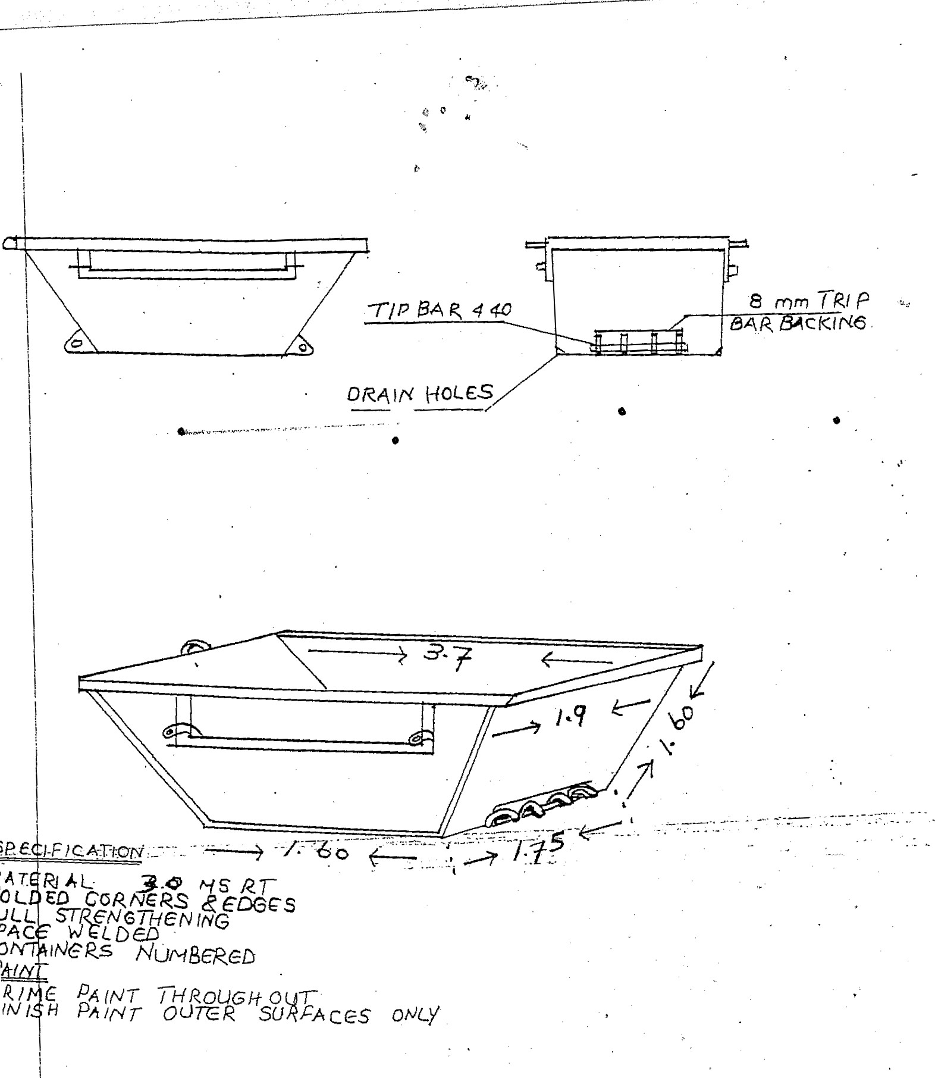
91.-1—
OAc
Details of the premises where these skip containers will be manufactured

Physical address:------------------------------------------------

-------------------------------------------------
-------------------------------------------------
Contact person: ------------------------------------------------
Contact No: ---------------------------------------------

MBD 4

DECLARATION OF INTEREST

1. No bid will be accepted from persons in the service of the state¹.

- Any person, having a kinship with persons in the service of the state, including a blood relationship, may make an offer or offers in terms of this invitation to bid. In view of possible allegations of favouritism, should the resulting bid, or part thereof, be awarded to persons connected with or related to persons in service of the state, it is required that the bidder or their authorised representative declare their position in relation to the evaluating/adjudicating authority.

3 In order to give effect to the above, the following questionnaire must be completed and submitted with the bid.

3.1 Full Name of bidder or his or her representative:……………………………………………..

3.2 Identity Number: ………………………………………………………………………………….

3.3 Position occupied in the Company (director, trustee, shareholder²):………………………..

3.4 Company Registration Number: ……………………………………………………………….

3.5 Tax Reference Number:…………………………………………………………………………

3.6 VAT Registration Number: ……………………………………………………………………

3.7 The names of all directors / trustees / shareholders members, their individual identity
numbers and state employee numbers must be indicated in paragraph 4 below.

3.8 Are you presently in the service of the state? YES / NO

3.8.1 If yes, furnish particulars. ….……………………………………………………………

……………………………………………………………………………………………..

¹MSCM Regulations: “in the service of the state” means to be –
- a member of –
  - any municipal council;
  - any provincial legislature; or
  - the national Assembly or the national Council of provinces;

- a member of the board of directors of any municipal entity;
- an official of any municipality or municipal entity;
- an employee of any national or provincial department, national or provincial public entity or constitutional institution within the meaning of the Public Finance Management Act, 1999 (Act No.1 of 1999);
- a member of the accounting authority of any national or provincial public entity; or
- an employee of Parliament or a provincial legislature.

² Shareholder” means a person who owns shares in the company and is actively involved in the management of the company or business and exercises control over the company.

3.9 Have you been in the service of the state for the past twelve months? ………YES / NO

3.9.1 If yes, furnish particulars.………………………...……………………………………..

…………………………………………………………………………………………….

3.10 Do you have any relationship (family, friend, other) with persons
in the service of the state and who may be involved with
the evaluation and or adjudication of this bid? ………………………………… YES / NO

3.10.1 If yes, furnish particulars.
………………………………………………………………………………
………………………………………………………………………………

3.11 Are you, aware of any relationship (family, friend, other) between
any other bidder and any persons in the service of the state who
may be involved with the evaluation and or adjudication of this bid?YES / NO

3.11.1 If yes, furnish particulars
…………………………………………………………………………………
……………………………….……............................................................

3.12 Are any of the company’s directors, trustees, managers,
principle shareholders or stakeholders in service of the state? YES / NO

3.12.1 If yes, furnish particulars.
……………………………………………………………………………….
……………………………………………………………………………….

3.13 Are any spouse, child or parent of the company’s directors
trustees, managers, principle shareholders or stakeholders
in service of the state? YES / NO

3.13.1 If yes, furnish particulars.
……………………………………………………………………………….
……………………………………………………………………………….

3.14 Do you or any of the directors, trustees, managers,
principle shareholders, or stakeholders of this company
have any interest in any other related companies or
business whether or not they are bidding for this contract. YES / NO

3.14.1 If yes, furnish particulars:
……………………………………………………………………………..
……………………………………………………………………………..

4. Full details of directors / trustees / members / shareholders.

Full Name | Identity Number | State Employee Number

CERTIFICATION

I, ____________________________ THE UNDERSIGNED CERTIFY THAT THE INFORMATION FURNISHED ON THIS DECLARATION FORM IS CORRECT.

ACCEPT THAT THE COUNCIL MAY ACT AGAINST ME SHOULD THIS DECLARATION PROVE TO BE FALSE.

………………………………….. ……………………………………..
Signature Date

…………………………………. …………………………………
Capacity Name of Bidder

MBD 5.1

CONTRACT FORM – PAST EXPERIENCE

Bidders must furnish hereunder details of similar works / service, which they have satisfactorily completed in the past. The information shall include a description of the works, the contract value and the name of the employer.

EMPLOYER | NATURE OF WORK | VALUE OF WORK | DURATION AND COMPLETION DATE | EMPLOYER CONTACT NO

__________________________ __________________________
DATE SIGNATURE OF BIDDER

MBD 6.1

PREFERENCE POINTS CLAIM FORM IN TERMS OF THE PREFERENTIAL PROCUREMENT REGULATIONS 2017

This preference form must form part of all bids invited. It contains general information and serves as a claim form for preference points for Broad-Based Black Economic Empowerment (B-BBEE) Status Level of Contribution

NB: BEFORE COMPLETING THIS FORM, BIDDERS MUST STUDY THE GENERAL CONDITIONS, DEFINITIONS AND DIRECTIVES APPLICABLE IN RESPECT OF B-BBEE, AS PRESCRIBED IN THE PREFERENTIAL PROCUREMENT REGULATIONS, 2017.

- GENERAL CONDITIONS
  - The following preference point systems are applicable to all bids:
- the 80/20 system for requirements with a Rand value of up to R50 000 000 (all applicable taxes included); and
- the 90/10 system for requirements with a Rand value above R50 000 000 (all applicable taxes included).

a) The value of this bid is estimated to exceed/not exceed R50 000 000 (all applicable taxes included) and therefore the …80/20 preference point system shall be applicable; or
b) Either the 80/20 or 90/10 preference point system will be applicable to this tender (delete whichever is not applicable for this tender).

  - Points for this bid shall be awarded for:
- Price; and
- B-BBEE Status Level of Contributor.
  - The maximum points for this bid are allocated as follows:
 | POINTS
PRICE | 80
B-BBEE STATUS LEVEL OF CONTRIBUTOR | 20
Total points for Price and B-BBEE must not exceed | 100

  - Failure on the part of a bidder to submit proof of B-BBEE Status level of contributor together with the bid, will be interpreted to mean that preference points for B-BBEE status level of contribution are not claimed.
  - The purchaser reserves the right to require of a bidder, either before a bid is adjudicated or at any time subsequently, to substantiate any claim in regard to preferences, in any manner required by the purchaser.

- DEFINITIONS
- “B-BBEE” means broad-based black economic empowerment as defined in section 1 of the Broad-Based Black Economic Empowerment Act;
- “B-BBEE status level of contributor” means the B-BBEE status of an entity in terms of a code of good practice on black economic empowerment, issued in terms of section 9(1) of the Broad-Based Black Economic Empowerment Act;
- “bid” means a written offer in a prescribed or stipulated form in response to an invitation by an organ of state for the provision of goods or services, through price quotations, advertised competitive bidding processes or proposals;
- “Broad-Based Black Economic Empowerment Act” means the Broad-Based Black Economic Empowerment Act, 2003 (Act No. 53 of 2003);
- “EME” means an Exempted Micro Enterprise in terms of a code of good practice on black economic empowerment issued in terms of section 9 (1) of the Broad-Based Black Economic Empowerment Act;
- “functionality” means the ability of a tenderer to provide goods or services in accordance with specifications as set out in the tender documents.
- “prices” includes all applicable taxes less all unconditional discounts;
- “proof of B-BBEE status level of contributor” means:
- B-BBEE Status level certificate issued by an authorized body or person;
- A sworn affidavit as prescribed by the B-BBEE Codes of Good Practice;
- Any other requirement prescribed in terms of the B-BBEE Act;
- “QSE” means a qualifying small business enterprise in terms of a code of good practice on black economic empowerment issued in terms of section 9 (1) of the Broad-Based Black Economic Empowerment Act;

- “rand value” means the total estimated value of a contract in Rand, calculated at the time of bid invitation, and includes all applicable taxes;

- POINTS AWARDED FOR PRICE
  - THE 80/20 OR 90/10 PREFERENCE POINT SYSTEMS
A maximum of 80 or 90 points is allocated for price on the following basis:

80/20 or 90/10

or
Where
Ps = Points scored for price of bid under consideration
Pt = Price of bid under consideration
Pmin = Price of lowest acceptable bid

- POINTS AWARDED FOR B-BBEE STATUS LEVEL OF CONTRIBUTOR
  - In terms of Regulation 6 (2) and 7 (2) of the Preferential Procurement Regulations, preference points must be awarded to a bidder for attaining the B-BBEE status level of contribution in accordance with the table below:
B-BBEE Status Level of Contributor | Number of points  (90/10 system) | Number of points  (80/20 system)
1 | 10 | 20
2 | 9 | 18
3 | 6 | 14
4 | 5 | 12
5 | 4 | 8
6 | 3 | 6
7 | 2 | 4
8 | 1 | 2
Non-compliant contributor | 0 | 0

- BID DECLARATION
  - Bidders who claim points in respect of B-BBEE Status Level of Contribution must complete the following:
- B-BBEE STATUS LEVEL OF CONTRIBUTOR CLAIMED IN TERMS OF PARAGRAPHS 1.4 AND 4.1
  - B-BBEE Status Level of Contributor: . = ………(maximum of 10 or 20 points)
(Points claimed in respect of paragraph 7.1 must be in accordance with the table reflected in paragraph 4.1 and must be substantiated by relevant proof of B-BBEE status level of contributor.
- SUB-CONTRACTING
  - Will any portion of the contract be sub-contracted?
(Tick applicable box)

YES |  | NO

    - If yes, indicate:
- What percentage of the contract will be subcontracted............…………….…………%
- The name of the sub-contractor…………………………………………………………..
- The B-BBEE status level of the sub-contractor......................................……………..
- Whether the sub-contractor is an EME or QSE
(Tick applicable box)
YES |  | NO
- Specify, by ticking the appropriate box, if subcontracting with an enterprise in terms of Preferential Procurement Regulations,2017:

Designated Group: An EME or QSE which is at last 51% owned by: | EME  √ | QSE  √
Black people
Black people who are youth
Black people who are women
Black people with disabilities
Black people living in rural or underdeveloped areas or townships
Cooperative owned by black people
Black people who are military veterans
OR
Any EME
Any QSE

- DECLARATION WITH REGARD TO COMPANY/FIRM
  - Name of company/firm:…………………………………………………………………………….
  - VAT registration number:……………………………………….…………………………………
  - Company registration number:…………….……………………….…………………………….
  - TYPE OF COMPANY/ FIRM
Partnership/Joint Venture / Consortium
One person business/sole propriety
Close corporation
Company
(Pty) Limited
[Tick applicable box]
  - DESCRIBE PRINCIPAL BUSINESS ACTIVITIES
…………………………………………………………………………………………………………………………………………………………………………………………………………………………………………………………………………………………………………………………………………………………………………………………………………………………..
  - COMPANY CLASSIFICATION
Manufacturer
Supplier
Professional service provider
Other service providers, e.g. transporter, etc.
[Tick applicable box]

  - Total number of years the company/firm has been in business:……………………………
  - I/we, the undersigned, who is / are duly authorised to do so on behalf of the company/firm, certify that the points claimed, based on the B-BBE status level of contributor indicated in paragraphs 1.4 and 6.1 of the foregoing certificate, qualifies the company/ firm for the preference(s) shown and I / we acknowledge that:
- The information furnished is true and correct;
- The preference points claimed are in accordance with the General Conditions as indicated in paragraph 1 of this form;
- In the event of a contract being awarded as a result of points claimed as shown in paragraphs 1.4 and 6.1, the contractor may be required to furnish documentary proof to the satisfaction of the purchaser that the claims are correct;
- If the B-BBEE status level of contributor has been claimed or obtained on a fraudulent basis or any of the conditions of contract have not been fulfilled, the purchaser may, in addition to any other remedy it may have –

  - disqualify the person from the bidding process;
  - recover costs, losses or damages it has incurred or suffered as a result of that person’s conduct;
  - cancel the contract and claim any damages which it has suffered as a result of having to make less favourable arrangements due to such cancellation;
  - recommend that the bidder or contractor, its shareholders and directors, or only the shareholders and directors who acted on a fraudulent basis, be restricted by the National Treasury from obtaining business from any organ of state for a period not exceeding 10 years, after the audi alteram partem (hear the other side) rule has been applied; and
  - forward the matter for criminal prosecution.

……………………………………….
SIGNATURE(S) OF BIDDERS(S)

DATE: …………………………………..
ADDRESS …………………………………..
…………………………………..
…………………………………..

WITNESSES

- ……………………………………..
- …………………………………….

MBD 6.2

DECLARATION CERTIFICATE FOR LOCAL PRODUCTION AND CONTENT FOR DESIGNATED SECTORS

This Municipal Bidding Document (MBD) must form part of all bids invited. It contains general information and serves as a declaration form for local content (local production and local content are used interchangeably).

Before completing this declaration, bidders must study the General Conditions, Definitions, Directives applicable in respect of Local Content as prescribed in the Preferential Procurement Regulations, 2017,the South African Bureau of Standards (SABS) approved technical specification number SATS 1286:2011 (Edition 1) and the Guidance on the Calculation of Local Content together with the Local Content Declaration Templates [Annex C (Local Content Declaration: Summary Schedule), D (Imported Content Declaration: Supporting Schedule to Annex C) and E (Local Content Declaration: Supporting Schedule to Annex C)].

- General Conditions

  - Preferential Procurement Regulations, 2017 (Regulation 8) make provision for the promotion of local production and content.

  - Regulation 8.(2) prescribes that in the case of designated sectors, organs of state must advertise such tenders with the specific bidding condition that only locally produced or manufactured goods, with a stipulated minimum threshold for local production and content will be considered.

  - Where necessary, for tenders referred to in paragraph 1.2 above, a two stage bidding process may be followed, where the first stage involves a minimum threshold for local production and content and the second stage price and B-BBEE.

  - A person awarded a contract in relation to a designated sector, may not sub-contract in such a manner that the local production and content of the overall value of the contract is reduced to below the stipulated minimum threshold.

  - The local content (LC) expressed as a percentage of the bid price must be calculated in accordance with the SABS approved technical specification number SATS 1286: 2011 as follows:

LC = [1 -x / y] * 100

Where
x is the imported content in Rand
y is the bid price in Rand excluding value added tax (VAT)

Prices referred to in the determination of x must be converted to Rand (ZAR) by using the exchange rate published by South African Reserve Bank (SARB) at 12:00 on the date of advertisement of the bid as indicated in paragraph 4.1 below.

The SABS approved technical specification number SATS 1286:2011 is accessible on http:/www.thedti.gov.za/industrial development/ip.jsp at no cost.

  - A bid may be disqualified if this Declaration Certificate and the Annex C (Local Content Declaration: Summary Schedule)are not submitted as part of the bid documentation;

- The stipulated minimum threshold(s) for local production and content (refer to Annex A of SATS 1286:2011) for this bid is/are as follows:

Description of services, works or goods Stipulated minimum threshold
steel 100%

3. Does any portion of the goods or services offered
have any imported content?
(Tick applicable box)

YES |  | NO

3.1 If yes, the rate(s) of exchange to be used in this bid to calculate the local content as prescribed in paragraph 1.5 of the general conditions must be the rate(s) published by SARB for the specific currency at 12:00 on the date of advertisement of the bid.

The relevant rates of exchange information is accessible on www.reservebank.co.za

Indicate the rate(s) of exchange against the appropriate currency in the table below (refer to Annex A of SATS 1286:2011):

Currency | Rates of exchange
US Dollar
Pound Sterling
Euro
Yen
Other

NB: Bidders must submit proof of the SARB rate (s) of exchange used.

- Where, after the award of a bid, challenges are experienced in meeting the stipulated minimum threshold for local content the dti must be informed accordingly in order for the dti to verify and in consultation with the AO/AA provide directives in this regard.

LOCAL CONTENT DECLARATION
(REFER TO ANNEX B OF SATS 1286:2011)

LOCAL CONTENT DECLARATION BY CHIEF FINANCIAL OFFICER OR OTHER LEGALLY RESPONSIBLE PERSON NOMINATED IN WRITING BY THE CHIEF EXECUTIVE OR SENIOR MEMBER/PERSON WITH MANAGEMENT RESPONSIBILITY (CLOSE CORPORATION, PARTNERSHIP OR INDIVIDUAL)

IN RESPECT OF BID NO. .................................................................................

ISSUED BY: (Procurement Authority / Name of Institution): .........................................................................................................................
NB

- The obligation to complete, duly sign and submit this declaration cannot be transferred to an external authorized representative, auditor or any other third party acting on behalf of the bidder.
- Guidance on the Calculation of Local Content together with Local Content Declaration Templates (Annex C, D and E) is accessible on http://www.thdti.gov.za/industrial development/ip.jsp. Bidders should first complete Declaration D. After completing Declaration D, bidders should complete Declaration E and then consolidate the information on Declaration C. Declaration C should be submitted with the bid documentation at the closing date and time of the bid in order to substantiate the declaration made in paragraph (c) below. Declarations D and E should be kept by the bidders for verification purposes for a period of at least 5 years. The successful bidder is required to continuously update Declarations C, D and E with the actual values for the duration of the contract.

I, the undersigned, …………………………….................................................... (full names),
do hereby declare, in my capacity as ……………………………………… ………..
of ...............................................................................................................(name of bidder entity), the following:

- The facts contained herein are within my own personal knowledge.

- I have satisfied myself that:
- the goods/services/works to be delivered in terms of the above-specified bid comply with the minimum local content requirements as specified in the bid, and as measured in terms of SATS 1286:2011; and
- The local content percentage (%) indicated below has been calculated using the formula given in clause 3 of SATS 1286:2011, the rates of exchange indicated in paragraph 4.1 above and the information contained in Declaration D and E which has been consolidated in Declaration C:
Bid price, excluding VAT (y) | R
Imported content(x), as calculated in terms of SATS 1286:2011 | R
Stipulated minimum threshold for local content (paragraph 3 above)
Local content %, as calculated in terms of SATS 1286:2011

If the bid is for more than one product, the local content percentages for each product contained in Declaration C shall be used instead of the table above.
The local content percentages for each product has been calculated using the formula given in clause 3 of SATS 1286:2011, the rates of exchange indicated in paragraph 4.1 above and the information contained in Declaration D and E.

- I accept that the Procurement Authority / Institution has the right to request that the local content be verified in terms of the requirements of SATS 1286:2011.
- I understand that the awarding of the bid is dependent on the accuracy of the information furnished in this application. I also understand that the submission of incorrect data, or data that are not verifiable as described in SATS 1286:2011, may result in the Procurement Authority / Institution imposing any or all of the remedies as provided for in Regulation 14 of the Preferential Procurement Regulations, 2017promulgated under the Preferential Policy Framework Act (PPPFA), 2000 (Act No. 5 of 2000).

SIGNATURE: DATE: ___________

WITNESS No. 1 DATE: ___________

WITNESS No. 2 DATE: ___________

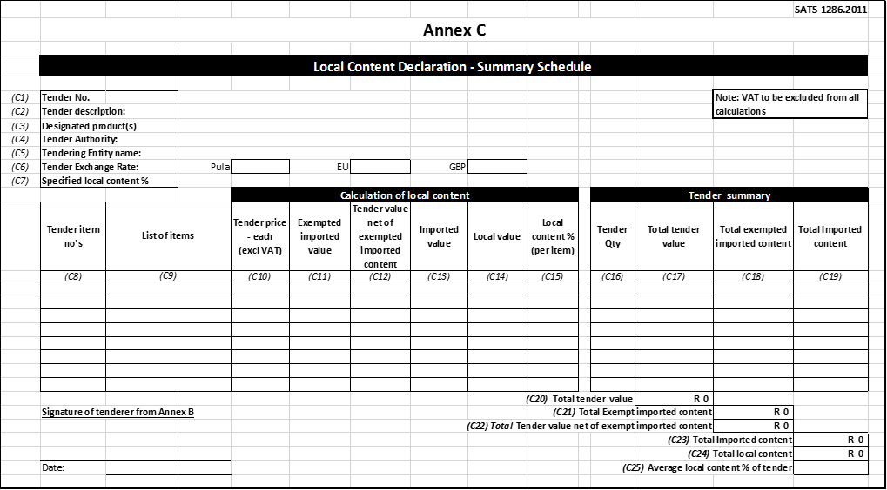

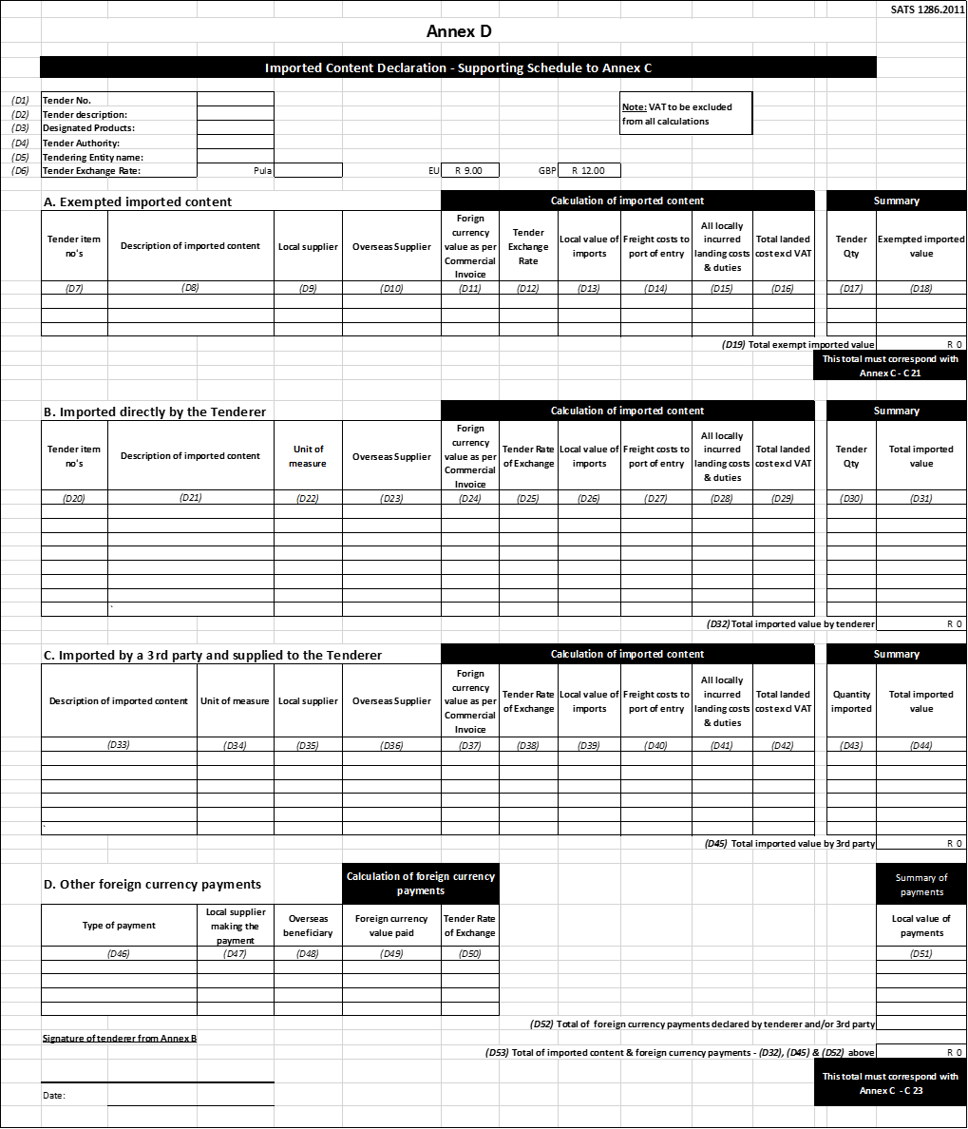

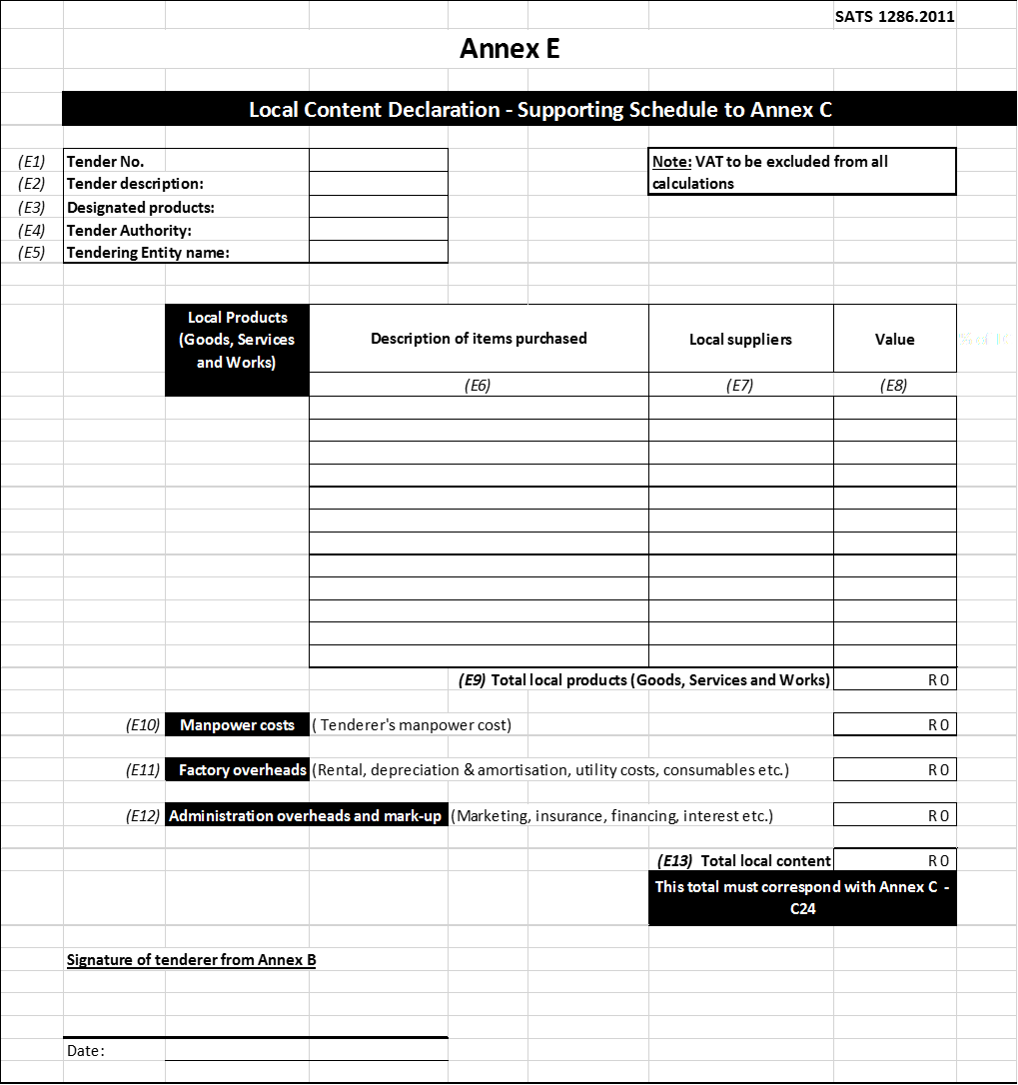

MBD 8

DECLARATION OF BIDDER’S PAST SUPPLY CHAIN MANAGEMENT PRACTICES

- This Municipal Bidding Document must form part of all bids invited.

- It serves as a declaration to be used by municipalities and municipal entities in ensuring that when goods and services are being procured, all reasonable steps are taken to combat the abuse of the supply chain management system.

- The bid of any bidder may be rejected if that bidder, or any of its directors have:

  - abused the municipality’s / municipal entity’s supply chain management system or committed any improper conduct in relation to such system;
  - been convicted for fraud or corruption during the past five years;
  - willfully neglected, reneged on or failed to comply with any government, municipal or other public sector contract during the past five years; or
  - been listed in the Register for Bid Defaulters in terms of section 29 of the Prevention and Combating of Corrupt Activities Act (No 12 of 2004).

- In order to give effect to the above, the following questionnaire must be completed and submitted with the bid.

Item | Question | Yes | No
4.1 | Is the bidder or any of its directors listed on the National Treasury’s Database of Restricted Suppliers as companies or persons prohibited from doing business with the public sector?  (Companies or persons who are listed on this Database were informed in writing of this restriction by the Accounting Officer/Authority of the institution that imposed the restriction after the audi alteram partem rule was applied).  The Database of Restricted Suppliers now resides on the National Treasury’s website(www.treasury.gov.za) and can be accessed by clicking on its link at the bottom of the home page. | Yes | No
4.1.1 | If so, furnish particulars:
4.2 | Is the bidder or any of its directors listed on the Register for Bid Defaulters in terms of section 29 of the Prevention and Combating of Corrupt Activities Act (No 12 of 2004)?  The Register for Bid Defaulters can be accessed on the National Treasury’s website (www.treasury.gov.za) by clicking on its link at the bottom of the home page. | Yes | No
4.2.1 | If so, furnish particulars:
4.3 | Was the bidder or any of its directors convicted by a court of law (including a court of law outside the Republic of South Africa) for fraud or corruption during the past five years? | Yes | No
4.3.1 | If so, furnish particulars:
Item | Question | Yes | No
4.4 | Does the bidder or any of its directors owe any municipal rates and taxes or municipal charges to the municipality / municipal entity, or to any other municipality / municipal entity, that is in arrears for more than three months? | Yes | No
4.4.1 | If so, furnish particulars:
4.5 | Was any contract between the bidder and the municipality / municipal entity or any other organ of state terminated during the past five years on account of failure to perform on or comply with the contract? | Yes | No
4.7.1 | If so, furnish particulars:

CERTIFICATION

I, THE UNDERSIGNED (FULL NAME) …………..…………………………………………..……
CERTIFY THAT THE INFORMATION FURNISHED ON THISDECLARATION FORM TRUE AND CORRECT.

I ACCEPT THAT, IN ADDITION TO CANCELLATION OF A CONTRACT, ACTION MAY BE TAKEN AGAINST ME SHOULD THIS DECLARATION PROVE TO BE FALSE.

………………………………………... …………………………..
Signature Date

………………………………………. ……………………………………………....
Position Name of Bidder

MBD 9

CERTIFICATE OF INDEPENDENT BID DETERMINATION

      - This Municipal Bidding Document (MBD) must form part of all bids¹ invited.

2. Section 4 (1) (b) (iii) of the Competition Act No. 89 of 1998, as amended, prohibits an agreement between, or concerted practice by, firms, or a decision by an association of firms, if it is between parties in a horizontal relationship and if it involves collusive bidding (or bid rigging).² Collusive bidding is a pe se prohibition meaning that it cannot be justified under any grounds.

3. Municipal Supply Regulation 38 (1) prescribes that a supply chain management policy must provide measures for the combating of abuse of the supply chain management system, and must enable the accounting officer, among others, to:

(a)take all reasonable steps to prevent such abuse;

(b) reject the bid of any bidder if that bidder or any of its directors has abused the supply chain management system of the municipality or municipal entity or has committed any improper conduct in relation to such system; and

(c) cancel a contract awarded to a person if the person committed any corrupt or fraudulent act during the bidding process or the execution of the contract.

4. This MBD serves as a certificate of declaration that would be used by institutions to ensure that, when bids are considered, reasonable steps are taken to prevent any form of bid-rigging.

5. In order to give effect to the above, the attached Certificate of Bid Determination (MBD9) must be completed and submitted with the bid:

¹Includes price quotations, advertised competitive bids, limited bids and proposals.

² Bid rigging (or collusive bidding) occurs when businesses, that would otherwise be expected to compete, secretly conspire to raise prices or lower the quality of goods and / or services for purchasers who wish to acquire goods and / or services through a bidding process. Bid rigging is, therefore, an agreement between competitors not to compete.
MBD 9
CERTIFICATE OF INDEPENDENT BID DETERMINATION

I, the undersigned, in submitting the accompanying bid:

________________________________________________________________
(Bid Number and Description)

in response to the invitation for the bid made by:

________________________________________________________________
(Name of Municipality / Municipal Entity)

do hereby make the following statements that I certify to be true and complete in every respect:

I certify, on behalf of:______________________.._______________________that:
(Name of Bidder)

1. I have read and I understand the contents of this Certificate;

2. I understand that the accompanying bid will be disqualified if this Certificate is found not to be true and complete in every respect;

3. I am authorized by the bidder to sign this Certificate, and to submit the accompanying bid, on behalf of the bidder;

4. Each person whose signature appears on the accompanying bid has been authorized by the bidder to determine the terms of, and to sign, the bid, on behalf of the bidder;

5. For the purposes of this Certificate and the accompanying bid, I understand that the word “competitor” shall include any individual or organization, other than the bidder, whether or not affiliated with the bidder, who:

(a) has been requested to submit a bid in response to this bid invitation;

(b) could potentially submit a bid in response to this bid invitation, based on
their qualifications, abilities or experience; and

(c) provides the same goods and services as the bidder and/or is in the same
line of business as the bidder.

6. The bidder has arrived at the accompanying bid independently from, and without
consultation, communication, agreement or arrangement with any competitor. However communication between partners in a joint venture or consortium³ will not be construed as collusive bidding.

7. In particular, without limiting the generality of paragraphs 6 above, there has been no consultation, communication, agreement or arrangement with any competitor regarding:

(a) prices;

(b) geographical area where product or service will be rendered (market allocation);

(c) methods, factors or formulas used to calculate prices;

(d) the intention or decision to submit or not to submit, a bid;

(e) the submission of a bid which does not meet the specifications and conditions of the bid; or

(f) bidding with the intention not to win the bid.

8. In addition, there have been no consultations, communications, agreements or arrangements with any competitor regarding the quality, quantity, specifications and conditions or delivery particulars of the products or services to which this bid invitation relates.

9. The terms of the accompanying bid have not been, and will not be, disclosed by the bidder, directly or indirectly, to any competitor, prior to the date and time of the official bid opening or of the awarding of the contract.

10. I am aware that, in addition and without prejudice to any other remedy provided to combat any restrictive practices related to bids and contracts, bids that are suspicious will be reported to the Competition Commission for investigation and possible imposition of administrative penalties in terms of section 59 of the Competition Act No. 89 of 1998 and or may be reported to the National Prosecuting Authority (NPA) for criminal investigation and or may be restricted from conducting business with the public sector for a period not exceeding ten (10) years in terms of the Prevention and Combating of Corrupt Activities Act No. 12 of 2004 or any other applicable legislation.

__________________________ __________________________
SIGNATURE DATE

__________________________ __________________________
POSITION NAME OF BIDDER

³ Joint venture or Consortium means an association of persons for the purpose of combining their expertise, property, capital, efforts, skill and knowledge in an activity for the execution of a contract.

