
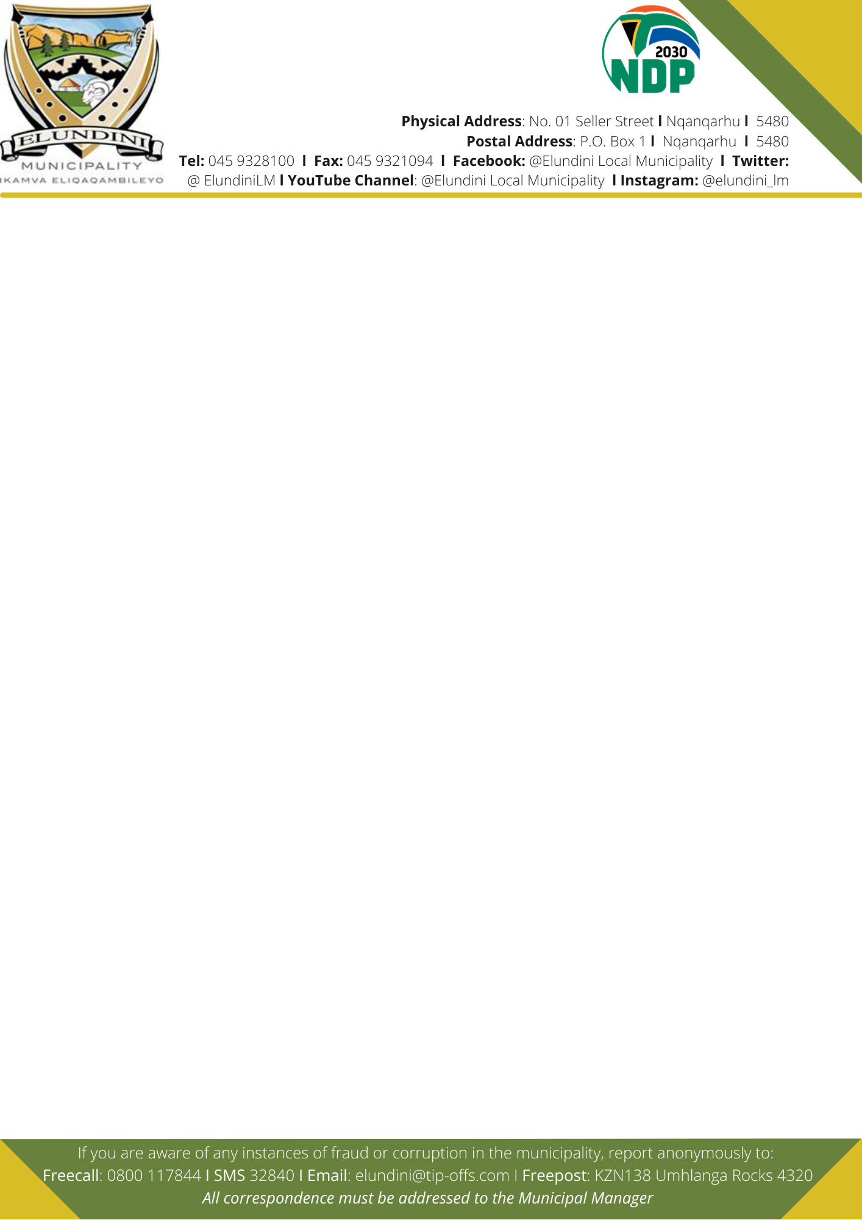

ELUNDINI LOCAL MUNICIPALITY
TENDER NOTICE AND INVITATION TO TENDER

The Elundini Local Municipality is Requesting for Proposals on the following goods and services:
PROJECT NAME | Contract Number | Closing Date | Technical Enquires contacts
Supply and Delivery of LDV Single Cab Vehicle | ELM-2/013/2022-2023 | Wednesday,30 November 2022 | Ms L. Ntshauzana  Tel. 045 932 8219 E-mail:  lindintshawuzana@elundini.gov.za
Supply and Delivery of LDV Double Cab Vehicle | ELM-2/014/2022-2023 | Wednesday,30 November 2022 | Ms L. Ntshauzana  Tel. 045 932 8219 E-mail:  lindintshawuzana@elundini.gov.za
Provision of Physical security services for the period of 3 years | ELM-4/021/2022-2023 | Thursday, 15 December 2022 | Ms M. Ramarou  Tel. 045 932 8261 E-mail:  ramaroum@elundini.gov.za
COMPULSORY BRIEFING:  Town: Tlokoeng  Venue: Municipality Town Hall  Date: Tuesday, 15 November 2022  Time: 10H00 | COMPULSORY SITE INSPECTION: Place  Tlokoeng Municipal Offices and around town  Time: 10H30 | COMPULSORY SITE INSPECTION: Place:Nqanqarhu Municipal Offices and around town  Time: 12H00 | COMPULSORY SITE INSPECTION: Place  Ugie Municipal offices and around town  Time: 13H15

1. To supply and delivery of one (1) LDV Single Cab Vehicle which will be utilised as pool vehicle and will be delivered to Nqanqarhu
2. To supply and delivery of one (1) LDV Double Cab Vehicle which will be utilised as pool vehicle and will be delivered to Nqanqarhu.
3. The Municipality is looking for three (3) suitably qualified and experienced service providers to provide 24/7 physical guards security services within Nqanqarhu, Ugie and Tlokoeng municipal offices and other sites for a period of three (3) years

Contracts will be based on the National Treasury General Condition of Contracts. The bids will be evaluated on the basis of the Preferential Procurement Policy Framework Act (Act No. 5, 2000), the Elundini Local Municipality’s Supply Chain Management Policy and the regulations pertaining thereto (2017) PRICE AND B-BBEE: Price 80, B-BBEE 20

Stage 1 of Evaluation: Eligibility Criteria: ELM-4/021/2022-2023 will be available on Tender Data that will be uploaded on Elundini Local Municipality Website, www.elundini.gov.za and will also be attached on the tender document. Bidders with non-compliant with the requirements of the eligibility criteria will be disqualified and not be considered for further evaluation stage (functionality).

Stage 2 of Evaluation: ELM-4/021/2022-2023 – Quality criteria and maximum score in respect of each of the criteria are as follows:
Quality Criteria | Maximum number of points
PSIRA registration and letter of Good Standing | 10
Company vehicle and equipment | 25
ICASA certification | 10
Corporate security experience and professional conduct of bidder | 25
Proposed Methodology | 30
Total Points | 100

A minimum score of 70% out of total points must be score in order to proceed to the Financial Evaluation in this bid.

Tender documents may be obtained from the Elundini Local Municipality SCM Unit upon payment of a non-refundable amount of R250 (two hundred and fifty Rand), either paid in cash or by means of electronic funds transfer (EFT) to the Elundini Local Municipality.The cash amount is to be paid at the cashier’s office between the hours of 08:00 and 16:00, prior to the collection of the tender documents form the SCM unit. The tender documents will be available from Tuesday, 08 November 2022.

NB: For EFT payment deposit at ELM FNB cheque account No: 62159933772 and use this reference No. 020114350000. Proof of payment to be sent to: kwaneles@elundini.gov.za upon receiving proof payment, Elundini Municipality will email the tender document to the service providers who are unable to make collections.

The Tender Data, Detailed breakdown Quality Criteria, Detailed Scheduled with minimum threshold for Local Content, scope of work including mandatory documents (eligibility criteria) and bid conditions will be uploaded on ELM Website. www.elundini.elundini.gov.za and will be also attached in the tender document.
Queries relating to the issue of these documents may be addressed to Ms H Mduzulwana, Tel No. 045 932 8125 or email: hlubikazi@elundini.gov.za

Completed bid documents and CD or Memory-Stick of the whole tender submission converted into PDF format and supporting documentation must to be placed in a sealed envelope endorsed with RELEVANT PROJECT NAMES AND BID NUMBERS: must be delivered to the Elundini Local Municipality, at No. 1 Seller Street, Nqanqarhu, Finance Department, Cashier’s reception area, and placed in the Tender Box not later than 12H00 Noon on the above mentioned dates for this bids at which time the tenders will be opened in public. Failure to adhere to the above conditions shall deem a bidder non-responsive.

Telegraphic, telephonic, telex, facsimile, e-mail and late tenders will not be accepted. Tenders may only be
submitted on the tender documentation that is issued. Requirements for sealing, addressing, delivery, opening and assessment of tenders are stated in the Tender Data.

_______________________________
JACK MDENI
MUNICIPAL MANAGER

