Schedule 3
Technical Specification

SCOPE OF WORK

Introduction
This document provides the technical specifications for the design, construction and operation of two new regional Sewage Treatment Plants (STPs) and their related infrastructure in two project areas: at uMdloti in the north and at Umkomaas in the south of eThekwini Municipality.
- The northern project area roughly covers the areas of Verulam, Umdloti and Genazzano, including Dube Trade port. The STP effluent will be disposed in the uMdloti River.
- The southern project area roughly covers the areas of Umkomaas, Cragieburn, Magabeni and Danganya/Umgababa. The STP effluent will be used by a neighbouring paper pulp factory.

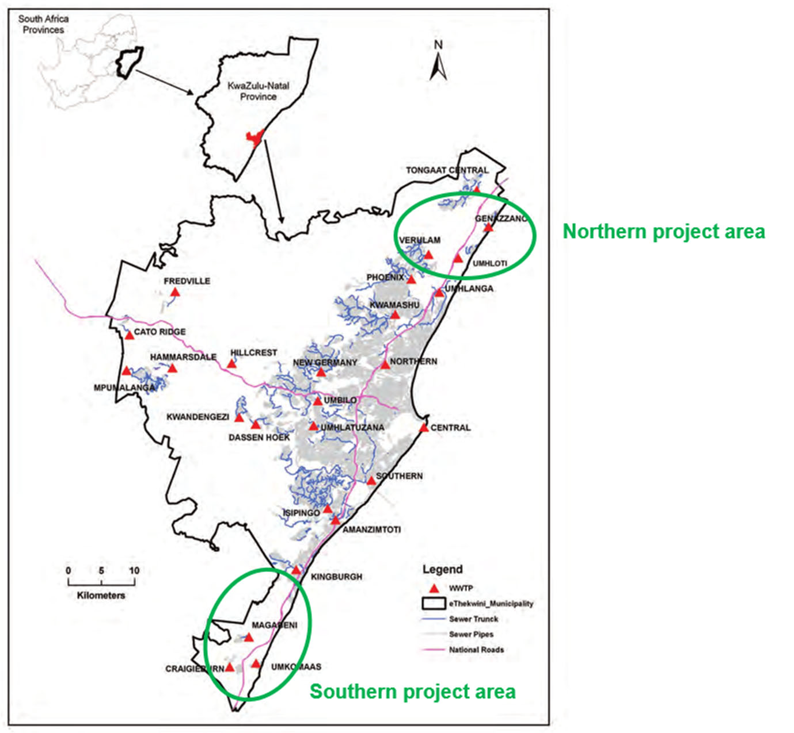
Figure 1: The Two Project Areas

Spatial scope
The spatial scope of the project consists of two new regional Sewage Treatment Plant, the uMdloti and Umkomaas STPs and includes Raw Sewage Conveyance Systems leading from existing STPs to the new STPs. For the uMdloti STP, this concerns four Conveyance systems from the existing Verulam, old uMdloti, Genazzano and KSIA Southern STPs. For the Umkomaas STP it concerns two Conveyance systems from the existing Cragieburn and old Umkomaas STPs.

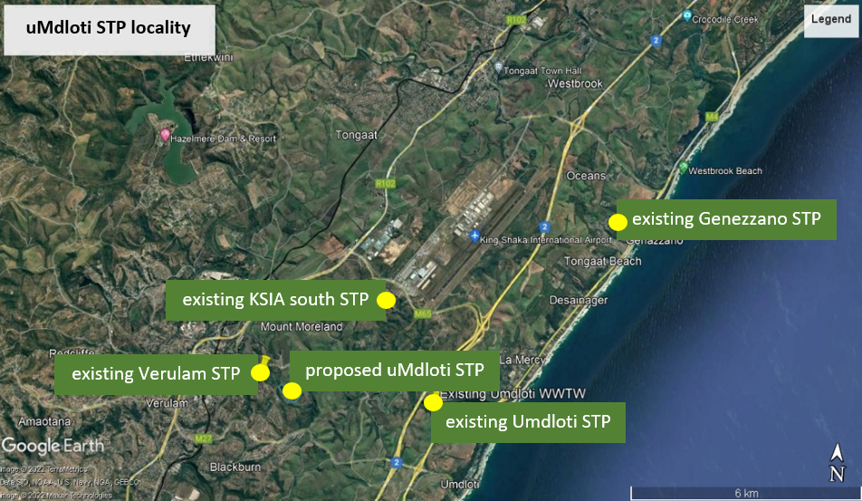
Figure 2: uMdloti Project area (showing the existing STPs to be replaced)

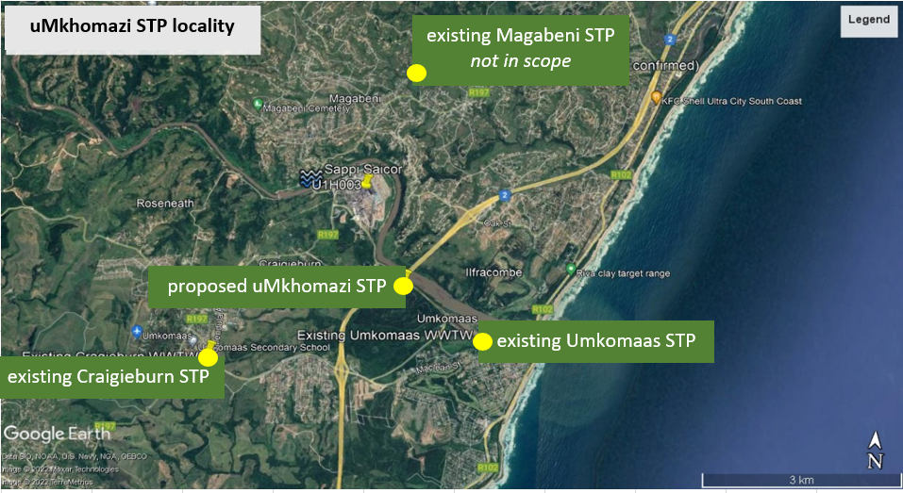
Figure 3: Umkomaas Project area (showing the existing STPs to be replaced)

The project spatial scope for each regional STP is schematised by Figure 4: Spatial scope raw sewage conveyance and STP infrastructure below. The scope is depicted in blue.

Figure 4: Spatial scope raw sewage conveyance and STP infrastructure

Scope of works
The technical scope of the project in the northern area covers:

The Ancillary Works:
- Raw Sewage Conveyance Systems from the existing Verulam, Umdloti, Genezzano and KSIA south STPs to the site of the proposed new STP:
- Decommissioning of these existing STPs;

The Facilities:
- The new regional uMdloti STP, including:
- Treatment of raw wastewater to the required effluent standards;
- Treatment and disposal of STP sludge;
- Pipeline for the disposal of treated effluent to point of discharge in the uMdloti river.

The technical scope of the project in the southern area covers:

The Ancillary Works:
- Raw Sewage Conveyance Systems from the existing Umkomaas and Craigieburn STPs to the site of the proposed new STP;
- Decommissioning of the existing Umkomaas and Craigieburn STPs;

The Facilities
- The new regional Umkomaas STP, including:
- Treatment of raw wastewater to the required effluent standards;
- Treatment and disposal of STP sludge;
- Pipeline for the disposal of treated effluent to point of discharge at the neighbouring paper pulp factory and a bypass discharge in the Umkomaas river.

Scope of operations
Design and construction of the infrastructure will be followed by an Operations period. The wastewater treatment, sludge handling and treated effluent infrastructure shall be operated and maintained by the Concessionaire. The operation and maintenance of the raw sewage conveyance infrastructure will be handed over to the Municipality for operation within a defined period after being put into operation.

OUTPUT SPECIFICATIONS

Raw Sewage Conveyance Systems
The raw sewage conveyance systems shall convey raw sewage from the existing STPs (each representing a “sub-catchment”) to the site of the applicable new regional STP. The conveyance systems shall be designed to accommodate all future flows from the service areas currently covered by sewer networks and areas to be sewered in the future without resulting in spills, overflows or other environmental nuisance.

The hydraulic designs shall be based on the peak wet weather flows (PWWF) as specified below:
Table 2-1: Design flows, raw sewage conveyance
Existing STP | Average daily flow  MLD | Peak hour factor | Peak wet weather flow (Design flow)  m³/hour
uMdloti area
- Verulam STP | 20.29 | 3.5 | 2,972
- Old Umdloti STP | 0.76 | 7.7 | 245
- Genazzano STP | 3.61 | 5.3 | 800
- KSIA Southern STP | 10.34 | 4.1 | 1,781
Umkomaas area
- old Umkomaas STP | 1.62 | 6.5 | 435
- Craigieburn STP | 3.48 | 5.4 | 778

The raw water conveyance pipelines and related infrastructure must meet the following standards:
- Raw sewage Conveyance systems must convey the raw sewage from the sites of the old STPs to the site of the new regional STPs;
- Conveyance pipelines must be capable of conveying the specified PWWFs without overflow or spills to the environment;
- Emergency storage, at least equal to 4 hours of PWWF, must be provided for all pumped systems to mitigate the potential impacts of power outages and equipment failures;
- The infrastructure must be designed and implemented to comply with applicable EWS standards, including EWS design standards;
- The conveyance infrastructure must not result in any public or environmental nuisance (e.g. odour, insects, flooding).

Where flows exceed the specified PWWF, the concessionaire shall be excused from performance for as long as the actual flow exceeds the design flow and shall not be liable for any damage that arises as a consequence of the design flow being exceeded.

Sewage treatment plant

Plant hydraulic capacity
All wastewater flow received at the inlet works of the new regional uMdloti and Umkomaas STPs shall be treated. The design flows for these STPs are as specified below:
Table 2-2: Design flows, new STPs
new STP | Average daily flow | Peak wet-weather flow  day |  | Peak wet-weather flow  hour
new STP | ADF | PF _{day} | PWWF _{day} | PF _{hour} | PWWF _{hour}
new STP | MLD | - | MLD | - | m³/hour
uMdloti STP
Initial capacity | 20 | 2.12 | 42.5 | 4.2 | 3,478
After expansion | 35 | 2.06 | 72.1 | 4.0 | 5,789
Umkomaas STP
Initial capacity | 6 | 2.27 | 13.7 | 4.7 | 1,180
After expansion | 11 | 2.20 | 24.2 | 4.1 | 1,870

The plants shall have a hydraulic capacity to handle the day and hourly peak wet weather flows (PWWF).

The Umdloti STP shall have an initial capacity of 20 MLD and shall be expanded to 35 MLD when required.

The Umkomaas STP shall have an initial capacity of 6 MLD and shall be expanded to 11 MLD when required.

In case the hourly peak weather flow (PWWF_{hour}) exceeds the value in Table 2-2, this shall constitute a Peak Influent Event.

In case trend analysis (of e.g. flows and loads) indicates that the average daily flows (ADF) approach the design capacity of the STP, eThekwini Municipality will enter in negotiations with the Concessionaire to develop the new infrastructure as required to deal with the additional volumes of wastewater, as further detailed in the Concession Agreement.

Effluent Standards, uMdloti STP
The effluent of the STP will be discharged to the adjacent uMdloti River. The ecological sensitivity of the river necessitates a high degree of treatment. Therefore, the minimum discharge standard (output) for the uMdloti treated effluent shall be the “special limit” as defined in the National Water Act 36 of 1998 (NWA). More stringent effluent discharge limits may be defined as an outcome of the ESIA, which will include an Estuarine ecological assessment and a Freshwater Assessment.

Table 2-3: Umdloti STP treated effluent discharge standard (special limit)
Parameter | Units | Discharge in river (special limit)
Faecal coliforms | (per 100 ml) | 0
COD | mg/ℓ | 30
pH |  | 5.5 < pH < 7.5
Ammonia as N | mg/ℓ | 2
Nitrate as N | mg/ℓ | 1.5
Free Chlorine | mg/ℓ | 0
Suspended Solids | mg/ℓ | 10
Electrical Conductivity | mS/m | 50 mS/m above background receiving water to a maximum of 100 mS/m
Ortho Phosphate as P | mg/ℓ | 1 (median)  2.5 (maximum)
Fluoride | mg/ℓ | 1
Soap, oil and grease | mg/ℓ | 0

The treated effluent shall be deemed to have complied with the discharge standard as set out above if all of the determinants listed in the above table, with the exception of pH, do not exceed the values given in the table. The pH of the treated effluent shall be required to fall within the range provided in the above table in order to be deemed to have complied with the discharge standard.

Effluent Standards, Umkomaas STP
The treated effluent will be used by the neighbouring Sappi Saiccor pulp plant as non-pulp process water and then disposed through the plant’s sea outfall. In times that Sappi is not able to take the effluent, the effluent will be discharged into to the Umkomaas River. The quality of the treated effluent shall comply with criteria under two operation conditions:
- When delivered to Sappi for use in its non-pulp process, quality standards are as prescribed by Sappi (“Reuse at Sappi” in the table below).
- During periods of planned annual maintenance and shut-down of the Sappi mill, during which the Sappi mill is unable to take effluent (which will normally be for 2 weeks per year), treated effluent is discharged the Umkomaas River and the “special limit” for effluent disposal in the environment as per NWA (“Discharge in river” in the table below).

Table 2-4: Umkomaas STP treated effluent discharge standard
Parameter | Units | Reuse at Sappi | Discharge in river (special limit)
Faecal coliforms | (per 100 ml) | 0 | 0
COD | mg/ℓ | 65 | 30
pH |  | 5.5 < pH < 9.5 | 5.5 < pH < 7.5
Ammonia as N | mg/ℓ | 3 | 2
Nitrate as N | mg/ℓ | - | 1.5
Free Chlorine | mg/ℓ | 0.25 | 0
Suspended solids | mg/ℓ | 25 | 10
Electrical Conductivity | mS/m | 70 mS/m | 50 mS/m above background receiving water to a maximum of 100 mS/m
Ortho Phosphate as P | mg/ℓ | 1 | 1 (median)  2.5 (maximum)
Fluoride | mg/ℓ | 1 | 1
Soap, oil and grease | mg/ℓ | 2.5 | 0

The treated effluent shall be deemed to have complied with the discharge standard as set out above if all of the determinants listed in the above table, with the exception of pH, do not exceed the values given in the table. The pH of the treated effluent shall be required to fall within the range provided in the above table in order to be deemed to have complied with the discharge standard.
More stringent effluent discharge limits may be defined as an outcome of the ESIA, which will include a Marine and Estuarine ecological assessment and a Freshwater Assessment.

Discharge standard for heavy metals
The National Water Act (36/1998) sets limit values for heavy metal concentrations in effluent to be discharged in water courses. For the uMdloti STP the special limits apply. For Umkomaas STP the general limit applies (for heavy metals) for effluent to be reused by Sappi and special limits apply when the effluent is discharged to the river.

Treated effluent reuse
A treated effluent pipeline and pumping infrastructure must be provided to convey treated effluent from the Umkomaas STP to the Sappi plant. A potential pipeline route has been identified for this treated effluent reuse pipeline with an approximate length of 4 025m.

The pipeline must terminate at the entrance to the Sappi plant and a metered connection must be provided at this point, which shall be the supply point. The residual pressure at the supply point shall be not less than 100 kPa.

A treated effluent discharge pipeline to the Umkomaas River, upstream of the existing weir (U1H003) shall be provided and shall be suitable to provide a means of discharge during periods when the treated effluent cannot be supplied to Sappi.

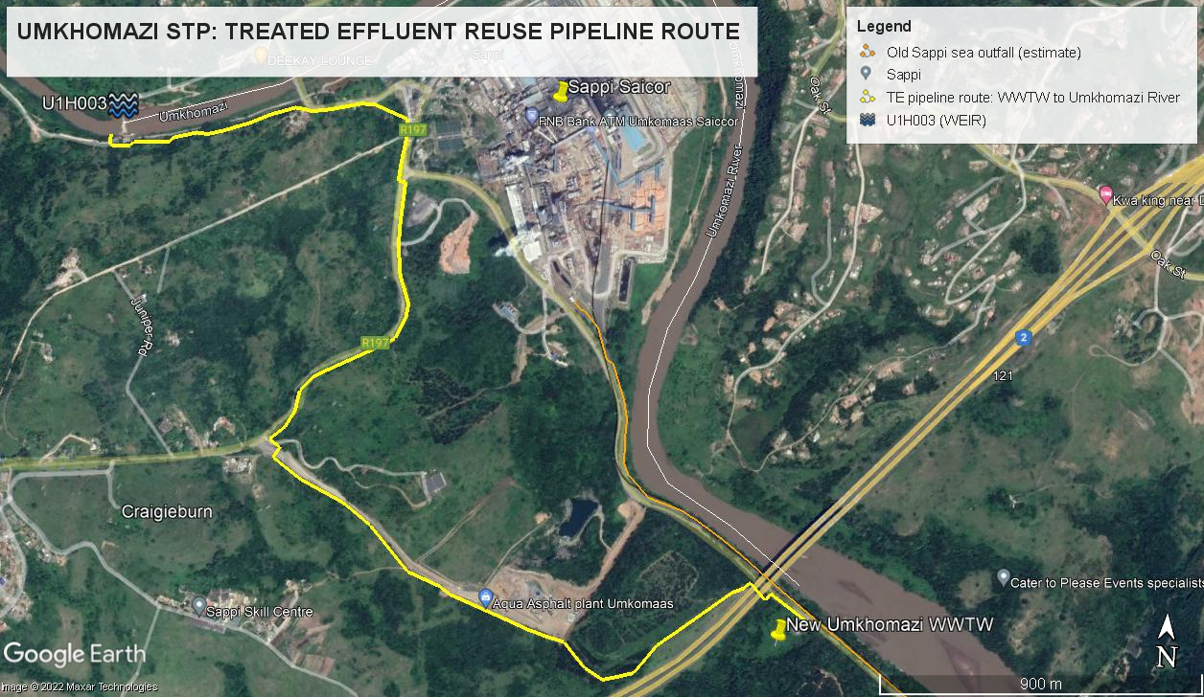
Figure 5: Umkomaas Treated Effluent Pipeline

Sludge treatment and reuse

General requirements
The Concessionaire will be required to treat and dispose of all sludge that is produced by the wastewater treatment process at each of the sites.
As part of the preparation of the ESIA the Concessionnaire shall conduct an analysis of alternatives for managing, treating, and re-using the sludge and prepare a sludge management plan.

Sludge treatment
All sludge shall be treated so that the final sludge achieves a sludge Stability Class of 1 and a SOUR not exceeding 2 mgO₂/gTSS.h.

Sludge disposal
While EWS has expressed a preference for sludge reuse, the method of sludge disposal is not prescribed. However, on-site incineration of sludge will not be permitted.

Disposal of grit and screenings
Disposal of grit and screenings on site will not be permitted. All grit, screenings and detritus that is produced at the sites must be properly disposed of at a suitable waste disposal site.

Mechanical sludge drying
The STP sludge must be dried by mechanical sludge dewatering plant. While solar drying of sludge is permissible, this may only be implemented as a secondary means of drying, e.g. to achieve lower moisture content, after initial mechanical dewatering.

Standards for sludge disposal and reuse
Irrespective the sludge treatment process and means of disposal, sludge produced by the plants, must comply with the relevant standards for reuse or disposal, including:

- South African “Guidelines for the Utilisation and Disposal of Wastewater Sludge” (as amended):
  - Volume 1: Selection of management options
  - Volume 2: Requirements for the agricultural use of sludge
  - Volume 3: Requirements for the on-site and off-site disposal of sludge
  - Volume 4: Requirements for the beneficial use of sludge at high loading rates
  - Volume 5: Requirements for thermal sludge management practices and for commercial products containing sludge
- The South African Guidelines for disposal of wastewater sludges to landfills, are now regulated by the National Environmental Management Waste Act (Act No. 59 of 2008) (NEM:WA). In terms of these regulations, landfills need to have a hazardous rating to allow for disposal of STP sludge to landfill. All sludge that is disposed to landfill shall comply with the requirements of the NEM:WA.
The applicable provisions of the WBG EHS Guidelines for Water and Sanitation, General EHS Guidelines on Wastewater and Ambient Water Quality, as well as the WHO Guidelines for the Safe Use of Wastewater, Excreta and Greywater

Combined heat and power
All biogas that is generated on site must be used for the generation of heat and/or power in order to offset electricity demand from the sites.

Sludge reuse
The beneficial reuse of sludge will be preferred by EWS, particularly where this involves the production of agricultural compost. Note, however, that this is not a prescribed requirement.

Decommissioning of existing STPs
The requirements for decommissioning of the existing STPs are addressed in Schedule 18.

RAW SEWAGE QUALITY

Biological Parameters
The Concessionaire’s responsibility for meeting biological effluent standards is waived in case the quality of raw sewage exceeds the threshold values as listed in the table below.

Table 3-1: Raw sewage quality threshold: uMdloti STP and Umkomaas STP
Parameter | UMDLOTI STP |  | UMKOMAAS STP
Parameter | Load (20 MLD) | Load (35 MLD) |  | Load (6 MLD) | Load (11 MLD)
Parameter | kg/d | kg/d |  | kg/d | kg/d
COD | 18 200 | 31 850 |  | 6 960 | 12 760
Suspended solids | 14 600 | 25 550 |  | 8 760 | 16 060
Ammonia nitrogen as N | 1 000 | 1 750 |  | 360 | 660
Ortho phosphate as P | 200 | 350 |  | 60 | 110

The applicable threshold values shall be determined based on the installed (ADF) capacity. For this purpose threshold values are provided based on installed capacity.

Raw Sewage quality is deemed to exceed threshold values for biological parameters in the event that one or more of the determinants listed in the above table exceeds the threshold for two or more consecutive days. In such an instance the raw sewage is considered to be Off-Specification Influent and the Concessionaire’s responsibility for meeting the effluent standard on the second day (and where applicable on the possible following days) is waived.

Compliance with the threshold is to be determined daily based on daily flow-proportional composite samples.

In the table below a range of values for pH, conductivity, alkalinity and total oil and grease of the raw sewage are provided for the two STPs. These values are provided for information only and do not form part of the threshold values.

Table 3-2: Range of values for selected raw sewage quality parameters: uMdloti STP and Umkomaas STP
Parameter | UMDLOTI STP | UMKOMAAS STP
pH | 6.3 - 9.1 | 6.3 - 8.3
Conductivity (mS/m) | 54 - 336 | 91 (average)
Total alkalinity (mg/l CaCO₃) | 275 (average) | 210 (average)
Total oil and grease (mg/l) | 33 (average) | 23 (average)

In case the electrical conductivity in the effluent exceeds the set limit, and the Concessionaire can demonstrate that this relates to high concentrations of that substance in the incoming raw sewage, the Concessionaire’s responsibility for not meeting the discharge standards is waived. For that purpose, appropriate monitoring of electrical conductivity in the raw sewage and the effluent shall be conducted as specified in Schedule 4.

Heavy Metals
The Concessionaire is not required to install additional treatment processes to remove heavy metals from the effluent with the objective to meet the t discharge standards for heavy metals as set out in Section 2.2.4. As a result, concentrations of heavy metals in the effluent and sludge will be largely dependent on concentrations in the raw sewage.

The Concessionaire shall not be responsible for meeting the discharge standards for heavy metals.

Appropriate monitoring of heavy metal concentrations in the raw sewage and the effluent shall be conducted as specified in Schedule 4. If this data indicates a trend in the concentration of any of the monitored heavy metals that may result in the discharge standard for heavy metals not being met, the Concessionaire shall notify the Municipality of the trend so that the Municipality may implement corrective action.

SPECIAL CONDITIONS

Sites for the infrastructure

General requirements
It will be the responsibility of the eThekwini Municipality to negotiate, arrange and register all land and servitude rights.

The Concessionaire will be required to compile a plan or series of plans (“hand plans”) giving the layout, co-ordinates, cadastral information, dimensions and areas of the land to be acquired or servitudes to be registered. As part of those plans and as per the Minimum E&S requirements, the concessionaire will identify physically or economically displaced persons and, as the case may, be develop a LRP or RAP for land to be acquired or servitudes to be registered. The LRP/RAP will include the entitlements of physically or economically displaced persons provided under applicable national laws and regulations and the supplemental measures that will be implemented by the Concessionaire to satisfy the requirements of the E&S Standards. It will articulate the financial and implementation responsibilities of the parties (Concessionaire, the eThekwini Municipality, and other relevant agencies). These plans shall be provided to EWS for the purpose of negotiating, arranging and registering all land and servitude rights.

Raw sewage conveyance systems
The Feasibility Study, undertaken in preparation of the Project, includes a conceptual design of the raw sewage conveyance systems, indicating potential routes, lengths and diameters of the raw sewage pipelines. An overview is provided below.

uMdloti Area
The following pipeline sections have been conceptualised to make up the uMdloti STP conveyance system:
- Seatides PS to La Mercy PS: | DN500 x 5 489m | (Rising main)
- La Mercy PS to Discharge manhole TM2: | DN500 x 2 943m | (Rising main)
- New Umdloti PS to Discharge manhole TM2: | DN315 x 687m | (Rising main)
- Discharge manhole TM2 to New STP: | DN650 x 10 248m | (Gravity main)
- KSIA STP to New STP: | DN700 x 8 034m | (Gravity main)
- Verulam STP to New STP: | DN750 x 1 036m | (Gravity main)

Figure 6: Schematic layout of the new proposed uMdloti STP raw sewage Conveyance system

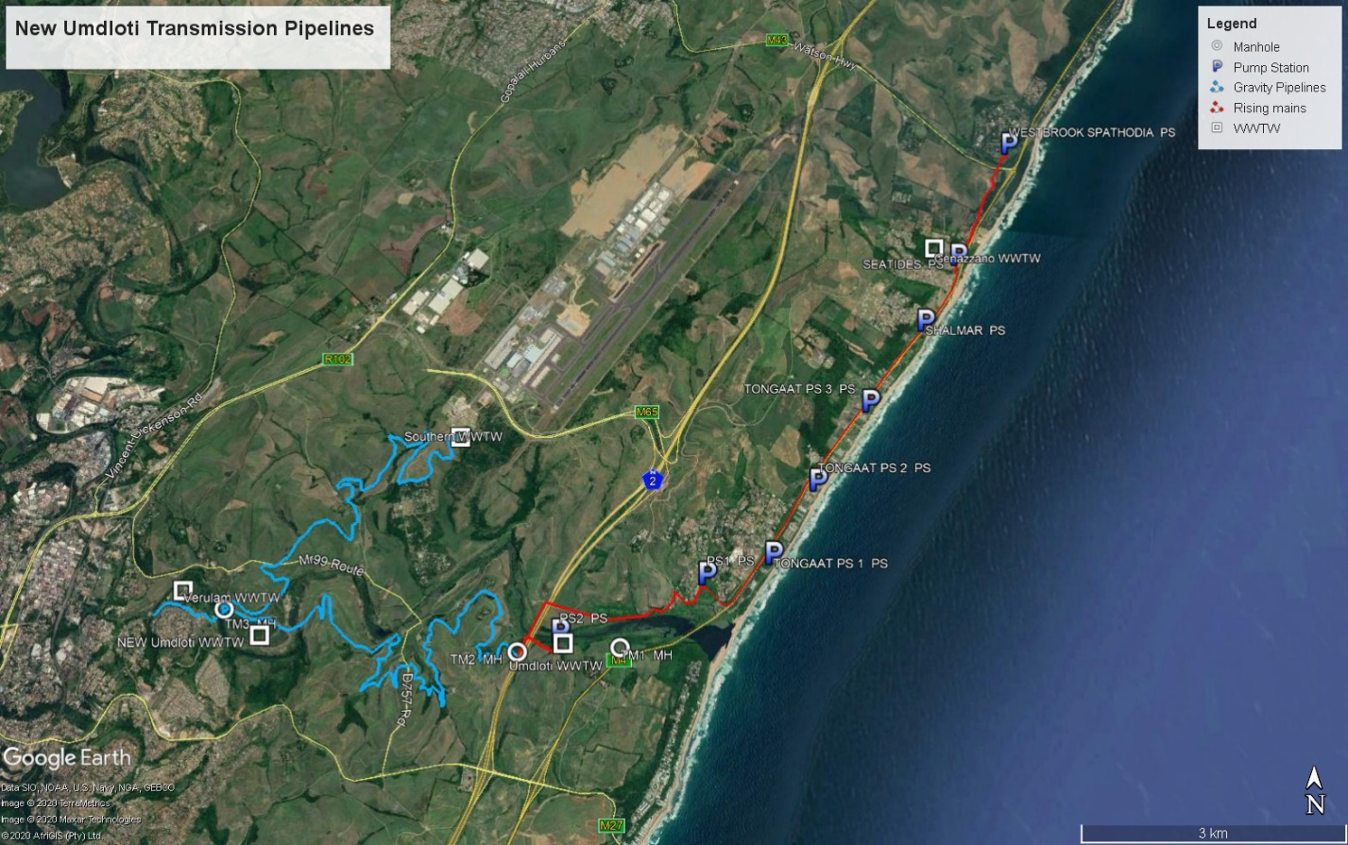
Figure 7: uMdloti STP raw sewage Conveyance system

Umkomaas Area
The following pipeline sections have been conceptualised to make up the Umkomaas STP conveyance pipelines:
- Craigieburn STP to Umkomaas STP | DN350 x 4 160m | (Gravity main)
- Umkomaas (old) STP to Umkomaas STP | DN350 x 1 520m | (Rising main)

Figure 8: Schematic layout of the new proposed Umkomaas STP raw sewage Conveyance system

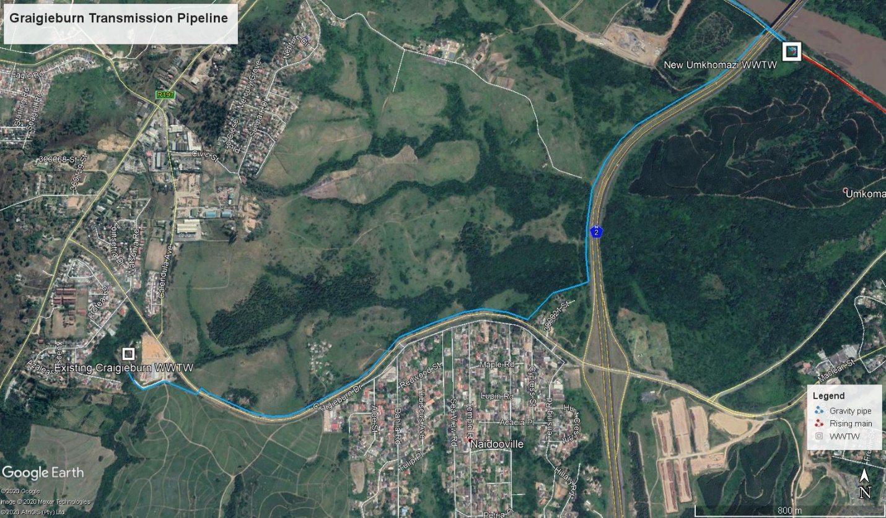
Figure 9: Craigieburn transmission pipeline

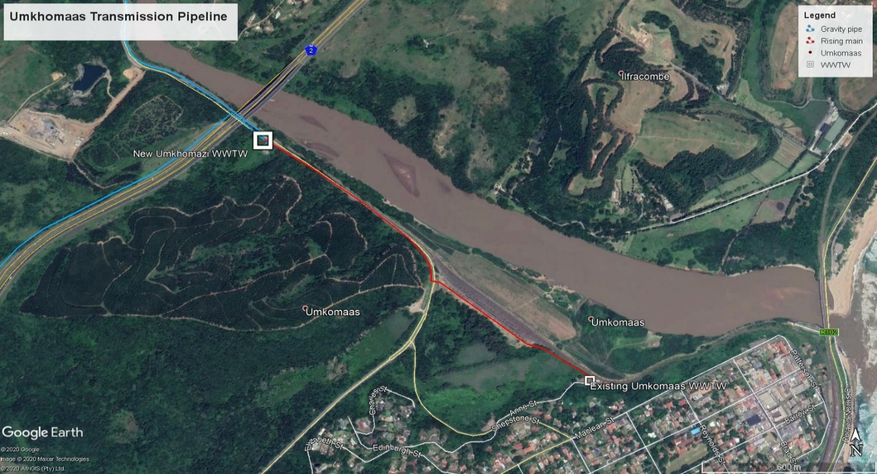
Figure 10: Umkomaas conveyance pipeline

Sewage treatment plants
Sites have been identified for both of the planned new regional STPs and EWS is in the process of procuring the land for the purposes of developing the STPs.

Both the uMdloti STP and the Umkomaas STP will be subject to future capacity upgrades to meet future demands. Infrastructure must be planned and constructed to provide sufficient space for future expansion within the identified site boundaries.
It is possible that the long-term treatment capacity at the uMdloti STP will be equivalent to an ADWF of 125 MLD, while that at Umkomaas STP will be equivalent to an ADWF of 20 MLD. The Concessionaire shall design the STPs subject to the requirements of the Concession Agreement (ADWF of 35 MLD and 11 MLD in two stages at uMdloti and Umkomaas respectively) with a layout that leaves sufficient space to accommodate the long-term capacity.

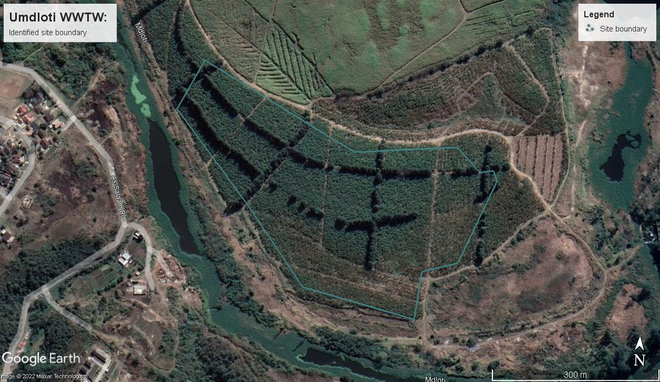
Figure 11: Umdloti STP site

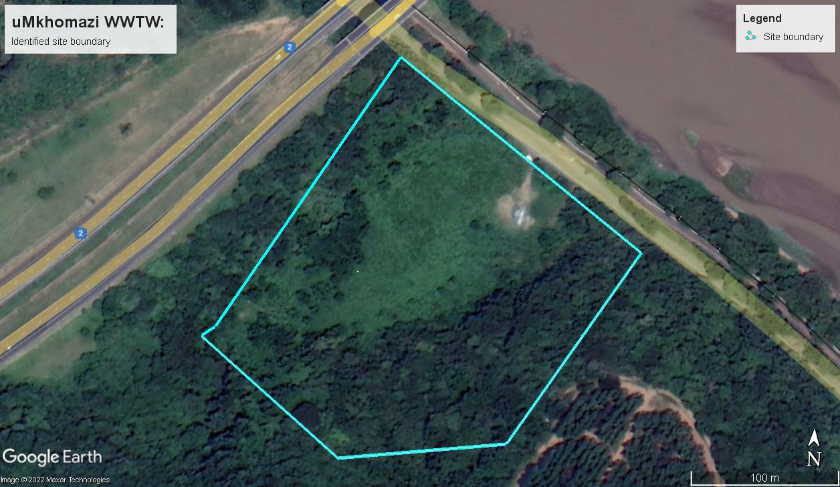
Figure 12: Umkomaas STP site

Treated effluent reuse pipeline (Umkomaas)
No sites have been identified for the treated effluent reuse pipeline and no land acquisition process has been undertaken.

Power supply to infrastructure
There is currently no suitable power supply to either of the STP sites. There is, however, power to the existing STP sites.

The Concessionaire will be required to make all arrangements for both temporary and permanent power supply to the various sites. This includes the new STP sites and any pump stations that may be required for the raw sewage conveyance and treated effluent pipelines.

Backup power supply
The Concessionaire shall provide backup power supply arrangements at sites (i.e. STPs and pumping installations) that can be adversely affected by power supply interruptions. The standby power supply arrangements shall provide sufficient capacity to power critical infrastructure for a duration of not less than 4 hours. Critical infrastructure shall include all processes and operation which, if interrupted, would result in either a deterioration in the quality of treated effluent or overflowing of process units and pumping installations, or both.

Potable water supply to infrastructure
There is currently no suitable potable water supply to either of the STP sites. The Concessionaire will be required to make all arrangements for potable water connections to the new sites.

Access, internal roads and access control
The Concessionaire shall design and construct suitable access roads to provide access to the site. The access road shall terminate at an access control point that shall be set up so as to prevent unauthorised access to the site.

Beyond the access control point, the Concessionaire shall provide internal roads that provide access to the various parts and components of the STP for operation, maintenance and inspection.

Landscaping
The Concessionaire shall reinstate and landscape all areas that are affected by the construction or operation of the STPs and raw sewage conveyance systems. Reinstatement and landscaping shall include:
- grading of surfaces to ensure proper drainage, prevent erosion and allow safe access;
- topsoiling of areas to be planted;
- planting of appropriate vegetation and ground covers.

Fencing
The Concessionaire shall provide a fenced perimeter to the STPs, sewage pump stations and emergency storage facilities so as to ensure that unauthorised access to these sites is prevented.

Topographical surveys and geotechnical investigations
No topographical surveys or geotechnical investigations have been undertaken for the STP site or the conveyance pipeline routes.

DESIGN AND TECHNICAL SPECIFICATIONS

Design Specifications
The design of all infrastructure shall be aligned to the requirements set out in this document and applicable prescribed specifications set out in Table 6-1: List of compulsory standards to be applied.

The following publications and sources shall, to the extent that they are applicable and relevant, provide the basis for “best practice” to be applied where this document and the list of compulsory standards do not provide any suitable design specification:

- METCALF and EDDY Wastewater engineering: Treatment and re-use. 5th Edition. McGraw Hill.
- WATER RESEARCH COMMISSION (2010) Process design guide for small wastewater works. WRC REPORT NO. TT 389/09.
- BRITISH WATER (2005) Code of Practice – Sizing criteria for small wastewater treatment systems.
- WATER ENVIRONMENT FOUNDATION Design of municipal wastewater treatment plants: WEF Manual of Practice No. 8. 5th Edition.
- US EPA (1978) Wastewater treatment plant design guidelines for operability, flexibility and maintainability.

Redundancy
The designs shall include sufficient redundancy (spare capacity) in individual components in each unit operation to ensure that, in case of shutdown of the unit with the largest flow capacity for operational, maintenance or repair purposes, the hydraulic capacity of the remaining units shall be sufficient to handle the peak wastewater flow.

Equalization basis and balancing tank shall not be considered a substitute for redundancy.

The table below provides specific redundancy requirements for selected unit operations and these shall be provided in addition to the general redundancy requirement specified above.
Table 5-1: Redundancy requirements for selected unit operations
Unit operation | Minimum units | Particular requirements
Pumps | 2 | - A backup pump shall be provided for each set of pumps which performs the same function.  - The capacity of the pumps shall be such that with any one pump out of service, the remaining pumps will have capacity to handle the peak flow.  - It is permissible for one pump to serve as backup to more than one set of pumps.
Mechanically cleaned bar screens and equivalent devices | 2 | - Works with only two bar screens shall have at least one additional bar screen designed to permit manual cleaning  - A backup bar screen shall be provided for all screening installations.  - It is permissible for the backup bar screen to be designed for manual cleaning only.
Primary and final sedimentation tanks (basins), digesters | 2 | - There shall be a sufficient number of units of a size, such that with the largest flow capacity unit out of service, the remaining units shall have a design flow capacity of 100 percent of the total design flow to that unit operation.
Trickling filters and filters | 2 | - There shall be a sufficient number of units of a size, such that with the largest flow capacity unit out of service, the remaining units shall have a design flow capacity of at least 85 percent of the total design flow to that unit operation.
Aeration equipment (incl. blowers or mechanical aerators) | 2 | - There shall be a sufficient number of blowers or mechanical aerators to enable the design oxygen transfer to be maintained with the largest capacity unit out of service. It is permissible for the backup unit to be an uninstalled unit, provided that the installed unit can be easily removed and replaced.  - At least two units shall be installed.
Air diffusion systems | 3 (sections) | - The air diffusion system for each aeration basin shall be designed such that the largest section of diffusers can be isolated without measurably impairing the oxygen transfer capability of the system.
Disinfectant contact tanks or basins | 2 | - There shall be a sufficient number of units of a size, such that with the largest flow capacity unit out of service, the remaining units shall have a design flow capacity of at least 80 percent of the total design flow to that unit operation.
Sludge holding tanks | 1 | - The supplied units shall have a design capacity of 100 percent of the total design volume to that unit operation.
Mechanical sludge dewatering plant | 2 | - The capacity of the sludge dewatering plant shall be such that with any one unit out of service, the remaining units will have capacity to handle the design sludge load.

Technical requirements

Raw sewage conveyance pipelines
No pipeline materials, pipeline routes or pumping equipment have been prescribed. Refer to 6 PRESCRIBED STANDARDS for output requirements.

Sewage treatment plants
No specific treatment process or type of equipment is prescribed.

Treated effluent reuse infrastructure
No pipeline materials, pipeline routes or pumping equipment has been prescribed.

Equipment
Unless a particular standard has been prescribed in this document, all equipment and materials shall comply with the applicable standardised specifications published by the South African Bureau of Standards (SABS). Where no applicable standard is published by the SABS, alternative international and industry standards and best practices, including ISO and BS standards, may be adopted.

Civil Works
For all civil works, the Standardized Specifications for Civil Engineering Construction (SABS 1200), issued by the South African Bureau of Standards, shall apply.

PRESCRIBED STANDARDS
The table below provides a summary of the standards that are prescribed for the design, construction and operation of the infrastructure.
Table 6-1: List of compulsory standards to be applied
Reference No. | Standard title
General
- | EWS Guidelines for the Design of Foul-Water Sewers (1999)
TT481-11 | Waterborne Sanitation Design Guide (2011)
- | Guidelines for the Utilisation and Disposal of Wastewater Sludge (Volumes 1 to 5) – Water Research Commission, South Africa
ISO 9000 (series) | Quality management
ISO 14000 (series) | Environmental management
ISO/IEC 17025 | Testing and calibration laboratories
Civil and building works
SANS 1200 (series) | Standardized specification for civil engineering construction
SANS 207 | The design and construction of reinforced soils and fills
ISO 2394 (SANS 2394) | General principles on reliability for structures
SANS 10400 (series) | National Building regulations
SANS 10100-1 | The structural use of concrete
SANS 10120 (Part 3) | Code of practice for use with standardised specifications for civil engineering construction and contract documents: Guidance for design
SANS 10160 | Basis of structural design and actions for buildings and industrial structures
SANS 10161 | Code of Practice for the design of foundations for buildings
SANS 10163 | The structural use of timber
SANS 10164 | The structural use of masonry
BS 8007 | Design of Concrete Structures for Retaining Aqueous Liquids
Structural steel
BS EN 1011 (Parts 1 to 8) | Welding. Recommendations for welding of metallic materials
ISO 12944 | Paints and varnishes — Corrosion protection of steel structures by protective paint systems
SANS 10094 | The use of high-strength friction-grip bolts
SANS 10104 | Handrailing and balustrading (safety aspects)
SANS 10162 | The structural use of steel
SANS 10400 B | The application of the National Building. Regulations. Part B: Structural design.
SANS 50025 | Hot rolled products of structural steels
Mechanical equipment
ISO 10816 | Mechanical vibration
SANS 1700 | Fasteners
SANS 10341 | Installation and maintenance of bearings - General guidelines
SANS 1465 | Steel castings for general engineering applications
SANS 200 | Aluminium and aluminium alloy pressure die castings
SANS 936 & 937 | Spheroidal graphite iron castings / Austenitic spheroidal graphite iron castings
SANS 991 & 992 | Aluminium and aluminium alloy sand castings and gravity die castings
Pipes, pipelines and related
ANSI B36.10 STD/Schedule 40 | Welded and Seamless Wrought Steel Pipe
ASTM A312 | Standard Specification for Seamless, Welded, and Heavily Cold Worked Austenitic Stainless Steel Pipes
BS 778 | Specification for steel pipes and joints for hydraulic purposes
BS EN 13480 (Parts 1 to 6) | Metallic industrial piping
ISO 10804 | Design method for ductile iron pipes
ISO 10804 | Restrained joint systems for ductile iron pipelines
PR EN 13476-1 & ISO 9969 | PE Structured Wall Sewer Pipes (Note that all pipes must be spigotted and socketed with a rubber seal)
SANS 1123 | Flanges
SANS 1209 | Pipe holderbats
SANS 460 | Plain-ended solid drawn copper tubes for potable water
SANS 719 | Electric welded low carbon steel pipes for aqueous fluids (large bore)
SANS 791 | Unplasticised poly(vinyl chloride) (PVC-U) sewer and drain pipes and pipe fittings
SANS 1198 | The manufacture of rubber sheeting for rubber lining
SANS 1217 1B | Internal and external organic coating protection for buried steel pipelines
SANS 966-1 | Components of pressure pipe systems Part 1: Unplasticised polyvinyl chloride (PVC-U) pressure pipe systems
SANS/ISO 1601 | Structured wall pipes and fittings of Unplasticised polyvinyl chloride (PVC-U) for buried drainage and sewerage systems:
SANS/ISO 21138 | Plastic piping systems of Unplasticised polyvinyl chloride (PVC-U) for non-pressure underground drainage and sewerage – structured wall piping systems etc.
SANS/ISO 21307 | Plastics pipes and fittings – butt fusion jointing procedures for polyethylene (PE) pipes and fittings.
SANS/ISO 4427 | Plastics piping systems – Polyethylene (PE) pipes and fittings for water supply:
SANS/ISO 4437 | Metric Series - Buried polyethylene pipes (PE) for the supply of gaseous fuels.
SANS/ISO 8772 | Plastics piping systems for non-pressure underground drainage and sewerage – Polyethylene (PE).
SANS/ISO 967 | Unplasticised polyvinyl chloride (PVC-U) soil, waste and vent pipes and pipe fittings
SIS 05-5900 | Pictorial surface preparation standards for painting steel surfaces
Valves
SANS 664 (1, 2 & 3) | Wedge gate and resilient seal valves for waterworks
SANS 665 | Resilient seal valves for general purposes
SANS 752 | Float valves
SANS 776 | Copper alloy gate valves - Heavy duty
SANS 1056 | Ball valves
SANS 1551 | Check valves
SANS 1849 | Butterfly valves for general purposes
DIN 3210 | Types of electric actuators for valves rated torque, sizes, specifications
ISO 5210 | Industrial valves — Multi-turn valve actuator attachments
Pumps
BS3790 | Specification for belt drives. Endless wedge belts, endless V-belts, banded wedge belts, banded V-belts and their corresponding pulleys
ISO 4183 | Belt drives — Classical and narrow V-belts — Grooved pulleys (system based on datum width)
ISO 9908 | Technical Specification for Centrifugal Pumps
SANS 9906 | Rotodynamic pumps — Hydraulic performance acceptance tests
Electrical, Control and Instrumentation
BS 1042 Part 1 1984 | Measurement of fluid flow in pipes. Orifice plates, nozzles and venturi tubes
BS 381C:1980 | Paint colour chart
EEMUA 191 | Alarm systems
EN 50091-1, -2 | General and safety requirements for UPS
IEC 60068-2-6 | Environmental Testing - Vibration
IEC 60076 | Power transformers
IEC 60502-1 | Power Cables With Extruded Insulation And Their Accessories For Rated Voltages From 1 KV (Um = 1,2 KV) Up To 30 KV (Um = 36 KV) - Part 1: Cables For Rated Voltages Of 1 KV (Um = 1,2 KV) And 3 KV (Um = 3,6 KV)
IEC 60502-2 | Power Cables With Extruded Insulation And Their Accessories For Rated Voltages From 1 KV (Um = 1,2 KV) Up To 30 KV (Um = 36 KV) - Part 2: Cables For Rated Voltages From 6 KV (Um = 7,2 KV) Up To 30 KV (Um = 36 KV)
IEC 60529 | Degrees of Protection Provided by Enclosures (IP Code)
IEC 60794-1-5B | Optical fibre cables – Part 1-2: Generic specification – Basic optical cable test procedures – General guidance
IEC 61131 | Programmable Logic Controllers (All parts)
IEC 61439-0 | Low-voltage switchgear and control gear assemblies  Part 0: Guidance to specifying assemblies
IEC 61643-11 | Surge protection devices – performance requirements and testing methods
IEC 61800-2 | Adjustable speed electrical power drive systems  Part 2: General requirements – Rating specifications for low voltage adjustable frequency A.C. power drive systems
IEC 61800-4 | Adjustable speed electrical power drive systems  Part 2: General requirements – Rating specifications for A.C. power drive systems above 1000V A.C. and not exceeding 35kV
IEC 62040-3 | Uninterruptable Power Systems (UPS) – Method of specifying the performance and test requirements
IEC 62271-200 | A.C. metal-enclosed switchgear and control gear for rated voltages above 1 kV and up to and including 52 kV
IEC 62271-201 | A.C. insulation-enclosed switchgear and control gear for rated voltages above 1 kV and up to and including 52 kV
ISA 88, | Batch Control (all parts)
ISA 95 | Control System-Enterprise Integration
ISA-5.1, | Instrumentation symbols and identification
ISO 10816 | Mechanical vibration
ISO 11064 | Ergonomic design of control centres
SANS 10142-1 | The wiring of premises, Part 1: Low-voltage installations
SANS 1029 | Miniature substations for rated A.C. voltages up to and including 24kV
SANS 1091:2004 | National Colour Standard.
SANS 1274-2005 | Coatings applied by the powder-coating process.
SANS 1973-1 | Low-voltage switchgear and control gear assemblies  Part 1: Type-tested Assemblies with stated deviations and a rated short-circuit withstand current strength above 10kA
SANS 61000-4/IEC 61000-4 | Electromagnetic compatibility – testing and measurement techniques
SANS 780 | Distribution transformers

Acronyms
Acronym | Acronym description
ADF | Average Daily flow
ADWF | Average dry weather flow
COD | Chemical Oxygen Demand
EWS | eThekwini Water and Sanitation (The Municipality)
IRIS | Integrated Regulatory Information System
KSIA | King Shaka International Airport
LIMS | Laboratory Information Management System
MLD | Megalitres per day
NWA | National Water Act 36 of 1998
PF | Peak factor
PWWF | Peak wet weather flow
SOUR | Specific oxygen uptake rate
STP | Sewage Treatment Plant

The hourly peak factor (PF_{hour}) in wet-weather conditions has been derived as a function of average daily flows: PF_{hour} = 38 x ADF ^{-0.24} , where ADF is the average daily flow in m³/day
Average daily flow: The average flow over 24 h during all months of the year. It is composed of the average sewage flow including inflow/infiltration.
The day peak factor (PF_{day}) in wet-weather conditions has been derived as a function of average daily flows: PF_{day} = 3.68 x ADF ^{-0.056} , where ADF is the average daily flow in m³/day
The hourly peak factor (PF_{hour}) in wet-weather conditions has been derived as a function of average daily flows: PF_{hour} = 38 x ADF ^{-0.24} , where ADF is the average daily flow in m³/day
The peak hourly flows for Umdloti STP are calculated as the arithmetic sum of the contributing flows from the raw sewage conveyance infrastructure.
Note that the design flows for the Umkomaas STP include flow contributions from Magabeni STP, but that no pipeline from Magabeni STP is provided for in Table 2-1.
The minimum number of units shall only apply where the unit operation is included in the treatment process, and is not intended as a process prescription.

