RFQ NUMBER | RFQ/MICT/60/2026
RFQ DESCRIPTION | APPOINTMENT OF A SERVICE PROVIDER FOR THE PROVISION OF HYGIENE SERVICES FOR THE WESTERN CAPE REGIONAL OFFICE FOR A PERIOD OF THIRTY-SIX (36) MONTHS
RFQ ISSUE DATE | 16 September 2026
BRIEFING SESSION | N/A
CLOSING DATE & TIME | 21 September 2026 @ 11:00 AM South African Time, RFQ submitted after the stipulated closing date and time will not be considered.
LOCATION FOR SUBMISSIONS | rfqs@mict.org.za
NO: OF DOCUMENTS | 1 SOFT COPY

For queries, please contact rfqs@mict.org.za before the closing date of this RFQ.

The MICT SETA requests your quotation on the services listed above. Please furnish us with all the information as requested and return your quotation on the date and time stipulated above. Late and incomplete submissions will invalidate the quote submitted.

SUPPLIER NAME: _________________________________________________________

NATIONAL TREASURY (CSD) SUPPLIER NUMBER: ________________________________________

POSTAL ADDRESS: _________________________________________________________

TELEPHONE NO: _________________________________________________________

E MAIL ADDRESS: _________________________________________________________

CONTACT PERSON: _________________________________________________________

CELL NO: _________________________________________________________

SIGNATURE OF BIDDER: _________________________________________________________

SUPPLIER REGISTRATION ON CSD

Prospective suppliers must register on the National Treasury Central Supplier database in terms of National Treasury circular no 4A of 2016/17. The bidder shall register prior submitting a proposal/bid.

MICT SETA: CHECKLIST INFORMATION

RETURNABLE DOCUMENTS CHECKLIST

Request For Quotation invitation document must be completed, signed and submitted as a whole by the authorised Company representative. All forms must be properly completed; list below serve as a checklist of your RFQ submission.

(Tick in the relevant block below)

DESCRIPTION | YES | NO
CSD Central Supplier Database (CSD) Registration Report
Pricing Schedule
Valid Tax Clearance Certificate(s) and/or proof of application endorsed by SARS and/or SARS-issued verification pin
SBD 4 – Bidder’s Disclosure
SBD 6.1 - Preferential Procurement Claim Form
Certified Copy of director(s) ID(s) not older than six (6) months
CIPC Document
Shareholding Certificate
Bidder’s eligibility: Form A

Note: This RFQ must be completed by the authorised company representative

MICT SETA –QUOTATION CONDITIONS

- QUOTATION CONDITIONS
NOTE: Quotation for the supply of goods or services described in this document are invited in accordance with the provision of Government Procurement: General Conditions of Contract available for download from http://www.treasury.gov.za/divisions/ocpo/sc/GeneralConditions/

a. MICT SETA does not bind itself to accept the lowest or any RFQ, nor shall it be responsible for or pay any expenses or losses which may be incurred by the bidder in the preparation and delivery of the RFQ.
b. No RFQ shall be deemed to have been accepted unless and until a formal contract/letter of intent is prepared and executed.

1.1 MICT SETA reserves the right to:

a. Not evaluate and award RFQ that do not comply strictly with the requirements of this RFQ.
b. Make a selection solely on the information received in the RFQs and Enter into negotiations with any one or more of the preferred bidder(s) based on the criteria specified in the evaluation of this RFQ.
c. Contact any bidder during the evaluation process, in order to clarify any information, without informing any other bidders, and no change in the content of the RFQ shall be sought, offered, or permitted.
d. Award a contract to one or more bidder(s).
e. Withdraw the RFQ at any stage
f. Accept a separate RFQ or any RFQ in part or full at its own discretion.
g. Cancel this RFQ or any part thereof at any stage as prescribed in the PPPFA regulation.
h. Select the bidder(s) for further negotiations based on the greatest benefit to MICT SETA and not necessarily on the basis of the lowest costs

- COST OF BIDDING

The bidder shall bear all costs and expenses associated with the preparation and submission of its RFQ or RFQ, and the MICT SETA shall under no circumstances be responsible or liable for any such costs, regardless of, without limitation, the conduct or outcome of the bidding, evaluation, and selection processes.

FORM A: BIDDER’S ELIGIBILITY FORM

Name of Bidder:
RFQ Number:

We, the undersigned, offer to provide the required services in accordance with the above Request for quotation and hereby declare that our firm, persons, or its directors, including any JV/Consortium /Association members or subcontractors or suppliers for any part of the contract:

- is not under procurement prohibition by National Treasury, from doing business with the public sector,"
- have not declared bankruptcy, are not involved in bankruptcy or engaged in corrupt / fraudulent practices, and there is no judgment or pending legal action against them that could impair their operations in the foreseeable future;
- undertake not to engage in prescribed practices, including but not limited to corruption, fraud, coercion, collusion, obstruction, or any other unethical practice, with the MICT SETA or any other party, and to conduct business in a manner that averts any financial, operational, reputational or other undue risk to the MICT SETA.
- We declare that all the information and statements made in this Proposal are true and we accept that any misinterpretation or misrepresentation contained in this RFQ submission may lead to elimination of our RFQ submission.

Name: ___________________________________________________________________________________

Title: _____________________________________________________________________________________

Date: ____________________________________________________________________________________

Signature: ________________________________________________________________________________
ANNEXURE A: SPECIFICATION

APPOINTMENT OF A SERVICE PROVIDER TO PROVIDE HYGIENE SERVICES FOR A PERIOD OF
THIRTY-SIX (36) MONTHS.

1. INTRODUCTION

The Media, Information and Communication Technologies Sector Education and Training
Authority (MICT SETA) is a public entity established in terms of Section 9(1) of the Skills
Development Act (Act No. 97 of 1998). The MICT SETA plays a pivotal role in achieving South
Africa’s skills development and economic growth within the 5 distinct sub-sectors it operates
in, i.e., Advertising, Film and Electronic Media, Electronics, Information Technology, and
Telecommunications.

The MICT SETA Cape Town regional office wishes to appoint a suitable service provider for provision of hygiene services for a period 36 of months.

2. SCOPE AND REQUIREMENTS

The appointed will be required is required to comply to the below scope for the duration of
the contract.

The appointed service provider shall be responsible for the supply, installation, maintenance, servicing, replenishment, and cleaning of hygiene-related equipment and consumables for the duration of the contract.

The appointed service provider shall comply with the following requirements:

2.1. Paper Towel Dispensers

- Once-off installation of two (2) paper towel folded dispensers,
- The dispensers shall be maintained and kept in good working condition for the duration of the contract.

2.2. Sanitary Hygiene (SHE) Bins

- Once-off installation of two (2) sanitary hygiene bins,
The bins shall be maintained, serviced, and kept hygienic throughout the contract period.

2.3. Seat Surface Dispensers

- Once-off installation of three (3) seat surface dispensers,
The dispensers shall be maintained and serviced as required.

2.4. Antibacterial Dispensers

- Once-off installation of two (2) antibacterial dispensers,
- The dispensers shall be maintained in good working condition and replenished with the required antibacterial product.

2.5. Urinal Auto-Flush System

- Once-off installation of one (1) automatic urinal flushing system,
- The system shall be maintained and repaired as necessary throughout the contract period.

2.6. Surface Cleaner Foam

- Monthly supply and delivery of three (3) units of surface cleaner foam,
- Products supplied shall be suitable for use in ablution facilities and comply with applicable health and safety requirements.

2.6. Antibacterial Dispenser Soap

- Monthly supply and delivery of one (1) 5-litre container of antibacterial dispenser soap,
- The service provider shall ensure that soap dispensers remain adequately stocked.

2.7. Air Freshener Dispensers

- Once-off installation of two (2) air freshener dispensers,
- The dispensers shall be maintained and kept operational throughout the contract period.

2.8. Air Freshener Refills

- Monthly supply and delivery of four (4) air freshener refills compatible with the installed dispensers.

2.9. Silver Wall Bins

- Once-off installation of two (2) silver wall-mounted bins,
- The bins shall be maintained and kept in a clean and hygienic condition throughout the contract period.

3.0. Quarterly Deep Cleaning

- Quarterly deep cleaning of all ablution facilities shall be undertaken,
- Deep cleaning shall include, but not be limited to, cleaning and sanitising of floors, walls, toilets, urinals, basins, taps, dispensers, bins, doors, and other relevant ablution surfaces, and
- The service provider shall use appropriate cleaning chemicals, equipment, and methods to ensure a high standard of hygiene.

3.1. GENERAL REQUIREMENTS

The appointed service provider shall:

- Provide all labour, equipment, cleaning materials, chemicals, consumables, transport, and other resources necessary to fulfil the requirements,
- Ensure that all installations are carried out professionally and safely,
- Maintain all installed hygiene equipment in good working order for the duration of the contract,
- Replace defective or damaged dispensers/equipment where necessary, subject to the terms of the contract,
- Ensure that all hygiene products supplied are of good quality and fit for their intended purpose,
- Comply with all applicable occupational health and safety, environmental, waste-management, and hygiene requirements,
- Ensure that ablution facilities remain clean, hygienic, presentable, and adequately stocked,
- Submit service reports or maintenance records when requested by the client,
- Attend to breakdowns, faults, or service-related complaints within an agreed response time, and
- Contractor's responsibility: The service provider shall be fully responsible for ensuring continuous availability, functionality, cleanliness, and proper maintenance of all hygiene equipment and consumables specified above for the duration of the contract.

3.2. Hygiene Specification – 2026

No. | Description | Specification | Quantity
1. | Paper Towel Folded Dispenser Silver  - 320 mmX240 mm (C-Fold 100 mm) | 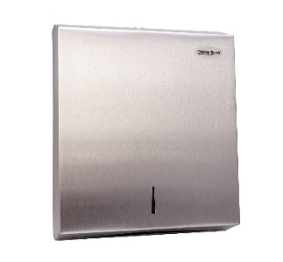 | 2
2. | Silver sanitary bins- SHE bins  - Steel Rectangular Pedal Bin Soft Close Lid Modern 28L |  | 2
3. | Seat surface dispenser silver  - Toilet seat and surface sanitizer dispenser is a wall-mounted device that dispenses 500ml | 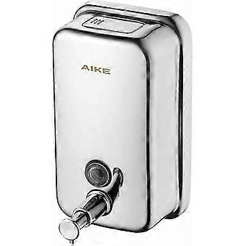 | 3
4. | Antibacterial dispenser silver  Stainless steel antibacterial and soap dispensers 500ml |  | 2
5. | Urinal Auto flush  - Flush Valve Electronic with Infrared Sensor for Urinal | 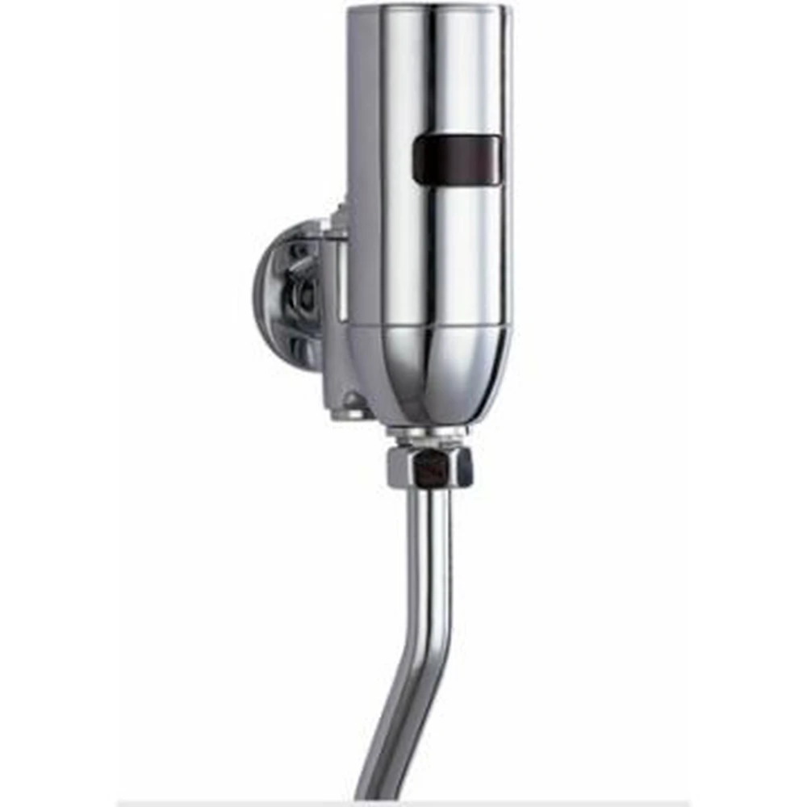 | 1
6. | Surface cleaner foam 500ml | 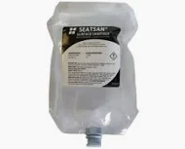
7. | Refresher Dispenser  Spray size 250ml | 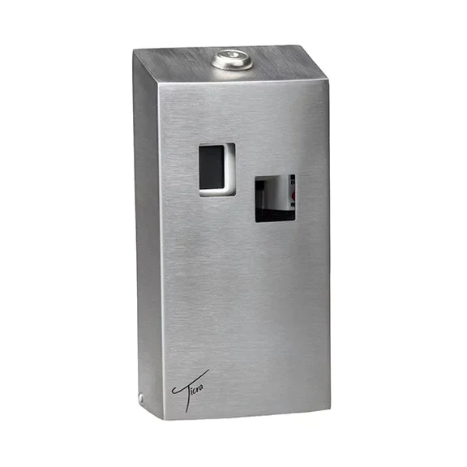 | 4
8. | Refresher Spray 250ml Service |  | 4
9. | - Electric diffuser scenting Unit/ crystal Aire dual waterless Fragrance diffuser electric  - Waterless technology ensures a more potent and pure aromatherapy experience, preserving the therapeutic integrity of your oils without adding moisture to the room  - Coverage Area: 50 m² to 70 m²  - Dimensions: 144 mm x 70 mm x 130 mm  - Material: Aluminium Alloy & ABS Plastic  - Power: USB-C Powered Rechargeable  - Charge Time: Approx. 6.5 Hours  - Oil Capacity: 10 ml per bottle | 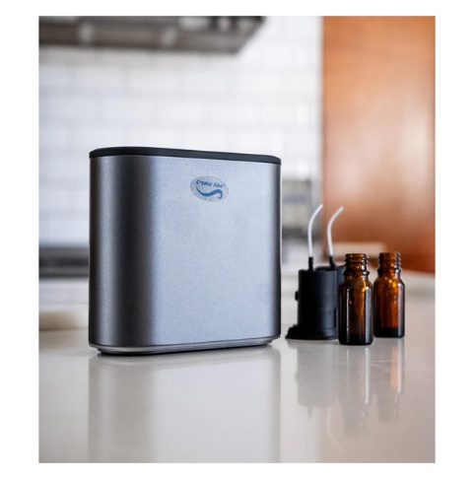 | 1
10. | Deep Cleaning quarterly (three times per year – 12months) | Deep Cleaning quarterly
11. | Blockage, bathrooms/ sink | As and when required.

4. PRICING SCHEDULE

Bidders to provide further cost breakdown where necessary under each line item, and sub-total and the overall RFB price (Total) should be included. The below table below is for illustration only:
Name of bidder_____________________________ RFQ number: __________________

Closing date _______________________________

RFQ shall remain valid for acceptance for a period of 90 days counted from the closing date.

Bidders to provide further cost breakdown where necessary under each line item, and sub-total and the overall RFQ price (Total) should be included. The below table is for illustration only:

ITEM | REQUIREMENT DESCRIPTION  APPOINTMENT OF A SERVICE PROVIDER FOR PROVISION OF HYGIENE SERVICES FOR A PERIOD OF THIRTY-SIX (36) MONTHS | QUANTITY | FREQUENCY | UNIT COST | TOTAL EXCL.  VAT | VAT | TOTAL INCL. VAT
1. | Paper towel folded dispenser Silver, 320 mmX240  mm (C-Fold 100 mm)  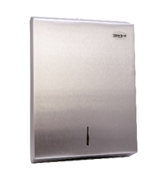 | 2 | Once off installation | R | R | R | R
2. | Silver sanitary bins- SHE bins  • Steel Rectangular Pedal Bin Soft Close Lid Modern 28L  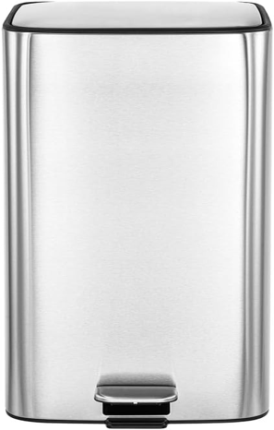 | 2 | Once off installation | R | R | R | R
3. | Seat surface dispenser silver  • Toilet seat and surface sanitizer dispenser is a wall-mounted device that dispenses 500ml Service  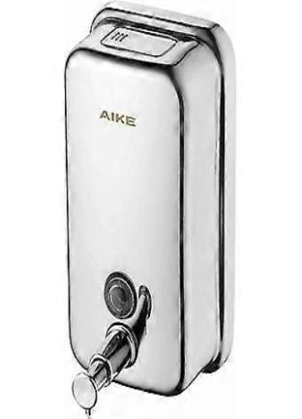 | 3 | Once off installation | R | R | R | R
4. | Antibacterial dispenser silver Stainless steel antibacterial and soap dispensers 500ml Service  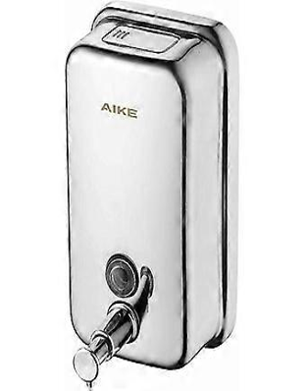 | 2 | Once off installation | R | R | R | R
5. | Urinal Auto flush  • Flush Valve Electronic with Infrared Sensor for Urinal  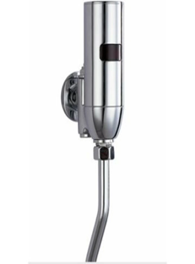 | 1 | Once off installation | R | R | R | R
6. | Surface cleaner foam 500ml, Service  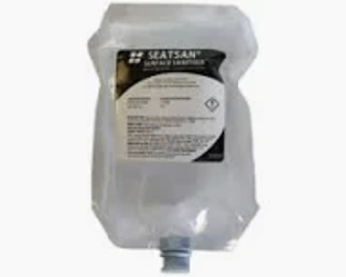 | 3 | Monthly basis | R | R | R | R
7. | Refresher dispenser Spray size 250ml  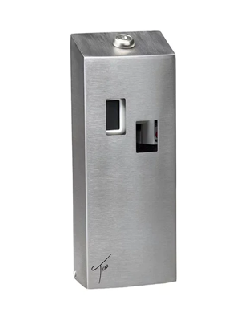 | 4 | Once off installation | R | R | R | R
8. | Refresher Spray 250ml,  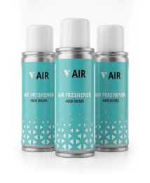 | 4 | Every Month replacement | R | R | R | R
9. | Electric Diffuser Scenting Unit/ Crystal Aire Dual Waterless Fragrance Diffuser electric Waterless technology ensures a more potent and pure aromatherapy experience, preserving the therapeutic integrity of your oils without adding moisture to the room  • Coverage Area: 50 m² to 70 m²  • Dimensions: 144 mm x 70 mm x 130 mm  • Material: Aluminium Alloy & ABS Plastic  • Power: USB-C Powered / Rechargeable  • Charge Time: Approx. 6.5 Hours  • Oil Capacity: 10 ml per bottle Rechargeable  • Charge Time: Approx. 6.5 Hours  • Oil Capacity: 10 ml per bottle  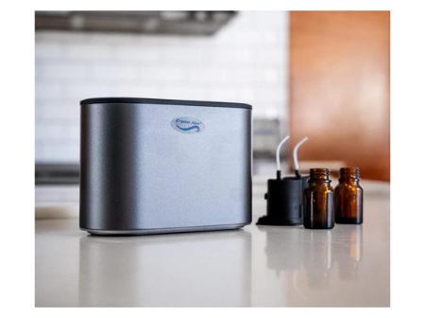 | 4 | Monthly basis | R | R | R | R
10. | Deep cleaning quarterly (three times per year – 12 months) | 3 | Quarterly | R | R | R | R
11. | Blockage, bathrooms/ sink |  | As and when services required | R | R | R | R
MONTHLY SUB-TOTAL |  |  |  | R | R | R | R
YEAR 1 R |  |  |  | R
YEAR 2 R |  |  |  | R
YEAR 3 R |  |  |  | R
TOTAL BID PRICE |  |  |  | R
TOTAL CONTRACT VALUE |  |  |  | R

Complete below:

- Delivery Address: The Boulevard Office Park
Block B Ground Floor
Searle Street
WOODSTOCK
7925

- Indicate Delivery period after order receipt……………….
- Is delivery period fixed? Yes/No
- Is the price(s) fixed? Yes/No
- Is the quote strictly to specification? Yes/No

I/We, the undersigned, agree that this bidding price shall remain binding on me/us and open for acceptance for the period stipulated above.

Authorised Company Representative: _______________________________________________________________________________________________

Capacity under which this quote is signed: ___________________________________________________________________________________________

Signature: __________________________________________________________________________________________________________________________

Date: _____________________________________________________________________________________________________________________________

5. EVALUATION CRITERIA

MICT SETA complies with the provisions of the Public Finance Management Act, Act No. 1 of 1999 as amended; Treasury Regulations of 2005; the Preferential Procurement Policy Framework Act, Act No. 5 of 2000; Preferential Procurement Regulations of 2022; and the MICT SETA Supply Chain Management (SCM) Policy. RFQ’s received will be evaluated on the following criteria:

5.1. FUNCTIONAL CRITERIA

Quotations submitted will be evaluated on the technical functionality out of a maximum of100 points. A threshold of 70 out of the 100 points has been set. Only RFQ submissions that have met or exceeded the qualification threshold on technical functionality of 70 points will qualify for further evaluation on price and specific goals.

FUNCTIONAL CRITERIA WEIGHING
Category | Description | Maximum Points
PROJECT IMPLEMENTATION PLAN | Bidder must provide project implementation plan that outlines how the operations will be managed daily to ensure the level of cleanliness and hygiene and is consistently managed at the highest level through their means. The implementation must include but not limited to:  - Schedule for Deep Cleaning;  - Maintenance of installed equipment and;  - Contingency plan which indicates risk management with regard to resources, transportation etc. and mitigation strategy.  Points on submission of project implementation plan will be allocated as follows:  - Bidder submitted project implementation plan that meets all three (03) elements= 30 points  - Bidder submitted project implementation plan that meets two (02) elements= 20 points  - Bidder submitted project implementation plan that meets one (01) elements= 10 points  Bidder that did not submit project implementation plan elements= 0 point | 30
SAFETY PLAN | Bidder must ensure that this project is carried out in a manner which promotes and incident and injury free site for the duration of the contract. Bidder must submit a Safety Plan that includes not limited to:  - Safe working procedures.  - PPE to be used by Cleaning Personnel.  Points on submission of Safety Plan will be allocated as follows:  - Bidder submitted Safety Plan that meets all the two (02) aspects= 10 points  - Bidder submitted Safety Plan that meets one (01) aspect= 05 points  Bidder submitted Safety Plan that does not meet any of the aspects or did not submit Safety Plan= 0 point | 10
LETTER OF GOOD STANDING | Bidder must ensure compliance with the Compensation for Occupational Injuries and Diseases Act 130 Of 1993 (As Amended). Bidder must submit a valid Letter of Good Standing issued by the Department of Employment and Labour.  Points for submission of valid Letter of Good Standing will be allocated as follows:  - Bidder submitted valid Letter of Good Standing= 10 points  Bidder submitted invalid Letter of Good Standing or did not submit Letter of Good Standing= 0 point | 10
EXPERIENCE OF THE COMPANY | Bidders must have experience in rendering hygiene services or similar services in the past five (05) years. Bidder must provide five (05) contactable reference letters from different clients indicating successful implementation of project. NB: reference letters must be on the client’s letterhead, contactable, signed, dated, indicate project duration and project description.  Points on submission of reference letters will be allocated as follows:  - Five (05) or more reference from different indicating experience in rendering hygiene services or similar services = 15 points  - Four (04) reference letters from different indicating experience in rendering hygiene services or similar services = 12 points  - Three (03) reference letters from different indicating experience in rendering hygiene services or similar services = 09 points  - Two (02) reference letter from different indicating experience in rendering hygiene services or similar services = 06 points  - One (01) reference letter = 03 points  Non-compliance with the minimum requirement = 0 points | 15
BIDDERS LOCATION | Bidder must be based within Cape Town area within 30km radius from Cape Town Regional Office (Searle Street, Woodstock). Bidder must submit proof of registered company address.  Points on submission of proof of address will be allocated as follows:  - Bidder is located in 30km radius or less from Cape Town Regional Office= 10 points  - Bidder is located in more than 30 km radius from Cape Town Regional Office =5 points  Non-compliance with the minimum requirement = 0 points | 10
RELEVANT EXPERIENCE FOR (TEAM SUPERVISOR) | The bidder must demonstrate the capacity and skills required to deliver the project scope by submitting a detailed CV/profile of the proposed Team Supervisor, together with contactable references and/or service certificates confirming the Team Supervisor’s stated experience in supervising hygiene services. The CV/profile must clearly indicate:  The name of the proposed Team Supervisor; The number of years of relevant experience in supervising hygiene services; and relevant duties and responsibilities performed.  The bidder must provide sufficient supporting evidence, in the form of contactable references and/or service certificates, to substantiate the experience claimed in the CV/profile. MICT SETA reserves the right to verify the information provided.  MICT SETA will not award points where the proposed Team Supervisor is not clearly identified or where the claimed experience cannot be substantiated by the information submitted.  Points on submission of Team Supervisor’s experience will be allocated as follows:  - Bidder submitted contactable references and/or service certificates with five (5) years or more=25 points  - Bidder submitted contactable references and/or service certificates with four (4) years=15 points  - Bidder submitted contactable references and/or service certificates with three (3) years=10 points  - Bidder submitted contactable references and/or service certificates with less than three (3) years=0 point  Non-compliance with the minimum requirement = 0 points | 25
TOTAL SCORE |  | 100
MINIMUM SCORE |  | 70

Note: Bidders that do not meet all the above specification requirements will be eliminated from
further evaluation process.

5.2. STAGE 2 PRICE AND SPECIFIC GOALS

Only bidder/s or RFQ submissions that have met the requirements of evaluation criteria will qualify for further evaluation on Price and Specific Goals according to the 80/20 preference point system in terms of the Preferential Procurement Regulations 2022, where 80 points will be for Price and 20 points will be for Specific Goals. RFQ will be awarded to the bidder scoring the highest points. Specific Goal to be evaluated out of 20 Points:

Specific Goals Criteria | Points
Enterprises which are at least 51% owned by historically disadvantaged persons. | 10
Enterprises which are at least 51% owned by historically disadvantaged women. | 05
Enterprises which are at least 51% owned by historically disadvantaged youth. | 05
Total | 20

** Enterprises that are not owned by historically disadvantaged persons will be allocated 0 points.

Bidder must submit the following documents:

- CIPC Document and a valid share certificate(s) (Indicating % shareholding by each director).
- Certified ID Copies of the company’s directors as per CIPC documents. (certified copies must not be older than six (06) months).

Failure on the part of a service provider to submit proof or documentation required in terms of this RFQ to claim points for specific goals, will be interpreted to mean that preference points for specific goals are not claimed.

SBD 4
BIDDER’S DISCLOSURE

- PURPOSE OF THE FORM
Any person (natural or juristic) may make an offer or offers in terms of this invitation to bid. In line with the principles of transparency, accountability, impartiality, and ethics as enshrined in the Constitution of the Republic of South Africa and further expressed in various pieces of legislation, it is required for the bidder to make this declaration in respect of the details required hereunder.

Where a person/s are listed in the Register for Tender Defaulters and / or the List of Restricted Suppliers, that person will automatically be disqualified from the bid process.

- Bidder’s declaration
2.1 Is the bidder, or any of its directors / trustees / shareholders / members / partners or any person having a controlling interest in the enterprise,
employed by the state? YES/NO

2.1.1 If so, furnish particulars of the names, individual identity numbers, and, if applicable, state employee numbers of sole proprietor/ directors / trustees / shareholders / members/ partners or any person having a controlling interest in the enterprise, in table below.
Full Name | Identity Number | Name of State institution

    - Do you, or any person connected with the bidder, have a relationship with any person who is employed by the procuring institution? YES/NO

2.2.1 If so, furnish particulars:……………………………………………………………………………………

2.3 Does the bidder or any of its directors / trustees / shareholders / members / partners or any person having a controlling interest in the enterprise have any interest in any other related enterprise whether or not they are bidding for this contract? YES/NO

    - If so, furnish particulars:…………………………………………………………………………….

- DECLARATION

I, the undersigned, (name)……………………………………………………………………. in submitting the accompanying bid, do hereby make the following statements that I certify to be true and complete in every respect:

3.1 I have read and I understand the contents of this disclosure;
3.2 I understand that the accompanying bid will be disqualified if this disclosure is found not to be true and complete in every respect;
3.3 The bidder has arrived at the accompanying bid independently from, and without consultation, communication, agreement or arrangement with any competitor. However, communication between partners in a joint venture or consortium will not be construed as collusive bidding.
3.4 In addition, there have been no consultations, communications, agreements or arrangements with any competitor regarding the quality, quantity, specifications, prices, including methods, factors or formulas used to calculate prices, market allocation, the intention or decision to submit or not to submit the bid, bidding with the intention not to win the bid and conditions or delivery particulars of the products or services to which this bid invitation relates.
3.4 The terms of the accompanying bid have not been, and will not be, disclosed by the bidder, directly or indirectly, to any competitor, prior to the date and time of the official bid opening or of the awarding of the contract.

3.5 There have been no consultations, communications, agreements or arrangements made by the bidder with any official of the procuring institution in relation to this procurement process prior to and during the bidding process except to provide clarification on the bid submitted where so required by the institution; and the bidder was not involved in the drafting of the specifications or terms of reference for this bid.

  - I am aware that, in addition and without prejudice to any other remedy provided to combat any restrictive practices related to bids and contracts, bids that are suspicious will be reported to the Competition Commission for investigation and possible imposition of administrative penalties in terms of section 59 of the Competition Act No 89 of 1998 and or may be reported to the National Prosecuting Authority (NPA) for criminal investigation and or may be restricted from conducting business with the public sector for a period not exceeding ten (10) years in terms of the Prevention and Combating of Corrupt Activities Act No 12 of 2004 or any other applicable legislation.

I CERTIFY THAT THE INFORMATION FURNISHED IN PARAGRAPHS 1, 2 and 3 ABOVE IS CORRECT.

I ACCEPT THAT THE STATE MAY REJECT THE BID OR ACT AGAINST ME IN TERMS OF PARAGRAPH 6 OF PFMA SCM INSTRUCTION 03 OF 2021/22 ON PREVENTING AND COMBATING ABUSE IN THE SUPPLY CHAIN MANAGEMENT SYSTEM SHOULD THIS DECLARATION PROVE TO BE FALSE.

……………………………… ..……………………………………………
Signature Date

……………………………… ………………………………………………
Position Name of bidder

SBD 6.1
PREFERENCE PROCUREMENT CLAIM FORM

PREFERENCE POINTS CLAIM FORM IN TERMS OF THE PREFERENTIAL PROCUREMENT REGULATIONS 2022

This preference form must form part of all tenders invited. It contains general information and serves as a claim form for preference points for specific goals.

NB: BEFORE COMPLETING THIS FORM, TENDERERS MUST STUDY THE GENERAL CONDITIONS, DEFINITIONS AND DIRECTIVES APPLICABLE IN RESPECT OF THE TENDER AND PREFERENTIAL PROCUREMENT REGULATIONS, 2022

- GENERAL CONDITIONS
  - The following preference point systems are applicable to invitations to tender:
- the 80/20 system for requirements with a Rand value of up to R50 000 000 (all applicable taxes included); and
- the 90/10 system for requirements with a Rand value above R50 000 000 (all applicable taxes included).

  - To be completed by the organ of state

- The applicable preference point system for this tender is the 80/20 preference point system.

- the 80/20 preference point system will be applicable in this tender. The lowest/ highest acceptable tender will be used to determine the accurate system once tenders are received.

  - Points for this tender (even in the case of a tender for income-generating contracts) shall be awarded for:
- Price; and
- Specific Goals.

  - To be completed by the organ of state:
The maximum points for this tender are allocated as follows:
 | POINTS
PRICE | 80
SPECIFIC GOALS | 20
Total points for Price and SPECIFIC GOALS | 100

  - Failure on the part of a tenderer to submit proof or documentation required in terms of this tender to claim points for specific goals with the tender, will be interpreted to mean that preference points for specific goals are not claimed.

  - The organ of state reserves the right to require of a tenderer, either before a tender is adjudicated or at any time subsequently, to substantiate any claim in regard to preferences, in any manner required by the organ of state.

- DEFINITIONS
- “tender” means a written offer in the form determined by an organ of state in response to an invitation to provide goods or services through price quotations, competitive tendering process or any other method envisaged in legislation;
- “price” means an amount of money tendered for goods or services, and includes all applicable taxes less all unconditional discounts;
- “rand value” means the total estimated value of a contract in Rand, calculated at the time of bid invitation, and includes all applicable taxes;
- “tender for income-generating contracts” means a written offer in the form determined by an organ of state in response to an invitation for the origination of income-generating contracts through any method envisaged in legislation that will result in a legal agreement between the organ of state and a third party that produces revenue for the organ of state, and includes, but is not limited to, leasing and disposal of assets and concession contracts, excluding direct sales and disposal of assets through public auctions; and
- “the Act” means the Preferential Procurement Policy Framework Act, 2000 (Act No. 5 of 2000).

- FORMULAE FOR PROCUREMENT OF GOODS AND SERVICES

  - POINTS AWARDED FOR PRICE

3.1.1 THE 80/20 OR 90/10 PREFERENCE POINT SYSTEMS
A maximum of 80 or 90 points is allocated for price on the following basis:

80/20 or 90/10

$Ps=80\left(1-\frac{Pt-P\min{}}{P\min{}}\right)$ or $Ps=90\left(1-\frac{Pt-P\min{}}{P\min{}}\right)$
Where:
Ps = Points scored for price of tender under consideration
Pt = Price of tender under consideration
Pmin = Price of lowest acceptable tender

  - FORMULAE FOR DISPOSAL OR LEASING OF STATE ASSETS AND INCOME GENERATING PROCUREMENT

    - POINTS AWARDED FOR PRICE

A maximum of 80 or 90 points is allocated for price on the following basis:

80/20 or 90/10

$Ps=80\left(1+\frac{Pt-P\max{}}{P\max{}}\right)$ or $Ps=90\left(1+\frac{Pt-P\max{}}{Pmax}\right)$
Where:
Ps = Points scored for price of tender under consideration
Pt = Price of tender under consideration
Pmax = Price of highest acceptable tender

- POINTS AWARDED FOR SPECIFIC GOALS

  - In terms of Regulation 4(2); 5(2); 6(2) and 7(2) of the Preferential Procurement Regulations, preference points must be awarded for specific goals stated in the tender. For the purposes of this tender the tenderer will be allocated points based on the goals stated in table 1 below as may be supported by proof/ documentation stated in the conditions of this tender:
  - In cases where organs of state intend to use Regulation 3(2) of the Regulations, which states that, if it is unclear whether the 80/20 or 90/10 preference point system applies, an organ of state must, in the tender documents, stipulate in the case of—
- an invitation for tender for income-generating contracts, that either the 80/20 or 90/10 preference point system will apply and that the highest acceptable tender will be used to determine the applicable preference point system; or

- any other invitation for tender, that either the 80/20 or 90/10 preference point system will apply and that the lowest acceptable tender will be used to determine the applicable preference point system,
then the organ of state must indicate the points allocated for specific goals for both the 90/10 and 80/20 preference point system.

Table 1: Specific goals for the tender and points claimed are indicated per the table below.
Note to tenderers: The tenderer must indicate how they claim points for each preference point system.)
The specific goals allocated points in terms of this tender | Number of points  allocated  (80/20 system)  (To be completed by the organ of state) | Number of points claimed (80/20 system)  (To be completed by the tenderer)
Enterprise owned by historically disadvantaged persons. | 10
Enterprise owned by historically disadvantaged women. | 05
Enterprise owned by historically disadvantaged youth. | 05

DECLARATION WITH REGARD TO COMPANY/FIRM

  - Name of company/firm…………………………………………………………………….
  - Company registration number: …………………………………………………………...
  - TYPE OF COMPANY/ FIRM
Partnership/Joint Venture / Consortium
One-person business/sole propriety
Close corporation
Public Company
Personal Liability Company
(Pty) Limited
Non-Profit Company
State Owned Company
[Tick applicable box]

  - I, the undersigned, who is duly authorised to do so on behalf of the company/firm, certify that the points claimed, based on the specific goals as advised in the tender, qualifies the company/ firm for the preference(s) shown and I acknowledge that:
- The information furnished is true and correct;
- The preference points claimed are in accordance with the General Conditions as indicated in paragraph 1 of this form;
- In the event of a contract being awarded as a result of points claimed as shown in paragraphs 1.4 and 4.2, the contractor may be required to furnish documentary proof to the satisfaction of the organ of state that the claims are correct;
- If the specific goals have been claimed or obtained on a fraudulent basis or any of the conditions of contract have not been fulfilled, the organ of state may, in addition to any other remedy it may have –

  - disqualify the person from the tendering process;
  - recover costs, losses, or damages it has incurred or suffered as a result of that person’s conduct;
  - cancel the contract and claim any damages which it has suffered as a result of having to make less favourable arrangements due to such cancellation;
  - recommend that the tenderer or contractor, its shareholders, and directors, or only the shareholders and directors who acted on a fraudulent basis, be restricted from obtaining business from any organ of state for a period not exceeding 10 years, after the audi alteram partem (hear the other side) rule has been applied; and
  - forward the matter for criminal prosecution, if deemed necessary.

……………………………………….
SIGNATURE(S) OF TENDERER(S)

SURNAME AND NAME: ……………………………………………………….

DATE: ………………………………………………………

ADDRESS: ………………………………………………………
………………………………………………………
………………………………………………………

………………………………………………………

the power, by one person or a group of persons holding the majority of the equity of an enterprise, alternatively, the person/s having the deciding vote or power to influence or to direct the course and decisions of the enterprise.
Joint venture or Consortium means an association of persons for the purpose of combining their expertise, property, capital, efforts, skill and knowledge in an activity for the execution of a contract.

