TERMS OF REFERENCE
Nature of Service: Install a modern CCTV surveillance system with a 1-year maintenance services when required
1. Background
The HSRC seeks to appoint a company that will supply 6 cameras, install 10 existing, and install a 16-channel modern CCTV surveillance system to improve security and monitor activities around the premises, including corridors, parking areas, and building entrances.
The system shall provide high-quality video coverage, reliable storage, and uninterrupted operation during power failures. The installation will include IP cameras, Network Video Recorders (NVRs), PoE network switches, cabling infrastructure, and power backup systems. The successful bidder will also need to provide a 12 months maintenance services when required (Old bus depot, Mbubu Rd, Sweetwaters, PMB, 3201) based on the following. The estimated start date is 10 April 2026.

2. SCOPE OF WORK
The successful bidder shall supply, install, configure, test, and commission a complete CCTV system as outlined below:

2.1 Supply and Installation
- Supply and install indoor IP dome cameras and outdoor bullet cameras (1080p or latest generation).
- Supply and install six (6) units of 16-channel Network Video Recorders (NVRs).
- Install ten (10) existing units of 16-channel Network Video Recorders (NVRs).
- Install approximately eleven (11) PoE network switches (12-port) in 9U cabinets.
- Divide the premises into 11 sections, each supported by one PoE switch.
- Provide Uninterruptible Power Supply (UPS) for:
  - CCTV system (minimum 8 hours backup).
  - Each PoE network switch.

2.2 Cabling and Infrastructure
- Install all cabling and conduit in accordance with industry standards and safety practices (SAQCC and electronic fire detection cabling standards).
- Ensure neat, safe, and secure installation of all equipment.

2.3 System Configuration and Setup
- Configure and commission the control room viewing console.
- Set up multiple user profiles (e.g., viewing only, viewing and playback).
- Configure recording modes (motion detection and continuous recording).
- Enable event and alarm management features.
- Integrate all cameras with NVRs and network switches.

2.4 System Features
The CCTV system shall include, but not be limited to:
- 1920 × 1080 resolution at 30fps.
- Backlight compensation or infrared for night viewing.
- High-definition video output.
- Storage capacity for at least 120 days of footage.
- Client-server architecture using industry-standard operating systems and protocols.
- Scalability for future camera additions.

2.5 Monitoring and Management
The monitoring system shall support:
- Live view, playback, storage, and alarm linkage.
- User management and access rights management.
- Health monitoring and diagnostics.
- Intrusion detection and line-crossing detection.
- Event-triggered alarms with video clips or still images.
- Remote NVR configuration via web browser.
- Optional facial recognition if feasible.

2. MANDATORY REQUIREMENTS (Bidders who do not comply with the below requirements will be disqualified)
- PSIRA Registration (Company or Technicians) – The company or at least one technician must be registered with the Private Security Industry Regulatory Authority (PSIRA). Provide valid certificates.
- COID Certificate – A copy of a valid Letter of Good Standing from the Compensation Commissioner must be provided (proof of registration alone will not be accepted).
- Public Liability Insurance – Provide proof of insurance cover of at least R500,000.00 per occurrence.
- Occupational Health and Safety Qualification – One or more technicians in the employ of the bidder must have a qualification in Occupational Health and Safety (SAMTRAC / COMSOC / OHS Certificate or relevalent). Provide proof of certification.
- CCTV Technical / Manufacturer Certification – At least one technician must hold a valid CCTV or IP surveillance system installation certification. Provide proof of certification.
- The bidders must provide proof of CIDB registration (1EB) – Provide valid proof
- The bidder must provide at least 12 months warranty on the work done and products supplied
- Experience and References – Provide at least three (3) contactable references where similar CCTV installation services were rendered – complete Table 1 below.

Table 1
Name of Company | Telephone | Contact Person | Services Rendered | Contract value | Contract period
1
2
3

4. Pricing Schedule:

Items | Year 1
Supply 6 cameras
Install 16 cameras and complete system
Cabling infrastructure
Total

Total price for 1-year Service Level Agreement (vat inclusive). Please include escalations R_________________________

5. Site visit
The suppliers are welcome to a non-compulsory site inspection between 08h00am to 16h00pm weekdays before closing date for the RFQ. Contact details below:

Contact name: Simphiwe
Contact details: Snzimande@hsrc.ac.za

Please complete Addendum for unplanned maintenance
ADDENDUM year 1
UNPLANNED MAINTENANCE COSTS
Where applicable, the following rates shall apply for the purpose of calculating any amounts owing in terms of this Agreement:

- LABOUR, NORMAL TIME:
Normal time: 07h00 to 18h00
Qualified Technician with assistant R ................... per hour
Additional assistant R ................... per hour

- LABOUR, OVERTIME:

Overtime: Weekdays 18h00 to 07h00
Weekends and Public Holidays

Qualified Technician with assistant R ................... per hour
Additional assistant R ................... per hour

- TRANSPORT:
Cost in excess of 50km return trip R ................... per Kilometre

- MATERIALS:

Material costs below R5, 000 Cost plus ................ %=R
Material costs between R5, 000 and R10, 000 Cost plus ................ %=R
Material costs above R15, 000 Cost plus ................ %=R

- BREAKDOWNS:

Breakdowns will be charged on an hourly rate as per the Contract and spare parts will be charged on cost plus mark-up as per Contract.

Mileage (Kilometre) claims will only be charged on breakdowns and are dependent on the distance between the service provider’s business premises and the HSRC building in Sweetwaters (Pietermaritzburg office). Payment will only be for mileage claims that exceed 50 kilometres (return trip).

Annexure A.

56 - Staff offices
10 - Toilets
11 - Storage areas
03 - Kitchens

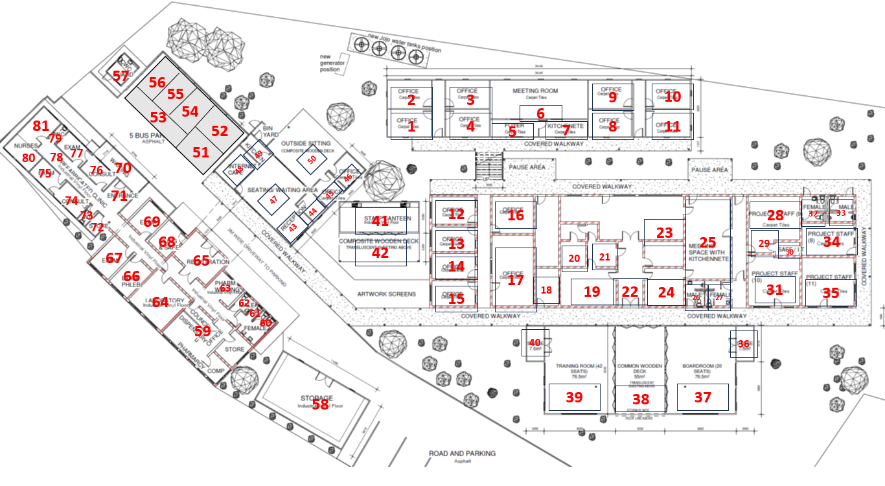
SMT (Office 1 -11)
Main Block (Office 12 – 35)
Admin (Office 43 – 50)
Bottom Block (Office 59 – 69)
Clinic (Office 71 – 79)
Lab (Office 51 – 56)
Pharmacy (Office 80 – 81)

