1 | A2 T- Squares (see attachment)  Specification  Transparent plastic  Acylic  Size 600mm  Detachable Head | 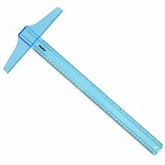
2 | 300mm Long 30˚/60˚ Set Squares (see attachment)  Specification  Transparent plastic  Acylic  Size 300mm | 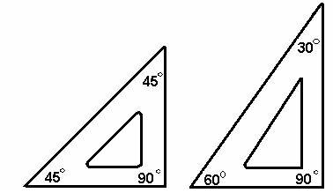
3 | 200mm Long 45˚ Set Squares (see attachment) Specification  Transparent plastic  Acylic  Size 200mm
4 | Pair of compasses (see attachment)  Specification  Materials- stainless steel  Resistant to rust  To be used with A2 and A3 drawing paper | 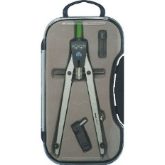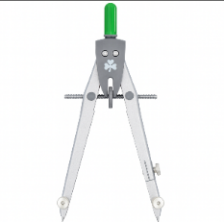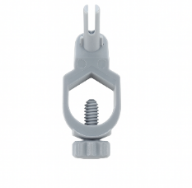
5 | 0.5mm Clutch Pencil leads packs (see attachment) | 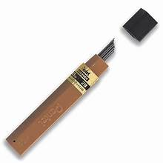
6 | 0.5mm Clutch Pencils (see attachment) | 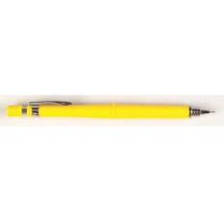
7 | Pencil erasers.
8 | 20mm x 40m Masking tapes (see attachment) | 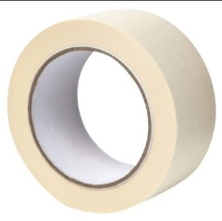
9 | A3 Drawing boards with T-square (see attachment) | 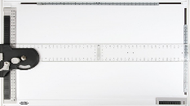
10 | 250mm x 130mm Drawing stencils (see attachment) | 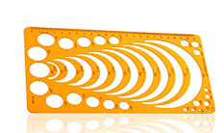
 | Specifications:  - Dimensions: 17.5 x 18.5 cm (Length x Breadth)  - Thickness: 18 mm  - Transparent  - Material: Acrylic | 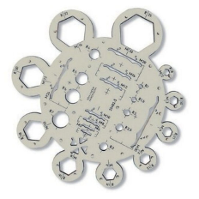
11 | 400mm Flexible curve | 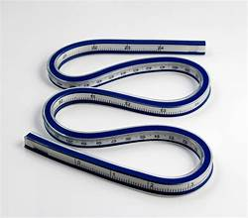
12 | A3 Snow drawing paper, 140 gsm, 100 sheets per rim
13 | A2 Assorted Chart sheets (15 green, 15 yellow, 15 blue, and 15 red) | 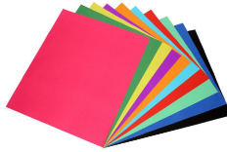
14 | Drawing Board Bag  Specifications:  - Size: A3  - No padding within bag  - Closure type: zip  - Straps to carry as a single shoulder bag  - Material: Nylon  - Black | 