ARC INFRUITEC - NIETVOORBIJ

Private Bag/Private X5026, Stellenbosch, 7599, South Africa
Tel: (021) 809 3093. Fax: (021) 809 3400/3592

Office of the Supply Chain Management

Description of Service: SUPPLY AND DELIVERY NURSERY PLASTIC POTS

Background: Pots needed for glasshouse trials

PURPOSE: Pots needed for glasshouse trials
SCOPE OF WORK: Procurement of plastic nursery pots
SPECIFICATION | Comply with specification. Please indicate (Yes or No)
 | Yes | No | If no, indicate deviation
- Plastic nursery pots medium
- 18 cm diameter
- 15 cm height
- Plastic
- White
- Plastic nursery pots large
- 25 cm diameter
- 20 cm height
- Plastic
- White
GENERAL CONDITIONS FOR THE PURCHASE ORDER AGREEMENT
- Comply with specs.

1.2 PRICING SCHEDULE SUPPLY AND DELIVERY NURSERY PLASTIC POTS

Item description | QTY | Unit price | Total Price
- Plastic nursery pots medium | 100
- Plastic nursery pots large | 100
SUBTOTAL
VAT
GRANDTOTAL

1. The specification prepared by:
DR R Knoetze

Date: 07/02/23

Signature: 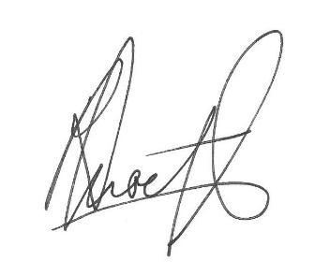

EVALUATION PROCESS & CRITERIA STAGE ONE FOR SUPPLY AND DELIVERY NURSERY PLASTIC POTS
ADMINISTRATIVE COMPLIANCE EVALUATION OF ALL PROPOSALS
 | Comply with specification. Please indicate (Yes or No)
 | Yes | No | If no, indicate deviation
EVALUATION PROCESS: NB: It must be noted that ARC reserve the rights to request for clarification if all the below questions are not answered properly.
STAGE ONE: ADMINISTRATION COMPLIANCE
All suppliers are duly lodged will be examined to determine compliance with quoting requirements and conditions. Quotes with obvious deviations from the requirements/conditions, will be eliminated or disqualified from further adjudication.
          - Mandatory
Quotes will only be compliant if supplier has submitted the following documents:
Administrative documents
- According to National Treasury SCM Instruction number 4 of 2016/2017, only suppliers who are registered on Central Supplier Database (CSD) may be appointed. Suppliers is therefore encourage to register their entities on CSD, www.csd.gov.za and such information will be verified through Central Supply Database (CSD);
- All SBD documents must be submitted and completed;
- The supplier must comply with all the specification
- Contact Details, VAT number, Company registration number, Bank details must be appended on the supplier quote.
          - Non-Mandatory
- Valid B-BBEE certificate or sworn affidavit certify by commissioner of oaths.

Delivery Address: ARC Infruitec Nietvoorbij, Helshoogte Road, Stellenbosch
Supplier’s Details:
Company Name: ……………………………………………………………………….
Contact person: …………………………………………………………………………
Contact number & Email: …………………………………………………………….
Date & Signature: ………………………………………………………………………

