Microsoft Teams Unified Communications

Terms of Reference

PROJECT DESCRIPTION:

APPOINTMENT OF A SERVICE PROVIDER TO MANAGE THE MICROSOFT TEAMS FOR UNIFIED COMMUNICATIONS(UC) SOLUTION FOR ALL HSRC STAFF

- Background & Introduction

  - Background
The Human Sciences Research Council (HSRC) is a research organisation that advances social sciences and humanities for public use. The HSRC subscribes to the values of good governance, accountable public administration and sound management of the resources as reflected in the Public Financial Management Act of 1999 (PFMA as amended by Act 29 of 1999) and other laws and regulations applicable to public administration.
Established in 1968 as South Africa’s statutory research agency the HSRC has grown to become the largest dedicated research institute in the social sciences and humanities on the African continent, doing cutting-edge public research in areas that are crucial to development.
The HSRC’s mandate is to inform the effective formulation and monitoring of government policy; to evaluate policy implementation; to stimulate public debate through the effective dissemination of research-based data and fact-based research results; to foster research collaboration and to help build research capacity and infrastructure for the human sciences.
- PROJECT GOALS

The goals of the Microsoft Teams Unified Communications project includes:
  - Implementing the Teams phone solution for all staff to reliably receive/make phone calls while working from anywhere on any device.
  - Implementing the Teams Video conferencing to reliably receive/make calls while working from anywhere on any device.
  - Implementing the Teams teleconferencing to reliably receive/make calls while working from anywhere on any device.

- SCOPE OF WORK
Accredited service providers are invited to provide proposals for the deployment of the Microsoft Teams Unified Communications system, hardware, training and documentation. The implementation of the solution should be aligned with the existing Microsoft Enterprise agreement in place ending in March 2023.

Service Provider to leverage the Microsoft Teams solution, existing licensing, features, hardware and performance needed to deliver an adequate Unified Communication solution for the HSRC’s environment.

  - SERVICE REQUIREMENTS
The HSRC currently has Microsoft Enterprise 1/3/5 and F3 plans.

Voice add-on licenses are required to supplement the existing O365 plans to enable the following:
  - Microsoft Teams Domestic Calling Plan
  - Microsoft Teams International Calling Plan (when required)
- Audio and Video Conferencing
- User Presence
- Simultaneous Ring
- Call from Email
- Exchange Automated Voicemail Attendant
- Migrate (Porting) existing phone numbers for all staff members to Teams phone -
- Service and maintenance contract
- Self-service administration portal, which will allow the HSRC to manage the account and report on data/voice usage, view bills etc.
- Bidder shall set up a billing system that reports on usage per user and cost Centre to ensure recovery of the telephone expenses with monthly feedback to HSRC.

  - Software configuration
- Deploy Microsoft Teams phone software
- Enable staff to receive incoming calls, make outgoing, receive voicemail to phone, forward calls, conduct conferencing, transcribe calls, and utilize other common VOIP phone features via the Teams app

  - Licensing Specifications
- Provide recommendations on calling plans and licensing requirements
- Deploy users under the Microsoft Teams phone licensing

  - Testing requirements
- Test the performance of the Teams phone app and desktop phones in the HSRC office environment
- Assess the features, reliability, and performance of Teams to determine the adequacy and as a call centre solution for the HSRC
- Assess the features, reliability, and performance of Teams to determine adequacy as an eFax solution
- Assess Teams support for Time Division Duplex – transmission and receive

  - Training and Documentation Requirements
- Provide necessary training to all staff on Teams softphone and Teams compatible desktop phones
- Provide advanced administrative training to HSRC’s IT staff on maintaining and configuring the Teams phone platform
- Create documentation on Teams platform setup of phone and user documentation for technicians.

  - Internet Connectivity
The deployed Teams solution must leverage the HSRC’s existing internet connectivity and available bandwidth (Refer to section 8).

  - Testing/ Pilot phase
- Twenty (20) HSRC staff members will participate in a physical pilot test of the Teams phone solution
- Eight (8) of the 20 staff members will participate in piloting a Teams compatible desk phone
- All four (4) HSRC offices are to form part of the Polycom video conferencing physical testing.

- Implementation phase
It is expected that the solution will be implemented within one (1) month from the signing of the contract by both parties.
- PRICING SCHEDULE
The price schedule must cover the 24 months maintenance contract period.

NB: Bidders are required to provide a detailed cost breakdown in a table format.
- Unless stated otherwise below, all proposed costing shall be fixed against any increase for the duration of the contract period.
- Delivery charges, fees, insurance, expenses, and/or overheads must be included in the total cost.

- HSRC Offices -

Office | No of extensions (estimate)
Pretoria | 215
Cape Town | 130
Durban | 80
Sweetwaters | 50

It is required that the new handsets will be owned by the successful bidder and maintained as part of the solution offering.

- Internal LAN
The HSRC is using Juniper Ex-series 48 ports switches across the network and all of these switches are Power over Ethernet (PoE's) compatible.

- Juniper Gig switches (PoE) – Rack-mountable.
- Cat5 cabling in Pretoria and Sweetwaters offices.
- Cat6 cabling in Durban and Cape Town offices.
- VLANs in all offices.
- 1 Gig inter-branch fibre backbone/ TENET connectivity.
- Each HSRC site can break out directly to the internet.
- All sites make use of SonicWall NSA firewalls (NGFWs).
- All sites have SonicPoint Wireless (Wi-Fi) connectivity.

- HSRC WAN diagram

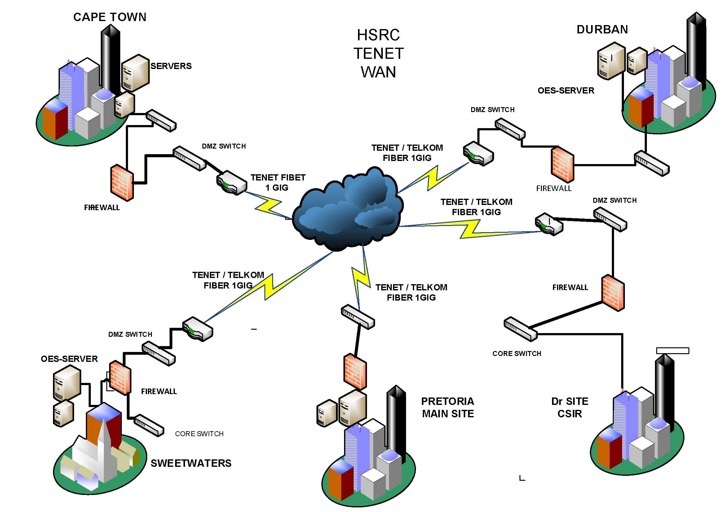

- HSRC LAN diagram

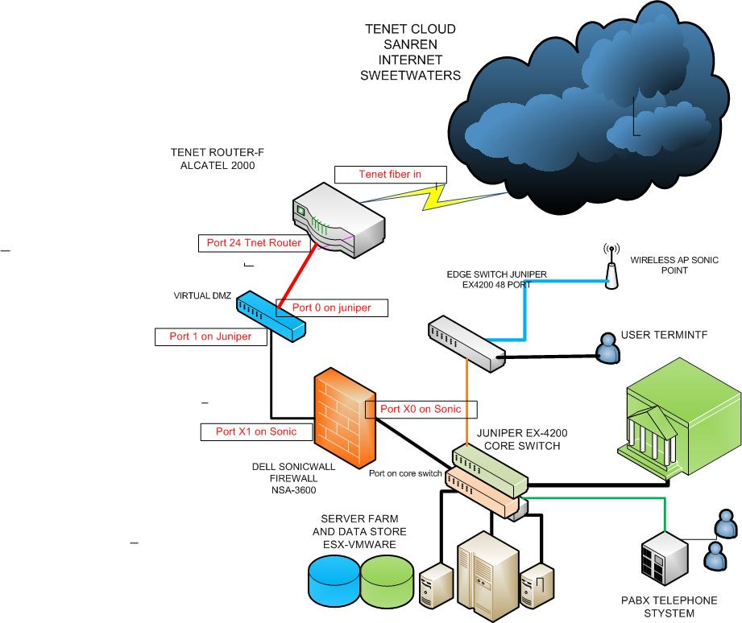

- COMPULSORY REQUIREMENTS

A bidder who fails to meet the minimum requirements as mentioned below will be disqualified.

The bidder must:

- Submit a company profile which indicates five (5) years’ experience in implementing, commissioning and supporting of a VOIP system.
- Submit three (3) contactable reference letters from previous clients where MS Teams services were rendered. All letters must be on the company letterhead of the referee and signed by the referee.
- Provide CV's for the project team members e.g. Project Manager, Network Engineer, Telecommunication Specialist and VOIP Engineer/ Architect etc. All team members must have a minimum of three (3) years experience in implementing, commission, supporting of VOIP system and list of projects they have successfully implemented.
- Provide ICASA accreditation certificate in providing the required services.
- Submit a document that indicates the system architecture and design, timelines and milestones for project completion, support and maintenance plan with turnaround times, training plan of HSRC staff etc.
- Microsoft Gold Partner

- PROJECT MANAGEMENT AND REPORTING

- A Service Level Agreement (SLA) must be signed between the successful bidder and the HSRC
- A Non-Disclosure Agreement (NDA) must be signed between the successful bidder and the HSRC
- The successful bidder must provide documented weekly progress reports and monthly reports about the implementation of the UC solution
- Produce a design plan for the proposed solution.
- Install, configure, test and commission the system at all four (4) HSRC regional offices.
- Provide an electronic user manual to assist with operating the UC system.
- Provide HSRC IT technicians and switchboard operators with training and manual of the UC system to provide first-line support after going live.
- Provide training to the HSRC end-users to enhance user experience.
- Provide and configure new handsets/softphones to all staff.

- COMPULSORY SUBMISSIONS

PLEASE COMPLETE THE TABLE BELOW AND ATTACH SUPPORTING DOCUMENTS

All bidders are expected to score 100% on the submission of the below listed
(Compulsory) before they can be recommended for evaluation.

- Requirements

 | REQUIRED DOCUMENTS | TICK
1 | Company Profile
2 | Proof of business address
3 | Registration Certificate with Industry Professional Bodies (operating license)
4 | CV & Qualification Certificates of Project Leader
5 | CV & Qualification Certificates of Installation/programming technician
6 | Project Implementation Plan (Methodology & timeline)
7 | Reference Letter/s from previous/current clients – with the same implementation
8 | Proposed Solution (System Functionalities)
9 | Valid B-BEE certificate

- Evaluation Criteria

 | Functionality | Weight | Score
1. | Experience  Service Provider years’ experience in providing similar VOIP solutions  - 5 years’ experience (5)  - Above 5 years’ experience (10) | 10
2. | Track record  The bidder must provide three (3) contactable reference letters where a MS Teams UC solution has been implemented | 10
3 | Qualifications and Skills of key personnel  Submit a structure composition of the proposed team, clearly outlining the main disciplines/ specialities and the key personnel responsible for each speciality. | 20
4. | Project plan  Provide Project plan with time lines | 40
5. | Implementation plan  Provide full details of the solution, provision and installation of the UC solution. | 10
6. | Financial Status  Provide three recent financial statements | 10
 | Total (minimum threshold 70) | 100
 | Phase 2 – Live demonstration | 100
 | Demonstration to be done from the HSRC offices
  - Microsoft Teams Domestic Calling Plan
  - Microsoft Teams International Calling Plan (when required)
- Audio and Video Conferencing (Polycom)
- User Presence
- Simultaneous Ring
- Call from Email
- Exchange Automated Voicemail Attendant

