Private Bag X, PIETERMARITZBURG, 3200

Inkosi uMhlabunzima Maphumulo House, 172 Burger Street, Pietermaritzburg, 3200

Tel: 033 355 8600 Fax:
DEPARTMENT

Invitation to Tender - ZNB 02209/00000/00/HOD/GEN/23/T

KwaZulu-Natal– Department of Transport

Suitable service providers are invited to bid for SUPPLY AND DELIVERT OF OFFICE FURNITURE FOR PRE-CHIEF DIRECTORATE.

The Department reserves the right to not to award this tender

Collection of Bid Documents

Free download of tender documents will be available on the www.kzntransport.gov.za and www.etenders.gov.za website and must be downloaded.

Documents may also be collected during working hours from 08H00 to 15H30.

The physical address for collection of Tender documents is Inkosi Mhlabunzima Maphumulo House, 172 Burger Street, Pietermaritzburg,3200

For Collection of Document there is a tender fee of R270.payable at Cashier’s office: 6th Floor A-block
Inkosi Mhlabunzima Maphumulo House, 172 Burger Street, Pietermaritzburg,3200,

Queries relating to the issue of these documents may be addressed to Siphokazi Godlwane Tel. No. (033) 335 0519: e-mail siphokazi.godlwane@kzntransport.gov.za

The closing time for receipt of Tenders is 11h00. Telegraphic, telephonic, telex, facsimile, e-mail and late Tender Proposals will not be accepted.

KWAZULU-NATAL PROVINCIAL GOVERNMENT BIDDING FORMS

SECTION A | INVITATION TO BID (SBD 1) | 1-3
SECTION B | TERMS AND CONDITIONS FOR BIDDING (SBD 1) | 4
SECTION C | SPECIAL INSTRUCTIONS REGARDING COMPLETION OF BID | 5-6
SECTION D | AUTHORITY TO SIGN | 7
SECTION E | REGISTRATION ON CENTRAL SUPPLIERS DATABASE | 8
SECTION F | DECLARATION THAT INFORMATION ON CENTRAL SUPPLIER DATABASE IS CORRECT AND UP TO DATE | 9
SECTION G | PRICING SCHEDULE | 10-14
SECTION H | BIDDER’S DISCLOSURE | 15-17
SECTION I | PREFERENCE POINTS CLAIM FORM IN TERMS OF THE PREFERENTIAL PROCUREMENT REGULATIONS 2022 (SBD6.1) | 18-22
SECTION J | CONTRACT FORM | 23-24
SECTION K | GENERAL CONDITIONS OF CONTRACT | 25-32
SECTION L | SPECIAL CONDITIONS OF CONTRACT | 33
SECTION M | TERMS OF REFERENCE | 34-49

SBD1

Section A

INVITATION TO BID

(Supplier to complete & return. Failure to complete, offer will be invalid)
YOU ARE HEREBY INVITED TO QUOTE FOR REQUIREMENTS OF THE DEPARTMENT OF TRANSPORT
BID NUMBER: | ZNB 02209/00000/00/HOD/GEN/23/T | CLOSING DATE: |  | 11/01/2024 |  |  |  | CLOSING TIME: | 11:00 am
DESCRIPTION | SUPPLY AND DELIVERY OF OFFICE FURNITURE FOR PRE-DIRECTORATE.
BID RESPONSE DOCUMENTS MAY BE DEPOSITED IN THE BID BOX SITUATED AT (STREET ADDRESS)
Department of Transport |  | Email:
172 Burger Street |  | Under no circumstances must suppliers submit their quotation offers/ responses to the official whose name appear on the enquiries.
PIETERMARITZBURG
3201
Mon to Fri: 07:30 until 16:00
BIDDING PROCEDURE ENQUIRIES MAY BE DIRECTED TO |  | TECHNICAL ENQUIRIES MAY BE DIRECTED TO:
CONTACT PERSON | Hlengiwe Ndlovu | CONTACT PERSON |  |  |  | SIPHOKAZI GODLWANE
TELEPHONE NUMBER | 033 355 8764 | TELEPHONE NUMBER |  |  |  | 033 335 0519
FACSIMILE NUMBER |  | FACSIMILE NUMBER
E-MAIL ADDRESS | Hlengiwe.Ndlovu@Kzntransport.gov.za | E-MAIL ADDRESS |  |  |  | siphokazi.godlwane@kzntransport.gov.za
SUPPLIER INFORMATION
NAME OF BIDDER
POSTAL ADDRESS
STREET ADDRESS
TELEPHONE NUMBER | CODE |  |  | NUMBER
CELLPHONE NUMBER
FACSIMILE NUMBER | CODE |  |  | NUMBER
E-MAIL ADDRESS
VAT REGISTRATION NUMBER
SUPPLIER COMPLIANCE STATUS | TAX COMPLIANCE SYSTEM PIN: |  | OR |  | CENTRAL SUPPLIER DATABASE No: |  | MAAA
B-BBEE STATUS LEVEL VERIFICATION CERTIFICATE | TICK APPLICABLE BOX]  Yes No | B-BBEE STATUS LEVEL SWORN AFFIDAVIT |  |  |  | [TICK APPLICABLE BOX]  Yes No
[A B-BBEE STATUS LEVEL VERIFICATION CERTIFICATE/ SWORN AFFIDAVIT (FOR EMES & QSEs) MUST BE SUBMITTED IN ORDER TO QUALIFY FOR PREFERENCE POINTS FOR B-BBEE]
ARE YOU THE ACCREDITED REPRESENTATIVE IN SOUTH AFRICA FOR THE GOODS /SERVICES /WORKS OFFERED? | Yes No  [IF YES ENCLOSE PROOF] | ARE YOU A FOREIGN BASED SUPPLIER FOR THE GOODS /SERVICES /WORKS OFFERED? |  |  |  | Yes No  [IF YES, ANSWER PART B:3 ]
B3: QUESTIONNAIRE TO BIDDING FOREIGN SUPPLIERS
IS THE ENTITY A RESIDENT OF THE REPUBLIC OF SOUTH AFRICA (RSA)? YES NO
DOES THE ENTITY HAVE A BRANCH IN THE RSA? YES NO
DOES THE ENTITY HAVE A PERMANENT ESTABLISHMENT IN THE RSA? YES NO
DOES THE ENTITY HAVE ANY SOURCE OF INCOME IN THE RSA? YES NO
IS THE ENTITY LIABLE IN THE RSA FOR ANY FORM OF TAXATION? YES NO
IF THE ANSWER IS “NO” TO ALL OF THE ABOVE, THEN IT IS NOT A REQUIREMENT TO REGISTER FOR A TAX COMPLIANCE STATUS SYSTEM PIN CODE FROM THE SOUTH AFRICAN REVENUE SERVICE (SARS) AND IF NOT REGISTER AS PER 2.3 BELOW.

YOU ARE HEREBY INVITED TO BID FOR REQUIREMENTS OF THE (NAME OF DEPARTMENT/ PUBLIC ENTITY)

SBD1

Section B

TERMS AND CONDITIONS FOR BIDDING

(Supplier to complete & return. Failure to complete, offer will be invalid)
- BID SUBMISSION:
  - BIDS MUST BE DELIVERED BY THE STIPULATED TIME TO THE CORRECT ADDRESS. LATE BIDS WILL NOT BE ACCEPTED FOR CONSIDERATION.
  - ALL BIDS MUST BE SUBMITTED ON THE OFFICIAL FORMS PROVIDED–(NOT TO BE RE-TYPED) OR IN THE MANNER PRESCRIBED IN THE BID DOCUMENT.
  - THIS BID IS SUBJECT TO THE PREFERENTIAL PROCUREMENT POLICY FRAMEWORK ACT, 2000 AND THE PREFERENTIAL PROCUREMENT REGULATIONS, 2022, THE GENERAL CONDITIONS OF CONTRACT (GCC) AND, IF APPLICABLE, ANY OTHER SPECIAL CONDITIONS OF CONTRACT.
  - IF THE BID WAS INVITED THROUGH A CLOSE QUOTATION PROCESS; WHERE SUPPLIERS WERE SOURCED FROM CSD USING THE COMMODITY PROCESS; SUPPLIERS WHO WERE NOT INVITED WILL NOT BE CONSIDERED.
  - USE OF OMISSION IN THE DOCUMENT IS PROHIBITED, ALL CORRECTIONS MUST BE INITIALLED BY TENDERR AND USE OF CORRECTION FLUID IS PROHIBITED.
  - FAILING TO COMPLY WITH THE ABOVE REQUIREMENTS WILL RESULT IN THE BID BEING NON-RESPONSIVE.
  - THE SUCCESSFUL BIDDER WILL BE REQUIRED TO FILL IN AND SIGN A WRITTEN CONTRACT FORM (SBD7).
- TAX COMPLIANCE REQUIREMENTS
- BIDDERS MUST ENSURE COMPLIANCE WITH THEIR TAX OBLIGATIONS.
- BIDDERS ARE REQUIRED TO SUBMIT THEIR UNIQUE PERSONAL IDENTIFICATION NUMBER (PIN) ISSUED BY SARS TO ENABLE THE ORGAN OF STATE TO VERIFY THE TAXPAYER’S PROFILE AND TAX STATUS.
- APPLICATION FOR TAX COMPLIANCE STATUS (TCS) PIN MAY BE MADE VIA E-FILING THROUGH THE SARS WEBSITE WWW.SARS.GOV.ZA.
- BIDDERS MAY ALSO SUBMIT A PRINTED TCS CERTIFICATE TOGETHER WITH THE BID.
- IN BIDS WHERE CONSORTIA / JOINT VENTURES / SUB-CONTRACTORS ARE INVOLVED; EACH PARTY MUST SUBMIT A SEPARATE TCS CERTIFICATE / PIN / CSD NUMBER.
- WHERE NO TCS IS AVAILABLE BUT THE BIDDER IS REGISTERED ON THE CENTRAL SUPPLIER DATABASE (CSD), A CSD NUMBER MUST BE PROVIDED.
- NO BIDS WILL BE CONSIDERED FROM PERSONS IN THE SERVICE OF THE STATE, COMPANIES WITH DIRECTORS WHO ARE PERSONS IN THE SERVICE OF THE STATE, OR CLOSE CORPORATIONS WITH MEMBERS PERSONS IN THE SERVICE OF THE STATE.”
- COMPLIANCE AND RETURNABLES: THE FOLLOWING RETURNABLE DOCUMENTS MUST RETURNED WITH THE QUOTATION DOCUMENT
- SBD 1 INVITATION TO QUOTE (SBD1 PART A)
- SBD 1 – TERMS AND CONDITIONS FOR BIDDING (SBD1 PART B)
- SBD 3 – OFFICIAL BRIEFING SESSION/SITE INSPECTION CERTIFICATE
- SBD 3.3 – PRICING SCHEDULE – PROFESSIONAL SERVICES
- SBD 4 - DECLARATION OF INTEREST FORM
- SBD 6.1 - PREFERENCE POINTS CLAIM FORM IN TERMS OF THE PREFERENTIAL PROCUREMENT REGULATIONS 2022

NB: FAILURE TO PROVIDE / OR COMPLY WITH ANY OF THE ABOVE PARTICULARS MAY RENDER THE BID INVALID.

SIGNATURE OF BIDDER: ……………………………………………

CAPACITY UNDER WHICH THIS BID IS SIGNED: ……………………………………………
(Proof of authority must be submitted e.g., company resolution)

DATE: …………………………………………...

SECTION C
NOTICES TO RESPONDENTS REGARDING THE COMPLETION OF FORMS

PLEASE NOTE THAT THIS CALL FOR BIDS IS SUBJECT TO TREASURY REGULATIONS 16A ISSUED IN TERMS OF THE PUBLIC FINANCE MANAGEMENT ACT, 1999, THE KWAZULU-NATAL SUPPLY CHAIN MANAGEMENT POLICY FRAMEWORK AND THE GENERAL CONDITIONS OF CONTRACT.

- Unless inconsistent with or expressly indicated otherwise by the context, the singular shall include the plural and vice versa and with words importing the masculine gender shall include the feminine and the neuter.
- Under no circumstances whatsoever may the Bids forms be retyped or redrafted but can be completed online without changing any words. Photocopies of the original Bids documentation may be used, but an original signature must appear on such photocopies.
- The Respondent is advised to check the number of pages and to satisfy himself that none are missing or duplicated.
- Bids submitted must be complete in all respects.
- Bids shall be lodged at the address indicated not later than the closing time specified for their receipt, and in accordance with the directives in the Bids documents.
- Each Bids shall be addressed in accordance with the directives in the BIDS documents and shall be lodged in a separate sealed envelope, with the name and address of the Respondent, the Bid number and closing date indicated on the envelope. The envelope shall not contain documents relating to any Bids other than that shown on the envelope. If this provision is not complied with, such Bids may be rejected as being invalid.
- All Bids received in sealed envelopes with the relevant Bids numbers on the envelopes are kept unopened in safe custody until the closing time of the Bids. Where, however, a Bids is received open, it shall be sealed. If it is received without a Bids number on the envelope, it shall be opened, the Bid number ascertained, the envelope sealed, and the Bid number written on the envelope.
- A specific box is provided for the receipt of Bids, and no Bids found in any other box or elsewhere subsequent to the closing date and time of Bids will be considered.
- No Bids sent through the post will be considered if it is received after the closing date and time stipulated in the BIDS documentation, and proof of posting will not be accepted as proof of delivery.
- No Bids submitted by telefax, telegraphic will be considered.
- Bids documents must not be included in packages containing samples. Such Bids may be rejected as being invalid.
- Any alteration made by the Respondent must be initialed. If not initialed the Respondent may be disqualified.
- Use of correcting fluid is prohibited
- Bids will be opened in public as soon as practicable after the closing time of Bids.
- Where practical, prices will be made public at the time of opening Bids.

- Acceptable Proof for the allocation of Specific Goals Points

The specific goals allocated points in terms of this tender | Points | Acceptable Proof for Allocation of Points
The promotion of enterprises located in KZN province for work to be done | 10 points | Municipal Account Letter/ Lease agreement/ Municipal Councilor Letter
An EME or QSE which at least 51% owned by Black people who are youth | 5 points | BBB-EE affidavit/ sworn affidavit
An EME or QSE which at least 51% owned by Black people who are women | 5 points | BBB-EE affidavit/ sworn affidavit

- Rights to Award

- KZN Department of Transport reserves the right to call for presentations from shortlisted suppliers or Reserves the Right to accept bids in Whole or In Part.”
- Not to make any award in this bid or accept any proposals submitted,
- Award the project to more than one (1) Respondent for the same activity
- Request further technical/functional information from any Respondent after the closing date,
- Verify information and documentation of the Respondent(s),
- Not to accept any of the bid document submitted,
- To withdraw or amend any of the bid conditions by notice in writing to all Respondents prior to closing of the bid and post award, and
- If an incorrect award has been made to remedy the matter in any lawful manner it may deem fit.

- Price Negotiation

KZN DoT reserves the right to negotiate with the shortlisted Respondents prior and/or post award. The terms and conditions for negotiations will be communicated to the shortlisted Respondents prior to invitation to negotiations. The negotiation terms and conditions may include presentations and/or site visits. This phase is meant to ensure the conditions of bid and projects will be implementable for the achievement of the project objectives.

AUTHORITY TO SIGN

Bid Number: ZNB002209/00000/00/HOD/GEN/23T – PROVISSION FOR OFFICE FURNITURE FOR PRE-DIRECTORATE.

Close Corporation / Company / Partnership / Trust /Sole proprietor or sole trader
Name: _______________________________________________________________________
Registration Number:_______________________________________________________
RESOLUTION OF THE DIRECTORS OF THE COMPANY etc. RESOLVED that _____________________, in his/her capacity as ______________________________________________, is authorized to make applications on behalf of the Close Corporation / Company / Partnership / Trust /Sole proprietor or sole trader for: any documentation relating to the business (which is not necessarily a change of ownership). The nominated person will also have access to webpage for the business.
Signature(s) for Close Corporation / Company / Partnership / Trust/ Sole proprietor or sole trader.
(Sole member still must sign this resolution)

Signature of members:
Name Signature Date

1. ______________________________ ____________________________ .
2. ______________________________ ___________________________ .
3. ______________________________ ___________________________ .
4. ______________________________ ____________________________ .
5. ______________________________ ____________________________ .
6. ______________________________ ____________________________ .

Specimen signature of the appointed Signatory: . (Please sign)

Failure to complete, sign and date the above certificate or provide the certificate(s) in the form of a resolution shall result in the tender being considered non-responsive and rejected.

SECTION E
REGISTRATION ON THE CENTRAL SUPPLIERS DATABASE

- In terms of the National Treasury Instruction Note, all suppliers of goods and services to the State are required to register on the Central Suppliers Database.

- Prospective suppliers should self-register on the CSD website www.csd.gov.za

- If a business is registered on the Database and it is found subsequently that false or incorrect information has been supplied, then the Department may, without prejudice to any other legal rights or remedies it may have.

3.1 cancel a bid or a contract awarded to such supplier, and the supplier would become liable for any damages if a less favourable bid is accepted or less favourable arrangements are made.

- The same principles as set out in paragraph 3 above are applicable should the supplier fail to request updating of its information on the Central Suppliers Database, relating to changed particulars or circumstances.

- IF THE SUPPLIER IS NOT REGISTERED AT THE CLOSING TIME OF BID, THE SUPPLIER WILL BE DISQUALIFIED AT THE BID EVALUATION PROCESS.

SECTION F
DECLARATION THAT INFORMATION ON CENTRAL SUPPLIER DATABASE IS CORRECT AND UP TO DATE
(To be completed by bidder)

THIS IS TO CERTIFY THAT I (name of bidder/authorized representative) …………………………………..........................., WHO

REPRESENTS (state name of bidder) …………………………...………..............................................................CSD Registration

Number.................................................

AM AWARE OF THE CONTENTS OF THE CENTRAL SUPPLIER DATABASE WITH RESPECT TO THE BIDDER’S DETAILS AND REGISTRATION INFORMATION, AND THAT THE SAID INFORMATION IS CORRECT AND UP TO DATE AS ON THE DATE OF SUBMITTING THIS BID.

AND I AM AWARE THAT INCORRECT OR OUTDATED INFORMATION MAY BE A CAUSE FOR DISQUALIFICATION OF THIS BID FROM THE BIDDING PROCESS, AND/OR POSSIBLE CANCELLATION OF THE CONTRACT THAT MAY BE AWARDED ON THE BASIS OF THIS BID.

............................................................................................................
SIGNATURE OF BIDDER OR AUTHORISED REPRESENTATIVE

DATE: ....................................................

SBD 3.1

SECTION G
PRICING SCHEDULE – FIRM PRICES
(PURCHASES)

NOTE: ONLY FIRM PRICES WILL BE ACCEPTED. NON-FIRM PRICES (INCLUDING PRICES SUBJECT TO RATES OF EXCHANGE VARIATIONS) WILL NOT BE CONSIDERED

IN CASES WHERE DIFFERENT DELIVERY POINTS INFLUENCE THE PRICING, A SEPARATE PRICING SCHEDULE MUST BE SUBMITTED FOR EACH DELIVERY POINT

Name of bidder……………………………………  Closing Time 11:00 am | Bid number: ZNB02209/00000/00/HOD/GEN/23/T  Closing date…11/01/2024………………………………………...

OFFER TO BE VALID FOR 120 DAYS FROM THE CLOSING DATE OF BID.
QUANTITY | DESCRIPTION | Unit Price | Total for each unit
HLUHLUWE PARK HOME BOARDROOM
1 | Conference tables (rectangular sitting-8-seater) Mahogany  Meeting table,
8 | Classic Eames Repo Range  Genuine leather midback chair  Black
30 | Classic Eames Boardroom Chair Range  Genuine leather midback chair  Black
6 | 3-Seater Heavy Duty Standard Steel  Cross beam:1.8mm steel Aluminium powder coated. Arms, legs & edges:  Heavy duty 1.5mm steel tubing-double chrome plated. Seat 1.2mm steel aluminium powder coated.  Up to 130kg per seat
2 | L Shaped Desk 2400mm x 1200mm x 800mm  Everest Credenza 1200mm x 600mm  Everest 4/Drawer Desk Height Pedestal  Mahogany
2 | Concorde Operators Mid Back Office Chair Upholstery: Full PVC (Vinyl)  Mechanism: Swivel & tilt with 1 position lock  Arms: PU  Base: 5 Star black nylon  Warranty: 2 years  Weight Capacity :110 Kg
2 | Lockable folio cabinets  Roller Door System Cupboard with 3x wooden shelves,  lockable, 1100W x 560D x 1500H  Mahogany
DIRECTORS’ OFFICES (172 Burger Street)
2 | President Range High Back Office Chair Specifications:  This chair is HEAVY DUTY supporting a user weighing up to 180kg  Swivel & tilt mechanism with 1 position lock  Gas height adjuster  Wooden armrests with upholstery.  5-star wood base (700mm diameter)  Combo of bonded leather on the front & PVC on the bac
2 | Executive desks with cabinets (Mahogany  Desk shell with half inlay,2100wX900Dx730H  Quarter link with curved base,800w X650DX730H(LHS)  Roller door credenza including shelf, Drawer, 2X std Drawer  1X deep filling Drawer, 250 W X 650D X 730H (LHS)  Wall unit with full glass top, hinge door bottom incl. 3xshelves, 900 W x 360D X1900H  Low wall unit with solid hinge doors, icnl.1 x shelf, 900W x 360Dx 750 H (32mmtop, 50mm solid edge. Veneer.  President Range High back Leather Chair.
2 | Boston Boardroom Table  Barrel Shape Table – Mahogany  70 x 25mm Top  1800 x 1200mm – 6-Seater
16 | Adda Wooden 4-Legged Boardroom Chairs  Weight:15.00 KGS  Width:60.00 (cm)  Height:100.00 (cm)  Depth:60.00 (cm)
2 | 2-Seater leather couches  Victorian Standard with mahogany bun feet  Double seater, 1800w X 840 x750H  Seat depth: 620mm. Seat width: 1280mm
2 | Small coffee tables  Alpha coffee tables glass square. 600W x600D x 450H. Mahogany
2 | Executive PU Leather Club Chair- Black  63cm (L) x 63cm (W) x 73cm (H)  - 12kg Weight  - PU Leather Material  - Wooden Legs
2 | Hat Stand  485x485x1680 -Mahogany
1 | Hardwood double letter desk tray, two tier, Mahogany
2 | Lockable folio cabinets (Mahogany)  Roller Door System Cupboard with 3x wooden shelves,  lockable, 1100W x 560D x 1500H  Mahogany
2 | Metallic Bar Fridge  Width: 475, Height: 850, Depth: 445, Total net litres: 92L
2 | 32 inch Smart Television
2 X DIRECTOR’S PERSONAL ASSISTANTS (172 Burger Street)
2 | L Shaped Desk 2400mm x 1200mm x 800mm  Everest Credenza 1200mm x 600mm  Everest 4/Drawer Desk Height Pedestal  Mahogany
2 | Lockable folio cabinets  Roller Door System Cupboard with 3x wooden shelves,  lockable, 1100W x 560D x 1500H  Mahogany
2 | Plastic Wastepaper Bin  Black
2 | Concorde Operators Mid Back Office Chair  Upholstery: Full PVC (Vinyl)  Mechanism: Swivel & tilt with 1 position lock  Arms: PU  Base: 5 Star black nylon  Warranty: 2 years  Weight Capacity :110 Kg
4 | Printing & Filling Room Cabinets  Folio Cabinet Range 4 drawer folio – 16 mm Square Top  3 rows of filing (Folio containers) per drawer = 15 X Folio containers per drawer  Internal steel frame. Height adjustable  Internal component: 3 rows of hanging files per drawer  Accommodate A4 and folio size files
5 | Printing & Filling Room Cabinets  Folio Cabinet Range 4 drawer folio – 16 mm Square Top  3 rows of filing (Folio containers) per drawer = 15 X Folio containers per drawer  Internal steel frame. Height adjustable  Internal component: 3 rows of hanging files per drawer  Accommodate A4 and folio size files
4 X LAND ASSESSMENT SPECIALISTS (225 Prince Alfred)
4 | Concorde Operators Mid Back Office Chair  Upholstery: Full PVC (Vinyl)  Mechanism: Swivel & tilt with 1 position lock  Arms: PU  Base: 5 Star black nylon  Warranty: 2 years  Weight Capacity :110 Kg
4 | L Shaped Desk 2400mm x 1200mm x 800mm  Everest Credenza 1200mm x 600mm  Everest 4/Drawer Desk Height Pedestal  Mahogany
4 | Plastic Wastepaper Bin  Black
2 X LAND ASSESSMENT ADMIN SUPPORT (225 prince Alfred)
2 | Concorde Operators Mid Back Office Chair  Upholstery: Full PVC (Vinyl)  Mechanism: Swivel & tilt with 1 position lock  Arms: PU  Base: 5 Star black nylon  Warranty: 2 years  Weight Capacity :110 Kg
2 | 2x Clu Cluster desk  Top ONLY 1600/1800x1200mm  3 x Steel Pole Legs  Perforated Steel Modesty Panel  4 X Drawers
2 | Lockable folio cabinets  Roller Door System Cupboard with 3x wooden shelves,  lockable, 1100W x 560D x 1500H  Mahogany
2 | Plastic Wastepaper Bin  Black
2 X GAZETTING AND VERIFICATION STAFF (172 Burger Street)
2 | Concorde Operators Mid Back Office Chair  Upholstery: Full PVC (Vinyl)  Mechanism: Swivel & tilt with 1 position lock  Arms: PU  Base: 5 Star black nylon  Warranty: 2 years  Weight Capacity :110 Kg
2 | L Shaped Desk 2400mm x 1200mm x 800mm  Everest Credenza 1200mm x 600mm  Everest 4/Drawer Desk Height Pedestal  Mahogany
4 | Plastic Wastepaper Bin  Black
2 | Portable Office Divider, Convenient Movable 3-panel, folding Partition Privacy Screen  102" W X 19.7" D X 71.3" H  BLACK
PORT SHEPSTONE PARK HOME BOARDROOM
1 | Conference tables (rectangular sitting-10-seater) Mahogany  Meeting table,
10 | Classic Eames Repo Range  Genuine leather midback chair Black
30 | Classic Eames Boardroom Chair Range  Genuine leather midback chair Black
PORT SHEPSTONE PARK HOME BANKING HALL
4 | 3-Seater Heavy Duty Standard Steel  Cross beam:1.8mm steel Aluminium powder coated. Arms, legs & edges:  Heavy duty 1.5mm steel tubing-double chrome plated. Seat 1.2mm steel aluminium powder coated.  Up to 130kg per seat
NB: DELIVERY OF THE ABOVE ITEMS MUST BE MADE TO HLUHLUWE: DEPARTMENT OF TRANSPORT, HLUHLUWE COST CENTRE. DELIVERY DATE WILL BE COMMUNICATED
NB: DELIVERY OF THE ABOVE ITEMS MUST BE MADE TO OLD TRAFFIC TRAINING COLLEGE, 225 PRINCE ALFRED STREET, PIETERMARITZBURG.
NB: DELIVERY OF THE ABOVE ITEMS MUST BE MADE TO PORT SHEPSTONE: MARBURG, ALLESUND ROAD, RTI PRECINCT. DELIVERY DATE WILL BE COMMUNICATED
NB: DELIVERY OF THE ABOVE ITEMS MUST BE MADE DEPARTMENT OF TRANSPORT, 172 BURGER STREET, PIETERMARITZBURG.
Find more specification on page 34-48
SUB-TOTAL
VAT AT 15%
GRAND TOTAL (BID PRICE IN RSA CURRENCY WITH ALL APPLICABLE TAXES INCLUDED)
I (full name)__________________________________________, in my capacity as ___________________________, the duly authorized representative of __________________________________________________(business name) hereby declares that the offer is in accordance with the attached specification, notes to suppliers & accepts all conditions/clauses contained in the said documents.
Signature of duly authorised representative |  | Date: _______________________

- Required by: ………………………………….

- At: ………………………………….

…………………………………

- Brand and model ………………………………….

- Country of origin ………………………………….

- Does the offer comply with the specification(s)? *YES/NO

- If not to specification, indicate deviation(s) ………………………………….

- Period required for delivery ………………………………….
*Delivery: Firm/not firm

- Delivery basis ……………………………………

Note: All delivery costs must be included in the bid price, for delivery at the prescribed destination.

** “all applicable taxes” includes value- added tax, pay as you earn, income tax, unemployment insurance fund contributions and skills development levies.

*Delete if not applicable

SBD 4

SECTION H
BIDDER’S DISCLOSURE

- PURPOSE OF THE FORM
Any person (natural or juristic) may make an offer or offers in terms of this invitation to bid. In line with the principles of transparency, accountability, impartiality, and ethics as enshrined in the Constitution of the Republic of South Africa and further expressed in various pieces of legislation, it is required for the bidder to make this declaration in respect of the details required hereunder.

Where a person/s are listed in the Register for Tender Defaulters and / or the List of Restricted Suppliers, that person will automatically be disqualified from the bid process.

- Bidder’s declaration
2.1 Is the bidder, or any of its directors / trustees / shareholders / members / partners or any person having a controlling interest in the enterprise, employed by the state?
YES
NO

2.1.1 If so, furnish particulars of the names, individual identity numbers, and, if applicable, state employee numbers of sole proprietor/ directors / trustees / shareholders / members/ partners or any person having a controlling interest in the enterprise, in table below.
Full Name | Identity Number | Name of State institution

2.2 Do you, or any person connected with the bidder, have a relationship with any person who is employed by the procuring institution?
YES
NO
2.2.1 If so, furnish particulars:
……………………………………………………………………………………
……………………………………………………………………………………

2.3 Does the bidder or any of its directors / trustees / shareholders / members / partners or any person having a controlling interest in the enterprise have any interest in any other related enterprise whether or not they are bidding for this contract?
YES
NO
    - If so, furnish particulars:
…………………………………………………………………………….
…………………………………………………………………………….

- DECLARATION

I, the undersigned, (name)……………………………………………………………………. in submitting the accompanying bid, do hereby make the following statements that I certify to be true and complete in every respect:

3.1 I have read, and I understand the contents of this disclosure.
3.2 I understand that the accompanying bid will be disqualified if this disclosure is found not to be true and complete in every respect;
3.3 The bidder has arrived at the accompanying bid independently from, and without consultation, communication, agreement or arrangement with any competitor. However, communication between partners in a joint venture or consortium will not be construed as collusive bidding.
3.4 In addition, there have been no consultations, communications, agreements or arrangements with any competitor regarding the quality, quantity, specifications, prices, including methods, factors or formulas used to calculate prices, market allocation, the intention or decision to submit or not to submit the bid, bidding with the intention not to win the bid and conditions or delivery particulars of the products or services to which this bid invitation relates.
3.4 The terms of the accompanying bid have not been, and will not be, disclosed by the bidder, directly or indirectly, to any competitor, prior to the date and time of the official bid opening or of the awarding of the contract.

3.5 There have been no consultations, communications, agreements or arrangements made by the bidder with any official of the procuring institution in relation to this procurement process prior to and during the bidding process except to provide clarification on the bid submitted where so required by the institution; and the bidder was not involved in the drafting of the specifications or terms of reference for this bid.

  - I am aware that, in addition and without prejudice to any other remedy provided to combat any restrictive practices related to bids and contracts, bids that are suspicious will be reported to the Competition Commission for investigation and possible imposition of administrative penalties in terms of section 59 of the Competition Act No 89 of 1998 and or may be reported to the National Prosecuting Authority (NPA) for criminal investigation and or may be restricted from conducting business with the public sector for a period not exceeding ten (10) years in terms of the Prevention and Combating of Corrupt Activities Act No 12 of 2004 or any other applicable legislation.

I CERTIFY THAT THE INFORMATION FURNISHED IN PARAGRAPHS 1, 2 and 3 ABOVE IS CORRECT.
I ACCEPT THAT THE STATE MAY REJECT THE BID OR ACT AGAINST ME IN TERMS OF PARAGRAPH 6 OF PFMA SCM INSTRUCTION 03 OF 2021/22 ON PREVENTING AND COMBATING ABUSE IN THE SUPPLY CHAIN MANAGEMENT SYSTEM SHOULD THIS DECLARATION PROVE TO BE FALSE.

……………………………… ..……………………………………………
Signature Date

……………………………… ………………………………………………
Position Name of bidder

Every question must be answered individually on this form, whether a relationship is present or not: Failure to do so will invalidate your tender/bid

SBD 6.1

SECTION I

PREFERENCE POINTS CLAIM FORM IN TERMS OF THE PREFERENTIAL PROCUREMENT REGULATIONS 2022

This preference form must form part of all tenders invited. It contains general information and serves as a claim form for preference points for specific goals.

NB: BEFORE COMPLETING THIS FORM, TENDERERS MUST STUDY THE GENERAL CONDITIONS, DEFINITIONS AND DIRECTIVES APPLICABLE IN RESPECT OF THE TENDER AND PREFERENTIAL PROCUREMENT REGULATIONS, 2022

- GENERAL CONDITIONS
  - The following preference point systems are applicable to invitations to tender:
- the 80/20 system for requirements with a Rand value of up to R50 000 000 (all applicable taxes included); and
- the 90/10 system for requirements with a Rand value above R50 000 000 (all applicable taxes included).

  - To be completed by the organ of state
- The applicable preference point system for this tender is the 80/20 preference point system.
- The 80/20 preference point system will be applicable in this tender. The lowest/ highest acceptable tender will be used to determine the accurate system once tenders are received.

  - Points for this tender (even in the case of a tender for income-generating contracts) shall be awarded for:
- Price; and
- Specific Goals.

  - To be completed by the organ of state:
The maximum points for this tender are allocated as follows:
 | POINTS
PRICE | 80
SPECIFIC GOALS | 20
Total points for Price and SPECIFIC GOALS | 100

  - Failure on the part of a tenderer to submit proof or documentation required in terms of this tender to claim points for specific goals with the tender, will be interpreted to mean that preference points for specific goals are not claimed.

  - The organ of state reserves the right to require of a tenderer, either before a tender is adjudicated or at any time subsequently, to substantiate any claim in regard to preferences, in any manner required by the organ of state.

- DEFINITIONS
- “tender” means a written offer in the form determined by an organ of state in response to an invitation to provide goods or services through price quotations, competitive tendering process or any other method envisaged in legislation;
- “price” means an amount of money tendered for goods or services, and includes all applicable taxes less all unconditional discounts;
- “rand value” means the total estimated value of a contract in Rand, calculated at the time of bid invitation, and includes all applicable taxes;
- “tender for income-generating contracts” means a written offer in the form determined by an organ of state in response to an invitation for the origination of income-generating contracts through any method envisaged in legislation that will result in a legal agreement between the organ of state and a third party that produces revenue for the organ of state, and includes, but is not limited to, leasing and disposal of assets and concession contracts, excluding direct sales and disposal of assets through public auctions; and
- “the Act” means the Preferential Procurement Policy Framework Act, 2000 (Act No. 5 of 2000).

- FORMULAE FOR PROCUREMENT OF GOODS AND SERVICES

  - POINTS AWARDED FOR PRICE

3.1.1 THE 80/20 OR 90/10 PREFERENCE POINT SYSTEMS
A maximum of 80 or 90 points is allocated for price on the following basis:

80/20 or 90/10

$Ps=80\left(1-\frac{Pt-P\min{}}{P\min{}}\right)$ or $Ps=90\left(1-\frac{Pt-P\min{}}{P\min{}}\right)$
Where
Ps = Points scored for price of tender under consideration
Pt = Price of tender under consideration
Pmin = Price of lowest acceptable tender

  - FORMULAE FOR DISPOSAL OR LEASING OF STATE ASSETS AND INCOME GENERATING PROCUREMENT

    - POINTS AWARDED FOR PRICE

A maximum of 80 or 90 points is allocated for price on the following basis:

80/20 or 90/10

$Ps=80\left(1+\frac{Pt-P\max{}}{P\max{}}\right)$ or $Ps=90\left(1+\frac{Pt-P\max{}}{Pmax}\right)$

Where
Ps = Points scored for price of tender under consideration
Pt = Price of tender under consideration
Pmax = Price of highest acceptable tender

- POINTS AWARDED FOR SPECIFIC GOALS

  - In terms of Regulation 4(2); 5(2); 6(2) and 7(2) of the Preferential Procurement Regulations, preference points must be awarded for specific goals stated in the tender. For the purposes of this tender the tenderer will be allocated points based on the goals stated in table 1 below as may be supported by proof/ documentation stated in the conditions of this tender:
  - In cases where organs of state intend to use Regulation 3(2) of the Regulations, which states that, if it is unclear whether the 80/20 or 90/10 preference point system applies, an organ of state must, in the tender documents, stipulate in the case of—
- an invitation for tender for income-generating contracts, that either the 80/20 or 90/10 preference point system will apply and that the highest acceptable tender will be used to determine the applicable preference point system: or

- any other invitation for tender, that either the 80/20 or 90/10 preference point system will apply and that the lowest acceptable tender will be used to determine the applicable preference point system,
then the organ of state must indicate the points allocated for specific goals for both the 90/10 and 80/20 preference point system.

Table 1: Specific goals for the tender and points claimed are indicated per the table below.
(Note to organs of state: Where either the 90/10 or 80/20 preference point system is applicable, corresponding points must also be indicated as such.
Note to tenderers: The tenderer must indicate how they claim points for each preference point system.)
The specific goals allocated points in terms of this tender | Number of points  allocated  (80/20 system)  (To be completed by the organ of state) | Number of points claimed  (80/20 system)  (To be completed by the tenderer)
The promotion of enterprises located in KZN province for work to be done | 10 points
An EME or QSE which at least 51% owned by Black people who are youth | 5 points
An EME or QSE which at least 51% owned by Black people who are women | 5 points

DECLARATION WITH REGARD TO COMPANY/FIRM

  - Name of company/firm…………………………………………………………………….
  - Company registration number: …………………………………………………………...
  - TYPE OF COMPANY/ FIRM
Partnership/Joint Venture / Consortium
One-person business/sole propriety
Close corporation
Public Company
Personal Liability Company
(Pty) Limited
Non-Profit Company
State Owned Company
[Tick applicable box]

  - I, the undersigned, who is duly authorised to do so on behalf of the company/firm, certify that the points claimed, based on the specific goals as advised in the tender, qualifies the company/ firm for the preference(s) shown and I acknowledge that:
- The information furnished is true and correct.
- The preference points claimed are in accordance with the General Conditions as indicated in paragraph 1 of this form;
- In the event of a contract being awarded as a result of points claimed as shown in paragraphs 1.4 and 4.2, the contractor may be required to furnish documentary proof to the satisfaction of the organ of state that the claims are correct;
- If the specific goals have been claimed or obtained on a fraudulent basis or any of the conditions of contract have not been fulfilled, the organ of state may, in addition to any other remedy it may have –

  - disqualify the person from the tendering process.
  - recover costs, losses, or damages it has incurred or suffered as a result of that person’s conduct.
  - cancel the contract and claim any damages which it has suffered as a result of having to make less favourable arrangements due to such cancellation;
  - recommend that the tenderer or contractor, its shareholders and directors, or only the shareholders and directors who acted on a fraudulent basis, be restricted from obtaining business from any organ of state for a period not exceeding 10 years, after the audi alteram partem (hear the other side) rule has been applied; and
  - forward the matter for criminal prosecution, if deemed necessary.

……………………………………….
SIGNATURE(S) OF TENDERER(S)

SURNAME AND NAME: ……………………………………………………….
DATE: ………………………………………………………
ADDRESS: ………………………………………………………
………………………………………………………
………………………………………………………
………………………………………………………

SBD 7.1

SECTION J
CONTRACT FORM - PURCHASE OF GOODS/WORKS

THIS FORM MUST BE FILLED IN DUPLICATE BY BOTH THE SUCCESSFUL BIDDER (PART 1) AND THE PURCHASER (PART 2). BOTH FORMS MUST BE SIGNED IN THE ORIGINAL SO THAT THE SUCCESSFUL BIDDER AND THE PURCHASER WOULD BE IN POSSESSION OF ORIGINALLY SIGNED CONTRACTS FOR THEIR RESPECTIVE RECORDS.

PART 1 (TO BE FILLED IN BY THE BIDDER)

- I hereby undertake to supply all or any of the goods and/or works described in the attached bidding documents to (name of institution)………..…………………………. in accordance with the requirements and specifications stipulated in bid number………..……….. at the price/s quoted. My offer/s remain binding upon me and open for acceptance by the purchaser during the validity period indicated and calculated from the closing time of bid.

- The following documents shall be deemed to form and be read and construed as part of this agreement:

- Bidding documents, viz
- Invitation to bid;
- Tax clearance certificate;
- Pricing schedule(s);
- Technical Specification(s);
- Preference claims for Broad Based Black Economic Empowerment Status Level of Contribution in terms of the Preferential Procurement Regulations 2011;
- Declaration of interest;
- Declaration of bidder’s past SCM practices;
- Certificate of Independent Bid Determination
- Special Conditions of Contract;
- General Conditions of Contract; and
- Other (specify)

- I confirm that I have satisfied myself as to the correctness and validity of my bid; that the price(s) and rate(s) quoted cover all the goods and/or works specified in the bidding documents; that the price(s) and rate(s) cover all my obligations and I accept that any mistakes regarding price(s) and rate(s) and calculations will be at my own risk.

- I accept full responsibility for the proper execution and fulfilment of all obligations and conditions devolving on me under this agreement as the principal liable for the due fulfillment of this contract.

- I declare that I have no participation in any collusive practices with any bidder or any other person regarding this or any other bid.

- I confirm that I am duly authorised to sign this contract.

NAME (PRINT) ………………………………………….
WITNESSES

1 …….……………

- ……………………

DATE: …………………….

CAPACITY ………………………………………….

SIGNATURE ………………………………………….

NAME OF FIRM ………………………………………….

DATE …………………………………………..

CONTRACT FORM - PURCHASE OF GOODS/WORKS

PART 2 (TO BE FILLED IN BY THE PURCHASER)

- I……………………………………………. in my capacity as…………………………………………………...….. accept your bid under reference number ………………dated………………………for the supply of goods/works indicated hereunder and/or further specified in the annexure(s).

- An official order indicating delivery instructions is forthcoming.

- I undertake to make payment for the goods/works delivered in accordance with the terms and conditions of the contract, within 30 (thirty) days after receipt of an invoice accompanied by the delivery note.

ITEM  NO. | PRICE (ALL APPLICABLE TAXES INCLUDED) | BRAND | DELIVERY PERIOD | B-BBEE STATUS LEVEL OF CONTRIBUTION | MINIMUM THRESHOLD FOR LOCAL PRODUCTION AND CONTENT (if applicable)

4. I confirm that I am duly authorised to sign this contract.

SIGNED AT ………………………………………ON………………………………..

NAME (PRINT) …………………………………….

SIGNATURE …………………………………….
WITNESSES

- ……………………….

- ……………………….

DATE ……………………….
OFFICIAL STAMP

SECTION K

GENERAL CONDITIONS OF CONTRACT

    - Definitions
The following terms shall be interpreted as indicated:

  - “Closing time” means the date and hour specified in the bidding documents for the receipt of bids.

  - “Contract” means the written agreement entered into between the purchaser and the supplier, as recorded in the contract form signed by the parties, including all attachments and appendices thereto and all documents incorporated by reference therein.

  - “Contract price” means the price payable to the supplier under the contract for the full and proper performance of his contractual obligations.

  - “Corrupt practice” means the offering, giving, receiving, or soliciting of anything of value to influence the action of a public official in the procurement process or in contract execution.

  - "Countervailing duties" are imposed in cases where an enterprise abroad is subsidized by its government and encouraged to market its products internationally.

  - “Country of origin” means the place where the goods were mined, grown or produced or from which the services are supplied. Goods are produced when, through manufacturing, processing or substantial and major assembly of components, a commercially recognized new product results that is substantially different in basic characteristics or in purpose or utility from its components.

  - “Day” means calendar day.

  - “Delivery” means delivery in compliance of the conditions of the contract or order.

  - “Delivery ex stock” means immediate delivery directly from stock actually on hand.

  - “Delivery into consignees store or to his site” means delivered and unloaded in the specified store or depot or on the specified site in compliance with the conditions of the contract or order, the supplier bearing all risks and charges involved until the supplies are so delivered and a valid receipt is obtained.

  - "Dumping" occurs when a private enterprise abroad market its goods on own initiative in the RSA at lower prices than that of the country of origin and which have the potential to harm the local industries in the RSA.

  - ”Force majeure” means an event beyond the control of the supplier and not involving the supplier’s fault or negligence and not foreseeable. Such events may include, but is not restricted to, acts of the purchaser in its sovereign capacity, wars or revolutions, fires, floods, epidemics, quarantine restrictions and freight embargoes.

  - “Fraudulent practice” means a misrepresentation of facts in order to influence a procurement process or the execution of a contract to the detriment of any bidder, and includes collusive practice among bidders (prior to or after bid submission) designed to establish bid prices at artificial non-competitive levels and to deprive the bidder of the benefits of free and open competition.

  - “GCC” means the General Conditions of Contract.

  - “Goods” means all of the equipment, machinery, and/or other materials that the supplier is required to supply to the purchaser under the contract.

  - “Imported content” means that portion of the bidding price represented by the cost of components, parts or materials which have been or are still to be imported (whether by the supplier or his subcontractors) and which costs are inclusive of the costs abroad, plus freight and other direct importation costs such as landing costs, dock dues, import duty, sales duty or other similar tax or duty at the South African place of entry as well as transportation and handling charges to the factory in the Republic where the supplies covered by the bid will be manufactured.

  - “Local content” means that portion of the bidding price which is not included in the imported content provided that local manufacture does take place.

  - “Manufacture” means the production of products in a factory using labour, materials, components and machinery and includes other related value-adding activities.

  - “Order” means an official written order issued for the supply of goods or works or the rendering of a service.

  - “Project site,” where applicable, means the place indicated in bidding documents.

  - “Purchaser” means the organization purchasing the goods.

  - “Republic” means the Republic of South Africa.

  - “SCC” means the Special Conditions of Contract.

  - “Services” means those functional services ancillary to the supply of the goods, such as transportation and any other incidental services, such as installation, commissioning, provision of technical assistance, training, catering, gardening, security, maintenance and other such obligations of the supplier covered under the contract.

  - “Written” or “in writing” means handwritten in ink or any form of electronic or mechanical writing.

    - Application

  - These general conditions are applicable to all bids, contracts and orders including bids for functional and professional services, sales, hiring, letting and the granting or acquiring of rights, but excluding immovable property, unless otherwise indicated in the bidding documents.

  - Where applicable, special conditions of contract are also laid down to cover specific supplies, services or works.

  - Where such special conditions of contract are in conflict with these general conditions, the special conditions shall apply.

    - General

  - Unless otherwise indicated in the bidding documents, the purchaser shall not be liable for any expense incurred in the preparation and submission of a bid. Where applicable a non-refundable fee for documents may be charged.

  - With certain exceptions, invitations to bid are only published in the Government Tender Bulletin. The Government Tender Bulletin may be obtained directly from the Government Printer, Private Bag X85, Pretoria 0001, or accessed electronically from www.treasury.gov.za

    - Standards

  - The goods supplied shall conform to the standards mentioned in the bidding documents and specifications.

    - Use of contract documents and information; inspection.

  - The supplier shall not, without the purchaser’s prior written consent, disclose the contract, or any provision thereof, or any specification, plan, drawing, pattern, sample, or information furnished by or on behalf of the purchaser in connection therewith, to any person other than a person employed by the supplier in the performance of the contract. Disclosure to any such employed person shall be made in confidence and shall extend only so far as may be necessary for purposes of such performance.

  - The supplier shall not, without the purchaser’s prior written consent, make use of any document or information mentioned in GCC clause 5.1 except for purposes of performing the contract.

  - Any document, other than the contract itself mentioned in GCC clause 5.1 shall remain the property of the purchaser and shall be returned (all copies) to the purchaser on completion of the supplier’s performance under the contract if so required by the purchaser.

  - The supplier shall permit the purchaser to inspect the supplier’s records relating to the performance of the supplier and to have them audited by auditors appointed by the purchaser, if so required by the purchaser.

    - Patent rights

  - The supplier shall indemnify the purchaser against all third-party claims of infringement of patent, trademark, or industrial design rights arising from use of the goods or any part thereof by the purchaser.

- Performance security

  - Within thirty (30) days of receipt of the notification of contract award, the successful bidder shall furnish to the purchaser the performance security of the amount specified in SCC.

  - The proceeds of the performance security shall be payable to the purchaser as compensation for any loss resulting from the supplier’s failure to complete his obligations under the contract.

  - The performance security shall be denominated in the currency of the contract or in a freely convertible currency acceptable to the purchaser and shall be in one of the following forms:

- a bank guarantee or an irrevocable letter of credit issued by a reputable bank located in the purchaser’s country or abroad, acceptable to the purchaser, in the form provided in the bidding documents or another form acceptable to the purchaser; or

- a cashier’s or certified cheque

  - The performance security will be discharged by the purchaser and returned to the supplier not later than thirty (30) days following the date of completion of the supplier’s performance obligations under the contract, including any warranty obligations, unless otherwise specified in SCC.

- Inspections, tests, and analyses

  - All pre-bidding testing will be for the account of the bidder.

  - If it is a bid condition that supplies to be produced or services to be rendered should at any stage during production or execution or on completion be subject to inspection, the premises of the bidder or contractor shall be open, at all reasonable hours, for inspection by a representative of the Department or an organization acting on behalf of the Department.

  - If there are no inspection requirements indicated in the bidding documents and no mention is made in the contract, but during the contract period it is decided that inspections shall be carried out, the purchaser shall itself make the necessary arrangements, including payment arrangements with the testing authority concerned.

  - If the inspections, tests, and analyses referred to in clauses 8.2 and 8.3 show the supplies to be in accordance with the contract requirements, the cost of the inspections, tests and analyses shall be defrayed by the purchaser.

  - Where the supplies or services referred to in clauses 8.2 and 8.3 do not comply with the contract requirements, irrespective of whether such supplies or services are accepted or not, the cost in connection with these inspections, tests or analyses shall be defrayed by the supplier.

  - Supplies and services which are referred to in clauses 8.2 and 8.3 and which do not comply with the contract requirements may be rejected.

  - Any contract supplies may on or after delivery be inspected, tested or analyzed and may be rejected if found not to comply with the requirements of the contract. Such rejected supplies shall be held at the cost and risk of the supplier who shall, when called upon, remove them immediately at his own cost and forthwith substitute them with supplies which do comply with the requirements of the contract. Failing such removal the rejected supplies shall be returned at the suppliers cost and risk. Should the supplier fail to provide the substitute supplies forthwith, the purchaser may, without giving the supplier further opportunity to substitute the rejected supplies, purchase such supplies as may be necessary at the expense of the supplier.

  - The provisions of clauses 8.4 to 8.7 shall not prejudice the right of the purchaser to cancel the contract on account of a breach of the conditions thereof, or to act in terms of Clause 23 of GCC.

9. Packing

  - The supplier shall provide such packing of the goods as is required to prevent their damage or deterioration during transit to their final destination, as indicated in the contract. The packing shall be sufficient to withstand, without limitation, rough handling during transit and exposure to extreme temperatures, salt and precipitation during transit, and open storage. Packing, case size and weights shall take into consideration, where appropriate, the remoteness of the goods’ final destination and the absence of heavy handling facilities at all points in transit.

  - The packing, marking, and documentation within and outside the packages shall comply strictly with such special requirements as shall be expressly provided for in the contract, including additional requirements, if any, specified in SCC, and in any subsequent instructions ordered by the purchaser.

- Delivery and documents

  - Delivery of the goods shall be made by the supplier in accordance with the terms specified in the contract. The details of shipping and/or other documents to be furnished by the supplier are specified in SCC.

  - Documents to be submitted by the supplier are specified in SCC.

- Insurance

  - The goods supplied under the contract shall be fully insured in a freely convertible currency against loss or damage incidental to manufacture or acquisition, transportation, storage and delivery in the manner specified in the SCC.

- Transportation

  - Should a price other than an all-inclusive delivered price be required, this shall be specified in the SCC.

- Incidental Services

  - The supplier may be required to provide any or all of the following services, including additional services, if any, specified in SCC:

- performance or supervision of on-site assembly and/or commissioning of the supplied goods.
- furnishing of tools required for assembly and/or maintenance of the supplied goods;
- furnishing of a detailed operations and maintenance manual for each appropriate unit of the supplied goods;
- performance or supervision or maintenance and/or repair of the supplied goods, for a period of time agreed by the parties, provided that this service shall not relieve the supplier of any warranty obligations under this contract; and
- training of the purchaser’s personnel, at the supplier’s plant and/or on-site, in assembly, start-up, operation, maintenance, and/or repair of the supplied goods.

  - Prices charged by the supplier for incidental services, if not included in the contract price for the goods, shall be agreed upon in advance by the parties and shall not exceed the prevailing rates charged to other parties by the supplier for similar services.

- Spare parts

  - As specified in SCC, the supplier may be required to provide any or all of the following materials, notifications, and information pertaining to spare parts manufactured or distributed by the supplier:

- such spare parts as the purchaser may elect to purchase from the supplier, provided that this election shall not relieve the supplier of any warranty obligations under the contract; and
- in the event of termination of production of the spare parts:
  - Advance notification to the purchaser of the pending termination, in sufficient time to permit the purchaser to procure needed requirements; and
  - following such termination, furnishing at no cost to the purchaser, the blueprints, drawings, and specifications of the spare parts, if requested.

- Warranty

  - The supplier warrants that the goods supplied under the contract are new, unused, of the most recent or current models, and that they incorporate all recent improvements in design and materials unless provided otherwise in the contract. The supplier further warrants that all goods supplied under this contract shall have no defect, arising from design, materials, or workmanship (except when the design and/or material is required by the purchaser’s specifications) or from any act or omission of the supplier, that may develop under normal use of the supplied goods in the conditions prevailing in the country of final destination.

  - This warranty shall remain valid for twelve (12) months after the goods, or any portion thereof as the case may be, have been delivered to and accepted at the final destination indicated in the contract, or for eighteen (18) months after the date of shipment from the port or place of loading in the source country, whichever period concludes earlier, unless specified otherwise in SCC.

  - The purchaser shall promptly notify the supplier in writing of any claims arising under this warranty.

  - Upon receipt of such notice, the supplier shall, within the period specified in SCC and with all reasonable speed, repair or replace the defective goods or parts thereof, without costs to the purchaser.

  - If the supplier, having been notified, fails to remedy the defect(s) within the period specified in SCC, the purchaser may proceed to take such remedial action as may be necessary, at the supplier’s risk and expense and without prejudice to any other rights which the purchaser may have against the supplier under the contract.

- Payment

  - The method and conditions of payment to be made to the supplier under this contract shall be specified in SCC.

  - The supplier shall furnish the purchaser with an invoice accompanied by a copy of the delivery note and upon fulfillment of other obligations stipulated in the contract.

  - Payments shall be made promptly by the purchaser, but in no case later than thirty (30) days after submission of an invoice or claim by the supplier.

  - Payment will be made in Rand unless otherwise stipulated in SCC.

- Prices

  - Prices charged by the supplier for goods delivered and services performed under the contract shall not vary from the prices quoted by the supplier in his bid, with the exception of any price adjustments authorized in SCC or in the purchaser’s request for bid validity extension, as the case may be.

- Contract amendments

  - No variation in or modification of the terms of the contract shall be made except by written amendment signed by the parties concerned.

- Assignment

  - The supplier shall not assign, in whole or in part, its obligations to perform under the contract, except with the purchaser’s prior written consent.

- Subcontracts

  - The supplier shall notify the purchaser in writing of all subcontracts awarded under this contracts if not already specified in the bid. Such notification, in the original bid or later, shall not relieve the supplier from any liability or obligation under the contract.

- Delays in the supplier’s performance

  - Delivery of the goods and performance of services shall be made by the supplier in accordance with the time schedule prescribed by the purchaser in the contract.

  - If at any time during performance of the contract, the supplier or its subcontractor(s) should encounter conditions impeding timely delivery of the goods and performance of services, the supplier shall promptly notify the purchaser in writing of the fact of the delay, its likely duration, and its cause(s). As soon as practicable after receipt of the supplier’s notice, the purchaser shall evaluate the situation and may at his discretion extend the supplier’s time for performance, with or without the imposition of penalties, in which case the extension shall be ratified by the parties by amendment of contract.

  - No provision in a contract shall be deemed to prohibit the obtaining of supplies or services from a national department, provincial department, or a local authority.

  - The right is reserved to procure outside of the contract small quantities or to have minor essential services executed if an emergency arises, the supplier’s point of supply is not situated at or near the place where the supplies are required, or the supplier’s services are not readily available.

  - Except as provided under GCC Clause 25, a delay by the supplier in the performance of its delivery obligations shall render the supplier liable to the imposition of penalties, pursuant to GCC Clause 22, unless an extension of time is agreed upon pursuant to GCC Clause 21.2 without the application of penalties.

  - Upon any delay beyond the delivery period in the case of a supplies contract, the purchaser shall, without cancelling the contract, be entitled to purchase supplies of a similar quality and up to the same quantity in substitution of the goods not supplied in conformity with the contract and to return any goods delivered later at the supplier’s expense and risk, or to cancel the contract and buy such goods as may be required to complete the contract and without prejudice to his other rights, be entitled to claim damages from the supplier.

- Penalties

  - Subject to GCC Clause 25, if the supplier fails to deliver any or all of the goods or to perform the services within the period(s) specified in the contract, the purchaser shall, without prejudice to its other remedies under the contract, deduct from the contract price, as a penalty, a sum calculated on the delivered price of the delayed goods or unperformed services using the current prime interest rate calculated for each day of the delay until actual delivery or performance. The purchaser may also consider termination of the contract pursuant to GCC Clause 23.

- Termination for default

  - The purchaser, without prejudice to any other remedy for breach of contract, by written notice of default sent to the supplier, may terminate this contract in whole or in part:
  - if the supplier fails to deliver any or all of the goods within the period(s) specified in the contract, or within any extension thereof granted by the purchaser pursuant to GCC Clause 21.2;
  - if the Supplier fails to perform any other obligation(s) under the contract; or
  - if the supplier, in the judgment of the purchaser, has engaged in corrupt or fraudulent practices in competing for or in executing the contract.

  - In the event the purchaser terminates the contract in whole or in part, the purchaser may procure, upon such terms and in such manner as it deems appropriate, goods, works or services similar to those undelivered, and the supplier shall be liable to the purchaser for any excess costs for such similar goods, works or services. However, the supplier shall continue performance of the contract to the extent not terminated.

  - Where the purchaser terminates the contract in whole or in part, the purchaser may decide to impose a restriction penalty on the supplier by prohibiting such supplier from doing business with the public sector for a period not exceeding 10 years.

  - If a purchaser intends imposing a restriction on a supplier or any person associated with the supplier, the supplier will be allowed a time period of not more than fourteen (14) days to provide reasons why the envisaged restriction should not be imposed. Should the supplier fail to respond within the stipulated fourteen (14) days the purchaser may regard the intended penalty as not objected against and may impose it on the supplier.

  - Any restriction imposed on any person by the Accounting Officer / Authority will, at the discretion of the Accounting Officer / Authority, also be applicable to any other enterprise or any partner, manager, director or other person who wholly or partly exercises or exercised or may exercise control over the enterprise of the first-mentioned person, and with which enterprise or person the first-mentioned person, is or was in the opinion of the Accounting Officer / Authority actively associated.

  - If a restriction is imposed, the purchaser must, within five (5) working days of such imposition, furnish the National Treasury, with the following information:
  - the name and address of the supplier and / or person restricted by the purchaser;
  - the date of commencement of the restriction
  - the period of restriction; and
  - the reasons for the restriction.

    - These details will be loaded in the National Treasury’s central database of suppliers or persons prohibited from doing business with the public sector.

  - If a court of law convicts a person of an offence as contemplated in sections 12 or 13 of the Prevention and Combating of Corrupt Activities Act, No. 12 of 2004, the court may also rule that such person’s name be endorsed on the Register for Tender Defaulters. When a person’s name has been endorsed on the Register, the person will be prohibited from doing business with the public sector for a period not less than five years and not more than 10 years. The National Treasury is empowered to determine the period of restriction and each case will be dealt with on its own merits. According to section 32 of the Act the Register must be open to the public. The Register can be perused on the National Treasury website.

- Anti-dumping and countervailing duties and rights

  - When, after the date of bid, provisional payments are required, or antidumping or countervailing duties are imposed, or the amount of a provisional payment or anti-dumping or countervailing right is increased in respect of any dumped or subsidized import, the State is not liable for any amount so required or imposed, or for the amount of any such increase. When, after the said date, such a provisional payment is no longer required or any such anti-dumping or countervailing right is abolished, or where the amount of such provisional payment or any such right is reduced, any such favourable difference shall on demand be paid forthwith by the contractor to the State or the State may deduct such amounts from moneys (if any) which may otherwise be due to the contractor in regard to supplies or services which he delivered or rendered, or is to deliver or render in terms of the contract or any other contract or any other amount which may be due to him.

- Force Majeure

  - Notwithstanding the provisions of GCC Clauses 22 and 23, the supplier shall not be liable for forfeiture of its performance security, damages, or termination for default if and to the extent that his delay in performance or other failure to perform his obligations under the contract is the result of an event of force majeure.

  - If a force majeure situation arises, the supplier shall promptly notify the purchaser in writing of such condition and the cause thereof. Unless otherwise directed by the purchaser in writing, the supplier shall continue to perform its obligations under the contract as far as is reasonably practical and shall seek all reasonable alternative means for performance not prevented by the force majeure event.

- Termination for insolvency

  - The purchaser may at any time terminate the contract by giving written notice to the supplier if the supplier becomes bankrupt or otherwise insolvent. In this event, termination will be without compensation to the supplier, provided that such termination will not prejudice or affect any right of action or remedy which has accrued or will accrue thereafter to the purchaser.

- Settlement of Disputes

  - If any dispute or difference of any kind whatsoever arises between the purchaser and the supplier in connection with or arising out of the contract, the parties shall make every effort to resolve amicably such dispute or difference by mutual consultation.

  - If, after thirty (30) days, the parties have failed to resolve their dispute or difference by such mutual consultation, then either the purchaser or the supplier may give notice to the other party of his intention to commence with mediation. No mediation in respect of this matter may be commenced unless such notice is given to the other party.

  - Should it not be possible to settle a dispute by means of mediation, it may be settled in a South African court of law.

  - Mediation proceedings shall be conducted in accordance with the rules of procedure specified in the SCC.

  - Notwithstanding any reference to mediation and/or court proceedings herein,

- the parties shall continue to perform their respective obligations under the contract unless they otherwise agree; and
- the purchaser shall pay the supplier any monies due the supplier.

- Limitation of liability

  - Except in cases of criminal negligence or willful misconduct, and in the case of infringement pursuant to Clause 6.
    - the supplier shall not be liable to the purchaser, whether in contract, tort, or otherwise, for any indirect or consequential loss or damage, loss of use, loss of production, or loss of profits or interest costs, provided that this exclusion shall not apply to any obligation of the supplier to pay penalties and/or damages to the purchaser; and
    - the aggregate liability of the supplier to the purchaser, whether under the contract, in tort or otherwise, shall not exceed the total contract price, provided that this limitation shall not apply to the cost of repairing or replacing defective equipment.

- Governing language

  - The contract shall be written in English. All correspondence and other documents pertaining to the contract that is exchanged by the parties shall also be written in English.

- Applicable law

  - The contract shall be interpreted in accordance with South African laws, unless otherwise specified in SCC.

- Notices

  - Every written acceptance of a bid shall be posted to the supplier concerned by registered or certified mail and any other notice to him shall be posted by ordinary mail to the address furnished in his bid or to the address notified later by him in writing and such posting shall be deemed to be proper service of such notice

  - The time mentioned in the contract documents for performing any act after such aforesaid notice has been given, shall be reckoned from the date of posting of such notice.

- Taxes and duties

  - A foreign supplier shall be entirely responsible for all taxes, stamp duties, license fees, and other such levies imposed outside the purchaser’s country.

  - A local supplier shall be entirely responsible for all taxes, duties, license fees, etc., incurred until delivery of the contracted goods to the purchaser.

  - No contract shall be concluded with any bidder whose tax matters are not in order. Prior to the award of a bid the Department must be in possession of a tax clearance certificate, submitted by the bidder. This certificate must be an original issued by the South African Revenue Services.

- National Industrial Participation (NIP) Programme

  - The NIP Programme administered by the Department of Trade and Industry shall be applicable to all contracts that are subject to the NIP obligation.

- Prohibition of Restrictive practices

  - In terms of section 4 (1) (b) (iii) of the Competition Act No. 89 of 1998, as amended, an agreement between, or concerted practice by, firms, or a decision by an association of firms, is prohibited if it is between parties in a horizontal relationship and if a bidder (s) is / are or a contractor(s) was / were involved in collusive bidding (or bid rigging).

  - If a bidder(s) or contractor(s), based on reasonable grounds or evidence obtained by the purchaser, has / have engaged in the restrictive practice referred to above, the purchaser may refer the matter to the Competition Commission for investigation and possible imposition of administrative penalties as contemplated in the Competition Act No. 89 of 1998.

SECTION L
SPECIAL CONDITIONS OF CONTRACT

This bid is subject to the Preferential Procurement Policy Framework Act and the Preferential Procurement Regulations, 2022; the General Conditions of Contract (GCC) and the following applicable other Special Conditions of Contract.

The offers must remain valid for a period of 120 days from the closing date of the submission of bids.

    - CONTRACT PERIOD

  - Once-off

  - EVALUATION CRITERIA

There are two main stages in the selection process, namely, ensuring that bids comply with administrative Compliance, and price and preference points.

  - Step 1 - Administrative Compliance
Check and verify compliance with the submission and completion of compulsory bid documents viz Annexure A, Sections A to Q. Failure to comply with any of the sections contained in the bid document that constitute step one will render the bid invalid

The following documentation must be submitted:
Criteria |  | Yes | No | Remarks
Section A | INVITATION TO BID (SBD 1)
Section B | TERMS AND CONDITIONS FOR BIDDING (SBD 1)
Section C | SPECIAL INSTRUCTIONS REGARDING COMPLETION OF BID
Section D | MEMBERS RESOLUTION
Section E | REGISTRATION ON CENTRAL SUPPLIERS DATABASE
Section F | DECLARATION THAT INFORMATION ON CENTRAL SUPPLIER DATABASE IS CORRECT AND UP TO DATE
Section G | OFFICIAL BRIEFING SESSION/SITE INSPECTION CERTIFICATE
Section H | PRICING SCHEDULE
Section I | BIDDER’S DISCLOSURE
Section J | PREFERENCE POINTS CLAIM FORM IN TERMS OF THE PREFERENTIAL PROCUREMENT REGULATIONS 2022 (SBD6.1)
Section K | CONTRACT FORM
Section L | GENERAL CONDITIONS OF CONTRACT
Section M | SPECIAL CONDITIONS OF CONTRACT

  - Preferential Point Evaluation
    - This bid will be evaluated using the 80/20 preference point system.
    - Bidders must comply with SBD 6.1 Declaration form to claim preference points.

- BID APPEAL TRIBUNAL

PLEASE NOTE:
Any appeals regarding the award of this bid should be lodged within 5 working days from the date of the publication of bid results in the KwaZulu Natal Department of transport and may be downloaded from the website www.kzntransport.gov.za.

The address provided for the lodging of appeals is:

The Chairperson
Bid Appeals Tribunal
Private Bag X9082
Pietermaritzburg
3200

FAX NO.: (033) 897 4501
SECTION M
Terms of Reference/ Specifications

HLUHLUWE PARK HOME BOARDROOM

Conference tables (rectangular sitting-8-seater) Mahogany Meeting table


8 X Classic Eames Repo Range 30 X Classic Eames Boardroom Chair Range
Genuine leather midback chair Genuine leather midback chair
Black Black

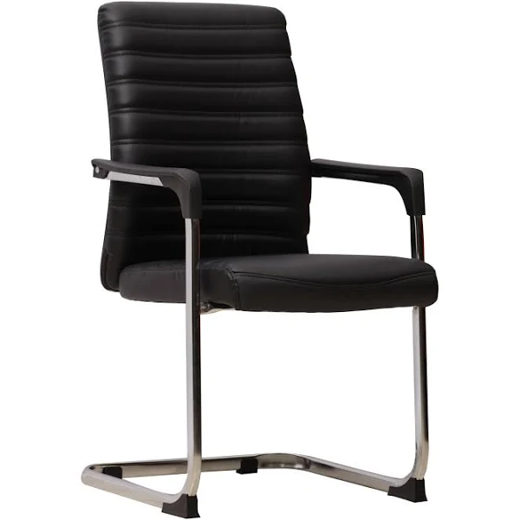

HLUHLUWE PARK HOME BANKING HALL

6x 3-Seater Heavy Duty Standard Steel
Cross beam:1.8mm steel Aluminium powder coated. Arms, legs & edges:
Heavy duty 1.5mm steel tubing-double chrome plated. Seat 1.2mm steel aluminium powder coated.
Up to 130kg per seat



HLUHLUWE PARK HOME ADMIN OFFICES

2X Concorde Operators Mid Back Office Chair
2X Administration Clerks Upholstery: Full PVC (Vinyl)
Mechanism: Swivel & tilt with 1 position lock
Arms: PU
Base: 5 Star black nylon
Warranty: 2 years
Weight Capacity :110 Kg
2X L Shaped Desk 2400mm x 1200mm x 800mm
Everest Credenza 1200mm x 600mm
Everest 4/Drawer Desk Height Pedestal
Mahogany

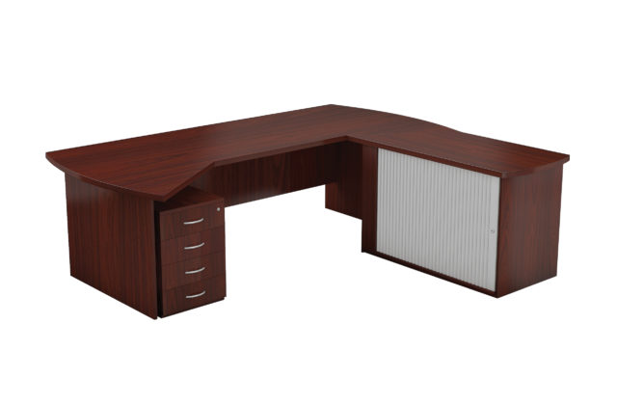

- x Lockable folio cabinets

Roller Door System Cupboard with 3x wooden shelves,
lockable, 1100W x 560D x 1500H
Mahogany

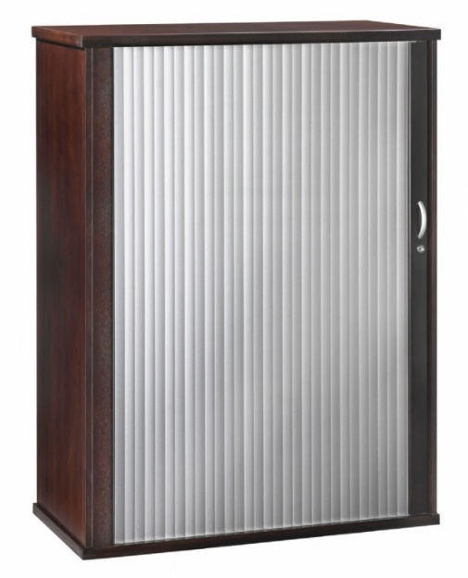

DIRECTORS’ OFFICES

2X President Range High Back Office Chair Specifications:
This chair is HEAVY DUTY supporting a user weighing up to 180kg
Swivel & tilt mechanism with 1 position lock
Gas height adjuster
Wooden armrests with upholstery.
5-star wood base (700mm diameter)
Combo of bonded leather on the front & PVC on the back



2X Executive desks with cabinets (Mahogany)

Desk shell with half inlay,2100wX900Dx730H
Quarter link with curved base,800w X650DX730H(LHS)
Roller door credenza including shelf, Drawer, 2X std Drawer
1X deep filling Drawer, 250 W X 650D X 730H (LHS)
Wall unit with full glass top, hinge door bottom incl. 3xshelves, 900 W x 360D X1900H
Low wall unit with solid hinge doors, icnl.1 x shelf, 900W x 360Dx 750 H (32mmtop, 50mm solid edge. Veneer.
President Range High back Leather Chair.
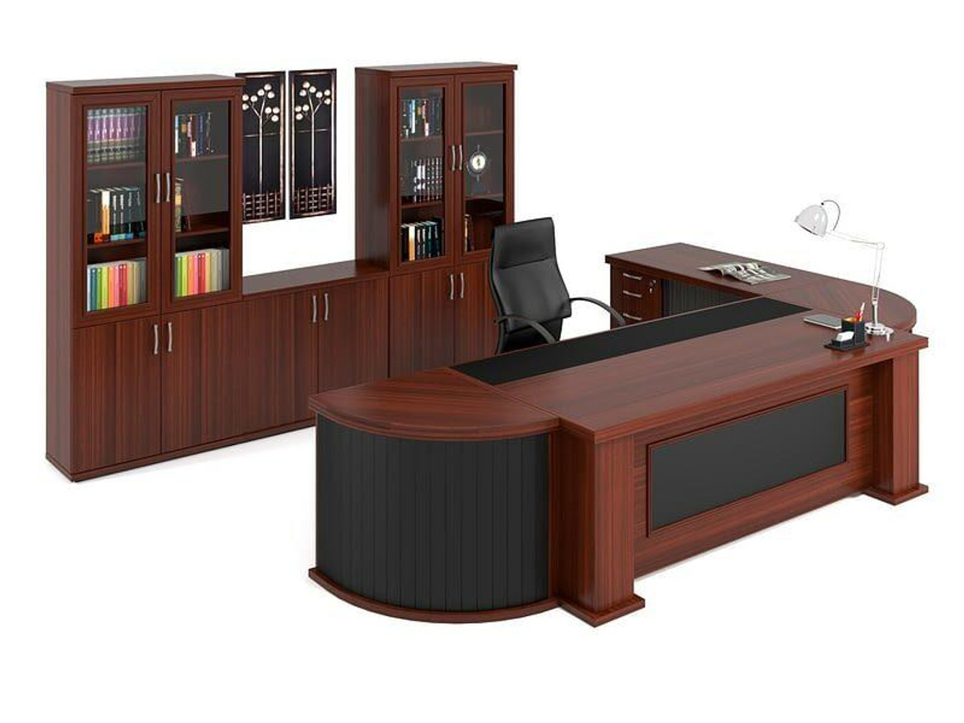
2 X Boston Boardroom Table
Barrel Shape Table – Mahogany
70 x 25mm Top
1800 x 1200mm – 6-Seater

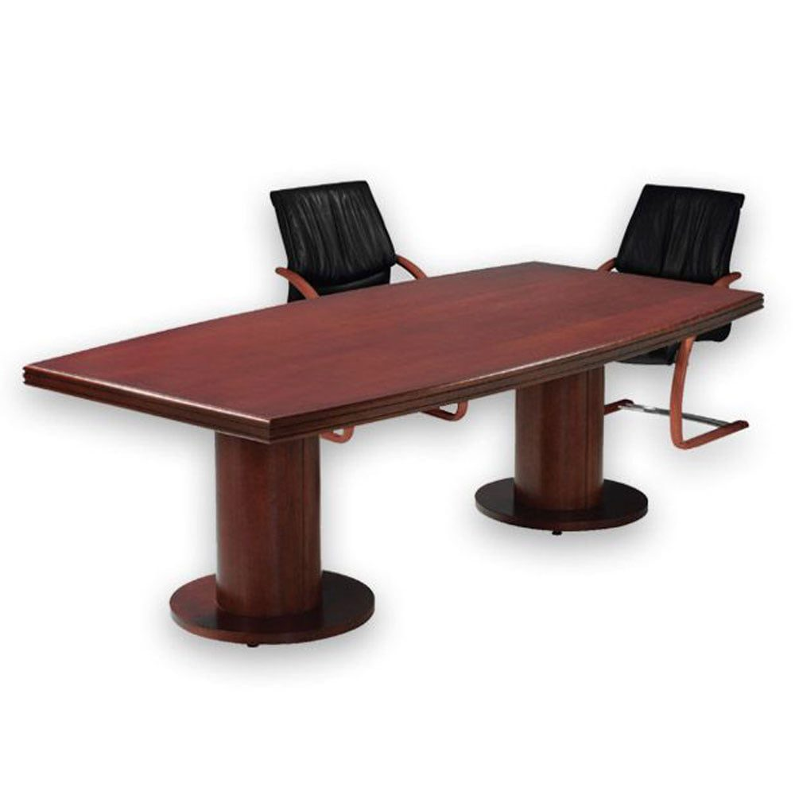
16 X Adda Wooden 4-Legged Boardroom Chairs
Weight:15.00 KGS
Width:60.00 (cm)
Height:100.00 (cm)
Depth:60.00 (cm)
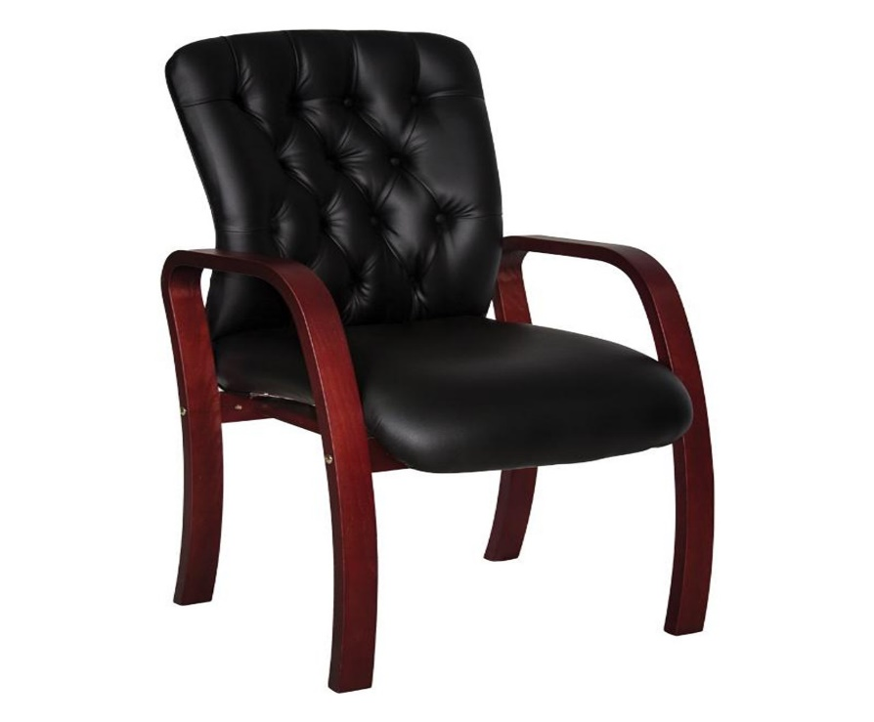

2 X 2-Seater leather couches
Victorian Standard with mahogany bun feet
Double seater, 1800w X 840 x750H
Seat depth: 620mm. Seat width: 1280mm

2x Small coffee tables
Alpha coffee tables glass square. 600W x600D x 450H. Mahogany

2 x Executive PU Leather Club Chair- Black
63cm (L) x 63cm (W) x 73cm (H)
- 12kg Weight
- PU Leather Material
- Wooden Legs
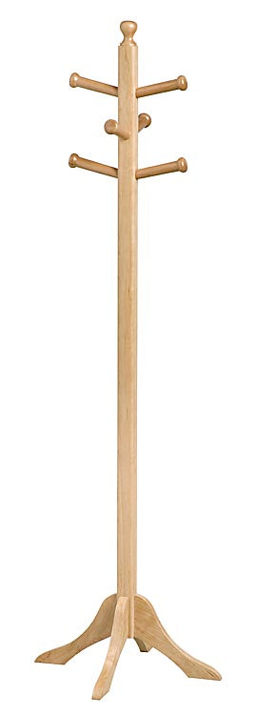
2x Hat Stand
485x485x1680 -Mahogany

2x Hardwood double letter desk tray, two tier, Mahogany

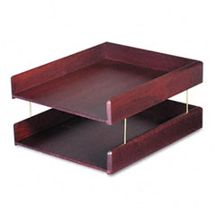

2 x Lockable folio cabinets (Mahogany)
Roller Door System Cupboard with 3x wooden shelves,
lockable, 1100W x 560D x 1500H
Mahogany

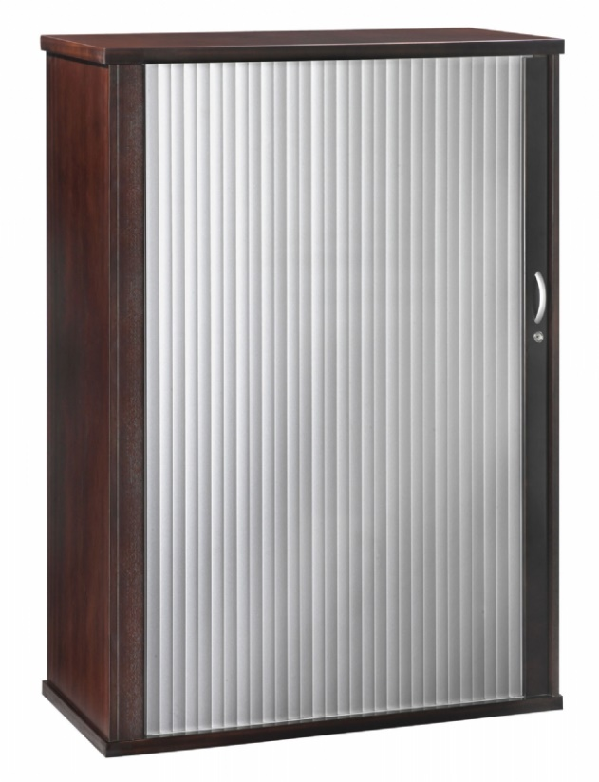

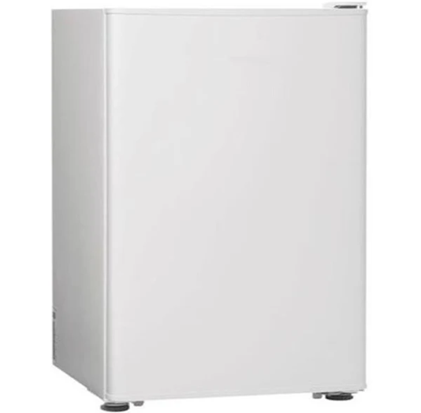

2 X Metallic Bar Fridge
Width: 475, Height: 850, Depth: 445, Total net litres: 92L 2X 32 inch Smart Television

2 X DIRECTOR’S PERSONAL ASSISTANTS

2 X L Shaped Desk 2400mm x 1200mm x 800mm
Everest Credenza 1200mm x 600mm
Everest 4/Drawer Desk Height Pedestal
Mahogany
2 x Lockable folio cabinets 2 x Plastic Wastepaper Bin Black

Roller Door System Cupboard with 3x wooden shelves,
lockable, 1100W x 560D x 1500H
Mahogany
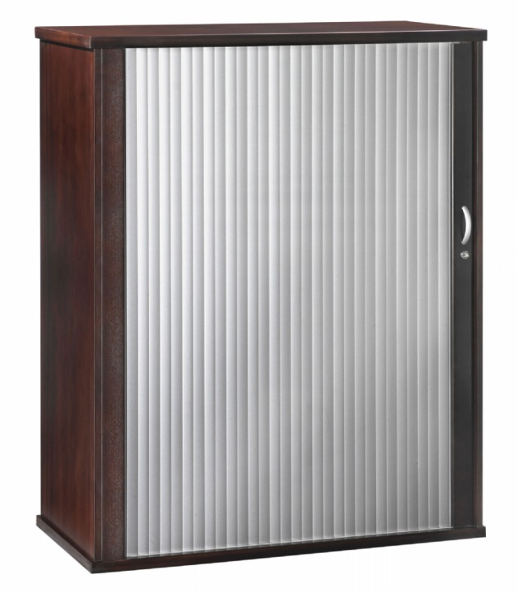



2X Concorde Operators Mid Back Office Chair
Upholstery: Full PVC (Vinyl)
Mechanism: Swivel & tilt with 1 position lock
Arms: PU
Base: 5 Star black nylon
Warranty: 2 years
Weight Capacity :110 Kg



Printing & Filling Room
4 x Cabinets
Folio Cabinet Range 4 drawer folio – 16 mm Square Top
3 rows of filing (Folio containers) per drawer = 15 X Folio containers per drawer
Internal steel frame. Height adjustable
Internal component: 3 rows of hanging files per drawer
Accommodate A4 and folio size files

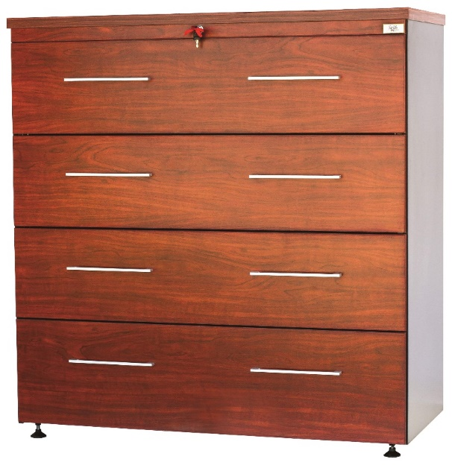
Printing & Filling Room
5 x Cabinets
Folio Cabinet Range 4 drawer folio – 16 mm Square Top
3 rows of filing (Folio containers) per drawer = 15 X Folio containers per drawer
Internal steel frame. Height adjustable
Internal component: 3 rows of hanging files per drawer
Accommodate A4 and folio size files

4 X Concorde Operators Mid Back Office Chair
4 X LAND ASSESSMENT SPECIALISTS Upholstery: Full PVC (Vinyl)
Mechanism: Swivel & tilt with 1 position lock
Arms: PU
Base: 5 Star black nylon
Warranty: 2 years
Weight Capacity :110 Kg
4 X L Shaped Desk 2400mm x 1200mm x 800mm
Everest Credenza 1200mm x 600mm
Everest 4/Drawer Desk Height Pedestal
Mahogany

4 x Plastic Wastepaper Bin
Black

2X Concorde Operators Mid Back Office Chair
2 X LAND ASSESSMENT ADMIN SUPPORT Upholstery: Full PVC (Vinyl)
Mechanism: Swivel & tilt with 1 position lock
Arms: PU
Base: 5 Star black nylon
Warranty: 2 years
Weight Capacity :110 Kg
2x Cluster Desk
Top ONLY 1600/1800x1200mm
3 x Steel Pole Legs
Perforated Steel Modesty Panel
4 X Drawers

2 x Lockable folio cabinets
Roller Door System Cupboard with 3x wooden shelves,
lockable, 1100W x 560D x 1500H
Mahogany 2 x Plastic Wastepaper Bin Black

2 X Concorde Operators Mid Back Office Chair

2 X GAZETTING AND VERIFICATION STAFF Upholstery: Full PVC (Vinyl)
Mechanism: Swivel & tilt with 1 position lock
Arms: PU
Base: 5 Star black nylon
Warranty: 2 years
Weight Capacity :110 Kg

2 X L Shaped Desk 2400mm x 1200mm x 800mm
Everest Credenza 1200mm x 600mm
Everest 4/Drawer Desk Height Pedestal
Mahogany

4 x Plastic Wastepaper Bin
Black

2x Portable Office Divider, Convenient Movable 3-panel, folding Partition Privacy Screen
102" W X 19.7" D X 71.3" H
BLACK

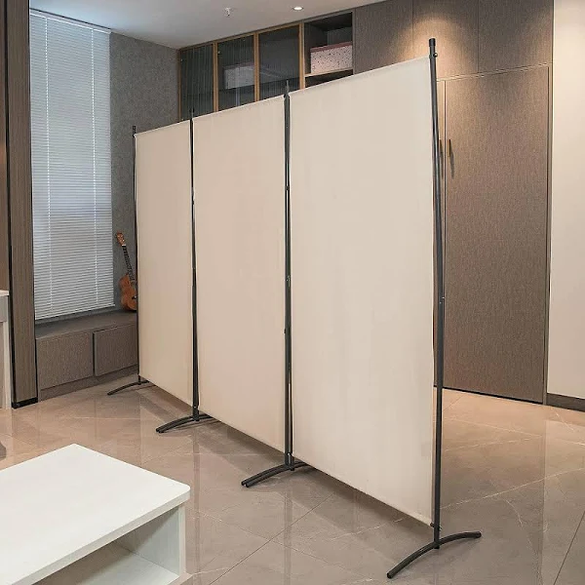

PORT SHEPSTONE PARK HOME BOARDROOM
Conference tables (rectangular sitting-10-seater) Mahogany
Meeting table,
10 X Classic Eames Repo Range 30 X Classic Eames Boardroom Chair Range
Genuine leather midback chair Genuine leather midback chair
Black Black


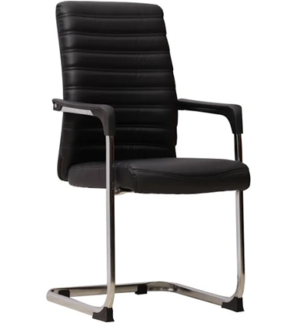

PORT SHEPSTONE PARK HOME BANKING HALL

4x 3-Seater Heavy Duty Standard Steel
Cross beam:1.8mm steel Aluminium powder coated. Arms, legs & edges:
Heavy duty 1.5mm steel tubing-double chrome plated. Seat 1.2mm steel aluminium powder coated.
Up to 130kg per seat

PREFERENTIAL GOALS

 | GOALS | 80% | 20%
1. | The promotion of enterprises located in KZN province for work to be done | 10 points
2. | Black people who are youth | 5 points
3. | Black people who are women | 5 points

the power, by one person or a group of persons holding the majority of the equity of an enterprise, alternatively, the person/s having the deciding vote or power to influence or to direct the course and decisions of the enterprise.
Joint venture or Consortium means an association of persons for the purpose of combining their expertise, property, capital, efforts, skill and knowledge in an activity for the execution of a contract.

