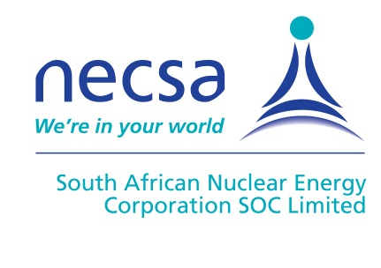
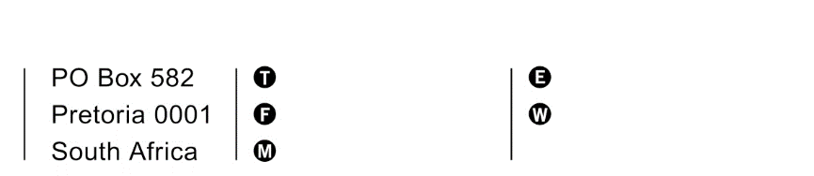
Necsa – The South African Nuclear Energy Corporation SOC Ltd

scm@necsa.co.za
+27 12 305 6072
+27 12 305 xxxx
+27 xx xxx xxxx
name.surname@necsa.co.za
www.necsa.co.za
xxxxxxxxxxxxxxxxxxx
xxxxxxxxxxxxxxxxxxx

Date 23 November 2021
Ref. No RFI 0007

Dear Sir/Madam

Closing date: 18 February 2021 at 16:00pm

Request for information (rfI) – THE UPGRADE OF P3000 RADIOPHARMACEUTICAL MANUFACTURING FACILITIES

NTP Radioisotopes, a subsidiary of Necsa, invites prospective service providers to submit their confirmation of interest and ability to render the above mention service, provide a cost estimate and the timelines for construction/implementation, considering the URS attached. The attached document contains all the information you will need to prepare a response.

We look forward to receiving your response.

Documents applicable to this Request for Information:
Item No | Item Description | Document No
1 | USER REQUIREMENT SPECIFICATION FOR THE UPGRADE OF P3000 RADIOPHARMACEUTICAL FACILITIES | RPH-SPE-3020

Background
NTP Radioisotopes SOC Ltd is a subsidiary of the South African Nuclear Energy Corporation (Necsa) and is a leading manufacturer and supplier of radiation-based products and services including essential medical radioisotopes. This proudly South African corporate citizen is situated at Necsa’s nuclear facility at Pelindaba west of Pretoria, and serves customers in 50 countries around the world. NTP has strategic partners and associates ranking among the world’s leading providers of nuclear technology products, nuclear imaging services, and pharmaceutical producers and suppliers.

For more information on NTP Radioisotopes SOC Ltd visit: www.ntp.co.za

Costs of Preparing RFI Response.
NTP shall not be liable to pay or reimburse the service provider for any cost incurred in relation to preparation of this document.
NTP shall accept no liability in respect of any loss or damage which may incur in the preparation and admission of this request for information.
The contents of these documents shall be held as confidential and private and may not be disclosed to a third party or be published in any way whatsoever.
This RFI is not an offer to purchase and NTP is under no obligation to award a purchase order as a result of this Request for Information.

Disclaimer
Respondents are hereby advised that NTP is not committed to any course of action as a result of this RFI. NTP reserves the right at its sole and full discretion to:
- Validate any information submitted by the Respondents in respond to this RFI. This would include, but not limited to, request the Respondents to provide supporting evidence. By responding to this RFI, Respondents hereby irrevocably grant the necessary consent to NTP to do so.
- Utilize any information provided to it in response to this RFI to draft the scope of requirements for inclusion in an RFP.
- Take no further action whatsoever, it is so decides
- Not bind itself to accept any or all of the RFI’s
- Withdraw from this process and the provisions of this project at any time
Increase or decrease the quantities and scope as indicated in the RFI.
Closing Date.
Your response should be in an email format with the email subject stating the RFI reference number, and submitted by the 18 of February 2022 at 16:00pm.

Briefing/Clarification meeting.
A clarification meeting will be held virtually on the 8th of December 2021 at 14:30. In order to attend the briefing kindly forward your request to scm@necsa.co.za and the link will be forwarded to you.

Any enquiry regarding this request shall be submitted in writing to scm@necsa.co.za.

Yours sincerely
Supply Chain Management.

