REQUEST FOR QUOTATIONS
SCOPE OF WORK
 | COST ESTIMATE
 | REPAIR AND MAINTENANCE RECOMMENDATIONS
2 | Health and Safety | Description | QTY | Rate | Amount (Rand)
2 | Health and Safety | Description | /M² | Rate | Amount (Rand)
 | 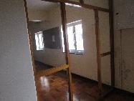
 |  | 5th Floor – Lift Lobby- Missing door to be replaced (smoke draft door)
2,22
 | 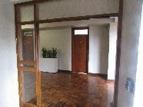
 |  | 4th Floor – Lift Lobby- Missing double door to be replaced (smoke draft doors)
2,27
 | 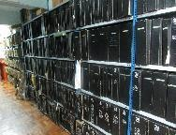
 |  | 3rd Floor – Room 308- Music Library- Shelving to be mounted to wall x36
2,32
 | 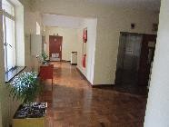
 |  | 1st Floor – Smoke draft doors to be installed x2
2,39
 | 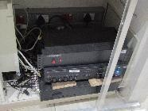
 |  | Ground Floor – PAE System to be serviced
2,45
 | 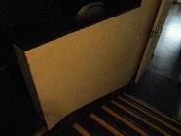
 |  | Ground Floor – Handrail to be installed 1,8m
2,52
 | 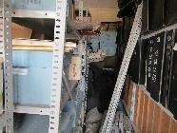
 |  | 8th Floor – Room 801- Fire risk and area to be cleaned out
2,63
 | 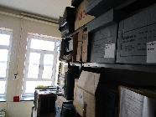
 |  | 8th Floor – Room 801- Shelves to be mounted to wall x11
2,64
 | 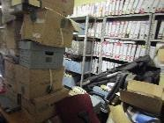
 |  | 8th Floor – Room 802- Fire risk and area to be cleaned out
2,65
 | 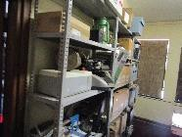
 |  | 8th Floor – Room 802- Shelves to be mounted to wall x10
2,66
 | 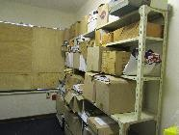
 |  | 8th Floor – Room 808- Shelves to be mounted to wall x6
2,67
 | 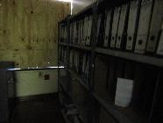
 |  | 8th Floor – Room 808- Shelves to be mounted to wall x6
2,68
 | 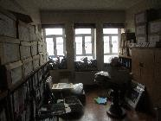
 |  | 7th Floor – Room 704- Fire risk and room to be cleaned out
2,69
 | 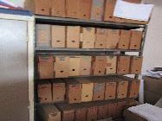
 |  | 6th Floor – Room 602- Shelves to be mounted to wall x5
2,71

