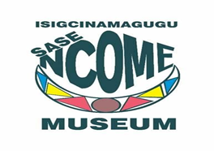

Date: 03 October 2022

Quotation No: NMQ 01 OF 2022

We are looking for a Graphic design service provider to develop and present a coffee shop concept customised to existing space and designs for other souvenirs for our Curio Shop. The service provider must deliver scaled and ready-to-print artworks for all of the below items:

- Restaurant & Coffee House Shopfront artwork (scaled/sized)
- Restaurant & Coffee House Uniform artwork (for apron and hat) (scaled/sized)
- Artworks for Tourist Merchandise as follows:
- Golf shirts (scaled/sized)
- Crew neck t-shirts (scaled/sized)
- Caps (scaled/sized))
- Mugs (scaled/sized)

A designer is expected to design against earthy colors with our iconic images. Iconic images are available in our museum photo collection.

Compulsory site briefing:

Date: 12 October 2022
Time: 12H00
Venue: Ncome Museum Hall

Closing Date: 17 October 2022 for submission of quotations @ 12:00

Documents to be supplied:
- Breakdown Quote with the total price
- SDB4 Form Declaration of interest
- Tax Compliance Status Pin
- Valid BBBEE Certificate or Sworn Affidavit
- Registration with CSD
- Contactable References (3)

For Enquiries please contact:
Mrs Nomvelo Kubheka
Administration Department
Ncome Museum: 087 527 0823
Email: Nomvelo.Kubheka@ncomemuseum.org

