ENOCH MGIJIMA LOCAL MUNICIPALITY
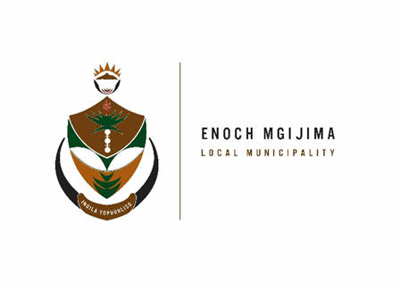
TENDER NOTICE

PROJECT NAME | TENDER NUMBER | DOCUMENT PRICE | BRIEFING MEETING | CLOSING DATE
Provision of legal services for a period of three (3) years | SCM09/02/2023 | R250.00 | NO BRIEFING  Enq: Mr. Z. Vumazonke  zvumazonke@enochmgijima.gov.za  045 807 2601 / 2 | 13 March 2023 at 12h00
Provision of Travelling and Accommodation services for a period of three (3) years | SCM10/02/2023 | R250.00 | NO BRIEFING  Enq: Ms. N. Myekwa  Nmyekwa@enochmgijima.gov.za  045 807 2086 | 13 March 2023 at 12h00

The PPPFA act No.5 of 2000 and the New amended regulations of 2022 effective as from the 16 January 2023 as per gazette No. 47452 is scheduled as follows:
PPPFA – |  | 80/20
PRICE – |  | 80 Points
BBBEE – |  | 10 Points
SPECIFIC GOALS - |  | 10 Points
Banking details
: Acc Name: Enoch Mgijima Local Municipality
Bank :FNB
Acc No :62438159809
Acc Type :Cheque
Branch Code : 250655 (internet Banking)
Ref : 3010142551022
Bid documents containing detailed terms of reference will be available as from Tuesday 28 February 2023 ; 08h00 - 16h00 week days, from the Supply Chain Management offices: Budget and treasury offices at No. 25-27 Owen Street; Queenstown upon payment of a non–refundable fee (either in cash or by means of an EFT made payable to the Enoch Mgijima Local Municipality) . Completed bid documents are to be place in a sealed envelope clearly marked the Bid number and Project Name and must be deposited in a bid Box situated at Budget and treasury offices at No. 25-27 Owen Street; Queenstown no later than 12h00pm on the closing date at which all bids will be opened in public
More details about the advert contact Mr. A Hoko (045 807 2000)
Issued By

A MKHANGELWA KOMANI HOSPITAL
ACTING MUNICIPAL MANAGER N6 ROUTE
KOMANI

