Dear User

Thank you for your recent attendance and participation in the e-auction system training. We hope that you found the training insightful and are now ready to utilise the system to positively contribute to the buckets of Eskom’s cost saving initiatives.

The question that is probably lingering on your mind is “What do I need to do next?”. This email is meant to provide you with the following:

- To answer the question.

- To provide with you more information with regard to accessing the system.

- To guide you on how to get help when experiencing challenges with the system.

- How to access various documents that are meant to continuously provide users with more information pertaining to the system.

You are advised to save this email which will serve as a quick reference guide in future. The links that you will need to access the system are all contained in this email.

How do I access and start using the system?

There are three links provided to give various accesses to the system:

- Training Link: http://eauctiontraining – You can use this link to test and play around with the system, to familiarise yourself with various functions available and even try loading an auction or two, just to help you get acquainted with the system.

- e-Auction production administrators link: https://eauctionadmin.eskom.co.za/ – This is the link that you need to use to access the system and start loading e-auctions for suppliers to bid on. Please note that, information that is loaded here becomes available and visible publicly to all invited bidders.

3. e-Auction Suppliers Link: https://eauction.eskom.co.za/ - This is the link that suppliers/bidders use to access the advertised auctions and bid on. The link is accessible to the general public, but suppliers need to be registered to gain access. Generally, you will not be having access to logon on to this link as it’s meant for suppliers. Your loaded auctions will however be visible on this link.

Logging on to the system:

Kindly note that, you have already been registered on the system and as such, you can log on to the system using your Elec credentials. For an example:
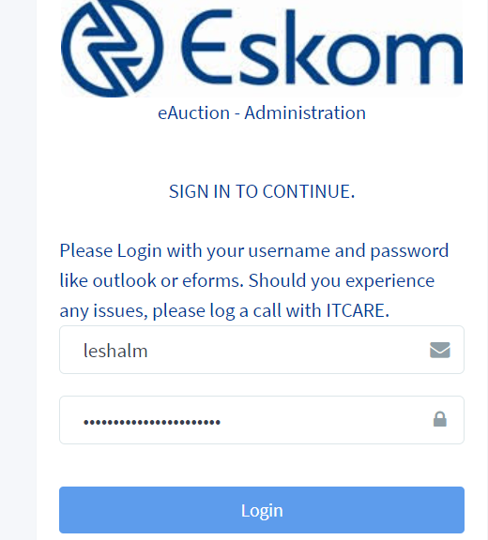

Support while using the system:

Several layers of support have been established to ensure that you have adequate support while using the system. If you experience any issues while using the system, you have three sources/areas to help you:

- e-Auction Champions/Divisional Representatives: Your first port of call will be in the form of your local divisional representatives who will be able to assist you with most of the minor challenges you might have. Most of these issues will be resolved at this level. Below are the contact persons for each division i.e. their names and contact numbers:

# | Division | Rep Full Name | E-mail Address | Office Number
1 | Corporate (Cx) | Malose Mokoatedi | MokoatMA@eskom.co.za | +27 11 516 7138
2 | Generation (Gx) | Louis Scholtz | ScholtLJ@eskom.co.za | +27 136932503
3 | Group Capital (GCD) | Raisibe Mphahlele | MphahlRL@eskom.co.za | +27 17 612 6174
4 | Distribution (Dx) | Motsatsi Magwele | MagwelME@eskom.co.za | +27 15 230 1729
5 | Transmission (Tx) | Frans Pooe | PooeF@eskom.co.za | +27 11 800 5661
6 | Eskom Rotek Industries (ERI) | Joseph Mabija | MabijaTJ@eskom.co.za | +27 11 621 3065

2. System Super Users/Administrators – Your next port of call will be the system administrators who will also help you with all your business related queries. These includes queries that pertains to business processes that are non-technical in nature. Below is the list and contact details:

# | Role | Name | e-mail address | Office Number
1 | Sourcing | Martin Nndwammbi | NndwamTM@eskom.co.za | +27 11 800 5234
2 | Disposal | Nkosingiphile Dlamini | DlaminNv@eskom.co.za | +27 11 516 7778

3. Group IT Support – For all technical issues, Group IT will be your port of call. You will need to log a request with ITCARE to get a reference number. This you can do by sending an email to: ITCARE@eskom.co.za. Clearly state in your email the issue you are experiencing and that this needs to be send to the e-auction support team. To speed up the resolution of your issue - once you receive your reference number, you can contact the following people:

Names | Contacts
Videsh Ramdath | RamdatVR@eskom.co.za
Segodi Leshalabe | leshalm@eskom.co.za

- System documentation – You have already received various documents to help guide you with the system, and/or should you need to access them online, you are welcome to use the following Hyperwave link: https://hyperwave.eskom.co.za/Eskom/Technology%20and%20Commercial/Procurement%20%26%20Supply%20Chain%20Management%20%28P%26SCM%29/IT%20Projects%20and%20Initiatives and the folder : E Auction Project.

We wish you all the best in using the system. Should you have suggestions for improvements, please share those with your Divisional reps, who will ensure that they are channelled to the relevant individuals to look into it.

Welcome aboard.

