 | Section/division | Supply Chain Management
 | REQUEST FOR QUOTE (RFQ)
Description of Goods/ Service required | Executive Dinner Venue for the DGCAs Aviation Resilience Training
SPECIFICATIONS OF ITEM/ SERVICE |  | QUANTITY
Source a venue to host the “Executive Dinner” for the Director Generals of the Civil Aviation’s.  The SACAA will be hosting the Director Generals/CEO’s from across the globe to a dinner. The venue must be classy and flawless to host a dinner for the esteemed delegates.  Date: 12 April 2023  Time: 18:30-11:00  Pax: 80  Area: Sandton  GENERAL REQUIREMENTS  - The SACAA is seeking a venue to host the dinner for our international delegates  - The venue must be in Sandton, Gauteng  - The venue must have a 4-5-star grading  - The venue should ideally provide a dedicated team to assist the event organising committee with logistics and liaison between various aspects of the event applicable to the venue, catering, décor, audio-visuals  - The venue should provide uncapped WI-FI with a strong signal  - The venue facilities should cater for persons living with physical disabilities  - The venue must be able to in or outsource all requirements detailed below.  - A minimum of 10 parking bays should be close the venue and be reserved for VIP guest.  - A minimum of 40 parking bays (not paid for by guests) should be provided  - The venue should have back up power which kicks immediately in case of power failure without interruptions to the programme.  SECURITY REQUIREMENTS  The venue should be able to produce the following on request by the SACAA security manager  - The venue must have emergency, security, and evacuation procedures in place.  - The venue must have access to emergency services within a 5km radius.  COVID-19 PROTOCOL REQUIREMENTS  - Sanitising and disinfecting protocols – all areas of the venue must have the touch free alcohol-based hand sanitisers stationed throughout the venue.  - The venue should provide access to hand sanitisers during the duration of the event.  ROOM REQUIREMENTS  The venue must provide us with the private dining intimate room that can give the look and feel of a cosy dinner. E.g. (lighting)  The décor should have the 5star class, meaning they should seek an external supplier to provide the full 5star décor (as attached)  On the entrance of the venue, we request a red carpet with stanchions, to create a VIP entrance feel with welcome drinks.  The venue should be able to do private catering buffet menu with starters on arrival, create a networking entrance ambiance with little bit of cocktail tables (so the guests could mee and greet before the dinner starts.  Date: 12 April 2022  Main Venue  - 8 round/square banqueting tables and chairs with full décor (Centre piece, runner, underplates, napkins with ring, crockery and cutlery, glasses, etc)  Please use chairs that have class not tiffany  - The preferred colours for décor: black, silver and cream  - Red carpet entrance through the venue    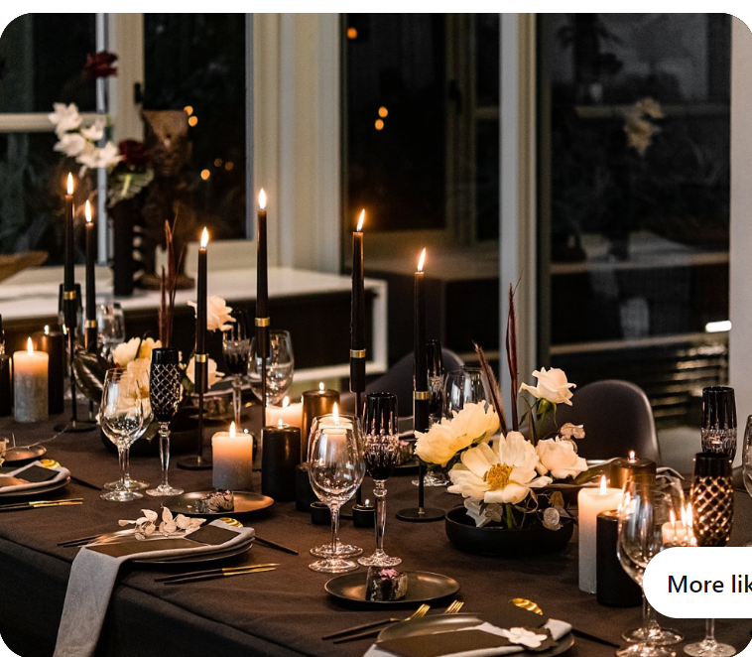  - social distancing  - Audio Visual Equipment including a basic stage 3x4m and a podium with 2 plants and the branded Lectern  Ministerial Holding Room  - Close to the main dinner venue but with a private entry way.  - Boardroom Set up  - 10 pax  CATERING REQUIREMENTS  Date: 12 April 2023  Dinner  - 80 pax arrival drinks alcohol and non-alcoholic  - 80 pax 2 course dinner (main and dessert) with beverage allocation of 2 x non-alcoholic drinks per person (a variety of sodas, juice, tizers and non-alcoholic cocktails)  - Bar limit of R20 000.00(no whisky, only beers, ciders.)  - Dinner to be served inside the banquet venue  Ministerial holding room  - Light snack platter  - Water and canned juice  AUDIO VISUAL REQUIREMENTS:  General Requirements  - PA system with PA speakers  - CD/USB port to play background music (the venue can provide the music)  - White Lectern Podium Microphone branded with our SACAA logo  - Strong Wi-Fi Connection  - Technician on the day  - 3x3 stage with black skirting |  | 1-night event

Budgeted - Yes | Cost Code: 01-01-00

