REQ 72776

ADDIS WATERING CAN HEAD PLASTIC (HEAD ONLY)
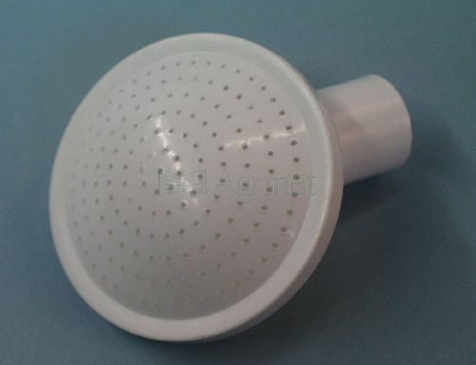

HOSE GARDEN STD 12mm x 30m
