IT Service Desk
(INCIDENT MANAGEMENT) SYSTEM

BID SPECIFICATION

PROJECT DESCRIPTION:

APPOINTMENT OF A SERVICE PROVIDER TO SUPPLY A CLOUD-BASED IT SERVICE DESK - INCIDENT MANAGEMENT SYSTEM

- Tender Notice & Invitation to Tender

The Human Science Research Council (HSRC) is seeking tenders/bidders from sufficiently experienced and qualified contractors to establish a contract to provide a cloud-based service desk system.

Bid documents can be obtained from?????? at a non-refundable fee of R????

Human Sciences Research Council (HSRC) Building
134 Pretorius Street
Pretoria

There will be a compulsory briefing session

Date: ?????
Venue: HSRC Building – Pretorius Street, Pretoria
Time: ????
The closing date for enquiries is (Date)
The closing date for submission is the (Date and time)

- Background & Introduction

  - Background
The Human Sciences Research Council (HSRC) is a research organisation that advances social sciences and humanities for public use. The HSRC subscribes to the values of good governance, accountable public administration and sound management of the resources as reflected in the Public Financial Management Act of 1999 (PFMA as amended by Act 29 of 1999) and other laws and regulations applicable to public administration.
Established in 1968 as South Africa’s statutory research agency the HSRC has grown to become the largest dedicated research institute in the social sciences and humanities on the African continent, doing cutting-edge public research in areas that are crucial to development.
The HSRC’s mandate is to inform the effective formulation and monitoring of government policy; to evaluate policy implementation; to stimulate public debate through the effective dissemination of research-based data and fact-based research results; to foster research collaboration and to help build research capacity and infrastructure for the human sciences.
- PROJECT GOALS

- The Council currently makes use of a hosted Service Desk system (OMA). As part of the transformation and to enhance the IT Service delivery, the organisation is looking to replace the current system with a modern ITIL-aligned cloud-based system that will offer:
  - better self-service
  - support flexible/agile working practices
  - availability at any time of day
  - accessible both over the corporate network and the internet.

- SCOPE OF SERVICES
This specification reflects the requirements of the HSRC Staff who will be users of the system.
The HSRC has a workforce of approximately 450 permanent staff members, 10 technicians and 2 super administrators across all HSRC offices countrywide.

Accredited service providers are, therefore, invited to provide proposals for the supply and deployment of the IT Service Desk – Incident Management system, licensing, training and documentation.

- Provide Service Desk Management application software that meets the system technical and modular functional requirements outlined in this document. The deliverable, in this case, is a Commercial Off-the-Shelf / out-of-the-box Service desk Management Software and all the associated quantity of software licenses.
- Provide Implementation and Technical Support Services to guarantee 100% success of the project and subsequent continual operation of the system. The deliverables, in this case, is a fully working Service Desk - Incident Management Software system that meets all the identified specific business requirements and use cases and all documentation including but not limited to use case specifications, technical design specifications, user manuals, installation manuals, operational manuals etc.
- Training to assist the HSRC to become self-sufficient in supporting, maintaining, managing, and utilising the Service Desk Management Software. The training program and training materials provided by the successful bidder must ensure that the HSRC employees can manage and operate the system.

  - SERVICE REQUIREMENTS
The bidder must demonstrate in the proposal that the various requirements stipulated in this document can be met. The following capabilities and more processes must be supported by the system.
- Incident Management
- Service Level Management
- Asset Management
- Self-Service Management
- Knowledge Management
- Chatbots capabilities
- Reports

  - Software Specifications
The technical requirements for the Service-Desk Management System are detailed below and bidders are expected to respond to each line item stating clearly how their proposed system meets the requirements.

All items MUST be responded to.

Minimum Technical Requirements
NO. | REQUIREMENT | BIDDERS RESPONSE
INCIDENT MANAGEMENT
(The system should meet the below features on Incident Management)
1 | Incident Classification
2 | Record Service Requests
3 | Impact
4 | Priority Matrix
5 | Urgency
6 | Priority
7 | Status (e.g. Open, on hold, Closed, etc)
8 | Link incidents to Assets and Ci’s
9 | Mailbox Management / Link an incident with an email
10 | Incident Templates
SERVICE LEVEL AGREEMENT MANAGEMENT
(The system should meet the below features on Service Level Agreement Management)
11 | Configuration of different levels of escalation
12 | Automation of escalation
13 | First response-based SLA
14 | Provision of notifications before SLA is breached
SELF-SERVICE
(The system should meet the below features on Self-Service)
15 | Self-Service portal included with the system
16 | Is it web-based?
17 | End users can create new requests
18 | Check status and update existing requests
19 | Update contact details
20 | Search knowledge base for users
21 | Access to Frequently Asked Questions (FAQs)
22 | View Announcements
23 | Take approval action
KNOWLEDGE MANAGEMENT
(The system should meet the below features on Knowledge Management)
24 | Access to knowledge management services for technicians
25 | Approval for newly added solutions
26 | Keyword search to find solutions based on request description
27 | Indexed document search for faster results
28 | Search history with previously resolved requests
ASSET MANAGEMENT
(The system should meet the below features on Asset Management)
29 | Automatic discovery of workstations in the network
30 | Discovery of all IP devices such as a printer, etc
31 | Discovery and complete scan for Windows, Linux and Mac machines
32 | Asset history along with the request
33 | Relationship chart explaining the relationship between assets, workstations, software, people etc
34 | Defining CI types and relationship types
35 | Integration of incident, problem and change with CMDB
REPORTING
(The system should meet the below features on Reporting)
36 | Pre-built standard reports
37 | Custom report
38 | Exporting reports to be exported in.CSV, XLs, and PDF formats
39 | Analysis of trends and performance levels
40 | Real-time update on reports

  - Licensing Specifications
- Provide recommendations on licensing requirements
- Deploy users under the recommended licensing structure and as per HSRC requirements and staffing
  - Testing Specification
- Test the performance of the system from the HSRC office and home network environment
- Assess the features, reliability, and performance thereof to determine adequacy
  - Training and Documentation Requirements
- Provide necessary training to general staff.
- Provide advanced administrative training to HSRC’s IT staff on maintaining and configuring the platform if need be.

- PERIOD OF PERFORMANCE
- The period of performance shall commence upon execution of an awarded contract, with the system expected to be implemented and completed within two (2) months of notice to proceed.
- If the option to proceed to full deployment is exercised, the period of performance would be extended for an additional three (3) months, with additional support continuing for an additional duration not to exceed six (6) months; in no case will the contract run longer than one (1) full year.
No guarantee is made regarding specific quantities of services which may be requested under this contract.
- FINANCIAL STRUCTURE
The price schedule must cover the 60 months contract period.

NB: Bidders are required to provide a detailed cost breakdown in a table format.
- Unless stated otherwise below, all prices offered by Proposers shall be firm against any increase for the duration of the initial contract period.
- Delivery charges, fees, insurance, expenses, and/or overhead shall be included in the total price.
- Contractor shall set up its billing system to ensure that invoices do include Value Added Tax (Vat) and is in South African Rands.
The successful bidder is required to:

- Produce a design plan for the proposed system.
- Install, configure, test and commission the system.
- Provide an electronic user manual to assist with operating the system.
- Provide HSRC IT technicians with training and manual of the system to provide first-line support after going live.
- Provide training to the HSRC end-users to enhance user experience.

- Internal LAN
The HSRC is using Juniper Ex-series 48 ports switches across the organisation and all of these switches are Power over Ethernet (PoE's) compatible.

- Juniper Gig switches (PoE) – Rack-mountable.
- Cat5 cabling in Pretoria and Sweetwaters offices.
- Cat6 cabling in Durban and Cape Town offices.
- VLANs in all offices.
- 1 Gig inter-branch fibre backbone/ TENET connectivity.
- Each HSRC site can break out directly to the internet.
- All sites make use of SonicWall NSA firewalls (NGFWs).
- All sites have SonicPoint Wireless (Wi-Fi) connectivity.

- HSRC WAN diagram

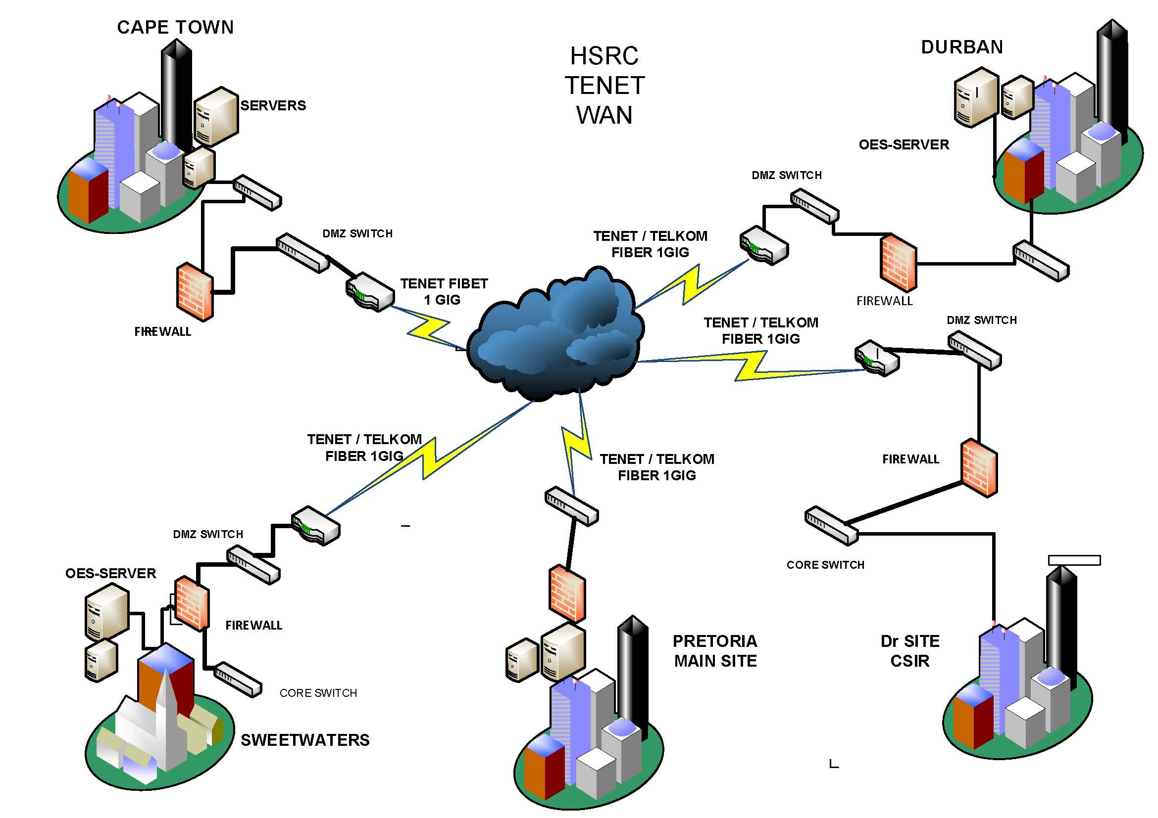

- HSRC LAN diagram

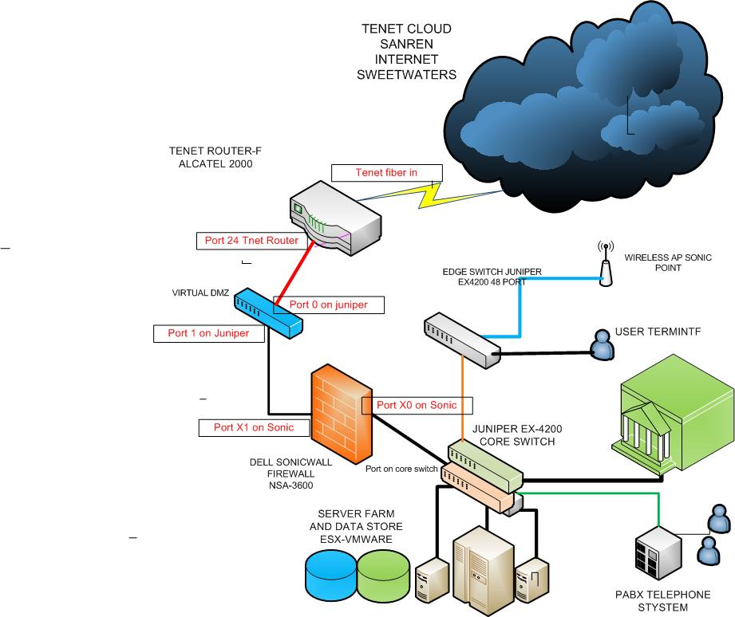

- COMPULSORY REQUIREMENTS

The bidder which fails to meet the minimum requirements as mentioned below will be disqualified.

The bidder must:

- Submit a company profile which indicates a five (5) years’ experience in implementing, commissioning and supporting of the same system.
- Submit three (3) contactable reference letters from previous clients where similar services were rendered. All letters must be on the company letterhead of the referee and signed by the referee.
- Submit a document that indicates the system architecture and design, timelines and milestones for project completion, support and maintenance plan with turnaround times, training plan of HSRC staff etc.

- PROJECT MANAGEMENT AND REPORTING

The project should commence before the end of September 2022 or soon after the issuing of the Purchase order

- A Service Level Agreement (SLA) must be signed between the successful bidder and the HSRC
- A Non-Disclosure Agreement (NDA) must be signed between the successful bidder and the HSRC
- The successful bidder must provide documented weekly progress reports and monthly reports about the implementation of the system

- COMPULSORY SUBMISSIONS

PLEASE COMPLETE THE TABLE BELOW AND ATTACH SUPPORTING DOCUMENTS

All bidders are expected to score 100% on the submission of the below listed
(Compulsory) before they can be recommended for evaluation.

- FUNCTIONALITY EVALUATION

 | REQUIRED DOCUMENTS | TICK
1 | Company Profile
2 | Proof of business address
3 | Registration Certificate with Industry Professional Bodies
6 | Project Implementation Plan (Methodology & timeline)
7 | Reference Letter/s from previous/current clients – with the same implementation
8 | Proposed system (Functionalities)
9 | B-BBEE Status Level

- Evaluation Criteria

 | Functionality | Weight | Score
 | Experience | 20
1. | Service Provider years’ of experience in implementing a similar system  - Equal to or greater than 10 years = (20 points)  - 5 years but less than 10 years = (10 points)  - 5 years and below (5)
2. | Project plan | 40
 | Provide a detailed Project plan with time lines
3. | References | 30
The Service Provider must provide 3 written and contactable references where a similar system has been implemented

One Reference letter = (10 points)
Two Reference letters =(20 points)
Three Reference letters = (40 points)
4. | Financials | 10
Provide Audited Financial statements for the last three years (2021, 2020,2019)
One statements = (10 points)
Two statements =(20 points)
Three statents = (40 points)
 | Total | 100
Minumum Treshold: 70%

For any enquiries please contact Mavis on: mmagoleng@hsrc.ac.za /012 302 2178

Please note that all proposals must be submitted electronically on: mmagoleng@hsrc.ac.za

