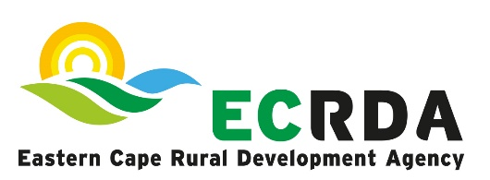

BID NOTICE
The Eastern Cape Rural Development Agency (ECRDA) hereby invites experienced and competent service providers to submit bids as outlined below.
Description | Evaluation Criteria | Compulsory Briefing Session | Closing Date and Time
SCMU 02 – 2023/24: Provision of Travel Management Services to ECRDA for a period of two years | 80/20 Preference Point System | No | 03 November @ 11h00

Bid documents outlining the detailed requirements and terms of reference will be obtainable from ECRDA website (www.ecrda.co.za) or via email upon request.

Administrative Enquiries should be directed to Mr A Langa -Telephone: 043 703 6300 or email: langaa@ecrda.co.za.

Technical Enquiries should be directed to Mrs M Esben – Telephone: 043 703 6300 or e-mail: esbenm@ecrda.co.za.

NB: Telephonic, telex, facsimile and late bids will not be accepted.
ECRDA reserves the right not to appoint.

