TERMS OF REFERENCE
Nature of Service: Fire Equipment Maintenance
1. SPECIFICATION
The HSRC seeks to appoint a company that will render fire equipment supply and servicing services for a period of twelve (12) months (estimated start date 05 January 2026) in the Sweetwaters office (Old bus depot, Mbubu Rd, Sweetwaters, PMB, 3201) based on the following:
- Fire Alarm supply and installation
- Annual fire extinguisher test and refill
- Supply and install fire escape plan
- Provide spares when needed after testing

2. MANDATORY REQUIREMENTS (Bidders who do not comply with the below requirements will be disqualified)
- SAQCC certification; (Company SANS 10139 Registration), or Registration with Fire Protection Association of Southern Africa or relevant – Provide valid certificate
- COID certificate (A copy of a valid Letter of Good standing from the Compensation Commissioner (note, proof of registration with the compensation commissioner will not be accepted).
- Company PSIRA registration, provide valid certificate
- Registration with CIDB and must have a grading of 1SF
- Provide proof of insurance liability of at least R500 000.00 per occurrence
- One or more technicians in the employ of the tenderer must have a diploma in Occupational Health and Safety- Provide proof of certification
- Provide at least three contactable references where similar services were rendered – complete table 1 below:

Table 1
Name of Company | Telephone | Contact Person | Services Rendered | Contract value | Contract period
1
2
3

3. PRICING SCHEDULE

SCOPE OF WORK | DETAILS | QTY |  |  | Price per |  |  | UNIT PRICE |  |  | TOTAL
SCOPE OF WORK | DETAILS | QTY | unit | kg |  |  |  | (excl VAT) |  |  | (excl VAT)
To Service | 9.0kg DCP fire extinguishers | 13 |  |  |  |  | R
 | 4.5kg DCP fire extinguishers | 5 |  |  |  |  | R
 | 2.5kg DCP fire extinguishers | 3 |  |  |  |  | R
 | 1.0kg DCP fire extinguishers | 13 |  |  |  |  | R
 | 5.0kg CO² fire extinguisher | 1 |  |  |  |  | R
 | 2.0kg CO² fire extinguishers | 10 |  |  |  |  | R
 | Fire Hose Reel | 3 |  |  |  |  | R
To Pressure Test | 9.0kg DCP fire extinguishers | 4 |  |  |  |  | R
 | 4.5kg DCP fire extinguishers | 5 |  |  |  |  | R
Hydro Test | 2.0 CO² fire extinguishers | 3 |  |  |  |  | R
To Recharge | Nitrogen refills | 9 |  |  |  |  | R
 | ABC powder refills (9.0kg x 2)(4.5kg x 4. | 36 |  |  |  |  | R
 | CO² refills (2.0kg x 6) | 12 |  |  |  |  | R
Spares | Head O - rings | 9 |  |  |  |  | R
 | Ffeta neck rings | 12 |  |  |  |  | R
 | Instruction labels | 3 |  |  |  |  | R
To Supply and Install | J.Brackets | 18 |  |  |  |  | R
 | 5.0kg CO² bracket | 1 |  |  |  |  | R
 | 2.0kg CO² bracket | 10 |  |  |  |  | R
 | 190² ABS Fire hydrant symbolic signage | 3 |  |  |  |  | R
 | 190² ABS Red arrow symbolic signage | 3 |  |  |  |  | R
 | 190² ABS Fire extinguisher symbolic signage | 26 |  |  |  |  | R
 | 190² ABS Red arrow symbolic signage | 26 |  |  |  |  | R
 | Travel, Installation and sundries | 1 |  |  |  |  | R
 | Fire Escape Plan | 1 |  |  |  |  | R
 | Fire Alarm plus installation | 1 |  |  |  |  | R
Total |  |  |  |  |  |  | R

Servicing | Year 1
Service and hydro test, pressure test, and to recharge
Supply and install fire alarm
Fire escape plan
Supply and install (spares & signs)
Total

Total price for 1-year Service Level Agreement (vat inclusive). Please include escalations R_________________________

Annexure A.

56 - Staff offices
10 - Toilets
11 - Storage areas
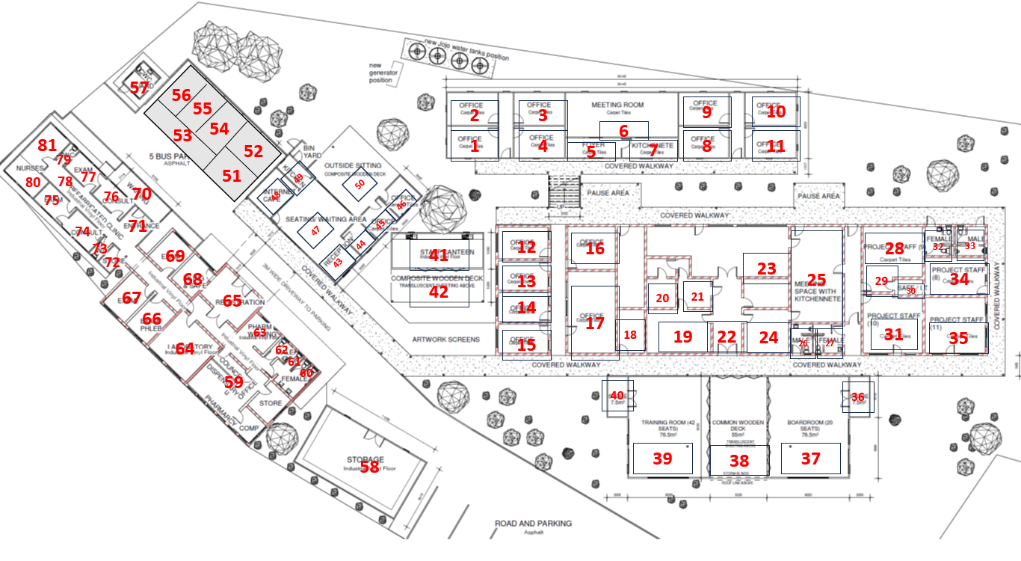
03 - Kitchens

SMT (Office 1 -11)
Main Block (Office 12 – 35)
Admin (Office 43 – 50)
Bottom Block (Office 59 – 69)
Clinic (Office 71 – 79)
Lab (Office 51 – 56)
Pharmacy (Office 80 – 81)

