Banners’ specifications
- X-Frame banner
- Quantity 4  - Full colour  - 1000 × 794 png Final artwork | 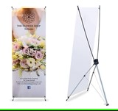

- Wall banners
- Quantity 10  - With expandable spring support stand (with hooks)  - Velcro attach strap  - Full colour  - (Width 3m x Height 2.2m)  - Final artwork will be provided | 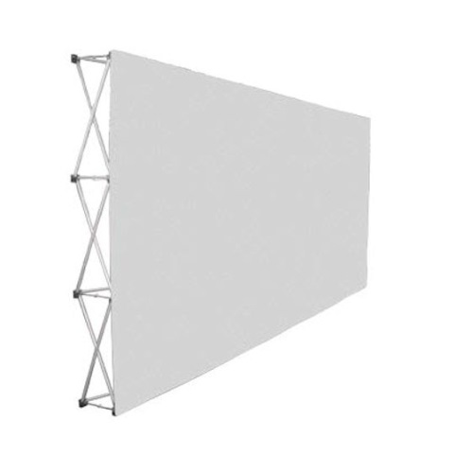

 | - Instaframe
 | - Quantity 2  - Full colour  - 1093 × 1401 jpeg  - Final artwork will be provided |  | 
- Table cloth

- Quantity 2  - Full colour  - 54*72in/137×183cm Rectangular Tablecloth  - Final artwork will be provided |  | 

- Tear Drop Banners
- Quantity 10  - Dual mount stand (spike + four-leg base) per banner  - Full colour  - Medium sized (Width 1.2m x 4.5m height)  - Final artwork will be provided | 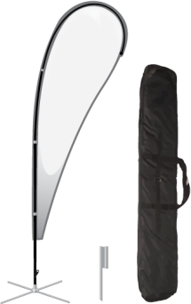  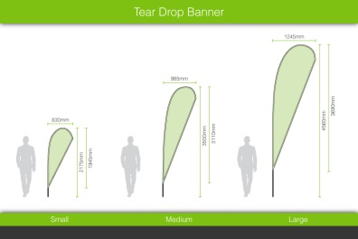

Identification badges specification (Plastic pouches and lanyards)
- Clear Plastic pouches ( 13cm H X 12cm W) Qty 5000 | 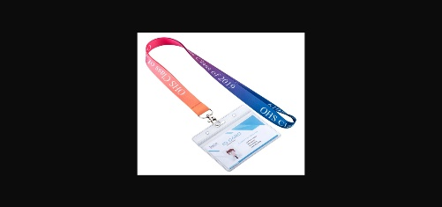
- Lanyards (normal size- green colour with white full departmental logo only which is attached herewith  Qty 5000 | 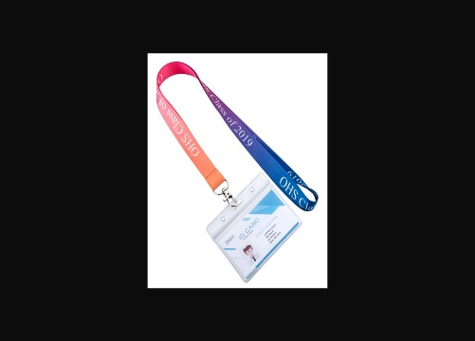

PLEASE NOTE THAT ALL ITEMS MUST BE DELIVERED TO LABORIA HOUSE ON 10 MAY 2024
Also note our requirements below:

1. Quotes must be valid for at least for 30 calendar days
2. Quotes must be on the official company letterhead
3. VAT inclusive
4. CSD Registration Report attached
5. Complete the attached SBD 4
6. Complete the attached SBD 6.1
7. *NO verbal/telephonic enquiries will be accepted, ALL enquiries must be directed to rfq.request@labour.gov.za ONLY!
8. *Any non-compliance in this regard will be viewed in a very serious light and may lead to the disqualification of your bid for quotation!!

Important Terms and Conditions!

As per the Preferential Procurement Regulations of 2022 in terms of the 80/20 Points system, the 20 points for Specific goals for the Department are allocated as follows:

1. 100% Women Ownership = 5 points;
2. 100% SMME/ Exempted Micro Enterprise =6 points
3. 100% owned by HDI =4 points
4. 100% owned by Disabled individuals =3 points;
5. Locality (Gauteng Province) = 2 points (Registered address on CSD will serve as proof)
6. Information from point 1 to 5 will be verified through the company’s CSD report.

NB – Please note that all quotations should be forwarded to rfq.request@labour.gov.za on or before 3 May 2024 @9:00

